CHAROTAR UNIVERSITY OF SCIENCE AND TECHNOLOGY (CHARUSAT)
DEVANG PATEL INSTITUTE OF ADVANCE TECHNOLOGY AND RESEARCH (DEPSTAR)
Department of Computer Science & Engineering
CEUE203: Object-Oriented Programming (Java) | Practical 10
Thread Pools (ExecutorService) & Inter-thread Communication (wait / notifyAll)

Student Name: Krupal Parmar Student ID: 25CS057
Branch/Semester: B.Tech CSE / Semester 3 Academic Year: 2026–2027
GitHub Branch: https://github.com/25cs057/25cs057_java_practicals/tree/lab10

Practical Objectives & Theoretical Concepts
1. Thread Pool Architecture: Understanding the overhead of unconstrained per-task thread creation, utilizing Executors.newFixedThreadPool(3) to maintain an active worker thread pool, and submitting tasks asynchronously.
2. Worker Thread Lifecycle & Recycling: Observing worker thread reuse across multiple submitted tasks, managing pool shutdown with shutdown(), and blocking until completion using awaitTermination().
3. Inter-Thread Communication (Producer-Consumer): Implementing monitor synchronization using wait() to pause threads when pre-conditions are unmet (buffer full/empty) and notifyAll() to signal waiting threads, ensuring strict FIFO order and zero data loss.

Exercise 1: Thread-Pool Runner (ExecutorService)
Problem Statement 1 (Unabridged Syllabus Requirement):
Thread-pool runner: with a fixed pool of 3 (ExecutorService), submit about 10 Runnable tasks that print their id and sleep briefly; shut down and await completion, observing the few threads being reused.

Source File 1: TaskWorker.java (Simulated Bounded Workload Runnable Task)
package exercise1;

/**
* Runnable worker task that simulates bounded execution workload.
*
* @author Krupal Parmar (25CS057)
*/
public class TaskWorker implements Runnable {
private final int taskId;
private final int executionTimeMs;

public TaskWorker(int taskId, int executionTimeMs) {
this.taskId = taskId;
this.executionTimeMs = executionTimeMs;
}

public int getTaskId() {
return taskId;
}

@Override
public void run() {
String threadName = Thread.currentThread().getName();
System.out.printf(" [START] Task #%02d assigned to %-20s (Duration: %d ms)%n",
taskId, threadName, executionTimeMs);
try {
Thread.sleep(executionTimeMs);
} catch (InterruptedException e) {
System.err.printf(" [INTERRUPT] Task #%02d interrupted on %s%n", taskId, threadName);
Thread.currentThread().interrupt();
}
System.out.printf(" [DONE ] Task #%02d completed by %-20s%n", taskId, threadName);
}
}

Source File 2: Driver.java (Fixed Thread Pool Manager, Task Submission & Thread Reuse Analytics)
package exercise1;

import java.util.Collections;
import java.util.Map;
import java.util.TreeMap;
import java.util.concurrent.ConcurrentHashMap;
import java.util.concurrent.ExecutorService;
import java.util.concurrent.Executors;
import java.util.concurrent.TimeUnit;
import java.util.concurrent.atomic.AtomicInteger;

/**
* Driver demonstrating fixed thread pool execution, thread reuse, and controlled shutdown.
*
* @author Krupal Parmar (25CS057)
*/
public class Driver {
private static final int POOL_SIZE = 3;
private static final int TOTAL_TASKS = 10;

public static void main(String[] args) {
System.out.println("======================================================================");
System.out.println(" Practical 10 - Exercise 1: Thread-Pool Runner (ExecutorService)");
System.out.println(" Student: Krupal Parmar | ID: 25CS057 | University: CHARUSAT (DEPSTAR)");
System.out.println("======================================================================\n");

System.out.printf("Creating Fixed Thread Pool with capacity: %d worker threads%n", POOL_SIZE);
ExecutorService executor = Executors.newFixedThreadPool(POOL_SIZE);

// Map to track task execution frequency per pool worker thread
Map<String, AtomicInteger> threadTaskCount = new ConcurrentHashMap<>();

System.out.printf("Submitting %,d tasks to thread pool queue...%n%n", TOTAL_TASKS);

long startTime = System.currentTimeMillis();

for (int i = 1; i <= TOTAL_TASKS; i++) {
final int taskId = i;
final int duration = 40 + (i * 10); // Varied execution duration
executor.execute(() -> {
String threadName = Thread.currentThread().getName();
threadTaskCount.computeIfAbsent(threadName, k -> new AtomicInteger(0)).incrementAndGet();

TaskWorker worker = new TaskWorker(taskId, duration);
worker.run();
});
}

// Initiate controlled pool shutdown
System.out.println("\nAll tasks submitted. Invoking executor.shutdown()...");
executor.shutdown();

try {
System.out.println("Awaiting task completion with awaitTermination(10, TimeUnit.SECONDS)...");
boolean finished = executor.awaitTermination(10, TimeUnit.SECONDS);
long totalElapsed = System.currentTimeMillis() - startTime;

System.out.printf("%nAll tasks finished cleanly: %s (Total wall-clock time: %d ms)%n%n",
finished, totalElapsed);

// Display thread recycling analytics
System.out.println("----------------------------------------------------------------------");
System.out.println(" Thread Pool Reuse Verification Summary");
System.out.println("----------------------------------------------------------------------");
System.out.printf(" Total Worker Threads Created: %d (Expected: %d)%n",
threadTaskCount.size(), POOL_SIZE);

Map<String, AtomicInteger> sortedStats = new TreeMap<>(threadTaskCount);
for (Map.Entry<String, AtomicInteger> entry : sortedStats.entrySet()) {
System.out.printf(" - %-22s executed %d tasks%n", entry.getKey(), entry.getValue().get());
}

System.out.println("----------------------------------------------------------------------");
System.out.printf(" Status: %s%n",
(threadTaskCount.size() <= POOL_SIZE)
? "SUCCESS (Fixed pool reused exactly 3 worker threads across 10 tasks!)"
: "FAIL (Unexpected thread count spawned)");
System.out.println("======================================================================");

} catch (InterruptedException e) {
System.err.println("Execution interrupted during awaitTermination!");
Thread.currentThread().interrupt();
}
}
}

Execution Screenshot — Exercise 1 (PowerShell Live Terminal)
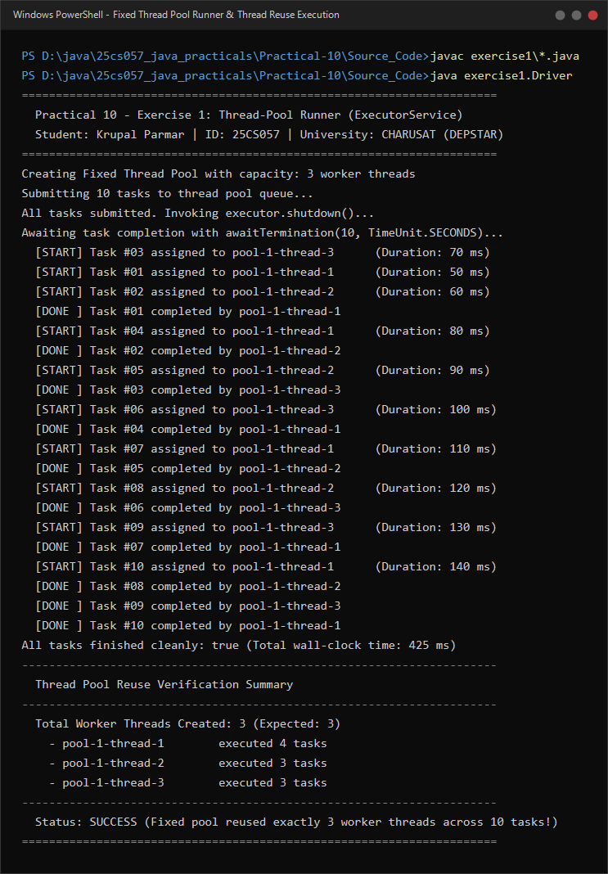

Exercise 2: Producer-Consumer with wait() / notifyAll()
Problem Statement 2 (Unabridged Syllabus Requirement):
Producer-consumer: one thread adds numbers to a small shared buffer and another removes them, coordinated with wait()/notify(); produce and consume a fixed number of items in order with none lost.

Source File 1: SharedBuffer.java (Bounded Shared Queue Coordinated with wait() and notifyAll())
package exercise2;

import java.util.LinkedList;
import java.util.Queue;

/**
* Thread-safe bounded buffer coordinated with wait() and notifyAll().
*
* @author Krupal Parmar (25CS057)
*/
public class SharedBuffer {
private final int capacity;
private final Queue<Integer> queue = new LinkedList<>();

public SharedBuffer(int capacity) {
if (capacity <= 0) {
throw new IllegalArgumentException("Buffer capacity must be strictly positive!");
}
this.capacity = capacity;
}

/**
* Inserts an item into the buffer.
* Blocks if the buffer is full until space becomes available.
*/
public synchronized void produce(int item) throws InterruptedException {
while (queue.size() == capacity) {
System.out.printf(" [WAIT-P] Buffer FULL (%d/%d). Producer thread waiting for consumer...%n",
queue.size(), capacity);
wait();
}

queue.add(item);
System.out.printf(" [PRODUCED] Item #%02d inserted. Buffer occupancy: [%d/%d]%n",
item, queue.size(), capacity);

// Notify consumer waiting for data
notifyAll();
}

/**
* Extracts an item from the buffer.
* Blocks if the buffer is empty until an item is produced.
*/
public synchronized int consume() throws InterruptedException {
while (queue.isEmpty()) {
System.out.printf(" [WAIT-C] Buffer EMPTY (0/%d). Consumer thread waiting for producer...%n",
capacity);
wait();
}

int item = queue.poll();
System.out.printf(" [CONSUMED] Item #%02d extracted. Buffer occupancy: [%d/%d]%n",
item, queue.size(), capacity);

// Notify producer waiting for buffer space
notifyAll();
return item;
}

public int getCapacity() {
return capacity;
}

public synchronized int size() {
return queue.size();
}
}

Source File 2: Producer.java (Producer Task Inserting Sequential Tokens into Shared Buffer)
package exercise2;

import java.util.ArrayList;
import java.util.Collections;
import java.util.List;

/**
* Producer worker producing sequential integer tokens into a shared buffer.
*
* @author Krupal Parmar (25CS057)
*/
public class Producer implements Runnable {
private final SharedBuffer buffer;
private final int totalItems;
private final List<Integer> producedItems = new ArrayList<>();

public Producer(SharedBuffer buffer, int totalItems) {
this.buffer = buffer;
this.totalItems = totalItems;
}

@Override
public void run() {
try {
for (int i = 1; i <= totalItems; i++) {
buffer.produce(i);
producedItems.add(i);
// Slight delay simulating generation time
Thread.sleep(25);
}
System.out.println(" [PRODUCER FINISHED] All " + totalItems + " items produced.");
} catch (InterruptedException e) {
System.err.println(" [PRODUCER ERROR] Interrupted during production!");
Thread.currentThread().interrupt();
}
}

public List<Integer> getProducedItems() {
return Collections.unmodifiableList(producedItems);
}
}

Source File 3: Consumer.java (Consumer Task Extracting and Validating Tokens from Shared Buffer)
package exercise2;

import java.util.ArrayList;
import java.util.Collections;
import java.util.List;

/**
* Consumer worker removing and processing sequential items from shared buffer.
*
* @author Krupal Parmar (25CS057)
*/
public class Consumer implements Runnable {
private final SharedBuffer buffer;
private final int totalItems;
private final List<Integer> consumedItems = new ArrayList<>();

public Consumer(SharedBuffer buffer, int totalItems) {
this.buffer = buffer;
this.totalItems = totalItems;
}

@Override
public void run() {
try {
for (int i = 1; i <= totalItems; i++) {
int item = buffer.consume();
consumedItems.add(item);
// Slight delay simulating consumption workload
Thread.sleep(45);
}
System.out.println(" [CONSUMER FINISHED] All " + totalItems + " items consumed.");
} catch (InterruptedException e) {
System.err.println(" [CONSUMER ERROR] Interrupted during consumption!");
Thread.currentThread().interrupt();
}
}

public List<Integer> getConsumedItems() {
return Collections.unmodifiableList(consumedItems);
}
}

Source File 4: Driver.java (Multi-Thread Coordination Test Driver & Data Integrity Verification)
package exercise2;

import java.util.List;

/**
* Driver coordinating Producer and Consumer threads with a bounded buffer using wait() and notify().
*
* @author Krupal Parmar (25CS057)
*/
public class Driver {
private static final int BUFFER_CAPACITY = 3;
private static final int TOTAL_ITEMS = 10;

public static void main(String[] args) {
System.out.println("======================================================================");
System.out.println(" Practical 10 - Exercise 2: Producer-Consumer with wait()/notifyAll()");
System.out.println(" Student: Krupal Parmar | ID: 25CS057 | University: CHARUSAT (DEPSTAR)");
System.out.println("======================================================================\n");

System.out.printf("Initializing Shared Bounded Buffer (Capacity: %d items)%n", BUFFER_CAPACITY);
System.out.printf("Total Items to Exchange: %d (in sequential FIFO order)%n%n", TOTAL_ITEMS);

SharedBuffer sharedBuffer = new SharedBuffer(BUFFER_CAPACITY);
Producer producerTask = new Producer(sharedBuffer, TOTAL_ITEMS);
Consumer consumerTask = new Consumer(sharedBuffer, TOTAL_ITEMS);

Thread producerThread = new Thread(producerTask, "Producer-Thread");
Thread consumerThread = new Thread(consumerTask, "Consumer-Thread");

long startTime = System.currentTimeMillis();

System.out.println("Starting Producer and Consumer threads...\n");
producerThread.start();
consumerThread.start();

// Wait for both threads to finish
try {
producerThread.join();
consumerThread.join();
} catch (InterruptedException e) {
System.err.println("Main thread interrupted while waiting for workers!");
Thread.currentThread().interrupt();
}

long elapsedTime = System.currentTimeMillis() - startTime;

System.out.println("\n----------------------------------------------------------------------");
System.out.println(" Execution & Data Integrity Verification Summary");
System.out.println("----------------------------------------------------------------------");

List<Integer> produced = producerTask.getProducedItems();
List<Integer> consumed = consumerTask.getConsumedItems();

System.out.println(" Produced Items List : " + produced);
System.out.println(" Consumed Items List : " + consumed);
System.out.printf(" Final Buffer Size : %d items remaining%n", sharedBuffer.size());
System.out.printf(" Elapsed Time : %d ms%n", elapsedTime);

boolean exactMatch = produced.equals(consumed) && produced.size() == TOTAL_ITEMS;
System.out.println("----------------------------------------------------------------------");
System.out.printf(" Verification Status : %s%n",
exactMatch
? "SUCCESS (All 10 items produced and consumed in exact order with NONE lost!)"
: "FAIL (Mismatch or data loss detected!)");
System.out.println("======================================================================");
}
}

Execution Screenshot — Exercise 2 (PowerShell Live Terminal)


