CHAROTAR UNIVERSITY OF SCIENCE AND TECHNOLOGY (CHARUSAT)
DEVANG PATEL INSTITUTE OF ADVANCE TECHNOLOGY AND RESEARCH (DEPSTAR)
Department of Computer Science & Engineering
CEUE203: Object-Oriented Programming (Java) | Practical 08

Student Name: Krupal Parmar  Student ID: 25CS057 | Semester: 3 (A.Y. 2026-27)  GitHub Branch: lab8

1. Guarded calculator: read two numbers and an operator; throw a custom DivideByZeroException and catch invalid-number input separately

A. Problem Statement
Official Problem Definition:
Guarded calculator: read two numbers and an operator; throw a custom DivideByZeroException and catch invalid-number input separately, printing a clear message each time; loop until a valid calculation succeeds and use finally to log each attempt.

B. Complete Java Source Code
File 1: Practical-08/Source_Code/exercise1/DivideByZeroException.java
package exercise1;

/**
* Custom checked exception thrown when an arithmetic division by zero is attempted.
*/
public class DivideByZeroException extends Exception {
public DivideByZeroException(String message) {
super(message);
}
}

File 2: Practical-08/Source_Code/exercise1/GuardedCalculator.java
package exercise1;

public class GuardedCalculator {

public static double calculate(double a, double b, String operator) throws DivideByZeroException {
return switch (operator) {
case "+" -> a + b;
case "-" -> a - b;
case "*" -> a * b;
case "/" -> {
if (Math.abs(b) < 1e-9) {
throw new DivideByZeroException("Arithmetic Error: Division by zero is undefined.");
}
yield a / b;
}
case "%" -> {
if (Math.abs(b) < 1e-9) {
throw new DivideByZeroException("Arithmetic Error: Modulo by zero is undefined.");
}
yield a % b;
}
default -> throw new IllegalArgumentException("Unknown operator '" + operator + "'. Supported: +, -, *, /, %");
};
}
}

File 3: Practical-08/Source_Code/exercise1/Driver.java
package exercise1;

import java.util.Scanner;

/**
* Practical 08 - Exercise 1 (Driver)
* Student Name: Krupal Parmar
* Student ID: 25CS057
* Course: CEUE203 - Object-Oriented Programming
*
* Problem Statement:
* Guarded calculator: read two numbers and an operator; throw a custom DivideByZeroException
* and catch invalid-number input separately, printing a clear message each time; loop until
* a valid calculation succeeds and use finally to log each attempt.
*/
public class Driver {
public static void main(String[] args) {
System.out.println("=== Practical 08 - Exercise 1: Guarded Calculator ===");
Scanner scanner = new Scanner(System.in);
int attempt = 0;
boolean success = false;

while (!success) {
attempt++;
System.out.println("\n--- Calculation Attempt #" + attempt + " ---");

try {
System.out.print("Enter calculation (format: <num1> <operator> <num2>): ");
if (!scanner.hasNextLine()) {
break;
}
String line = scanner.nextLine().trim();
if (line.isEmpty()) {
continue;
}

String[] parts = line.split("\\s+");
if (parts.length < 3) {
throw new IllegalArgumentException("Incomplete expression. Expected: <number1> <operator> <number2>");
}

double a = Double.parseDouble(parts[0]);
String op = parts[1];
double b = Double.parseDouble(parts[2]);

double result = GuardedCalculator.calculate(a, b, op);
System.out.printf("SUCCESS: %.2f %s %.2f = %.2f%n", a, op, b, result);
success = true;

} catch (NumberFormatException e) {
System.out.println("[ERROR - Invalid Input] Non-numeric input encountered: " + e.getMessage());
} catch (DivideByZeroException e) {
System.out.println("[ERROR - Custom Exception] " + e.getMessage());
} catch (IllegalArgumentException e) {
System.out.println("[ERROR - Invalid Operation] " + e.getMessage());
} finally {
System.out.println(" [FINALLY LOG] Finished processing Attempt #" + attempt +
" | Status: " + (success ? "SUCCEEDED" : "FAILED / RETRYING"));
}
}

System.out.println("\nCalculator session terminated.");
scanner.close();
}
}

C. Execution Output Screenshot
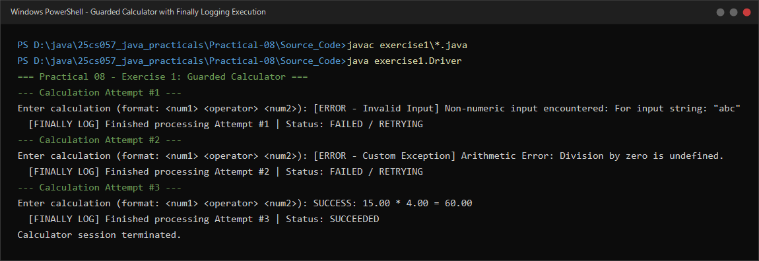
Figure 8.1: Live execution of GuardedCalculator demonstrating invalid input handling, DivideByZeroException catch, and finally block logging.

2. Stock issue: a Warehouse where issue(item, qty) throws a custom checked OutOfStockException carrying the shortfall, and InvalidQuantityException for qty <= 0

A. Problem Statement
Official Problem Definition:
Stock issue: a Warehouse where issue(item, qty) throws a custom checked OutOfStockException carrying the shortfall, and InvalidQuantityException for qty <= 0. Process a list of requests, catching and reporting each failure without stopping the run.

B. Complete Java Source Code
File 1: Practical-08/Source_Code/exercise2/OutOfStockException.java
package exercise2;

/**
* Custom checked exception thrown when an inventory shortfall occurs.
* Carries the specific shortfall quantity and item name.
*/
public class OutOfStockException extends Exception {
private final String item;
private final int shortfall;

public OutOfStockException(String item, int shortfall) {
super(String.format("Out of Stock: Request for '%s' exceeds available stock by %d units.", item, shortfall));
this.item = item;
this.shortfall = shortfall;
}

public String getItem() {
return item;
}

public int getShortfall() {
return shortfall;
}
}

File 2: Practical-08/Source_Code/exercise2/InvalidQuantityException.java
package exercise2;

/**
* Custom checked exception thrown when requested quantity is non-positive (<= 0).
*/
public class InvalidQuantityException extends Exception {
private final int quantity;

public InvalidQuantityException(int quantity) {
super(String.format("Invalid Quantity: Requested quantity %d must be strictly positive (> 0).", quantity));
this.quantity = quantity;
}

public int getQuantity() {
return quantity;
}
}

File 3: Practical-08/Source_Code/exercise2/Warehouse.java
package exercise2;

import java.util.HashMap;
import java.util.Map;

public class Warehouse {
private final Map<String, Integer> stock = new HashMap<>();

public void addStock(String item, int qty) {
stock.put(item, stock.getOrDefault(item, 0) + qty);
}

public int getStock(String item) {
return stock.getOrDefault(item, 0);
}

public Map<String, Integer> getAllStock() {
return new HashMap<>(stock);
}

/**
* Issues stock for an item.
* @throws InvalidQuantityException if qty <= 0
* @throws OutOfStockException if current available stock is less than requested
*/
public void issue(String item, int qty) throws OutOfStockException, InvalidQuantityException {
if (qty <= 0) {
throw new InvalidQuantityException(qty);
}

int current = stock.getOrDefault(item, 0);
if (current < qty) {
int shortfall = qty - current;
throw new OutOfStockException(item, shortfall);
}

stock.put(item, current - qty);
System.out.printf(" [SUCCESS] Issued %d units of '%s'. Remaining stock: %d%n", qty, item, stock.get(item));
}
}

File 4: Practical-08/Source_Code/exercise2/Driver.java
package exercise2;

/**
* Practical 08 - Exercise 2 (Driver)
* Student Name: Krupal Parmar
* Student ID: 25CS057
* Course: CEUE203 - Object-Oriented Programming
*
* Problem Statement:
* Stock issue: a Warehouse where issue(item, qty) throws a custom checked OutOfStockException
* carrying the shortfall, and InvalidQuantityException for qty <= 0. Process a list of
* requests, catching and reporting each failure without stopping the run.
*/
public class Driver {

record IssueRequest(String item, int qty) {}

public static void main(String[] args) {
System.out.println("=== Practical 08 - Exercise 2: Warehouse Stock Issue System ===");

Warehouse warehouse = new Warehouse();
warehouse.addStock("Laptop", 10);
warehouse.addStock("Keyboard", 15);
warehouse.addStock("Monitor", 5);

System.out.println("Initial Warehouse Inventory:");
warehouse.getAllStock().forEach((item, qty) ->
System.out.println(" * " + item + ": " + qty + " units"));

// List of batch requests to test various scenarios
IssueRequest[] batchRequests = new IssueRequest[] {
new IssueRequest("Laptop", 6), // Valid: 10 - 6 = 4 remaining
new IssueRequest("Monitor", -2), // Invalid: qty <= 0 -> InvalidQuantityException
new IssueRequest("Laptop", 8), // Out of Stock: only 4 left, requested 8 (shortfall: 4)
new IssueRequest("Keyboard", 12), // Valid: 15 - 12 = 3 remaining
new IssueRequest("Printer", 4), // Out of Stock: 0 left, requested 4 (shortfall: 4)
new IssueRequest("Monitor", 0), // Invalid: qty == 0 -> InvalidQuantityException
new IssueRequest("Monitor", 3) // Valid: 5 - 3 = 2 remaining
};

System.out.println("\nProcessing Batch Issue Requests (Non-terminating Error Handling):");

for (int i = 0; i < batchRequests.length; i++) {
IssueRequest req = batchRequests[i];
System.out.printf("%n[Request #%d] Attempting to issue %d units of '%s':%n",
(i + 1), req.qty(), req.item());

try {
warehouse.issue(req.item(), req.qty());
} catch (InvalidQuantityException e) {
System.out.println(" [CAUGHT InvalidQuantityException] " + e.getMessage());
System.out.println(" -> Error Detail: Invalid input value: " + e.getQuantity());
} catch (OutOfStockException e) {
System.out.println(" [CAUGHT OutOfStockException] " + e.getMessage());
System.out.println(" -> Error Detail: Available shortfall = " + e.getShortfall() + " unit(s) for item '" + e.getItem() + "'");
}
}

System.out.println("\n--- Final Warehouse Inventory Summary ---");
warehouse.getAllStock().forEach((item, qty) ->
System.out.println(" * " + item + ": " + qty + " units"));
}
}

C. Execution Output Screenshot
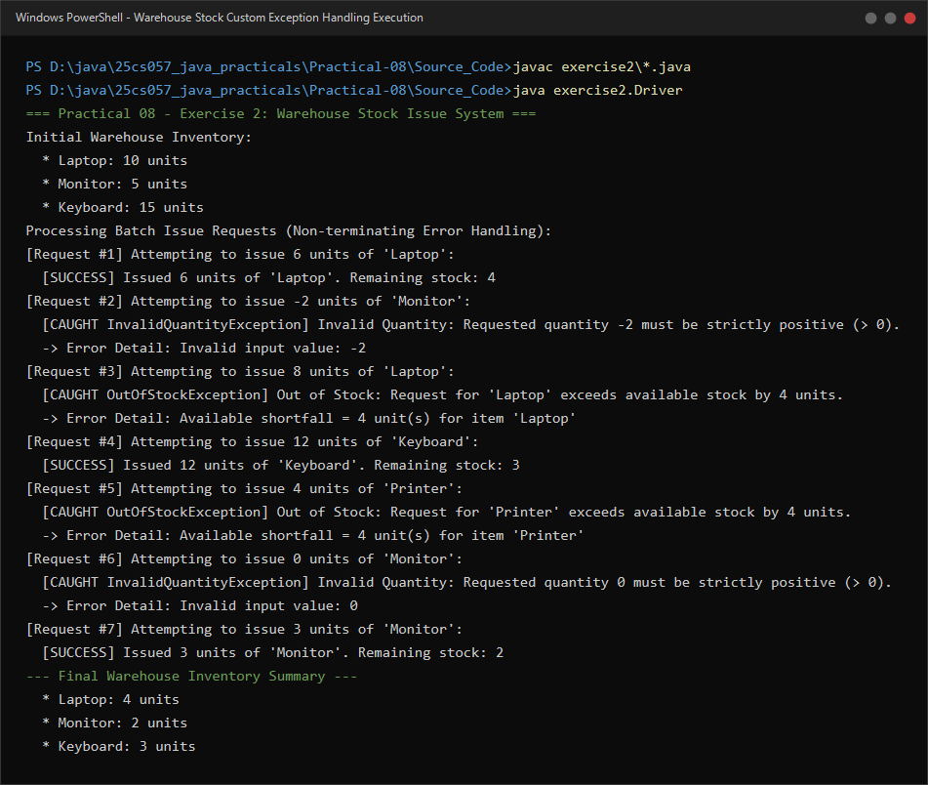
Figure 8.2: Live execution of Warehouse batch issue processing showing granular exception reporting with shortfall metadata.

