CHAROTAR UNIVERSITY OF SCIENCE AND TECHNOLOGY (CHARUSAT)
DEVANG PATEL INSTITUTE OF ADVANCE TECHNOLOGY AND RESEARCH (DEPSTAR)
Department of Computer Science & Engineering
CEUE203: Object-Oriented Programming (Java) | Practical 02

Student Name: Krupal Parmar  Student ID: 25CS057 | Semester: 3 (A.Y. 2026-27)  GitHub Branch: lab2

1. Smart thermostat (Thermostat.java, main in this file)

A. Problem Statement
Official Problem Definition:
(a) Create class Thermostat with private String location, private int temperature, private static final int MIN=16 and MAX=30, and private static int activeCount=0.
(b) Constructor(location, startTemp): store location; set temperature to startTemp if it is within MIN..MAX else 22; increment activeCount.
(c) Constructor(location): chain with this(location, 22).
(d) raise(): if temperature < MAX add 1, else print "Already at maximum (30)".
(e) lower(): if temperature > MIN subtract 1, else print "Already at minimum (16)".
(f) Add getTemperature() (no setter) and static getActiveCount().
(g) In main: create two thermostats, call raise() 10 times then lower() 20 times in loops (printing the temperature each time), then print getActiveCount().
Expected output: temperature rises to 30 then "Already at maximum", falls to 16 then "Already at minimum", count 2.

B. Complete Java Source Code
File: Practical-02/Source_Code/Thermostat.java
/**
* Practical 02 - Exercise 1
* Student Name: Krupal Parmar
* Student ID: 25CS057
* Course: CEUE203 - Object-Oriented Programming
*
* Problem Statement:
* 1. Smart thermostat (Thermostat.java, main in this file)
* (a) Create class Thermostat with private String location, private int temperature,
* private static final int MIN=16 and MAX=30, and private static int activeCount=0.
* (b) Constructor(location, startTemp): store location; set temperature to startTemp
* if it is within MIN..MAX else 22; increment activeCount.
* (c) Constructor(location): chain with this(location, 22).
* (d) raise(): if temperature < MAX add 1, else print "Already at maximum (30)".
* (e) lower(): if temperature > MIN subtract 1, else print "Already at minimum (16)".
* (f) Add getTemperature() (no setter) and static getActiveCount().
* (g) In main: create two thermostats, call raise() 10 times then lower() 20 times
* in loops (printing the temperature each time), then print getActiveCount().
* Expected output: temperature rises to 30 then "Already at maximum", falls to 16
* then "Already at minimum", count 2.
*/

public class Thermostat {
// (a) Private fields, constants, and static counter
private String location;
private int temperature;
private static final int MIN = 16;
private static final int MAX = 30;
private static int activeCount = 0;

// (b) Constructor(location, startTemp)
public Thermostat(String location, int startTemp) {
this.location = location;
if (startTemp >= MIN && startTemp <= MAX) {
this.temperature = startTemp;
} else {
this.temperature = 22; // default safe fallback
}
activeCount++;
}

// (c) Constructor(location) chained with this(location, 22)
public Thermostat(String location) {
this(location, 22);
}

// (d) raise(): increment temperature or report maximum reached
public void raise() {
if (this.temperature < MAX) {
this.temperature++;
} else {
System.out.println("Already at maximum (" + MAX + ")");
}
}

// (e) lower(): decrement temperature or report minimum reached
public void lower() {
if (this.temperature > MIN) {
this.temperature--;
} else {
System.out.println("Already at minimum (" + MIN + ")");
}
}

// (f) Getter for temperature (no setter provided to preserve encapsulation)
public int getTemperature() {
return this.temperature;
}

public String getLocation() {
return this.location;
}

// Static getter for active count
public static int getActiveCount() {
return activeCount;
}

// (g) In main: create two thermostats, call raise() 10 times then lower() 20 times in loops
public static void main(String[] args) {
System.out.println("=== Smart Thermostat Simulation ===");

// Creating two thermostat instances
Thermostat livingRoom = new Thermostat("Living Room", 24);
Thermostat bedroom = new Thermostat("Bedroom"); // uses chained constructor with default 22

System.out.println("Created Thermostat 1: " + livingRoom.getLocation() + " (Initial Temp: " + livingRoom.getTemperature() + "°C)");
System.out.println("Created Thermostat 2: " + bedroom.getLocation() + " (Initial Temp: " + bedroom.getTemperature() + "°C)");

System.out.println("\n--- Testing raise() 10 times on " + livingRoom.getLocation() + " ---");
for (int i = 1; i <= 10; i++) {
livingRoom.raise();
System.out.println("Step " + i + " -> Temperature: " + livingRoom.getTemperature());
}

System.out.println("\n--- Testing lower() 20 times on " + livingRoom.getLocation() + " ---");
for (int i = 1; i <= 20; i++) {
livingRoom.lower();
System.out.println("Step " + i + " -> Temperature: " + livingRoom.getTemperature());
}

System.out.println("\n--- Active Thermostats Count ---");
System.out.println("Active Count: " + Thermostat.getActiveCount());
}
}

C. Execution Output Screenshot
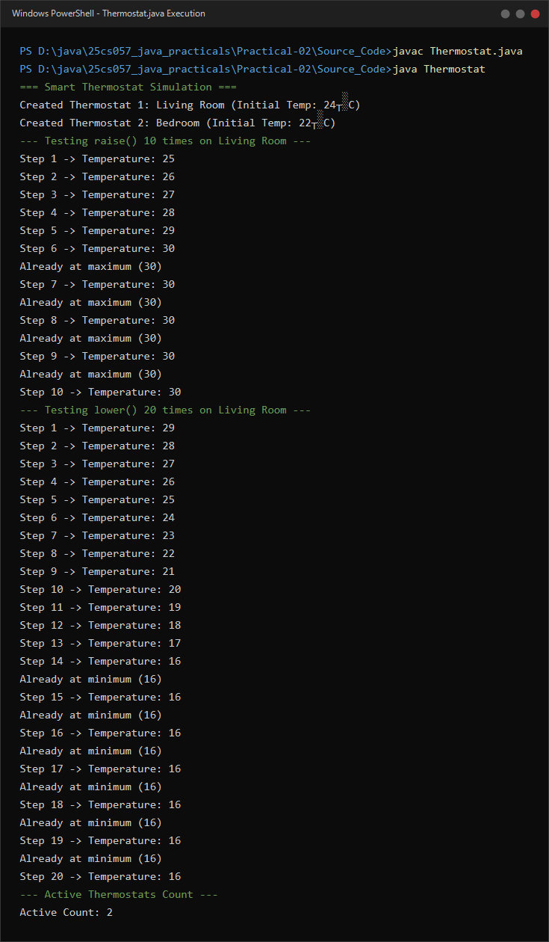
Figure 2.1: Live execution of Thermostat.java showing constructor chaining, encapsulation limits, and static tracking.

2. Cinema show (CinemaShow.java, main in this file)

A. Problem Statement
Official Problem Definition:
(a) Create class CinemaShow with private String title, private int seatsAvailable, private final int capacity, and private static int totalBooked=0.
(b) Constructor(title, capacity): set both and seatsAvailable = capacity. Constructor(title): chain with this(title, 100).
(c) book(int n): if n <= seatsAvailable, reduce seatsAvailable by n, add n to totalBooked, return true; else return false unchanged.
(d) cancel(int n): increase seatsAvailable by n but never above capacity.
(e) Add getSeatsAvailable() and static getTotalBooked().
(f) In main: run a sequence of book and cancel calls, printing the result and seats after each, then print getTotalBooked().
Expected output: booking more than available prints false and leaves seats unchanged; totalBooked equals the successful bookings.

B. Complete Java Source Code
File: Practical-02/Source_Code/CinemaShow.java
/**
* Practical 02 - Exercise 2
* Student Name: Krupal Parmar
* Student ID: 25CS057
* Course: CEUE203 - Object-Oriented Programming
*
* Problem Statement:
* 2. Cinema show (CinemaShow.java, main in this file)
* (a) Create class CinemaShow with private String title, private int seatsAvailable,
* private final int capacity, and private static int totalBooked=0.
* (b) Constructor(title, capacity): set both and seatsAvailable = capacity.
* Constructor(title): chain with this(title, 100).
* (c) book(int n): if n <= seatsAvailable, reduce seatsAvailable by n, add n to totalBooked,
* return true; else return false unchanged.
* (d) cancel(int n): increase seatsAvailable by n but never above capacity.
* (e) Add getSeatsAvailable() and static getTotalBooked().
* (f) In main: run a sequence of book and cancel calls, printing the result and seats
* after each, then print getTotalBooked().
* Expected output: booking more than available prints false and leaves seats unchanged;
* totalBooked equals the successful bookings.
*/

public class CinemaShow {
// (a) Private fields, final capacity, and static counter
private String title;
private int seatsAvailable;
private final int capacity;
private static int totalBooked = 0;

// (b) Constructor(title, capacity)
public CinemaShow(String title, int capacity) {
this.title = title;
this.capacity = capacity;
this.seatsAvailable = capacity;
}

// Constructor(title) chained with this(title, 100)
public CinemaShow(String title) {
this(title, 100);
}

// (c) book(int n): book seats if available, increment totalBooked, return true; else return false
public boolean book(int n) {
if (n <= 0) {
System.out.println("Booking count must be positive.");
return false;
}
if (n <= this.seatsAvailable) {
this.seatsAvailable -= n;
totalBooked += n;
return true;
}
return false;
}

// (d) cancel(int n): increase seatsAvailable by n but never above capacity
public void cancel(int n) {
if (n <= 0) {
System.out.println("Cancellation count must be positive.");
return;
}
this.seatsAvailable = Math.min(this.capacity, this.seatsAvailable + n);
}

// (e) Getters
public int getSeatsAvailable() {
return this.seatsAvailable;
}

public int getCapacity() {
return this.capacity;
}

public String getTitle() {
return this.title;
}

public static int getTotalBooked() {
return totalBooked;
}

// (f) In main: run a sequence of book and cancel calls, printing the result and seats after each
public static void main(String[] args) {
System.out.println("=== Cinema Show Booking System ===");

// Create CinemaShow instances: one with explicit capacity, one with default chained capacity 100
CinemaShow morningShow = new CinemaShow("Inception", 50);
CinemaShow eveningShow = new CinemaShow("Interstellar"); // default capacity 100

System.out.println("Show 1: " + morningShow.getTitle() + " | Capacity: " + morningShow.getCapacity() + " | Available: " + morningShow.getSeatsAvailable());
System.out.println("Show 2: " + eveningShow.getTitle() + " | Capacity: " + eveningShow.getCapacity() + " | Available: " + eveningShow.getSeatsAvailable());

System.out.println("\n--- Performing Transactions on '" + morningShow.getTitle() + "' ---");

// Action 1: Book 30 seats (should succeed)
boolean res1 = morningShow.book(30);
System.out.println("Booking 30 seats -> Result: " + res1 + " | Seats Available: " + morningShow.getSeatsAvailable());

// Action 2: Book 25 seats (only 20 left, should fail and return false with seats unchanged)
boolean res2 = morningShow.book(25);
System.out.println("Booking 25 seats -> Result: " + res2 + " | Seats Available: " + morningShow.getSeatsAvailable());

// Action 3: Book 15 seats (should succeed)
boolean res3 = morningShow.book(15);
System.out.println("Booking 15 seats -> Result: " + res3 + " | Seats Available: " + morningShow.getSeatsAvailable());

// Action 4: Cancel 10 seats (should increase seats available)
System.out.println("Cancelling 10 seats...");
morningShow.cancel(10);
System.out.println("After cancellation -> Seats Available: " + morningShow.getSeatsAvailable());

// Action 5: Try to cancel 100 seats (should never exceed capacity 50)
System.out.println("Cancelling 100 seats (boundary check against capacity)...");
morningShow.cancel(100);
System.out.println("After over-cancellation -> Seats Available: " + morningShow.getSeatsAvailable() + " (Capacity: " + morningShow.getCapacity() + ")");

System.out.println("\n--- System Summary ---");
System.out.println("Total Booked across all shows: " + CinemaShow.getTotalBooked());
}
}

C. Execution Output Screenshot
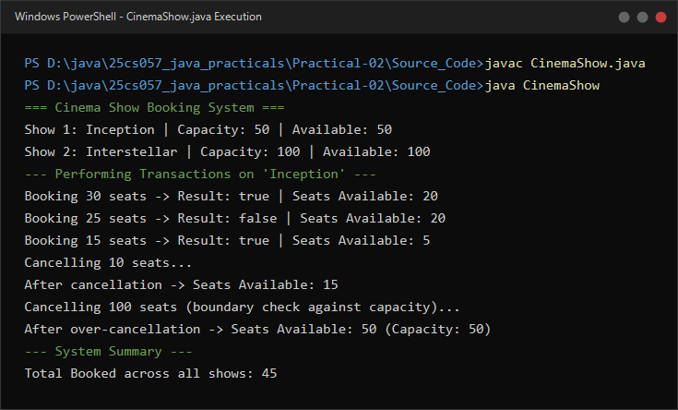
Figure 2.2: Live execution of CinemaShow.java showing capacity clamping, booking validations, and cumulative booked tally.

