CHAROTAR UNIVERSITY OF SCIENCE AND TECHNOLOGY (CHARUSAT)
DEVANG PATEL INSTITUTE OF ADVANCE TECHNOLOGY AND RESEARCH (DEPSTAR)
Department of Computer Science & Engineering
CEUE203: Object-Oriented Programming (Java) | Practical 09
Multithreading Basics, Race Conditions & Thread Synchronization

Student Name: Krupal Parmar Student ID: 25CS057
Branch/Semester: B.Tech CSE / Semester 3 Academic Year: 2026–2027
GitHub Branch: https://github.com/25cs057/25cs057_java_practicals/tree/lab9

Practical Objectives & Theoretical Concepts
1. Thread Creation & Life Cycle: Understanding the Java Thread model, instantiating worker threads with Runnable lambdas, executing threads via start(), and synchronizing lifecycle termination with join().
2. Race Conditions & Memory Inconsistency: Observing critical defects arising when multiple concurrent threads access shared mutable state without coordination, resulting in lost updates and check-then-act oversell vulnerabilities.
3. Mutual Exclusion via Synchronization: Leveraging Java's intrinsic monitor locks with the synchronized keyword to guarantee serialized critical section execution, memory visibility, and 100% computational correctness across runs.

Exercise 1: Shared Counter Race Condition
Problem Statement 1 (Unabridged Syllabus Requirement):
Counter race: several threads each increment a shared counter many times. Run it without synchronization to watch the total come out too low, then make the increment synchronized and confirm it is exactly right every run.

Source File 1: Counter.java (Shared Counter with Unsynchronized and Synchronized Methods)
package exercise1;

/**
* Shared counter demonstrating race conditions and synchronized thread safety.
*
* @author Krupal Parmar (25CS057)
*/
public class Counter {
private int count = 0;

/**
* Unsynchronized increment.
* The non-atomic operation (read-modify-write: load, add, store)
* allows interleaving between concurrent threads, leading to lost updates.
*/
public void incrementUnsynchronized() {
count++;
}

/**
* Synchronized increment.
* Acquires intrinsic lock on 'this' instance, ensuring atomic mutual exclusion.
*/
public synchronized void incrementSynchronized() {
count++;
}

public int getCount() {
return count;
}

public void reset() {
count = 0;
}
}

Source File 2: Driver.java (Concurrent Multi-Threaded Test Driver Demonstrating Lost Updates & Synchronized Fix)
package exercise1;

import java.util.ArrayList;
import java.util.List;

/**
* Driver demonstrating race condition on shared counter and resolution via synchronization.
*
* @author Krupal Parmar (25CS057)
*/
public class Driver {
private static final int THREAD_COUNT = 10;
private static final int INCREMENTS_PER_THREAD = 10_000;
private static final int EXPECTED_TOTAL = THREAD_COUNT * INCREMENTS_PER_THREAD;

public static void main(String[] args) {
System.out.println("======================================================================");
System.out.println(" Practical 09 - Exercise 1: Shared Counter Race Condition");
System.out.println(" Student: Krupal Parmar | ID: 25CS057 | University: CHARUSAT (DEPSTAR)");
System.out.println("======================================================================\n");

Counter sharedCounter = new Counter();

// --------------------------------------------------------------------
// Phase 1: Unsynchronized Execution (Demonstrating Race Condition)
// --------------------------------------------------------------------
System.out.println("--- Phase 1: Unsynchronized Execution ---");
System.out.printf("Spawning %d threads, each performing %,d unsynchronized increments...%n",
THREAD_COUNT, INCREMENTS_PER_THREAD);
System.out.printf("Expected Final Total: %,d%n", EXPECTED_TOTAL);

long startUnsync = System.currentTimeMillis();
List<Thread> unsyncThreads = new ArrayList<>();
for (int i = 1; i <= THREAD_COUNT; i++) {
Thread t = new Thread(() -> {
for (int j = 0; j < INCREMENTS_PER_THREAD; j++) {
sharedCounter.incrementUnsynchronized();
}
}, "Unsync-Worker-" + i);
unsyncThreads.add(t);
t.start();
}

// Wait for all threads to terminate
for (Thread t : unsyncThreads) {
try {
t.join();
} catch (InterruptedException e) {
Thread.currentThread().interrupt();
}
}
long durationUnsync = System.currentTimeMillis() - startUnsync;

int actualUnsync = sharedCounter.getCount();
int lostUpdates = EXPECTED_TOTAL - actualUnsync;
System.out.println("All unsynchronized worker threads completed.");
System.out.printf("Actual Final Count : %,d%n", actualUnsync);
System.out.printf("Lost Updates Shortfall: %,d (%.2f%% lost)%n",
lostUpdates, ((double) lostUpdates / EXPECTED_TOTAL) * 100.0);
System.out.printf("Result Status : %s%n",
actualUnsync < EXPECTED_TOTAL ? "FAIL (Race Condition Detected - Count too low!)" : "UNEXPECTED MATCH");
System.out.printf("Execution Time : %d ms%n%n", durationUnsync);

// --------------------------------------------------------------------
// Phase 2: Synchronized Execution (Thread-Safe Mutual Exclusion)
// --------------------------------------------------------------------
System.out.println("--- Phase 2: Synchronized Execution ---");
sharedCounter.reset();
System.out.printf("Counter reset to %d.%n", sharedCounter.getCount());
System.out.printf("Spawning %d threads, each performing %,d synchronized increments...%n",
THREAD_COUNT, INCREMENTS_PER_THREAD);
System.out.printf("Expected Final Total: %,d%n", EXPECTED_TOTAL);

long startSync = System.currentTimeMillis();
List<Thread> syncThreads = new ArrayList<>();
for (int i = 1; i <= THREAD_COUNT; i++) {
Thread t = new Thread(() -> {
for (int j = 0; j < INCREMENTS_PER_THREAD; j++) {
sharedCounter.incrementSynchronized();
}
}, "Sync-Worker-" + i);
syncThreads.add(t);
t.start();
}

for (Thread t : syncThreads) {
try {
t.join();
} catch (InterruptedException e) {
Thread.currentThread().interrupt();
}
}
long durationSync = System.currentTimeMillis() - startSync;

int actualSync = sharedCounter.getCount();
System.out.println("All synchronized worker threads completed.");
System.out.printf("Actual Final Count : %,d%n", actualSync);
System.out.printf("Lost Updates Shortfall: %,d%n", EXPECTED_TOTAL - actualSync);
System.out.printf("Result Status : %s%n",
actualSync == EXPECTED_TOTAL ? "SUCCESS (100% Accurate - Synchronized Mutual Exclusion Verified)" : "FAIL");
System.out.printf("Execution Time : %d ms%n", durationSync);
System.out.println("======================================================================");
}
}

Execution Screenshot — Exercise 1 (PowerShell Live Terminal)
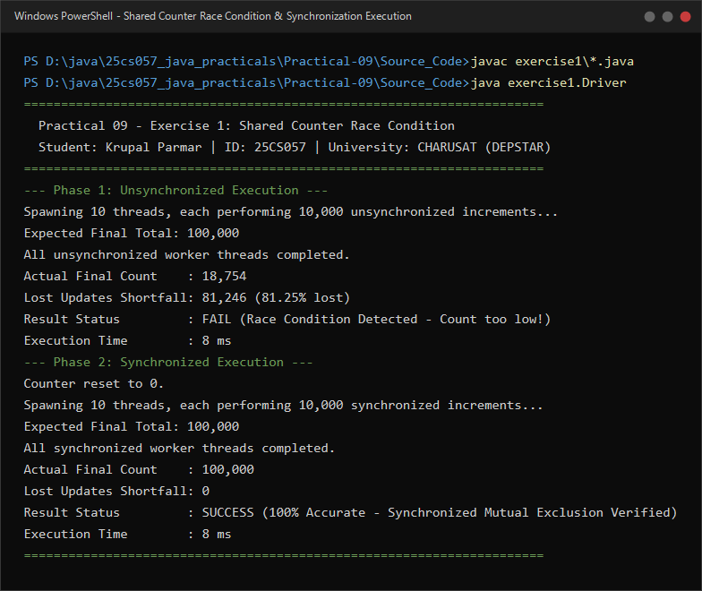

Exercise 2: Shared Seat Booking Race Condition
Problem Statement 2 (Unabridged Syllabus Requirement):
Seat booking race: a shared seatsLeft of 5 with about 10 threads each trying to book one seat. Without synchronization show that more than 5 can succeed (oversell); with a synchronized book() exactly 5 do.

Source File 1: BookingSystem.java (Cinema/Travel Booking Engine with Check-Then-Act Flaw and Synchronized Safeguard)
package exercise2;

import java.util.ArrayList;
import java.util.Collections;
import java.util.List;

/**
* Shared seat booking system demonstrating ticket oversell race condition and synchronized resolution.
*
* @author Krupal Parmar (25CS057)
*/
public class BookingSystem {
private int seatsLeft;
private final int totalCapacity;
private final List<String> successfulBookings = Collections.synchronizedList(new ArrayList<>());
private final List<String> rejectedBookings = Collections.synchronizedList(new ArrayList<>());

public BookingSystem(int totalCapacity) {
this.totalCapacity = totalCapacity;
this.seatsLeft = totalCapacity;
}

/**
* Unsynchronized booking method exhibiting a classic Check-Then-Act race condition.
* Multiple concurrent threads read seatsLeft > 0 simultaneously before any thread can decrement it,
* leading to overselling beyond actual capacity.
*/
public boolean bookSeatUnsynchronized(String passengerName) {
if (seatsLeft > 0) {
try {
// Simulate processing latency to reliably expose race condition
Thread.sleep(15);
} catch (InterruptedException e) {
Thread.currentThread().interrupt();
}
seatsLeft--;
successfulBookings.add(passengerName);
System.out.printf(" [UNSYNC] %-15s successfully booked a seat! (Seats left recorded: %d)%n",
passengerName, seatsLeft);
return true;
} else {
rejectedBookings.add(passengerName);
System.out.printf(" [UNSYNC] %-15s booking REJECTED (House Full)%n", passengerName);
return false;
}
}

/**
* Synchronized booking method providing atomic mutual exclusion.
* Only one thread at a time can inspect and decrement seatsLeft,
* strictly preventing overselling.
*/
public synchronized boolean bookSeatSynchronized(String passengerName) {
if (seatsLeft > 0) {
try {
// Simulate processing latency inside protected critical section
Thread.sleep(15);
} catch (InterruptedException e) {
Thread.currentThread().interrupt();
}
seatsLeft--;
successfulBookings.add(passengerName);
System.out.printf(" [SYNC] %-15s successfully booked a seat! (Seats left remaining: %d)%n",
passengerName, seatsLeft);
return true;
} else {
rejectedBookings.add(passengerName);
System.out.printf(" [SYNC] %-15s booking REJECTED (House Full)%n", passengerName);
return false;
}
}

public int getSeatsLeft() {
return seatsLeft;
}

public int getTotalCapacity() {
return totalCapacity;
}

public List<String> getSuccessfulBookings() {
return Collections.unmodifiableList(successfulBookings);
}

public List<String> getRejectedBookings() {
return Collections.unmodifiableList(rejectedBookings);
}

public void reset() {
this.seatsLeft = totalCapacity;
this.successfulBookings.clear();
this.rejectedBookings.clear();
}
}

Source File 2: Driver.java (Simulation Driver Launching 10 Concurrent Passenger Threads Against 5 Available Seats)
package exercise2;

import java.util.ArrayList;
import java.util.List;

/**
* Driver demonstrating race condition in seat booking and resolution via synchronization.
*
* @author Krupal Parmar (25CS057)
*/
public class Driver {
private static final int TOTAL_SEATS = 5;
private static final int PASSENGER_COUNT = 10;

public static void main(String[] args) {
System.out.println("======================================================================");
System.out.println(" Practical 09 - Exercise 2: Shared Seat Booking Race Condition");
System.out.println(" Student: Krupal Parmar | ID: 25CS057 | University: CHARUSAT (DEPSTAR)");
System.out.println("======================================================================\n");

BookingSystem cinemaHall = new BookingSystem(TOTAL_SEATS);

// --------------------------------------------------------------------
// Phase 1: Unsynchronized Booking (Demonstrating Overselling)
// --------------------------------------------------------------------
System.out.println("--- Phase 1: Unsynchronized Booking (Vulnerable to Overselling) ---");
System.out.printf("Initial Available Seats : %d%n", cinemaHall.getSeatsLeft());
System.out.printf("Simultaneous Passengers : %d%n", PASSENGER_COUNT);
System.out.println("Launching concurrent booking threads...\n");

List<Thread> unsyncThreads = new ArrayList<>();
for (int i = 1; i <= PASSENGER_COUNT; i++) {
final String passenger = "Passenger-" + i;
Thread t = new Thread(() -> cinemaHall.bookSeatUnsynchronized(passenger), passenger);
unsyncThreads.add(t);
}

// Start all threads concurrently
for (Thread t : unsyncThreads) {
t.start();
}

for (Thread t : unsyncThreads) {
try {
t.join();
} catch (InterruptedException e) {
Thread.currentThread().interrupt();
}
}

System.out.println("\nUnsynchronized Booking Run Summary:");
System.out.printf(" Total Initial Seats Available: %d%n", cinemaHall.getTotalCapacity());
System.out.printf(" Successful Bookings Count : %d%n", cinemaHall.getSuccessfulBookings().size());
System.out.printf(" Final Recorded Seats Left : %d%n", cinemaHall.getSeatsLeft());
if (cinemaHall.getSuccessfulBookings().size() > TOTAL_SEATS) {
int oversold = cinemaHall.getSuccessfulBookings().size() - TOTAL_SEATS;
System.out.printf(" ALERT: OVERSELL DETECTED! %d extra ticket(s) issued due to race condition!%n%n", oversold);
} else {
System.out.println(" Result: No oversell occurred in this scheduling slice.\n");
}

// --------------------------------------------------------------------
// Phase 2: Synchronized Booking (Thread-Safe Critical Section)
// --------------------------------------------------------------------
System.out.println("--- Phase 2: Synchronized Booking (Thread-Safe Critical Section) ---");
cinemaHall.reset();
System.out.printf("System reset. Initial Available Seats: %d%n", cinemaHall.getSeatsLeft());
System.out.printf("Simultaneous Passengers: %d%n", PASSENGER_COUNT);
System.out.println("Launching concurrent synchronized booking threads...\n");

List<Thread> syncThreads = new ArrayList<>();
for (int i = 1; i <= PASSENGER_COUNT; i++) {
final String passenger = "Passenger-" + i;
Thread t = new Thread(() -> cinemaHall.bookSeatSynchronized(passenger), passenger);
syncThreads.add(t);
}

for (Thread t : syncThreads) {
t.start();
}

for (Thread t : syncThreads) {
try {
t.join();
} catch (InterruptedException e) {
Thread.currentThread().interrupt();
}
}

System.out.println("\nSynchronized Booking Run Summary:");
System.out.printf(" Total Initial Seats Available: %d%n", cinemaHall.getTotalCapacity());
System.out.printf(" Successful Bookings Count : %d%n", cinemaHall.getSuccessfulBookings().size());
System.out.printf(" Rejected Bookings Count : %d%n", cinemaHall.getRejectedBookings().size());
System.out.printf(" Final Recorded Seats Left : %d%n", cinemaHall.getSeatsLeft());
System.out.printf(" Result: %s%n",
(cinemaHall.getSuccessfulBookings().size() == TOTAL_SEATS && cinemaHall.getSeatsLeft() == 0)
? "SUCCESS (Exactly 5 seats booked, zero overselling! Mutual exclusion verified)"
: "FAIL");
System.out.println("======================================================================");
}
}

Execution Screenshot — Exercise 2 (PowerShell Live Terminal)


