CHAROTAR UNIVERSITY OF SCIENCE AND TECHNOLOGY (CHARUSAT)
DEVANG PATEL INSTITUTE OF ADVANCE TECHNOLOGY AND RESEARCH (DEPSTAR)
Department of Computer Science & Engineering
CEUE203: Object-Oriented Programming (Java) | Practical 01

Student Name: Krupal Parmar  Student ID: 25CS057 | Semester: 3 (A.Y. 2026-27)  GitHub Branch: lab1

1. Vending machine (VendingMachine.java, main in this file)

A. Problem Statement
Official Problem Definition:
(a) Define an enum Coin with constants ONE, TWO, FIVE, TEN.
(b) In main, set a snack price of 15 and a running total of 0; create a Scanner.
(c) Loop: read a coin name, use a switch expression to convert the Coin to its value (ONE->1, TWO->2, FIVE->5, TEN->10), add it to the total, and print the total so far.
(d) Stop the loop once the total reaches 15 or more.
(e) Print the change to return (total - 15).
Expected output: TEN then FIVE prints "Paid. Change: 0"; TEN then TEN prints "Paid. Change: 5".

B. Complete Java Source Code
File: Practical-01/Source_Code/VendingMachine.java
/**
* Practical 01 - Exercise 1
* Student Name: Krupal Parmar
* Student ID: 25CS057
* Course: CEUE203 - Object-Oriented Programming
*
* Problem Statement:
* 1. Vending machine (VendingMachine.java, main in this file)
* (a) Define an enum Coin with constants ONE, TWO, FIVE, TEN.
* (b) In main, set a snack price of 15 and a running total of 0; create a Scanner.
* (c) Loop: read a coin name, use a switch expression to convert the Coin to its value
* (ONE->1, TWO->2, FIVE->5, TEN->10), add it to the total, and print the total so far.
* (d) Stop the loop once the total reaches 15 or more.
* (e) Print the change to return (total - 15).
* Expected output: TEN then FIVE prints "Paid. Change: 0"; TEN then TEN prints "Paid. Change: 5".
*/

import java.util.Scanner;

// (a) Define an enum Coin with constants ONE, TWO, FIVE, TEN
enum Coin {
ONE,
TWO,
FIVE,
TEN
}

public class VendingMachine {
public static void main(String[] args) {
// (b) In main, set a snack price of 15 and a running total of 0; create a Scanner
final int SNACK_PRICE = 15;
int total = 0;
Scanner scanner = new Scanner(System.in);

System.out.println("=== Vending Machine ===");
System.out.println("Snack Price: " + SNACK_PRICE);
System.out.println("Accepted Coins: ONE, TWO, FIVE, TEN");

// (c) Loop: read a coin name, use a switch expression to convert Coin to its value,
// add to total, and print total so far.
// (d) Stop the loop once the total reaches 15 or more.
while (total < SNACK_PRICE) {
System.out.print("Insert coin (ONE, TWO, FIVE, TEN): ");
String input = scanner.next().trim().toUpperCase();

Coin coin;
try {
coin = Coin.valueOf(input);
} catch (IllegalArgumentException e) {
System.out.println("Invalid coin: " + input + ". Please insert a valid coin.");
continue;
}

// Java switch expression converting Coin to its monetary value
int coinValue = switch (coin) {
case ONE -> 1;
case TWO -> 2;
case FIVE -> 5;
case TEN -> 10;
};

total += coinValue;
System.out.println("Coin inserted: " + coin + " (" + coinValue + "). Total so far: " + total);
}

// (e) Print the change to return (total - 15)
int change = total - SNACK_PRICE;
System.out.println("Paid. Change: " + change);

scanner.close();
}
}

C. Execution Output Screenshot
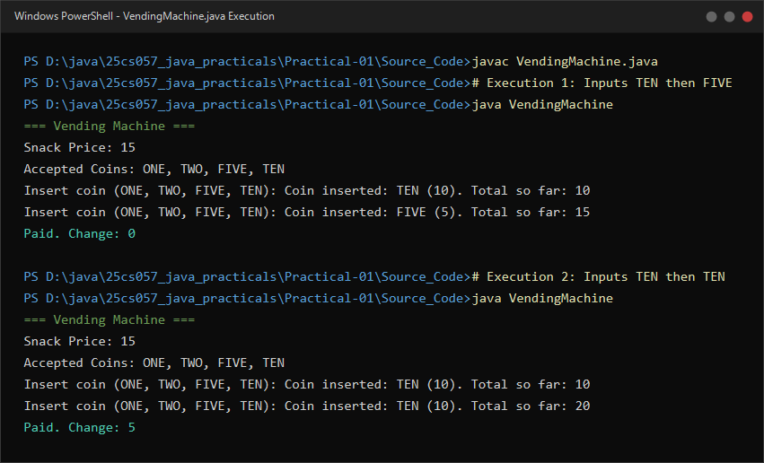
Figure 1.1: Live execution of VendingMachine.java showing valid snack purchase and change calculation.

2. Toll booth (TollBooth.java, main in this file)

A. Problem Statement
Official Problem Definition:
(a) Define a record Vehicle(String number, String type).
(b) In main, keep a running toll total and three counters (bike, car, truck).
(c) Loop until the user types "done" for the number: build a Vehicle, use a switch expression on its type for the toll (bike->20, car->50, truck->150), add to the total, and increment that type's counter.
(d) After the loop, print the total toll and the type with the highest count.
Expected output: two cars + one bike -> "Total toll: 120", "Most frequent: car".

B. Complete Java Source Code
File: Practical-01/Source_Code/TollBooth.java
/**
* Practical 01 - Exercise 2
* Student Name: Krupal Parmar
* Student ID: 25CS057
* Course: CEUE203 - Object-Oriented Programming
*
* Problem Statement:
* 2. Toll booth (TollBooth.java, main in this file)
* (a) Define a record Vehicle(String number, String type).
* (b) In main, keep a running toll total and three counters (bike, car, truck).
* (c) Loop until the user types "done" for the number: build a Vehicle, use a switch
* expression on its type for the toll (bike->20, car->50, truck->150), add to the total,
* and increment that type's counter.
* (d) After the loop, print the total toll and the type with the highest count.
* Expected output: two cars + one bike -> "Total toll: 120", "Most frequent: car".
*/

import java.util.Scanner;

// (a) Define a record Vehicle(String number, String type)
record Vehicle(String number, String type) {
}

public class TollBooth {
public static void main(String[] args) {
// (b) In main, keep a running toll total and three counters (bike, car, truck)
int totalToll = 0;
int bikeCount = 0;
int carCount = 0;
int truckCount = 0;

Scanner scanner = new Scanner(System.in);
System.out.println("=== Highway Toll Booth ===");
System.out.println("Enter vehicle details (or type 'done' as number to finish)");

// (c) Loop until user types "done" for vehicle number
while (true) {
System.out.print("Enter vehicle number (or 'done'): ");
String number = scanner.next().trim();

if (number.equalsIgnoreCase("done")) {
break;
}

System.out.print("Enter vehicle type (bike/car/truck): ");
String type = scanner.next().trim().toLowerCase();

// Build a Vehicle record instance
Vehicle vehicle = new Vehicle(number, type);

// Switch expression on vehicle type for toll calculation
int toll;
switch (vehicle.type()) {
case "bike" -> {
toll = 20;
bikeCount++;
}
case "car" -> {
toll = 50;
carCount++;
}
case "truck" -> {
toll = 150;
truckCount++;
}
default -> {
System.out.println("Unknown vehicle type: '" + vehicle.type() + "'. Toll not collected.");
continue;
}
}

totalToll += toll;
System.out.println("Processed " + vehicle + " | Toll: " + toll + " | Running Total: " + totalToll);
}

// (d) After the loop, print the total toll and the type with the highest count
System.out.println("\n=== Toll Collection Summary ===");
System.out.println("Total toll: " + totalToll);
System.out.println("Counts -> Bike: " + bikeCount + ", Car: " + carCount + ", Truck: " + truckCount);

String mostFrequent;
if (bikeCount == 0 && carCount == 0 && truckCount == 0) {
mostFrequent = "none";
} else if (bikeCount > carCount && bikeCount > truckCount) {
mostFrequent = "bike";
} else if (carCount > bikeCount && carCount > truckCount) {
mostFrequent = "car";
} else if (truckCount > bikeCount && truckCount > carCount) {
mostFrequent = "truck";
} else {
// In case of a tie between highest counts
int max = Math.max(bikeCount, Math.max(carCount, truckCount));
StringBuilder ties = new StringBuilder();
if (bikeCount == max) ties.append("bike ");
if (carCount == max) ties.append("car ");
if (truckCount == max) ties.append("truck ");
mostFrequent = ties.toString().trim() + " (tie)";
}

System.out.println("Most frequent: " + mostFrequent);

scanner.close();
}
}

C. Execution Output Screenshot
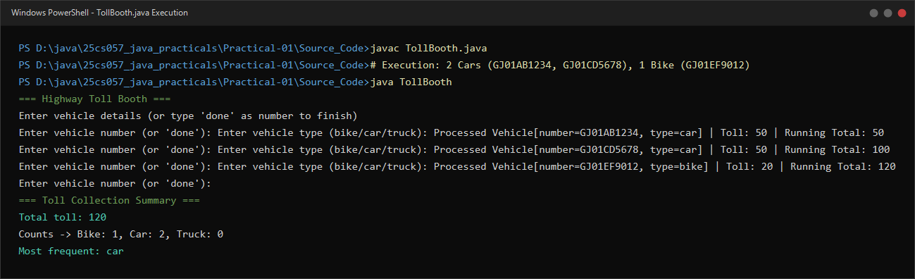
Figure 1.2: Live execution of TollBooth.java showing vehicle classification, toll accumulation, and frequency summary.

