- A portal needs structured layout. Create a webpage using CSS grid.
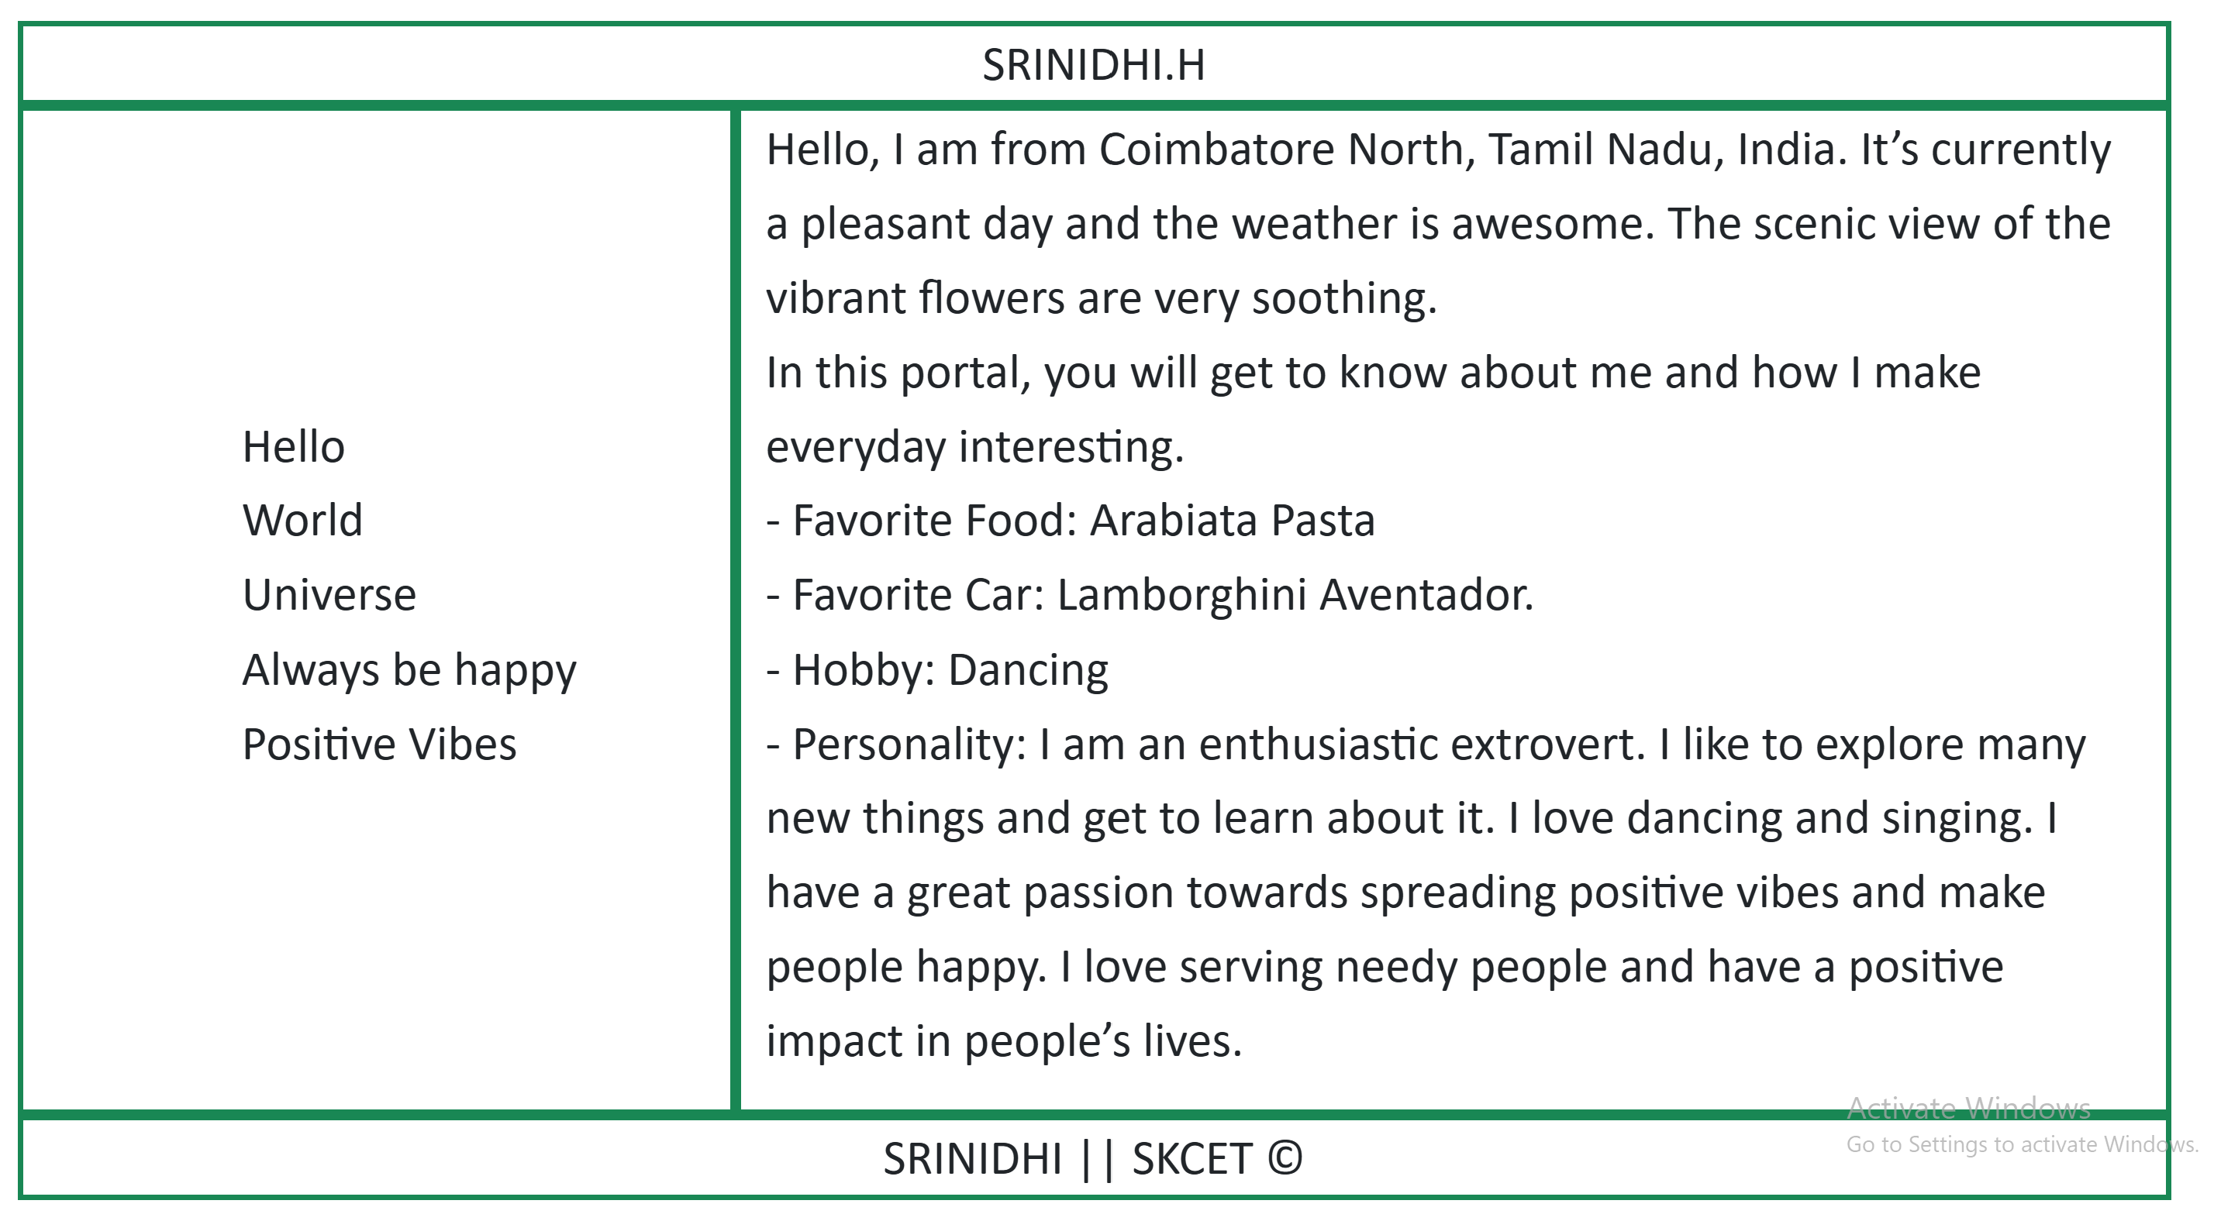

- Write a shell script to find greatest of 2 numbers
$ ./Greaterno.sh
Enter the first number:
67
Enter the second number:
90
The greatest number is : 90

