CHAROTAR UNIVERSITY OF SCIENCE AND TECHNOLOGY (CHARUSAT)
CSPIT – Computer Science and Engineering
CEUE203 – Object-Oriented Programming | Practical 08 – Part A
Student Name: Pratham Patel
Student ID: 25CS076
Semester: 3rd Semester – 2026–27 (Odd)

Program 1: Guarded calculator

1. Program Title

Guarded calculator

2. Problem Statement

read two numbers and an operator; throw a custom DivideByZeroException and catch invalid-number input separately, printing a clear message each time; loop until a valid calculation succeeds and use finally to log each attempt.

3. Java Source Code
DivideByZeroException.java.java
public class DivideByZeroException extends Exception {
public DivideByZeroException(String message) {
super(message);
}
}
GuardedCalculator.java
public class GuardedCalculator {

public static double calculate(double a, double b, char op)
throws DivideByZeroException {

switch (op) {
case '+':
return a + b;

case '-':
return a - b;

case '*':
return a * b;

case '/':
if (b == 0) {
throw new DivideByZeroException("Cannot divide by zero");
}
return a / b;

default:
throw new IllegalArgumentException("Invalid operator");
}
}
}
DriverCalculator.java
import java.util.Scanner;

public class DriverCalculator {
public static void main(String[] args) {

Scanner sc = new Scanner(System.in);
boolean success = false;

while (!success) {
try {
System.out.print("Enter first number: ");
double a = Double.parseDouble(sc.nextLine());

System.out.print("Enter operator (+, -, *, /): ");
char op = sc.nextLine().charAt(0);

System.out.print("Enter second number: ");
double b = Double.parseDouble(sc.nextLine());

double result = GuardedCalculator.calculate(a, b, op);

System.out.println("Result: " + result);
success = true;

} catch (NumberFormatException e) {
System.out.println("Invalid number input!");

} catch (DivideByZeroException e) {
System.out.println(e.getMessage());

} catch (IllegalArgumentException e) {
System.out.println(e.getMessage());

} finally {
System.out.println("Calculation attempt completed.");
}
}

sc.close();
}
}

4. Execution Output
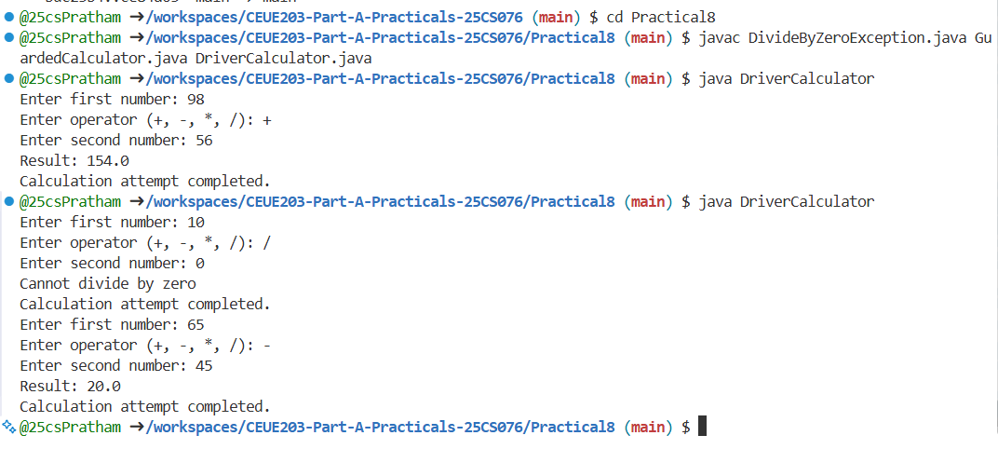

Program 2: Stock issue

1. Program Title

Stock issue

2. Problem Statement

: a Warehouse where issue(item, qty) throws a custom checked OutOfStockException carrying the shortfall, and InvalidQuantityException for qty ≤ 0. Process a list of requests, catching and reporting each failure without stopping the run.

3. Java Source Code
OutOfStockException.java
public class OutOfStockException extends Exception {
private int shortfall;

public OutOfStockException(String message, int shortfall) {
super(message);
this.shortfall = shortfall;
}

public int getShortfall() {
return shortfall;
}
}
InvalidQuantityException.java
public class InvalidQuantityException extends Exception {
public InvalidQuantityException(String message) {
super(message);
}
}
Warehouse.java
import java.util.HashMap;

public class Warehouse {

private HashMap<String, Integer> stock = new HashMap<>();

public Warehouse() {
stock.put("Laptop", 5);
stock.put("Mouse", 10);
stock.put("Keyboard", 3);
}

public void issue(String item, int qty)
throws OutOfStockException, InvalidQuantityException {

if (qty <= 0) {
throw new InvalidQuantityException("Quantity must be greater than zero");
}

int available = stock.getOrDefault(item, 0);

if (qty > available) {
throw new OutOfStockException(
"Not enough stock for " + item,
qty - available
);
}

stock.put(item, available - qty);

System.out.println(qty + " " + item + " issued successfully.");
}
}

DriverWarehouse.java

public class DriverWarehouse {

public static void main(String[] args) {

Warehouse warehouse = new Warehouse();

String[] items = {"Laptop", "Mouse", "Keyboard", "Laptop"};

int[] quantities = {2, 15, -1, 5};

for (int i = 0; i < items.length; i++) {

try {

warehouse.issue(items[i], quantities[i]);

} catch (OutOfStockException e) {

System.out.println(e.getMessage());

System.out.println("Shortfall: " + e.getShortfall());

} catch (InvalidQuantityException e) {

System.out.println(e.getMessage());

}

}

System.out.println("All requests processed.");

}

}

4. Execution Output
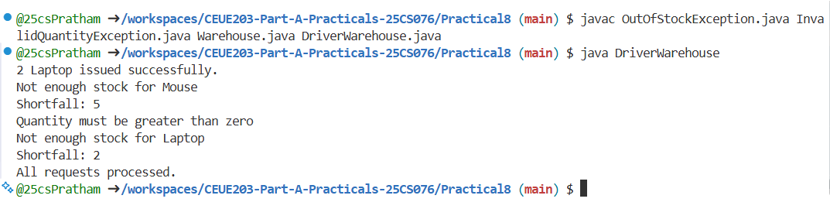

Program 3: AutoCloseable Resource

1. Program Title

AutoCloseable Resource

2. Problem Statement

. (For Advanced Learners – home) Create an AutoCloseable resource and use try-with resources to prove it always closes — even when an exception is thrown inside the block — and that the original error is the one reported. Decide what to model as the resource.

3. Java Source Code
DemoResource.java
public class DemoResource implements AutoCloseable {

public DemoResource() {
System.out.println("Resource opened.");
}

public void use() throws Exception {
System.out.println("Using resource.");
throw new Exception("Original error occurred.");
}

public void close() throws Exception {
System.out.println("Resource closed.");
throw new Exception("Error while closing resource.");
}
}
DriverResource.java
public class DriverResource {
public static void main(String[] args) {

try (DemoResource resource = new DemoResource()) {

resource.use();

} catch (Exception e) {

System.out.println("Caught: " + e.getMessage());

for (Throwable t : e.getSuppressed()) {
System.out.println("Suppressed: " + t.getMessage());
}
}
}
}

4. Execution Output


