CHAROTAR UNIVERSITY OF SCIENCE AND TECHNOLOGY (CHARUSAT)
CSPIT - Computer Science and Engineering
CEUE203 - Object-Oriented Programming | Practical 09 - Part A
Student Name: Pratham Patel
Student ID: 25CS076
Semester: 3rd Semester - 2026-27 (Odd)

Program 1: Counter race

1. Program Title

Counter race

2. Problem Statement

several threads each increment a shared counter many times. Run it without synchronization to watch the total come out too low, then make the increment synchronized and confirm it is exactly right every run.

3. Java Source Code
Counter.java
public class Counter {
private int count = 0;

public void increment() {
count++;
}

public synchronized void syncIncrement() {
count++;
}

public int getCount() {
return count;
}

public void reset() {
count = 0;
}
}

DriverCounterRace.java
public class DriverCounterRace {
public static void main(String[] args) throws InterruptedException {
Counter counter = new Counter();
int numThreads = 5;
int incrementsPerThread = 10000;
int expectedTotal = numThreads * incrementsPerThread;

System.out.println("=== Unsynchronized Counter Run ===");
Thread[] threads = new Thread[numThreads];
for (int i = 0; i < numThreads; i++) {
threads[i] = new Thread(() -> {
for (int j = 0; j < incrementsPerThread; j++) {
counter.increment();
}
});
threads[i].start();
}
for (Thread t : threads) {
t.join();
}
System.out.println("Expected count: " + expectedTotal);
System.out.println("Actual count : " + counter.getCount());
if (counter.getCount() < expectedTotal) {
System.out.println("Race condition detected: count came out too low!");
}

System.out.println("\n=== Synchronized Counter Run ===");
counter.reset();
for (int i = 0; i < numThreads; i++) {
threads[i] = new Thread(() -> {
for (int j = 0; j < incrementsPerThread; j++) {
counter.syncIncrement();
}
});
threads[i].start();
}
for (Thread t : threads) {
t.join();
}
System.out.println("Expected count: " + expectedTotal);
System.out.println("Actual count : " + counter.getCount());
if (counter.getCount() == expectedTotal) {
System.out.println("Synchronization successful: count is exactly right!");
}
}
}

4. Execution Output
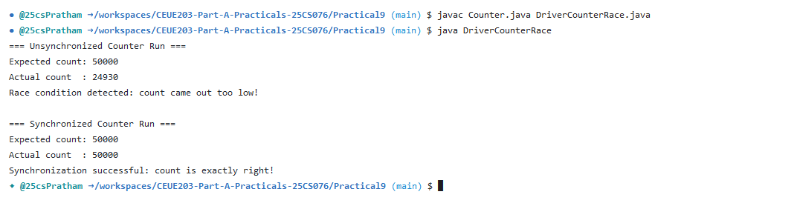

Program 2: Seat booking race

1. Program Title

Seat booking race

2. Problem Statement

a shared seatsLeft of 5 with about 10 threads each trying to book one seat. Without synchronization show that more than 5 can succeed (oversell); with a synchronized book() exactly 5 do.

3. Java Source Code
SeatBooking.java
public class SeatBooking {
private int seatsLeft = 5;

public boolean bookUnsafe(String passenger) {
if (seatsLeft > 0) {
try {
Thread.sleep(10);
} catch (InterruptedException e) {
Thread.currentThread().interrupt();
}
seatsLeft--;
System.out.println(passenger + " successfully booked a seat. Remaining: " + seatsLeft);
return true;
} else {
System.out.println(passenger + " failed to book. Sold out!");
return false;
}
}

public synchronized boolean bookSafe(String passenger) {
if (seatsLeft > 0) {
try {
Thread.sleep(10);
} catch (InterruptedException e) {
Thread.currentThread().interrupt();
}
seatsLeft--;
System.out.println(passenger + " successfully booked a seat. Remaining: " + seatsLeft);
return true;
} else {
System.out.println(passenger + " failed to book. Sold out!");
return false;
}
}

public void reset() {
seatsLeft = 5;
}

public int getSeatsLeft() {
return seatsLeft;
}
}

DriverSeatBooking.java
public class DriverSeatBooking {
public static void main(String[] args) throws InterruptedException {
SeatBooking booking = new SeatBooking();
int totalRequests = 10;

System.out.println("=== Unsynchronized Seat Booking ===");
Thread[] threads = new Thread[totalRequests];
for (int i = 0; i < totalRequests; i++) {
final String passenger = "Passenger-" + (i + 1);
threads[i] = new Thread(() -> booking.bookUnsafe(passenger));
threads[i].start();
}
for (Thread t : threads) {
t.join();
}
System.out.println("Final seats left (unsafe): " + booking.getSeatsLeft());

System.out.println("\n=== Synchronized Seat Booking ===");
booking.reset();
for (int i = 0; i < totalRequests; i++) {
final String passenger = "Passenger-" + (i + 1);
threads[i] = new Thread(() -> booking.bookSafe(passenger));
threads[i].start();
}
for (Thread t : threads) {
t.join();
}
System.out.println("Final seats left (safe): " + booking.getSeatsLeft());
}
}

4. Execution Output
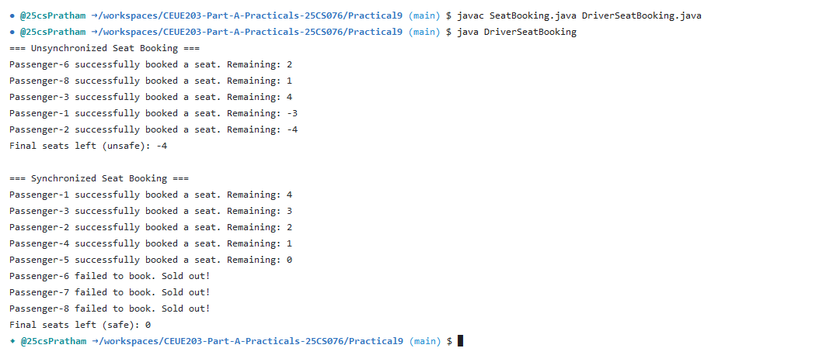

Program 3: Parallel array sum

1. Program Title

Parallel array sum

2. Problem Statement

(For Advanced Learners - home) Split a large array of numbers across several threads that add into one shared total, show the wrong result, then fix it two ways and compare; decide how to measure the difference.

3. Java Source Code
ArraySum.java
public class ArraySum {
private long total = 0;

public void addUnsafe(long val) {
total += val;
}

public synchronized void addSync(long val) {
total += val;
}

public long getTotal() {
return total;
}

public void reset() {
total = 0;
}
}

DriverArraySum.java
public class DriverArraySum {
public static void main(String[] args) throws InterruptedException {
int size = 1_000_000;
int[] numbers = new int[size];
for (int i = 0; i < size; i++) {
numbers[i] = 1;
}
long expectedSum = size;
int numThreads = 4;
int chunkSize = size / numThreads;

ArraySum sumTracker = new ArraySum();

// 1. Unsynchronized Shared Total
Thread[] threads = new Thread[numThreads];
for (int i = 0; i < numThreads; i++) {
final int start = i * chunkSize;
final int end = (i == numThreads - 1) ? size : start + chunkSize;
threads[i] = new Thread(() -> {
for (int j = start; j < end; j++) {
sumTracker.addUnsafe(numbers[j]);
}
});
threads[i].start();
}
for (Thread t : threads) {
t.join();
}
System.out.println("1. Unsynchronized Sum: " + sumTracker.getTotal() + " (Expected: " + expectedSum + ")");

// 2. Fix 1: Synchronized method
sumTracker.reset();
long startSync = System.currentTimeMillis();
for (int i = 0; i < numThreads; i++) {
final int start = i * chunkSize;
final int end = (i == numThreads - 1) ? size : start + chunkSize;
threads[i] = new Thread(() -> {
for (int j = start; j < end; j++) {
sumTracker.addSync(numbers[j]);
}
});
threads[i].start();
}
for (Thread t : threads) {
t.join();
}
long timeSync = System.currentTimeMillis() - startSync;
System.out.println("2. Fix 1 (Synchronized): " + sumTracker.getTotal() + " in " + timeSync + " ms");

// 3. Fix 2: Thread-local partial sums (Divide-and-Conquer)
long startLocal = System.currentTimeMillis();
long[] partialSums = new long[numThreads];
for (int i = 0; i < numThreads; i++) {
final int threadIdx = i;
final int start = i * chunkSize;
final int end = (i == numThreads - 1) ? size : start + chunkSize;
threads[i] = new Thread(() -> {
long localSum = 0;
for (int j = start; j < end; j++) {
localSum += numbers[j];
}
partialSums[threadIdx] = localSum;
});
threads[i].start();
}
for (Thread t : threads) {
t.join();
}
long finalTotal = 0;
for (long p : partialSums) {
finalTotal += p;
}
long timeLocal = System.currentTimeMillis() - startLocal;
System.out.println("3. Fix 2 (Thread-local Partial Sums): " + finalTotal + " in " + timeLocal + " ms");
System.out.println("Performance Comparison: Thread-local computation is significantly faster due to zero lock contention!");
}
}

4. Execution Output


