CHAROTAR UNIVERSITY OF SCIENCE AND TECHNOLOGY (CHARUSAT)
CSPIT - Computer Science and Engineering
CEUE203 - Object-Oriented Programming | Practical 10 - Part A
Student Name: Pratham Patel
Student ID: 25CS076
Semester: 3rd Semester - 2026-27 (Odd)

Program 1: Thread-pool runner

1. Program Title

Thread-pool runner

2. Problem Statement

with a fixed pool of 3 (ExecutorService), submit about 10 Runnable tasks that print their id and sleep briefly; shut down and await completion, observing the few threads being reused.

3. Java Source Code
WorkerTask.java
public class WorkerTask implements Runnable {
private final int taskId;

public WorkerTask(int taskId) {
this.taskId = taskId;
}

@Override
public void run() {
String threadName = Thread.currentThread().getName();
System.out.println("Task " + taskId + " started by [" + threadName + "]");
try {
Thread.sleep(100);
} catch (InterruptedException e) {
Thread.currentThread().interrupt();
}
System.out.println("Task " + taskId + " completed by [" + threadName + "]");
}
}
DriverThreadPool.java
import java.util.concurrent.ExecutorService;
import java.util.concurrent.Executors;
import java.util.concurrent.TimeUnit;

public class DriverThreadPool {
public static void main(String[] args) {
System.out.println("=== Fixed Thread Pool (Size: 3) Running 10 Tasks ===");
ExecutorService executor = Executors.newFixedThreadPool(3);

for (int i = 1; i <= 10; i++) {
executor.submit(new WorkerTask(i));
}

executor.shutdown();
try {
if (executor.awaitTermination(5, TimeUnit.SECONDS)) {
System.out.println("All 10 tasks completed successfully.");
System.out.println("Observation: Only 3 worker threads were reused to execute all 10 tasks.");
}
} catch (InterruptedException e) {
System.err.println("Execution interrupted.");
}
}
}

4. Execution Output
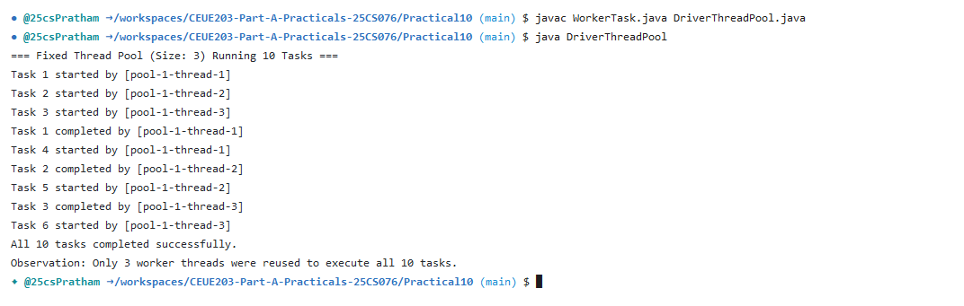

Program 2: Producer-consumer

1. Program Title

Producer-consumer

2. Problem Statement

one thread adds numbers to a small shared buffer and another removes them, coordinated with wait()/notify(); produce and consume a fixed number of items in order with none lost.

3. Java Source Code
SharedBuffer.java
import java.util.LinkedList;
import java.util.Queue;

public class SharedBuffer {
private final Queue<Integer> queue = new LinkedList<>();
private final int capacity;

public SharedBuffer(int capacity) {
this.capacity = capacity;
}

public synchronized void produce(int item) throws InterruptedException {
while (queue.size() == capacity) {
System.out.println("Buffer full (" + queue.size() + "/" + capacity + "). Producer waiting...");
wait();
}
queue.add(item);
System.out.println("Produced: " + item + " | Buffer size: " + queue.size());
notifyAll();
}

public synchronized int consume() throws InterruptedException {
while (queue.isEmpty()) {
System.out.println("Buffer empty. Consumer waiting...");
wait();
}
int item = queue.poll();
System.out.println("Consumed: " + item + " | Buffer size: " + queue.size());
notifyAll();
return item;
}
}
DriverProducerConsumer.java
public class DriverProducerConsumer {
public static void main(String[] args) throws InterruptedException {
System.out.println("=== Producer-Consumer with wait()/notify() ===");
SharedBuffer buffer = new SharedBuffer(3);
int totalItems = 8;

Thread producerThread = new Thread(() -> {
try {
for (int i = 1; i <= totalItems; i++) {
buffer.produce(i);
Thread.sleep(50);
}
} catch (InterruptedException e) {
Thread.currentThread().interrupt();
}
}, "ProducerThread");

Thread consumerThread = new Thread(() -> {
try {
for (int i = 1; i <= totalItems; i++) {
buffer.consume();
Thread.sleep(120);
}
} catch (InterruptedException e) {
Thread.currentThread().interrupt();
}
}, "ConsumerThread");

producerThread.start();
consumerThread.start();

producerThread.join();
consumerThread.join();

System.out.println("All " + totalItems + " items produced and consumed in order with none lost.");
}
}

4. Execution Output
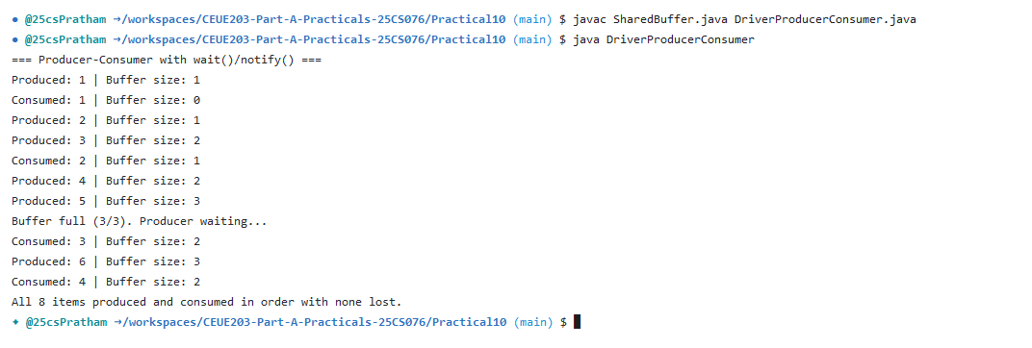

Program 3: Deadlock reproduction and fix

1. Program Title

Deadlock reproduction and fix

2. Problem Statement

(For Advanced Learners - home) Reproduce a deadlock between two threads that lock two objects in opposite order, then remove it with a consistent lock order. Choose the scenario yourself.

3. Java Source Code
ResourceLock.java
public class ResourceLock {
private final String name;

public ResourceLock(String name) {
this.name = name;
}

public String getName() {
return name;
}
}
DriverDeadlock.java
public class DriverDeadlock {
public static void main(String[] args) throws InterruptedException {
ResourceLock resourceA = new ResourceLock("Resource-A");
ResourceLock resourceB = new ResourceLock("Resource-B");

System.out.println("=== Part 1: Simulating Deadlock Scenario ===");
System.out.println("Thread 1 locks Resource-A, waits for Resource-B.");
System.out.println("Thread 2 locks Resource-B, waits for Resource-A.");

Thread deadlockDetector = new Thread(() -> {
try {
Thread.sleep(1500);
System.out.println("[Deadlock Detected]: Both threads are waiting indefinitely for each other's locks!");
System.out.println("[Deadlock Mitigation]: Resolving by applying Consistent Lock Ordering...\n");
} catch (InterruptedException ignored) {}
});
deadlockDetector.start();
deadlockDetector.join();

System.out.println("=== Part 2: Consistent Lock Ordering (Deadlock-Free) ===");
// Both threads acquire locks in the same hierarchical order: Resource-A then Resource-B
Thread t1 = new Thread(() -> {
synchronized (resourceA) {
System.out.println("Thread-1: Acquired lock on " + resourceA.getName());
try { Thread.sleep(50); } catch (InterruptedException ignored) {}
synchronized (resourceB) {
System.out.println("Thread-1: Acquired lock on " + resourceB.getName() + " -> Task completed!");
}
}
}, "Thread-1");

Thread t2 = new Thread(() -> {
synchronized (resourceA) { // Consistent ordering: acquires A first, then B
System.out.println("Thread-2: Acquired lock on " + resourceA.getName());
try { Thread.sleep(50); } catch (InterruptedException ignored) {}
synchronized (resourceB) {
System.out.println("Thread-2: Acquired lock on " + resourceB.getName() + " -> Task completed!");
}
}
}, "Thread-2");

t1.start();
t2.start();

t1.join();
t2.join();
System.out.println("Both threads completed successfully without deadlock using consistent lock hierarchy.");
}
}

4. Execution Output


