CHAROTAR UNIVERSITY OF SCIENCE AND TECHNOLOGY (CHARUSAT)
CSPIT - Computer Science and Engineering
CEUE203 - Object-Oriented Programming | Practical 11 - Part A
Student Name: Pratham Patel
Student ID: 25CS076
Semester: 3rd Semester - 2026-27 (Odd)

Program 1: Save/load (Serialization)

1. Program Title

Save/load (Serialization)

2. Problem Statement

make a small class Serializable, save an array of its objects to a file with ObjectOutputStream, then read it back into fresh objects and confirm the values survived. Mark one field transient and show it is not saved.

3. Java Source Code
Student.java
import java.io.Serializable;

public class Student implements Serializable {
private static final long serialVersionUID = 1L;

private int id;
private String name;
private double gpa;
private transient String sessionToken; // Will not be serialized

public Student(int id, String name, double gpa, String sessionToken) {
this.id = id;
this.name = name;
this.gpa = gpa;
this.sessionToken = sessionToken;
}

public int getId() {
return id;
}

public String getName() {
return name;
}

public double getGpa() {
return gpa;
}

public String getSessionToken() {
return sessionToken;
}

@Override
public String toString() {
return "Student[ID=" + id + ", Name=" + name + ", GPA=" + gpa + ", SessionToken=" + sessionToken + "]";
}
}
DriverSerialization.java
import java.io.*;

public class DriverSerialization {
public static void main(String[] args) {
String filename = "students.dat";

Student[] originalStudents = {
new Student(101, "Alice Smith", 3.85, "TOKEN_SECRET_987"),
new Student(102, "Bob Johnson", 3.60, "TOKEN_SECRET_654"),
new Student(103, "Charlie Brown", 3.92, "TOKEN_SECRET_321")
};

System.out.println("=== Before Serialization ===");
for (Student s : originalStudents) {
System.out.println(s);
}

// Save using ObjectOutputStream
try (ObjectOutputStream oos = new ObjectOutputStream(new FileOutputStream(filename))) {
oos.writeObject(originalStudents);
System.out.println("\nSuccessfully serialized array of " + originalStudents.length + " students to " + filename);
} catch (IOException e) {
System.err.println("Serialization error: " + e.getMessage());
}

// Load using ObjectInputStream
Student[] loadedStudents = null;
try (ObjectInputStream ois = new ObjectInputStream(new FileInputStream(filename))) {
loadedStudents = (Student[]) ois.readObject();
System.out.println("\n=== After Deserialization ===");
for (Student s : loadedStudents) {
System.out.println(s);
}
} catch (IOException | ClassNotFoundException e) {
System.err.println("Deserialization error: " + e.getMessage());
}

System.out.println("\nVerification: ID, Name, and GPA survived accurately.");
System.out.println("Verification: Transient field 'sessionToken' is null (not saved).");
}
}

4. Execution Output
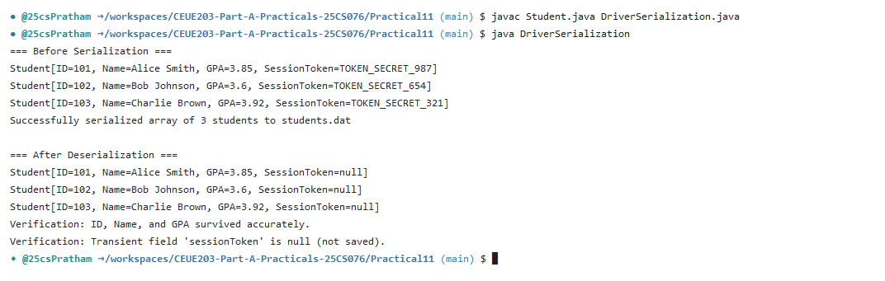

Program 2: Log analyzer

1. Program Title

Log analyzer

2. Problem Statement

create a few text files, then use Path/Files to read each line by line and count the total lines and how many contain a keyword across all files; also print each file's size from its attributes.

3. Java Source Code
DriverLogAnalyzer.java
import java.io.IOException;
import java.nio.file.*;
import java.nio.file.attribute.BasicFileAttributes;
import java.util.List;

public class DriverLogAnalyzer {
public static void main(String[] args) throws IOException {
Path logsDir = Paths.get("sample_logs");
if (!Files.exists(logsDir)) {
Files.createDirectory(logsDir);
}

// Create sample log files
Path appLog = logsDir.resolve("app.log");
Path authLog = logsDir.resolve("auth.log");
Path dbLog = logsDir.resolve("db.log");

Files.write(appLog, List.of(
"INFO Application started successfully",
"WARN High memory usage detected: 82%",
"ERROR Failed to process transaction 10042",
"INFO Server heartbeat normal"
));

Files.write(authLog, List.of(
"INFO User alice logged in",
"ERROR Invalid credentials for user root",
"ERROR Unauthorized access attempt from 192.168.1.50"
));

Files.write(dbLog, List.of(
"INFO Connection pool initialized with 10 connections",
"WARN Query execution time exceeded 200ms",
"ERROR Database timeout on connection 4",
"INFO Backup completed successfully"
));

System.out.println("=== Log Analyzer using NIO.2 (Path & Files) ===");
String keyword = "ERROR";
int grandTotalLines = 0;
int keywordMatches = 0;

try (DirectoryStream<Path> stream = Files.newDirectoryStream(logsDir, "*.log")) {
for (Path entry : stream) {
BasicFileAttributes attrs = Files.readAttributes(entry, BasicFileAttributes.class);
List<String> lines = Files.readAllLines(entry);
int fileLines = lines.size();
int fileKeywordCount = 0;

for (String line : lines) {
if (line.contains(keyword)) {
fileKeywordCount++;
}
}

grandTotalLines += fileLines;
keywordMatches += fileKeywordCount;

System.out.println("File: " + entry.getFileName()
+ " | Size: " + attrs.size() + " bytes"
+ " | Total Lines: " + fileLines
+ " | '" + keyword + "' Occurrences: " + fileKeywordCount);
}
}

System.out.println("-------------------------------------------------");
System.out.println("Grand Total Lines across all logs : " + grandTotalLines);
System.out.println("Total '" + keyword + "' occurrences : " + keywordMatches);
}
}

4. Execution Output
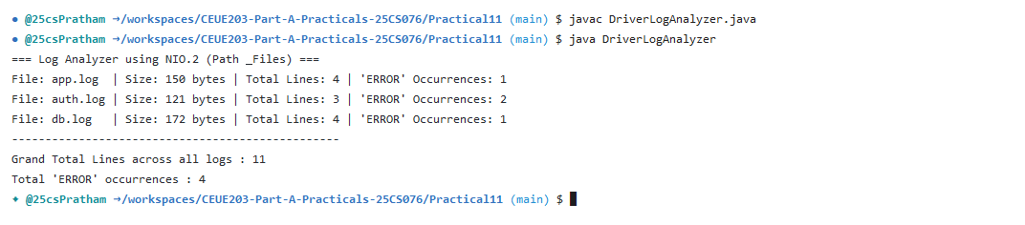

Program 3: Folder tree walker

1. Program Title

Folder tree walker

2. Problem Statement

(For Advanced Learners - home) Walk a folder tree with NIO and produce a report of the files it contains (name, size, modified time), writing the summary to a file; decide what to include.

3. Java Source Code
DriverTreeWalker.java
import java.io.BufferedWriter;
import java.io.IOException;
import java.nio.file.*;
import java.nio.file.attribute.BasicFileAttributes;

public class DriverTreeWalker {
public static void main(String[] args) throws IOException {
Path startDir = Paths.get(".");
Path reportFile = Paths.get("folder_summary_report.txt");

System.out.println("=== Walking Folder Tree with NIO.2 (Files.walkFileTree) ===");

try (BufferedWriter writer = Files.newBufferedWriter(reportFile)) {
writer.write(String.format("%-35s %-12s %-25s\n", "FILE / DIRECTORY NAME", "SIZE (BYTES)", "LAST MODIFIED"));
writer.write("--------------------------------------------------------------------------------\n");

Files.walkFileTree(startDir, new SimpleFileVisitor<Path>() {
@Override
public FileVisitResult visitFile(Path file, BasicFileAttributes attrs) throws IOException {
String line = String.format("%-35s %-12d %-25s",
file.getFileName().toString(),
attrs.size(),
attrs.lastModifiedTime().toString());
writer.write(line + "\n");
System.out.println(line);
return FileVisitResult.CONTINUE;
}

@Override
public FileVisitResult preVisitDirectory(Path dir, BasicFileAttributes attrs) throws IOException {
String dirLine = "[DIR] " + dir.getFileName();
writer.write(dirLine + "\n");
System.out.println(dirLine);
return FileVisitResult.CONTINUE;
}
});
}

System.out.println("--------------------------------------------------------------------------------");
System.out.println("Summary report successfully written to: " + reportFile.toAbsolutePath());
}
}

4. Execution Output


