CHAROTAR UNIVERSITY OF SCIENCE AND TECHNOLOGY (CHARUSAT)
CSPIT - Computer Science and Engineering
CEUE203 - Object-Oriented Programming | Practical 12 - Part A
Student Name: Pratham Patel
Student ID: 25CS076
Semester: 3rd Semester - 2026-27 (Odd)

Program 1: Word frequency

1. Program Title

Word frequency

2. Problem Statement

split a paragraph into words, count each in a HashMap, and print the words sorted by frequency (highest first) using a Comparator.

3. Java Source Code
DriverWordFrequency.java
import java.util.*;

public class DriverWordFrequency {
public static void main(String[] args) {
String paragraph = "Java is an object-oriented programming language. Java is widely used for enterprise software. "
+ "Object-oriented concepts in Java make code reusable and robust. Java threads support concurrency.";

System.out.println("=== Input Paragraph ===");
System.out.println(paragraph + "\n");

// Normalize and split by non-alphanumeric characters
String[] words = paragraph.toLowerCase().split("[^a-zA-Z0-9]+");

Map<String, Integer> freqMap = new HashMap<>();
for (String w : words) {
if (!w.isEmpty()) {
freqMap.put(w, freqMap.getOrDefault(w, 0) + 1);
}
}

// Sort entries by frequency (descending) using Comparator
List<Map.Entry<String, Integer>> entryList = new ArrayList<>(freqMap.entrySet());
entryList.sort(new Comparator<Map.Entry<String, Integer>>() {
@Override
public int compare(Map.Entry<String, Integer> e1, Map.Entry<String, Integer> e2) {
int cmp = e2.getValue().compareTo(e1.getValue()); // Descending by count
if (cmp == 0) {
return e1.getKey().compareTo(e2.getKey()); // Ascending alphabetically
}
return cmp;
}
});

System.out.println("=== Word Frequencies (Sorted Highest First) ===");
System.out.printf("%-18s %s\n", "WORD", "FREQUENCY");
System.out.println("---------------------------");
for (Map.Entry<String, Integer> entry : entryList) {
System.out.printf("%-18s %d\n", entry.getKey(), entry.getValue());
}
}
}

4. Execution Output
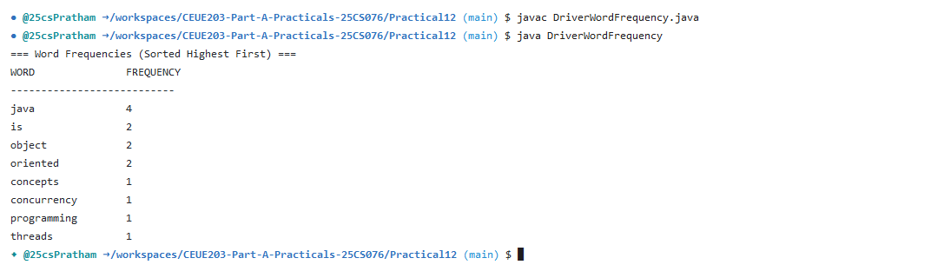

Program 2: Unique visitors

1. Program Title

Unique visitors

2. Problem Statement

from a list of login names with repeats, use a HashSet to count unique users and a LinkedHashSet to keep first-seen order; print the unique count and the first three distinct names.

3. Java Source Code
DriverUniqueVisitors.java
import java.util.*;

public class DriverUniqueVisitors {
public static void main(String[] args) {
// List of login records with duplicate visitors
List<String> logins = Arrays.asList(
"alice", "bob", "charlie", "alice", "david",
"bob", "eve", "frank", "alice", "charlie"
);

System.out.println("=== Raw Login Stream ===");
System.out.println(logins);

// 1. HashSet for counting unique users
Set<String> uniqueSet = new HashSet<>(logins);
System.out.println("\nTotal unique users (using HashSet): " + uniqueSet.size());

// 2. LinkedHashSet to preserve first-seen insertion order
Set<String> orderedSet = new LinkedHashSet<>(logins);
System.out.println("First-seen ordered unique visitors (using LinkedHashSet):");
System.out.println(orderedSet);

// Print first 3 distinct names
System.out.println("\nFirst 3 distinct visitors:");
int count = 0;
for (String user : orderedSet) {
System.out.println((count + 1) + ". " + user);
count++;
if (count == 3) break;
}
}
}

4. Execution Output
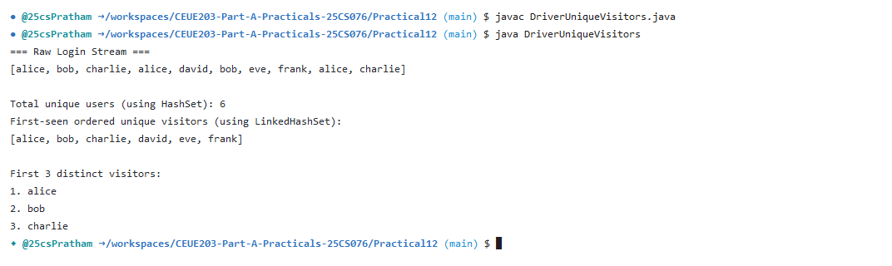

Program 3: Leaderboard

1. Program Title

Leaderboard

2. Problem Statement

(For Advanced Learners - home) Build a leaderboard from player scores held in a Map and print the top-N sorted by score (ties broken by name); choose the data and sorting details.

3. Java Source Code
PlayerScore.java
public class PlayerScore {
private final String name;
private final int score;

public PlayerScore(String name, int score) {
this.name = name;
this.score = score;
}

public String getName() {
return name;
}

public int getScore() {
return score;
}

@Override
public String toString() {
return String.format("%-15s : %d pts", name, score);
}
}
DriverLeaderboard.java
import java.util.*;

public class DriverLeaderboard {
public static void printTopN(Map<String, Integer> scoreMap, int n) {
List<PlayerScore> leaderboard = new ArrayList<>();
for (Map.Entry<String, Integer> entry : scoreMap.entrySet()) {
leaderboard.add(new PlayerScore(entry.getKey(), entry.getValue()));
}

// Comparator: Sort by score descending; tie-break by name ascending
leaderboard.sort((p1, p2) -> {
int scoreDiff = Integer.compare(p2.getScore(), p1.getScore());
if (scoreDiff != 0) {
return scoreDiff;
}
return p1.getName().compareToIgnoreCase(p2.getName());
});

System.out.println("=== Top " + n + " Leaderboard (Ties Broken by Name) ===");
System.out.printf("%-6s %-15s %s\n", "RANK", "PLAYER", "SCORE");
System.out.println("------------------------------------");
int limit = Math.min(n, leaderboard.size());
for (int i = 0; i < limit; i++) {
PlayerScore p = leaderboard.get(i);
System.out.printf("#%-5d %-15s %d\n", (i + 1), p.getName(), p.getScore());
}
}

public static void main(String[] args) {
Map<String, Integer> scores = new HashMap<>();
scores.put("Riya", 2850);
scores.put("Aarav", 3200);
scores.put("Vivaan", 3200); // Tied score with Aarav -> Alphabetical order tie-breaker
scores.put("Ananya", 2400);
scores.put("Kabir", 3100);
scores.put("Diya", 2950);
scores.put("Arjun", 2850); // Tied score with Riya

printTopN(scores, 5);
}
}

4. Execution Output


