CHAROTAR UNIVERSITY OF SCIENCE AND TECHNOLOGY (CHARUSAT)
CSPIT - Computer Science and Engineering
CEUE203 - Object-Oriented Programming | Practical 13 - Part A
Student Name: Pratham Patel
Student ID: 25CS076
Semester: 3rd Semester - 2026-27 (Odd)

Program 1: Generic containers

1. Program Title

Generic containers

2. Problem Statement

a generic Box<T> with get/set and a Pair<A,B>; use them with different types to show type safety without casts, and write a generic method that returns the first element of any array.

3. Java Source Code
Box.java
public class Box<T> {
private T value;

public Box() {}

public Box(T value) {
this.value = value;
}

public void set(T value) {
this.value = value;
}

public T get() {
return value;
}

@Override
public String toString() {
return "Box[" + value + "]";
}
}
Pair.java
public class Pair<A, B> {
private final A first;
private final B second;

public Pair(A first, B second) {
this.first = first;
this.second = second;
}

public A getFirst() {
return first;
}

public B getSecond() {
return second;
}

@Override
public String toString() {
return "(" + first + ", " + second + ")";
}
}
DriverGenericContainers.java
public class DriverGenericContainers {
// Generic method returning the first element of any array
public static <T> T getFirst(T[] array) {
if (array == null || array.length == 0) {
return null;
}
return array[0];
}

public static void main(String[] args) {
System.out.println("=== 1. Generic Box<T> ===");
Box<String> stringBox = new Box<>("Java Generics Demonstration");
Box<Integer> intBox = new Box<>(2026);

// Type safety: No casts required
String strVal = stringBox.get();
int intVal = intBox.get();
System.out.println("String Box contains: " + strVal);
System.out.println("Integer Box contains: " + intVal);

System.out.println("\n=== 2. Generic Pair<A, B> ===");
Pair<String, Double> productPrice = new Pair<>("MacBook Pro", 199999.00);
Pair<Integer, String> studentRoll = new Pair<>(76, "Pratham Patel");

System.out.println("Product: " + productPrice.getFirst() + " | Price: Rs. " + productPrice.getSecond());
System.out.println("Roll No: " + studentRoll.getFirst() + " | Name: " + studentRoll.getSecond());

System.out.println("\n=== 3. Generic Method getFirst() ===");
String[] fruits = {"Apple", "Banana", "Cherry"};
Integer[] numbers = {10, 20, 30, 40};
Double[] decimals = {3.14, 2.718, 1.414};

System.out.println("First fruit : " + getFirst(fruits));
System.out.println("First number : " + getFirst(numbers));
System.out.println("First decimal: " + getFirst(decimals));
}
}

4. Execution Output
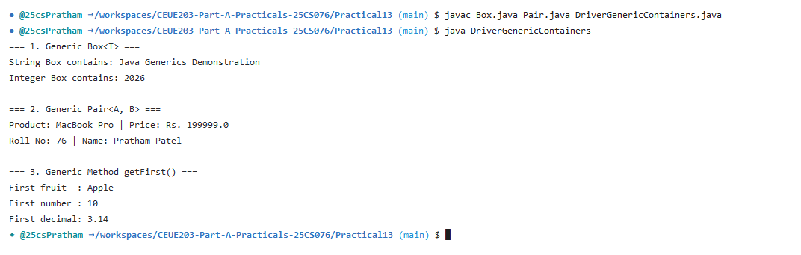

Program 2: Bounded stats

1. Program Title

Bounded stats

2. Problem Statement

a generic method <N extends Number> double average(N[] values) that works for Integer[], Double[] and Long[]; note why it refuses non-Number types.

3. Java Source Code
DriverBoundedStats.java
public class DriverBoundedStats {
// Generic method with bounded type parameter <N extends Number>
public static <N extends Number> double average(N[] values) {
if (values == null || values.length == 0) {
return 0.0;
}
double sum = 0.0;
for (N val : values) {
sum += val.doubleValue(); // Safe because N is guaranteed to be a subtype of Number
}
return sum / values.length;
}

public static void main(String[] args) {
System.out.println("=== Generic Bounded Method: <N extends Number> double average(N[] values) ===");

Integer[] intValues = {10, 25, 30, 45, 50};
Double[] doubleValues = {12.5, 23.4, 34.6, 45.8};
Long[] longValues = {100000L, 250000L, 400000L};

System.out.printf("Average of Integer[] : %.2f\n", average(intValues));
System.out.printf("Average of Double[] : %.2f\n", average(doubleValues));
System.out.printf("Average of Long[] : %.2f\n", average(longValues));

System.out.println("\nCompiler Constraint Explanation:");
System.out.println("Attempting to pass non-Number types (e.g. String[] names = {\"A\", \"B\"})");
System.out.println("results in a compile-time error: 'type argument String is not within bounds of type-variable N'.");
System.out.println("This guarantees compile-time type safety and prevents ClassCastException at runtime.");
}
}

4. Execution Output
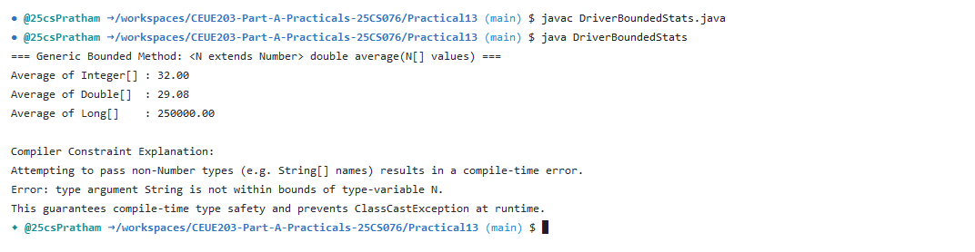

Program 3: Generic Stack

1. Program Title

Generic Stack

2. Problem Statement

(For Advanced Learners - home) Implement a small generic container of your choice (e.g. a stack) backed by an array, reuse it for two different types, and handle the empty case sensibly.

3. Java Source Code
GenericStack.java
import java.util.EmptyStackException;

public class GenericStack<T> {
private Object[] elements;
private int size = 0;
private static final int DEFAULT_CAPACITY = 10;

public GenericStack() {
elements = new Object[DEFAULT_CAPACITY];
}

public void push(T item) {
if (size == elements.length) {
resize();
}
elements[size++] = item;
}

@SuppressWarnings("unchecked")
public T pop() {
if (isEmpty()) {
throw new EmptyStackException();
}
T item = (T) elements[--size];
elements[size] = null; // Prevent memory leak
return item;
}

@SuppressWarnings("unchecked")
public T peek() {
if (isEmpty()) {
throw new EmptyStackException();
}
return (T) elements[size - 1];
}

public boolean isEmpty() {
return size == 0;
}

public int size() {
return size;
}

private void resize() {
Object[] newElements = new Object[elements.length * 2];
System.arraycopy(elements, 0, newElements, 0, elements.length);
elements = newElements;
}
}
DriverGenericStack.java
import java.util.EmptyStackException;

public class DriverGenericStack {
public static void main(String[] args) {
System.out.println("=== 1. GenericStack<Integer> Test ===");
GenericStack<Integer> intStack = new GenericStack<>();
intStack.push(10);
intStack.push(20);
intStack.push(30);
System.out.println("Stack size: " + intStack.size());
System.out.println("Peek top element: " + intStack.peek());
System.out.println("Popped: " + intStack.pop());
System.out.println("Popped: " + intStack.pop());
System.out.println("Remaining size: " + intStack.size());

System.out.println("\n=== 2. Reusing GenericStack<String> Test ===");
GenericStack<String> strStack = new GenericStack<>();
strStack.push("First");
strStack.push("Second");
strStack.push("Third");
System.out.println("Popped from String stack: " + strStack.pop());
System.out.println("Popped from String stack: " + strStack.pop());
System.out.println("Popped from String stack: " + strStack.pop());

System.out.println("\n=== 3. Testing Empty Stack Handling ===");
try {
System.out.println("Attempting pop on empty stack...");
strStack.pop();
} catch (EmptyStackException e) {
System.out.println("Caught Expected Exception: EmptyStackException successfully handled!");
}
}
}

4. Execution Output


