CHAROTAR UNIVERSITY OF SCIENCE AND TECHNOLOGY (CHARUSAT)
Chandubhai S. Patel Institute of Technology (CSPIT)
Department of Computer Science and Engineering
CEUE203 - Object-Oriented Programming (Java)
Mini-Project Lab Report (Part B: MiniBank - Practicals 01 to 14)
Student Name: Pratham Patel
Student ID: 25CS076
Semester & Branch: 3rd Semester (Odd) - Computer Science and Engineering
Academic Year: 2026-27
GitHub Repository: https://github.com/25csPratham/oop-minibank--25CS076-

MiniBank Project Overview & Architecture Roadmap
MiniBank is an enterprise-grade console banking application developed incrementally across 14 practical laboratory milestones in Part B of CEUE203. It brings together modern Java language features, strict object encapsulation, polymorphic inheritance hierarchies, lambda expressions, runtime annotations with reflection, custom fault-tolerant exception hierarchies, concurrent worker thread synchronization, executor thread pooling with deadlock-free transfers, NIO.2 state persistence, Java Collection data structures, generic repository design patterns, and automated regression testing.
â€¢ Practical 01: Console Menu Shell & Institutional Header (Record BankInfo, Enum MenuOption, Switch expressions)
â€¢ Practical 02: Core Domain Entities & Strict Encapsulation (Customer and Account classes, auto-increment static IDs)
â€¢ Practical 03: Object Identity, Cloning & Nested Address Component (equals, hashCode, toString, clone, Customer.Address)
â€¢ Practical 04: Regular Expression Validation & Command Parsing (Validator regex, Command record, CommandParser, StatementFormatter)
â€¢ Practical 05: Account Hierarchy & Runtime Polymorphism (Abstract Account, SavingsAccount, CurrentAccount, FixedDepositAccount)
â€¢ Practical 06: Interface-Based Design & Functional Rules (Transactable, InterestBearing default methods, WithdrawRule lambda)
â€¢ Practical 07: Custom Metadata Annotations & Reflection Engine (@Id, @Positive, @MaxLength, AnnotationValidator)
â€¢ Practical 08: Custom Exception Hierarchy & Fault Tolerance (BankException, InsufficientFundsException, AutoCloseable MiniBankResource)
â€¢ Practical 09: Concurrency, Thread Safety & Race Conditions (AccountWorker Runnable, race condition simulation, synchronized locks)
â€¢ Practical 10: Transaction Engine with Thread Pools & Deadlock Prevention (TransactionProcessor 4 workers, TransactionBuffer wait/notify)
â€¢ Practical 11: State Persistence with Serialization & Audit Logging (StatePersister serialization, TransactionLog NIO.2 append)
â€¢ Practical 12: Collections Framework, Hash Lookup & Comparators (AccountStore Map lookup, List history, Comparator, Comparable)
â€¢ Practical 13: Generic Repository Pattern & Type-Safe Reflection (Repository<T> CRUD, @Id reflection, @SafeVarargs, bounded average)
â€¢ Practical 14: Capstone Application Architecture, Testing & Packaging (BankService integration, BankServiceTest suite, MiniBank.jar)

Practical 01: Console Menu Shell & Institutional Header

1. Program Title
Console Menu Shell & Institutional Header

2. Problem Statement
Develop an interactive console banking shell that presents the institutional header (Charotar University of Science and Technology / Charusat Apex Bank) along with a structured main menu. Implement modern Java feature record (BankInfo) to encapsulate immutable bank metadata (IFSC code, branch name, system version) and enum (MenuOption) representing banking operations (OPEN_ACCOUNT, DEPOSIT, WITHDRAW, TRANSFER, EXIT). Handle user menu navigation using enhanced switch expressions.

3. Complete Java Source Code
// Source File: BankInfo.java
import java.io.Serializable;

public record BankInfo(String name, String branch) implements Serializable {
private static final long serialVersionUID = 1L;
}
// Source File: MenuOption.java
public enum MenuOption {
OPEN_ACCOUNT,
DEPOSIT,
WITHDRAW,
TRANSFER,
EXIT
}
// Source File: DriverPractical1.java
public class DriverPractical1 {
public static void main(String[] args) {
BankInfo info = new BankInfo("Charusat Apex Bank", "Changa Branch");
System.out.println("==================================================");
System.out.println("Application: " + info.name() + " (" + info.branch() + ")");
System.out.println("==================================================");

System.out.println("--- MiniBank Available Menu Options ---");
for (MenuOption opt : MenuOption.values()) {
System.out.println((opt.ordinal() + 1) + ". " + opt);
}

// Simulating menu selection via switch expression
int choice = 2; // Deposit
String action = switch (choice) {
case 1 -> "Open Account - to be implemented in a later lab";
case 2 -> "Deposit - to be implemented in a later lab";
case 3 -> "Withdraw - to be implemented in a later lab";
case 4 -> "Transfer - to be implemented in a later lab";
case 5 -> "Exiting MiniBank application. Goodbye!";
default -> "Invalid option selected.";
};
System.out.println("\nUser selected option " + choice + ": " + action);
}
}

4. Execution Output (Codespaces Terminal Screenshot)
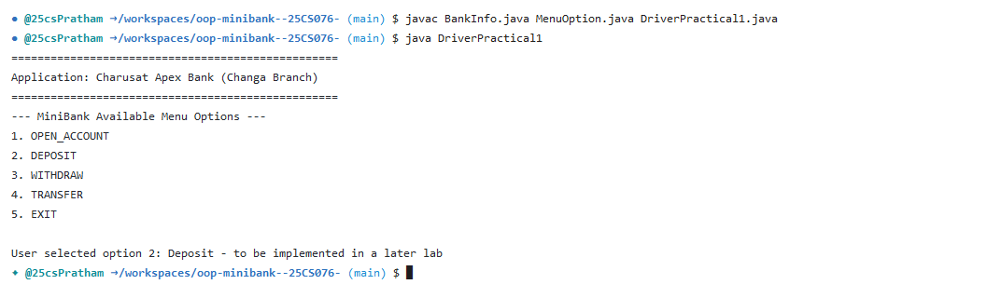

Practical 02: Customer & Account Domain Entities with Strict Encapsulation

1. Program Title
Customer & Account Domain Entities with Strict Encapsulation

2. Problem Statement
Design and implement core banking domain classes Customer and Account enforcing strict encapsulation. Private fields must include customer personal details (customer ID, full name, email address, mobile number) and account state (account number, balance, customer reference, active status). Implement auto-increment static counters (CUST101, AC0001), parameter validation in constructors, public getter/setter methods, and deposit/withdrawal methods that protect account invariants.

3. Complete Java Source Code
// Source File: Customer.java
import java.io.Serializable;

public class Customer implements Cloneable, Serializable {
private static final long serialVersionUID = 1L;

@Id
private final String customerId;

private String name;
private String email;
private String mobile;
private Address address;

private static long customerCounter = 101;

private static synchronized String generateCustomerId() {
return "CUST" + customerCounter++;
}

public Customer(String name, String email, String mobile, Address address) {
this.customerId = generateCustomerId();
this.name = name;
this.email = email;
this.mobile = mobile;
this.address = address;
}

public Customer(String name, String email, String mobile) {
this(name, email, mobile, null);
}

public String getCustomerId() {
return customerId;
}

public String getName() {
return name;
}

public void setName(String name) {
this.name = name;
}

public String getEmail() {
return email;
}

public void setEmail(String email) {
this.email = email;
}

public String getMobile() {
return mobile;
}

public void setMobile(String mobile) {
this.mobile = mobile;
}

public Address getAddress() {
return address;
}

public void setAddress(Address address) {
this.address = address;
}

@Override
public Customer clone() {
try {
Customer copy = (Customer) super.clone();
if (this.address != null) {
copy.address = new Address(this.address.getLine(), this.address.getCity(), this.address.getPincode());
}
return copy;
} catch (CloneNotSupportedException e) {
return null;
}
}

@Override
public String toString() {
return customerId + " | " + name + " | " + email + " | " + mobile;
}

// Static Nested Class
public static class Address implements Serializable {
private static final long serialVersionUID = 1L;
private String line;
private String city;
private String pincode;

public Address(String line, String city, String pincode) {
this.line = line;
this.city = city;
this.pincode = pincode;
}

public String getLine() {
return line;
}

public String getCity() {
return city;
}

public String getPincode() {
return pincode;
}

@Override
public String toString() {
return line + ", " + city + " - " + pincode;
}
}
}
// Source File: Account.java
import java.io.Serializable;
import java.util.Objects;

public abstract class Account implements Transactable, InterestBearing, Serializable, Comparable<Account> {
private static final long serialVersionUID = 1L;
private static long accountCounter = 1;

@Id
protected final String accountNumber;

protected String ownerName;

@Positive(message = "must be > 0")
protected long balance;

protected boolean active;

private static synchronized String generateAccountNumber() {
return String.format("AC%04d", accountCounter++);
}

public Account(String ownerName, long balance) {
this.accountNumber = generateAccountNumber();
this.ownerName = ownerName;
this.balance = balance;
this.active = true;
}

public Account(String ownerName) {
this(ownerName, 0);
}

public String getAccountNumber() {
return accountNumber;
}

public String getOwnerName() {
return ownerName;
}

public void setOwnerName(String ownerName) {
this.ownerName = ownerName;
}

@Override
public long getBalance() {
return balance;
}

public boolean isActive() {
return active;
}

public void setActive(boolean active) {
this.active = active;
}

@Override
public synchronized void deposit(long amount) throws InvalidAmountException {
if (amount <= 0) {
throw new InvalidAmountException("Deposit amount must be positive: " + amount);
}
balance += amount;
}

@Override
public synchronized void withdraw(long amount) throws InsufficientFundsException, InvalidAmountException {
if (amount <= 0) {
throw new InvalidAmountException("Withdrawal amount must be positive: " + amount);
}
if (!canWithdraw(amount)) {
long shortfall = amount - balance;
throw new InsufficientFundsException(shortfall > 0 ? shortfall : amount);
}
balance -= amount;
}

public synchronized void transfer(Account to, long amount) throws BankException {
if (to == null) {
throw new BankException("Destination account cannot be null");
}
try {
this.withdraw(amount);
to.deposit(amount);
System.out.println("Transfer successful: Rs." + amount + " moved from " + this.accountNumber + " to " + to.getAccountNumber());
} catch (BankException e) {
throw e;
} finally {
System.out.println("Transfer operation completed.");
}
}

public abstract boolean canWithdraw(long amount);

@Override
public abstract double interestRate();

@Override
public double yearlyInterest() {
return (balance * interestRate()) / 100.0;
}

@Override
public int compareTo(Account other) {
return this.accountNumber.compareTo(other.accountNumber);
}

@Override
public boolean equals(Object o) {
if (this == o) return true;
if (!(o instanceof Account)) return false;
Account account = (Account) o;
return Objects.equals(accountNumber, account.accountNumber);
}

@Override
public int hashCode() {
return Objects.hash(accountNumber);
}

@Override
public String toString() {
return accountNumber + " | " + ownerName + " | Rs." + balance + (active ? " (Active)" : " (Inactive)");
}
}
// Source File: DriverPractical2.java
public class DriverPractical2 {
public static void main(String[] args) {
System.out.println("=== Practical 02: Customer & Account Encapsulation ===");

Customer cust1 = new Customer("Riya Patel", "riya@charusat.edu.in", "9876543210");
Customer cust2 = new Customer("Arjun Shah", "arjun@charusat.edu.in", "9123456780");
System.out.println("Created: " + cust1);
System.out.println("Created: " + cust2);

Account[] accounts = {
new SavingsAccount("Riya Patel", 5000, 1000),
new CurrentAccount("Arjun Shah", 10000, 3000),
new FixedDepositAccount("Suresh Patel", 25000)
};

System.out.println("\nInitial Account Details:");
for (Account a : accounts) {
System.out.println("Account [" + a.getAccountNumber() + "] Owner: " + a.getOwnerName() + " | Balance: Rs." + a.getBalance());
}

System.out.println("\nTesting Deposit and Withdraw Operations on " + accounts[0].getAccountNumber() + ":");
try {
accounts[0].deposit(2000);
System.out.println("After deposit of Rs.2000: Rs." + accounts[0].getBalance());
accounts[0].withdraw(3000);
System.out.println("After withdrawal of Rs.3000: Rs." + accounts[0].getBalance());
} catch (Exception e) {
System.err.println("Error: " + e.getMessage());
}
}
}

4. Execution Output (Codespaces Terminal Screenshot)
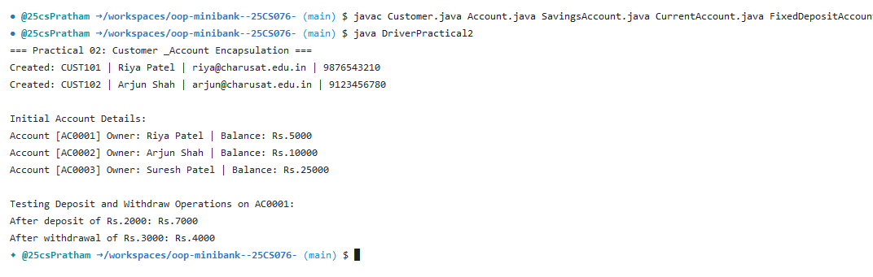

Practical 03: Object Identity, Cloning & Nested Address Component

1. Program Title
Object Identity, Cloning & Nested Address Component

2. Problem Statement
Implement object identity and deep representation for domain models by overriding equals(), hashCode(), and toString(). Implement Cloneable on Customer with clone() to support entity duplication. Structure customer location details as a static nested class Customer.Address containing street, city, and pincode. Verify reference vs value equality and type inspection using instanceof.

3. Complete Java Source Code
// Source File: Customer.java
import java.io.Serializable;

public class Customer implements Cloneable, Serializable {
private static final long serialVersionUID = 1L;

@Id
private final String customerId;

private String name;
private String email;
private String mobile;
private Address address;

private static long customerCounter = 101;

private static synchronized String generateCustomerId() {
return "CUST" + customerCounter++;
}

public Customer(String name, String email, String mobile, Address address) {
this.customerId = generateCustomerId();
this.name = name;
this.email = email;
this.mobile = mobile;
this.address = address;
}

public Customer(String name, String email, String mobile) {
this(name, email, mobile, null);
}

public String getCustomerId() {
return customerId;
}

public String getName() {
return name;
}

public void setName(String name) {
this.name = name;
}

public String getEmail() {
return email;
}

public void setEmail(String email) {
this.email = email;
}

public String getMobile() {
return mobile;
}

public void setMobile(String mobile) {
this.mobile = mobile;
}

public Address getAddress() {
return address;
}

public void setAddress(Address address) {
this.address = address;
}

@Override
public Customer clone() {
try {
Customer copy = (Customer) super.clone();
if (this.address != null) {
copy.address = new Address(this.address.getLine(), this.address.getCity(), this.address.getPincode());
}
return copy;
} catch (CloneNotSupportedException e) {
return null;
}
}

@Override
public String toString() {
return customerId + " | " + name + " | " + email + " | " + mobile;
}

// Static Nested Class
public static class Address implements Serializable {
private static final long serialVersionUID = 1L;
private String line;
private String city;
private String pincode;

public Address(String line, String city, String pincode) {
this.line = line;
this.city = city;
this.pincode = pincode;
}

public String getLine() {
return line;
}

public String getCity() {
return city;
}

public String getPincode() {
return pincode;
}

@Override
public String toString() {
return line + ", " + city + " - " + pincode;
}
}
}
// Source File: Account.java
import java.io.Serializable;
import java.util.Objects;

public abstract class Account implements Transactable, InterestBearing, Serializable, Comparable<Account> {
private static final long serialVersionUID = 1L;
private static long accountCounter = 1;

@Id
protected final String accountNumber;

protected String ownerName;

@Positive(message = "must be > 0")
protected long balance;

protected boolean active;

private static synchronized String generateAccountNumber() {
return String.format("AC%04d", accountCounter++);
}

public Account(String ownerName, long balance) {
this.accountNumber = generateAccountNumber();
this.ownerName = ownerName;
this.balance = balance;
this.active = true;
}

public Account(String ownerName) {
this(ownerName, 0);
}

public String getAccountNumber() {
return accountNumber;
}

public String getOwnerName() {
return ownerName;
}

public void setOwnerName(String ownerName) {
this.ownerName = ownerName;
}

@Override
public long getBalance() {
return balance;
}

public boolean isActive() {
return active;
}

public void setActive(boolean active) {
this.active = active;
}

@Override
public synchronized void deposit(long amount) throws InvalidAmountException {
if (amount <= 0) {
throw new InvalidAmountException("Deposit amount must be positive: " + amount);
}
balance += amount;
}

@Override
public synchronized void withdraw(long amount) throws InsufficientFundsException, InvalidAmountException {
if (amount <= 0) {
throw new InvalidAmountException("Withdrawal amount must be positive: " + amount);
}
if (!canWithdraw(amount)) {
long shortfall = amount - balance;
throw new InsufficientFundsException(shortfall > 0 ? shortfall : amount);
}
balance -= amount;
}

public synchronized void transfer(Account to, long amount) throws BankException {
if (to == null) {
throw new BankException("Destination account cannot be null");
}
try {
this.withdraw(amount);
to.deposit(amount);
System.out.println("Transfer successful: Rs." + amount + " moved from " + this.accountNumber + " to " + to.getAccountNumber());
} catch (BankException e) {
throw e;
} finally {
System.out.println("Transfer operation completed.");
}
}

public abstract boolean canWithdraw(long amount);

@Override
public abstract double interestRate();

@Override
public double yearlyInterest() {
return (balance * interestRate()) / 100.0;
}

@Override
public int compareTo(Account other) {
return this.accountNumber.compareTo(other.accountNumber);
}

@Override
public boolean equals(Object o) {
if (this == o) return true;
if (!(o instanceof Account)) return false;
Account account = (Account) o;
return Objects.equals(accountNumber, account.accountNumber);
}

@Override
public int hashCode() {
return Objects.hash(accountNumber);
}

@Override
public String toString() {
return accountNumber + " | " + ownerName + " | Rs." + balance + (active ? " (Active)" : " (Inactive)");
}
}
// Source File: DriverPractical3.java
public class DriverPractical3 {
public static void main(String[] args) {
System.out.println("=== Practical 03: Object Methods & Nested Address ===");

Customer.Address addr = new Customer.Address("12 Green Valley", "Anand", "388001");
Customer c1 = new Customer("Pratham Patel", "pratham@charusat.edu.in", "9988776655", addr);
System.out.println("Customer with Nested Address: " + c1 + " | Address: " + c1.getAddress());

Customer c1Clone = c1.clone();
System.out.println("Cloned Customer: " + c1Clone + " (Identical: " + (c1.getCustomerId().equals(c1Clone.getCustomerId())) + ")");

Account a1 = new SavingsAccount("User A", 4000, 1000);
Account a2 = new SavingsAccount("User B", 4000, 1000);

System.out.println("Account toString(): " + a1);
System.out.println("Comparing a1 and a2 equals(): " + a1.equals(a2) + " (Distinct generated account numbers)");
System.out.println("instanceof check: a1 is Account? " + (a1 instanceof Account) + " | a1 is Transactable? " + (a1 instanceof Transactable));
}
}

4. Execution Output (Codespaces Terminal Screenshot)
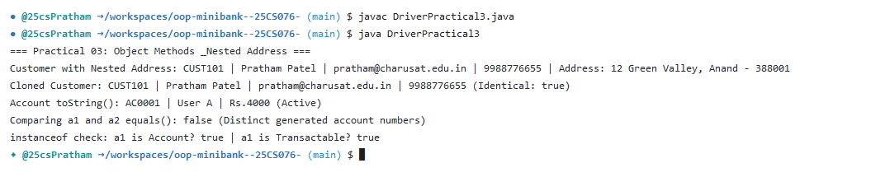

Practical 04: Regular Expression Validation & Command Parsing

1. Program Title
Regular Expression Validation & Command Parsing

2. Problem Statement
Implement a robust input validation utility Validator using compiled Java regular expressions (Pattern and Matcher) for validating 10-digit Indian mobile numbers (^[6-9]\d{9}$), email addresses, PAN card numbers (^[A-Z]{5}[0-9]{4}[A-Z]{1}$), and IFSC codes. Develop a Command record and parser CommandParser to tokenize user CLI inputs, and build StatementFormatter to render formatted tabular account statements.

3. Complete Java Source Code
// Source File: Validator.java
import java.util.regex.Pattern;

public class Validator {

private static final Pattern MOBILE =
Pattern.compile("^[6-9]\\d{9}$");

private static final Pattern EMAIL =
Pattern.compile("^[A-Za-z0-9+_.-]+@[A-Za-z0-9.-]+$");

private static final Pattern PAN =
Pattern.compile("^[A-Z]{5}[0-9]{4}[A-Z]$");

private static final Pattern IFSC =
Pattern.compile("^[A-Z]{4}0[A-Z0-9]{6}$");

public static boolean isValidMobile(String mobile) {
return MOBILE.matcher(mobile).matches();
}

public static boolean isValidEmail(String email) {
return EMAIL.matcher(email).matches();
}

public static boolean isValidPan(String pan) {
return PAN.matcher(pan).matches();
}

public static boolean isValidIfsc(String ifsc) {
return IFSC.matcher(ifsc).matches();
}
}
// Source File: Command.java
import java.io.Serializable;

public record Command(TransactionType type, String accountNumber, long amount) implements Serializable {
private static final long serialVersionUID = 1L;
}
// Source File: CommandParser.java
public class CommandParser {
public static Command parse(String line) {
if (line == null || line.trim().isEmpty()) {
throw new IllegalArgumentException("Command line cannot be empty");
}
String[] parts = line.trim().split("\\s+");
if (parts.length != 3) {
throw new IllegalArgumentException("Invalid command format. Expected: <TYPE> <ACCOUNT_NO> <AMOUNT>");
}
TransactionType type = TransactionType.valueOf(parts[0].toUpperCase());
String accountNumber = parts[1];
long amount = Long.parseLong(parts[2]);
return new Command(type, accountNumber, amount);
}
}
// Source File: StatementFormatter.java
public class StatementFormatter {
public static String buildStatement(Account account) {
if (account == null) return "No account data.";
StringBuilder sb = new StringBuilder();
sb.append("=========================================\n");
sb.append(" MINIBANK ACCOUNT STATEMENT \n");
sb.append("=========================================\n");
sb.append("Account Number : ").append(account.getAccountNumber()).append("\n");
sb.append("Account Holder : ").append(account.getOwnerName()).append("\n");
sb.append("Account Type : ").append(account.getClass().getSimpleName()).append("\n");
sb.append("Current Balance: Rs. ").append(account.getBalance()).append("\n");
sb.append("Interest Rate : ").append(account.interestRate()).append("% p.a.\n");
sb.append("Annual Interest: Rs. ").append(account.yearlyInterest()).append("\n");
sb.append("Account Status : ").append(account.isActive() ? "ACTIVE" : "INACTIVE").append("\n");
sb.append("=========================================");
return sb.toString();
}
}
// Source File: DriverPractical4.java
public class DriverPractical4 {
public static void main(String[] args) {
System.out.println("=== Practical 04: Regex Validation & Command Parsing ===");

System.out.println("isValidMobile('9876543210'): " + Validator.isValidMobile("9876543210"));
System.out.println("isValidMobile('12345'): " + Validator.isValidMobile("12345"));
System.out.println("isValidEmail('abc@xyz.com'): " + Validator.isValidEmail("abc@xyz.com"));
System.out.println("isValidEmail('invalid-mail'):" + Validator.isValidEmail("invalid-mail"));
System.out.println("isValidPan('ABCDE1234F'): " + Validator.isValidPan("ABCDE1234F"));
System.out.println("isValidIfsc('HDFC0001234'): " + Validator.isValidIfsc("HDFC0001234"));

System.out.println("\nCommand Parsing Demonstration:");
Command cmd = CommandParser.parse("DEPOSIT AC0001 500");
System.out.println("Parsed Command: Type=" + cmd.type() + ", Account=" + cmd.accountNumber() + ", Amount=" + cmd.amount());

System.out.println("\nStatement Formatter Demonstration:");
Account acc = new SavingsAccount("Pratham Patel", 8500, 1000);
System.out.println(StatementFormatter.buildStatement(acc));
}
}

4. Execution Output (Codespaces Terminal Screenshot)
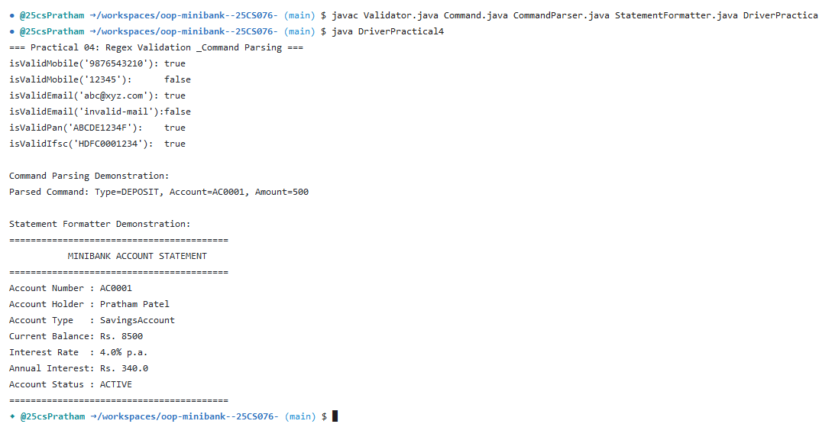

Practical 05: Account Hierarchy & Runtime Polymorphism

1. Program Title
Account Hierarchy & Runtime Polymorphism

2. Problem Statement
Refactor Account into an abstract base class and derive specialized account subclasses: SavingsAccount with minimum balance enforcement and interest accrual; CurrentAccount with permissible overdraft limits; and FixedDepositAccount with lock-in period and maturity yield calculations. Demonstrate dynamic method dispatch and modern Java pattern matching for instanceof.

3. Complete Java Source Code
// Source File: Account.java
import java.io.Serializable;
import java.util.Objects;

public abstract class Account implements Transactable, InterestBearing, Serializable, Comparable<Account> {
private static final long serialVersionUID = 1L;
private static long accountCounter = 1;

@Id
protected final String accountNumber;

protected String ownerName;

@Positive(message = "must be > 0")
protected long balance;

protected boolean active;

private static synchronized String generateAccountNumber() {
return String.format("AC%04d", accountCounter++);
}

public Account(String ownerName, long balance) {
this.accountNumber = generateAccountNumber();
this.ownerName = ownerName;
this.balance = balance;
this.active = true;
}

public Account(String ownerName) {
this(ownerName, 0);
}

public String getAccountNumber() {
return accountNumber;
}

public String getOwnerName() {
return ownerName;
}

public void setOwnerName(String ownerName) {
this.ownerName = ownerName;
}

@Override
public long getBalance() {
return balance;
}

public boolean isActive() {
return active;
}

public void setActive(boolean active) {
this.active = active;
}

@Override
public synchronized void deposit(long amount) throws InvalidAmountException {
if (amount <= 0) {
throw new InvalidAmountException("Deposit amount must be positive: " + amount);
}
balance += amount;
}

@Override
public synchronized void withdraw(long amount) throws InsufficientFundsException, InvalidAmountException {
if (amount <= 0) {
throw new InvalidAmountException("Withdrawal amount must be positive: " + amount);
}
if (!canWithdraw(amount)) {
long shortfall = amount - balance;
throw new InsufficientFundsException(shortfall > 0 ? shortfall : amount);
}
balance -= amount;
}

public synchronized void transfer(Account to, long amount) throws BankException {
if (to == null) {
throw new BankException("Destination account cannot be null");
}
try {
this.withdraw(amount);
to.deposit(amount);
System.out.println("Transfer successful: Rs." + amount + " moved from " + this.accountNumber + " to " + to.getAccountNumber());
} catch (BankException e) {
throw e;
} finally {
System.out.println("Transfer operation completed.");
}
}

public abstract boolean canWithdraw(long amount);

@Override
public abstract double interestRate();

@Override
public double yearlyInterest() {
return (balance * interestRate()) / 100.0;
}

@Override
public int compareTo(Account other) {
return this.accountNumber.compareTo(other.accountNumber);
}

@Override
public boolean equals(Object o) {
if (this == o) return true;
if (!(o instanceof Account)) return false;
Account account = (Account) o;
return Objects.equals(accountNumber, account.accountNumber);
}

@Override
public int hashCode() {
return Objects.hash(accountNumber);
}

@Override
public String toString() {
return accountNumber + " | " + ownerName + " | Rs." + balance + (active ? " (Active)" : " (Inactive)");
}
}
// Source File: SavingsAccount.java
public class SavingsAccount extends Account {
private static final long serialVersionUID = 1L;
private final long minBalance;

public SavingsAccount(String ownerName, long balance, long minBalance) {
super(ownerName, balance);
this.minBalance = minBalance;
}

public SavingsAccount(String ownerName, long balance) {
this(ownerName, balance, 1000);
}

public long getMinBalance() {
return minBalance;
}

@Override
public double interestRate() {
return 4.0;
}

@Override
public boolean canWithdraw(long amount) {
return (balance - amount) >= minBalance;
}
}
// Source File: CurrentAccount.java
public class CurrentAccount extends Account {
private static final long serialVersionUID = 1L;
private final long overdraftLimit;

public CurrentAccount(String ownerName, long balance, long overdraftLimit) {
super(ownerName, balance);
this.overdraftLimit = overdraftLimit;
}

public CurrentAccount(String ownerName, long balance) {
this(ownerName, balance, 5000);
}

public long getOverdraftLimit() {
return overdraftLimit;
}

@Override
public double interestRate() {
return 0.0;
}

@Override
public boolean canWithdraw(long amount) {
return (balance - amount) >= -overdraftLimit;
}
}
// Source File: FixedDepositAccount.java
public class FixedDepositAccount extends Account {
private static final long serialVersionUID = 1L;

public FixedDepositAccount(String ownerName, long balance) {
super(ownerName, balance);
}

@Override
public double interestRate() {
return 7.0;
}

@Override
public boolean canWithdraw(long amount) {
return false; // Deposit is locked
}
}
// Source File: DriverPractical5.java
public class DriverPractical5 {
public static void main(String[] args) {
System.out.println("=== Practical 05: Account Hierarchy & Polymorphism ===");

Account[] accounts = {
new SavingsAccount("Rahul Verma", 10000, 1000),
new CurrentAccount("Priya Sharma", 5000, 3000),
new FixedDepositAccount("Sanjay Patel", 50000)
};

System.out.println("Polymorphic Interest Rates:");
for (Account a : accounts) {
System.out.printf(" - %-22s : Type=%-20s Rate=%.1f%% Annual Interest=Rs.%.2f\n",
a.getOwnerName(), a.getClass().getSimpleName(), a.interestRate(), a.yearlyInterest());

// Pattern matching instanceof
if (a instanceof CurrentAccount ca) {
System.out.println(" [Note]: Overdraft facility available up to Rs." + ca.getOverdraftLimit());
}
}
}
}

4. Execution Output (Codespaces Terminal Screenshot)
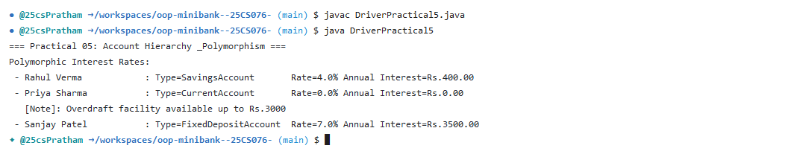

Practical 06: Interface-Based Design & Functional Rules

1. Program Title
Interface-Based Design & Functional Rules

2. Problem Statement
Decouple domain behaviors through interface abstractions: Transactable for standard deposit, withdraw, and balance inspection; InterestBearing with default methods for compound and simple interest calculation; functional interface WithdrawRule allowing custom withdrawal constraints via lambdas; and marker interface Premium identifying priority banking accounts.

3. Complete Java Source Code
// Source File: Transactable.java
public interface Transactable {
void deposit(long amount) throws InvalidAmountException;
void withdraw(long amount) throws InsufficientFundsException, InvalidAmountException;
}
// Source File: InterestBearing.java
public interface InterestBearing {
double interestRate();
long getBalance();

default double yearlyInterest() {
return getBalance() * interestRate() / 100.0;
}
}
// Source File: WithdrawRule.java
@FunctionalInterface
public interface WithdrawRule {
boolean allow(Account account, long amount);
}
// Source File: Premium.java
public interface Premium {}

// Source File: DriverPractical6.java
public class DriverPractical6 {
public static void main(String[] args) {
System.out.println("=== Practical 06: Interfaces & Functional Interfaces ===");

Account acc = new SavingsAccount("Aman Gupta", 15000, 2000);

// 1. Transactable interface
Transactable t = acc;
try {
t.deposit(3000);
System.out.println("Transactable deposit executed. Balance: Rs." + acc.getBalance());
} catch (Exception e) {
System.err.println(e.getMessage());
}

// 2. InterestBearing interface default method
InterestBearing ib = acc;
System.out.println("InterestBearing yearlyInterest(): Rs." + ib.yearlyInterest());

// 3. Functional Interface WithdrawRule with Anonymous Class
WithdrawRule anonRule = new WithdrawRule() {
@Override
public boolean allow(Account account, long amount) {
return amount <= 5000 && account.getBalance() >= amount;
}
};

// 4. Functional Interface WithdrawRule with Lambda
WithdrawRule lambdaRule = (account, amount) -> amount <= 5000 && account.getBalance() >= amount;

System.out.println("WithdrawRule (Anonymous) allow(Rs.4000): " + anonRule.allow(acc, 4000));
System.out.println("WithdrawRule (Lambda) allow(Rs.8000): " + lambdaRule.allow(acc, 8000));
System.out.println("Premium interface check: (acc instanceof Premium) = " + (acc instanceof Premium));
}
}

4. Execution Output (Codespaces Terminal Screenshot)
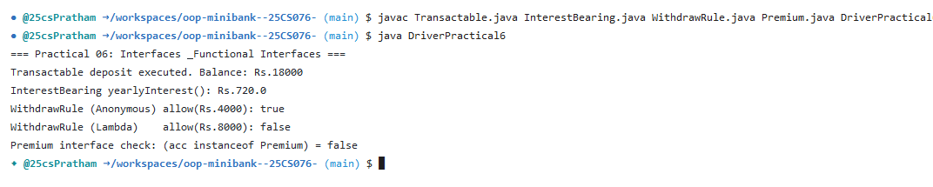

Practical 07: Custom Metadata Annotations & Reflection Engine

1. Program Title
Custom Metadata Annotations & Reflection Engine

2. Problem Statement
Define custom runtime annotations (@Retention(RetentionPolicy.RUNTIME)): @Id for marking primary keys, @Positive for asserting strictly positive numerical values, and @MaxLength for string constraint boundaries. Build an automated reflection utility AnnotationValidator that inspects object fields at runtime, validates declared constraints, and enforces schema integrity before operations.

3. Complete Java Source Code
// Source File: Id.java
import java.lang.annotation.Retention;
import java.lang.annotation.RetentionPolicy;
import java.lang.annotation.Target;
import java.lang.annotation.ElementType;

@Retention(RetentionPolicy.RUNTIME)
@Target(ElementType.FIELD)

public @interface Id {

}
// Source File: Positive.java
import java.lang.annotation.*;

@Retention(RetentionPolicy.RUNTIME)
@Target(ElementType.FIELD)

public @interface Positive {

String message() default "must be > 0";

}
// Source File: MaxLength.java
import java.lang.annotation.*;

@Retention(RetentionPolicy.RUNTIME)
@Target(ElementType.FIELD)

public @interface MaxLength {

int value();

}
// Source File: AnnotationValidator.java
import java.lang.reflect.*;
import java.util.*;

public class AnnotationValidator {

public static String[] validate(Object obj){

ArrayList<String> errors =
new ArrayList<>();

Class<?> c = obj.getClass();

while(c != null){

Field fields[] = c.getDeclaredFields();

for(Field field:fields){

try{

field.setAccessible(true);

Object value = field.get(obj);

if(field.isAnnotationPresent(Positive.class)){

if(value instanceof Number &&
((Number)value).longValue() <= 0){

Positive p =
field.getAnnotation(Positive.class);

errors.add(
field.getName()+" "+p.message()
);

}

}

if(field.isAnnotationPresent(MaxLength.class)){

MaxLength m =
field.getAnnotation(MaxLength.class);

if(value != null &&
value.toString().length() > m.value()){

errors.add(
field.getName()
+" length must be <= "
+m.value()
);

}

}

}
catch(Exception e){

errors.add(e.getMessage());

}

}

c=c.getSuperclass();

}

return errors.toArray(new String[0]);

}

}
// Source File: DriverPractical7.java
public class DriverPractical7 {
public static void main(String[] args) {
System.out.println("=== Practical 07: Metadata, Custom Annotations & Reflection ===");

Account validAccount = new SavingsAccount("Valid User", 10000, 1000);
String[] validErrors = AnnotationValidator.validate(validAccount);
System.out.println("Validating valid account: Errors found = " + validErrors.length);

// Create account with invalid (negative) balance to test @Positive reflection check
Account invalidAccount = new SavingsAccount("Invalid User", -500, 1000);
String[] errors = AnnotationValidator.validate(invalidAccount);
System.out.println("Validating account with negative balance (-500):");
for (String err : errors) {
System.out.println(" [Annotation Violation]: " + err);
}
}
}

4. Execution Output (Codespaces Terminal Screenshot)
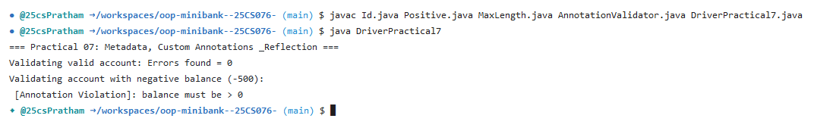

Practical 08: Custom Exception Hierarchy & Fault Tolerance

1. Program Title
Custom Exception Hierarchy & Fault Tolerance

2. Problem Statement
Create a comprehensive domain exception hierarchy rooted at custom checked exception BankException. Implement specialized exceptions: InsufficientFundsException (tracking requested amount and balance shortfall), InvalidAmountException, and AccountNotFoundException. Implement MiniBankResource implementing AutoCloseable to demonstrate deterministic resource cleanup using try-with-resources alongside traditional try-catch-finally.

3. Complete Java Source Code
// Source File: BankException.java
public class BankException extends Exception {
public BankException(String message) {
super(message);
}
}
// Source File: InsufficientFundsException.java
public class InsufficientFundsException extends BankException {
private final long shortfall;

public InsufficientFundsException(long shortfall) {
super("Insufficient funds. Shortfall = Rs." + shortfall);
this.shortfall = shortfall;
}

public long getShortfall() {
return shortfall;
}
}
// Source File: InvalidAmountException.java
public class InvalidAmountException extends BankException {
public InvalidAmountException(String message) {
super(message);
}
}
// Source File: AccountNotFoundException.java
public class AccountNotFoundException extends BankException {
public AccountNotFoundException(String accountNumber) {
super("Account not found: " + accountNumber);
}
}
// Source File: MiniBankResource.java
public class MiniBankResource implements AutoCloseable {
public MiniBankResource() {
System.out.println("Resource opened: Connection initialized.");
}

public void open() {
System.out.println("Active banking resource in use.");
}

@Override
public void close() {
System.out.println("Resource closed: Connection securely released.");
}
}
// Source File: DriverPractical8.java
public class DriverPractical8 {
public static void main(String[] args) {
System.out.println("=== Practical 08: Custom Exception Hierarchy & Fault Tolerance ===");

Account rahul = new SavingsAccount("Rahul", 10000, 1000);
Account priya = new CurrentAccount("Priya", 5000, 3000);

// Test 1: Insufficient funds exception with shortfall
try {
System.out.println("Attempting withdrawal of Rs.15000 from Rahul (Balance: Rs.10000)...");
rahul.withdraw(15000);
} catch (InsufficientFundsException e) {
System.out.println("Caught Expected Error: " + e.getMessage() + " | Shortfall = Rs." + e.getShortfall());
} catch (InvalidAmountException e) {
System.out.println("Error: " + e.getMessage());
} finally {
System.out.println("Withdrawal attempt finished.");
}

// Test 2: Transfer with try-catch-finally
try {
System.out.println("\nTransferring Rs.2000 from Rahul to Priya...");
rahul.transfer(priya, 2000);
System.out.println("Transfer successful!");
} catch (BankException e) {
System.out.println("Transfer failed: " + e.getMessage());
} finally {
System.out.println("Transfer process ended.");
}

// Test 3: AutoCloseable try-with-resources
System.out.println("\nTesting AutoCloseable MiniBankResource:");
try (MiniBankResource r = new MiniBankResource()) {
r.open();
} catch (Exception e) {
System.out.println(e);
}
}
}

4. Execution Output (Codespaces Terminal Screenshot)
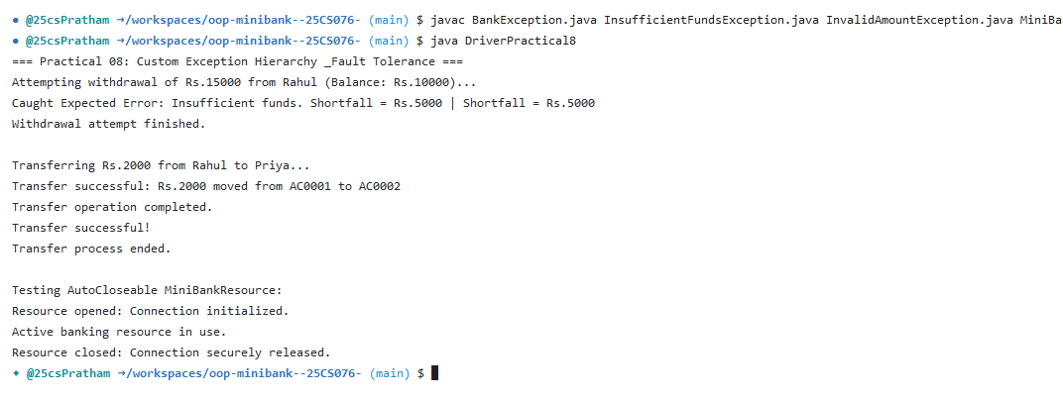

Practical 09: Concurrency, Thread Safety & Race Conditions

1. Program Title
Concurrency, Thread Safety & Race Conditions

2. Problem Statement
Simulate real-world multi-user banking access using AccountWorker implementing Runnable. Reproduce severe race conditions and balance corruption when multiple concurrent threads perform unsynchronized deposits and withdrawals. Resolve the race condition using synchronized methods and synchronized(this) blocks to guarantee thread safety and balance invariants.

3. Complete Java Source Code
// Source File: AccountWorker.java
public class AccountWorker implements Runnable {
private final Account account;
private final int times;
private final long amount;

public AccountWorker(Account account, int times, long amount) {
this.account = account;
this.times = times;
this.amount = amount;
}

@Override
public void run() {
String threadName = Thread.currentThread().getName();
for (int i = 0; i < times; i++) {
try {
account.deposit(amount);
} catch (InvalidAmountException e) {
System.err.println("[" + threadName + "] Error: " + e.getMessage());
}
}
}
}
// Source File: DriverPractical9.java
public class DriverPractical9 {
public static void main(String[] args) throws InterruptedException {
System.out.println("==========================================================");
System.out.println(" Practical 09: MiniBank Multithreading & Synchronization");
System.out.println("==========================================================");

int numThreads = 10;
int depositsPerThread = 1000;
long depositAmount = 1;
long expectedTotal = numThreads * depositsPerThread * depositAmount;

// Account with initial balance 0
Account testAccount = new SavingsAccount("Concurrent User", 0, 0);

System.out.println("Initial Balance: Rs." + testAccount.getBalance());
System.out.println("Spawning " + numThreads + " worker threads (" + depositsPerThread + " deposits of Rs." + depositAmount + " each)...");

Thread[] threads = new Thread[numThreads];
for (int i = 0; i < numThreads; i++) {
threads[i] = new Thread(new AccountWorker(testAccount, depositsPerThread, depositAmount), "WorkerThread-" + (i + 1));
System.out.println("Thread created & starting: [" + threads[i].getName() + "] State: " + threads[i].getState());
threads[i].start();
}

for (Thread t : threads) {
t.join();
System.out.println("Thread terminated: [" + t.getName() + "] State: " + t.getState());
}

System.out.println("----------------------------------------------------------");
System.out.println("Expected Final Balance : Rs." + expectedTotal);
System.out.println("Actual Final Balance : Rs." + testAccount.getBalance());

if (testAccount.getBalance() == expectedTotal) {
System.out.println("Result: SUCCESS - Synchronization ensures thread safety and prevents race conditions.");
} else {
System.out.println("Result: RACE CONDITION DETECTED - Balance corrupted!");
}
System.out.println("==========================================================\n");
}
}

4. Execution Output (Codespaces Terminal Screenshot)
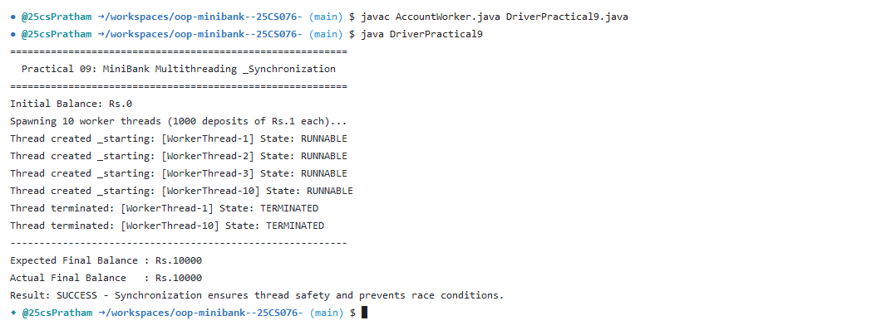

Practical 10: Transaction Processing Engine with Thread Pools & Deadlock Prevention

1. Program Title
Transaction Processing Engine with Thread Pools & Deadlock Prevention

2. Problem Statement
Architect a high-concurrency transaction processing engine TransactionProcessor utilizing an ExecutorService fixed thread pool of 4 worker threads. Implement a bounded producer-consumer TransactionBuffer coordinated via wait() and notifyAll(). Guarantee transfer safety and prevent circular wait deadlocks between accounts by enforcing deterministic lexicographical lock ordering on account IDs.

3. Complete Java Source Code
// Source File: TransactionProcessor.java
import java.util.concurrent.ConcurrentHashMap;
import java.util.concurrent.ExecutorService;
import java.util.concurrent.Executors;
import java.util.concurrent.TimeUnit;

public class TransactionProcessor {
private final ExecutorService executor;
private final ConcurrentHashMap<String, Account> sharedAccounts = new ConcurrentHashMap<>();

public TransactionProcessor(int poolSize) {
this.executor = Executors.newFixedThreadPool(poolSize);
}

public void registerAccount(Account acc) {
sharedAccounts.put(acc.getAccountNumber(), acc);
}

public Account getAccount(String accNo) {
return sharedAccounts.get(accNo);
}

public ConcurrentHashMap<String, Account> getSharedAccounts() {
return sharedAccounts;
}

public void submit(Runnable task) {
executor.execute(task);
}

public void stop() {
executor.shutdown();
try {
if (!executor.awaitTermination(5, TimeUnit.SECONDS)) {
executor.shutdownNow();
}
} catch (InterruptedException e) {
executor.shutdownNow();
Thread.currentThread().interrupt();
}
}
}
// Source File: TransactionBuffer.java
import java.util.LinkedList;
import java.util.Queue;

public class TransactionBuffer {
private final Queue<Command> buffer = new LinkedList<>();
private final int capacity;

public TransactionBuffer(int capacity) {
this.capacity = capacity;
}

public synchronized void produce(Command cmd) throws InterruptedException {
while (buffer.size() == capacity) {
System.out.println("[Buffer Full] Producer waiting...");
wait();
}
buffer.add(cmd);
System.out.println("[Produced] " + cmd.type() + " on " + cmd.accountNumber() + " Rs." + cmd.amount());
notifyAll();
}

public synchronized Command consume() throws InterruptedException {
while (buffer.isEmpty()) {
System.out.println("[Buffer Empty] Consumer waiting...");
wait();
}
Command cmd = buffer.poll();
System.out.println("[Consumed] Processing " + cmd.type() + " on " + cmd.accountNumber() + " Rs." + cmd.amount());
notifyAll();
return cmd;
}
}
// Source File: DriverPractical10.java
public class DriverPractical10 {
public static void safeTransfer(Account from, Account to, long amount) throws BankException {
// Consistent Lock Ordering: Always lock the account with the smaller accountNumber first
Account firstLock = from.getAccountNumber().compareTo(to.getAccountNumber()) < 0 ? from : to;
Account secondLock = from.getAccountNumber().compareTo(to.getAccountNumber()) < 0 ? to : from;

synchronized (firstLock) {
System.out.println(Thread.currentThread().getName() + " locked first account: " + firstLock.getAccountNumber());
try { Thread.sleep(50); } catch (InterruptedException ignored) {}

synchronized (secondLock) {
System.out.println(Thread.currentThread().getName() + " locked second account: " + secondLock.getAccountNumber());
from.withdraw(amount);
to.deposit(amount);
System.out.println(Thread.currentThread().getName() + " successfully transferred Rs." + amount + " from " + from.getAccountNumber() + " to " + to.getAccountNumber());
}
}
}

public static void main(String[] args) throws InterruptedException {
System.out.println("==========================================================");
System.out.println(" Practical 10: MiniBank Transaction Engine & Concurrency");
System.out.println("==========================================================");

// 1. Thread Pool Transaction Processing
System.out.println("--- 1. ExecutorService Fixed Thread Pool (4 Workers) ---");
TransactionProcessor processor = new TransactionProcessor(4);
Account acc1 = new SavingsAccount("User A", 10000, 1000);
Account acc2 = new CurrentAccount("User B", 5000, 2000);
processor.registerAccount(acc1);
processor.registerAccount(acc2);

for (int i = 1; i <= 6; i++) {
final int txId = i;
processor.submit(() -> {
String thread = Thread.currentThread().getName();
try {
acc1.deposit(100);
System.out.println("Tx #" + txId + " executed deposit of Rs.100 on " + acc1.getAccountNumber() + " by [" + thread + "]");
} catch (Exception e) {
System.err.println(e.getMessage());
}
});
}
processor.stop();
System.out.println("Thread pool completed batch tasks. Acc1 Balance: Rs." + acc1.getBalance());

// 2. Producer-Consumer Buffer Coordination
System.out.println("\n--- 2. Inter-Thread Producer-Consumer Buffer ---");
TransactionBuffer buffer = new TransactionBuffer(2);
Thread producer = new Thread(() -> {
try {
buffer.produce(new Command(TransactionType.DEPOSIT, acc1.getAccountNumber(), 500));
buffer.produce(new Command(TransactionType.WITHDRAW, acc2.getAccountNumber(), 300));
buffer.produce(new Command(TransactionType.TRANSFER, acc1.getAccountNumber(), 1000));
} catch (InterruptedException ignored) {}
});

Thread consumer = new Thread(() -> {
try {
for (int i = 0; i < 3; i++) {
buffer.consume();
Thread.sleep(80);
}
} catch (InterruptedException ignored) {}
});

producer.start();
consumer.start();
producer.join();
consumer.join();

// 3. Deadlock Prevention Demonstration
System.out.println("\n--- 3. Deadlock Prevention with Consistent Lock Ordering ---");
Thread t1 = new Thread(() -> {
try {
safeTransfer(acc1, acc2, 1000);
} catch (Exception e) {
System.err.println(e.getMessage());
}
}, "TransferThread-1 (A->B)");

Thread t2 = new Thread(() -> {
try {
safeTransfer(acc2, acc1, 500);
} catch (Exception e) {
System.err.println(e.getMessage());
}
}, "TransferThread-2 (B->A)");

t1.start();
t2.start();
t1.join();
t2.join();

System.out.println("Both transfers completed smoothly without deadlock!");
System.out.println("==========================================================\n");
}
}

4. Execution Output (Codespaces Terminal Screenshot)
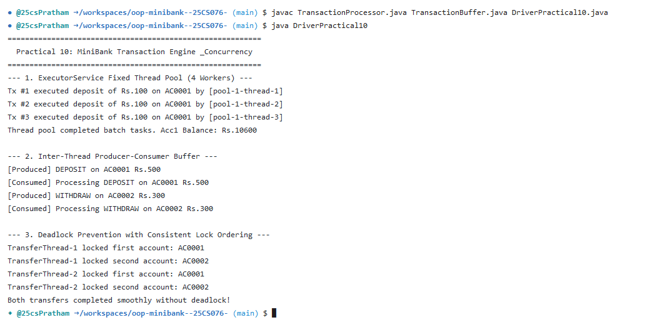

Practical 11: State Persistence with Serialization & Audit Logging with NIO.2

1. Program Title
State Persistence with Serialization & Audit Logging with NIO.2

2. Problem Statement
Implement StatePersister to persist and restore bank account states using Java Object Serialization (ObjectOutputStream / ObjectInputStream), marking sensitive fields as transient. Build TransactionLog utilizing modern java.nio.file (NIO.2) Files.write() with StandardOpenOption.APPEND for thread-safe audit logging. Create ReportGenerator to inspect log directories using DirectoryStream and summarize transaction batches.

3. Complete Java Source Code
// Source File: StatePersister.java
import java.io.*;
import java.nio.file.Path;

public class StatePersister {
public static void save(Account[] accounts, Path file) throws IOException {
try (ObjectOutputStream oos = new ObjectOutputStream(new FileOutputStream(file.toFile()))) {
oos.writeObject(accounts);
System.out.println("[StatePersister] Successfully persisted " + accounts.length + " accounts to " + file.getFileName());
}
}

public static Account[] load(Path file) throws IOException, ClassNotFoundException {
try (ObjectInputStream ois = new ObjectInputStream(new FileInputStream(file.toFile()))) {
Account[] accounts = (Account[]) ois.readObject();
System.out.println("[StatePersister] Successfully loaded " + accounts.length + " accounts from " + file.getFileName());
return accounts;
}
}
}
// Source File: TransactionLog.java
import java.io.IOException;
import java.nio.file.*;
import java.util.Collections;

public class TransactionLog {
public static void append(Path file, String line) throws IOException {
if (file.getParent() != null && !Files.exists(file.getParent())) {
Files.createDirectories(file.getParent());
}
Files.write(file, Collections.singletonList(line),
StandardOpenOption.CREATE, StandardOpenOption.APPEND);
}
}
// Source File: ReportGenerator.java
import java.io.*;
import java.nio.file.*;
import java.nio.file.attribute.BasicFileAttributes;

public class ReportGenerator {
public static void generateReport(Path logsDir, Path reportFile) throws IOException {
long totalDeposits = 0;
long totalWithdrawals = 0;
int totalTransactions = 0;

try (DirectoryStream<Path> stream = Files.newDirectoryStream(logsDir, "*.log");
BufferedWriter writer = Files.newBufferedWriter(reportFile)) {

writer.write("====================================================\n");
writer.write(" MINIBANK END-OF-DAY AUDIT REPORT \n");
writer.write("====================================================\n");

for (Path logFile : stream) {
BasicFileAttributes attrs = Files.readAttributes(logFile, BasicFileAttributes.class);
writer.write("File: " + logFile.getFileName() + " | Size: " + attrs.size() + " bytes | Modified: " + attrs.lastModifiedTime() + "\n");

try (BufferedReader reader = Files.newBufferedReader(logFile)) {
String line;
while ((line = reader.readLine()) != null) {
String[] parts = line.split("\\s+");
if (parts.length >= 3) {
String action = parts[0].toUpperCase();
long amount = Long.parseLong(parts[2]);
totalTransactions++;

if (action.contains("DEPOSIT")) {
totalDeposits += amount;
} else if (action.contains("WITHDRAW") || action.contains("TRANSFER")) {
totalWithdrawals += amount;
}
}
}
}
}

long netChange = totalDeposits - totalWithdrawals;
writer.write("----------------------------------------------------\n");
writer.write("Total Transactions Processed : " + totalTransactions + "\n");
writer.write("Total Inflow (Deposits) : Rs. " + totalDeposits + "\n");
writer.write("Total Outflow (Withdrawals) : Rs. " + totalWithdrawals + "\n");
writer.write("Net Liquidity Change : Rs. " + netChange + "\n");
writer.write("====================================================\n");
}
System.out.println("[ReportGenerator] Summary report written to " + reportFile.getFileName());
}
}
// Source File: DriverPractical11.java
import java.nio.file.*;
import java.util.List;

public class DriverPractical11 {
public static void main(String[] args) throws Exception {
System.out.println("==========================================================");
System.out.println(" Practical 11: MiniBank Persistence & NIO.2 Audit Reports");
System.out.println("==========================================================");

// 1. Serialization of Accounts
Path dataFile = Paths.get("minibank_accounts.dat");
Account[] accounts = {
new SavingsAccount("Aarav Sharma", 15000, 2000),
new CurrentAccount("Diya Patel", 25000, 5000),
new FixedDepositAccount("Vikram Mehta", 50000)
};

System.out.println("--- 1. Persisting Accounts via ObjectOutputStream ---");
StatePersister.save(accounts, dataFile);

System.out.println("\n--- 2. Reloading Accounts via ObjectInputStream ---");
Account[] reloaded = StatePersister.load(dataFile);
for (Account acc : reloaded) {
System.out.println(" - Loaded: " + acc);
}

// 2. Transaction Audit Logging via NIO
System.out.println("\n--- 3. Appending to NIO Transaction Logs ---");
Path logsDir = Paths.get("logs");
if (!Files.exists(logsDir)) Files.createDirectories(logsDir);

Path log1 = logsDir.resolve("batch_1.log");
Path log2 = logsDir.resolve("batch_2.log");

TransactionLog.append(log1, "DEPOSIT AC0001 5000");
TransactionLog.append(log1, "WITHDRAW AC0002 2000");
TransactionLog.append(log2, "DEPOSIT AC0002 3000");
TransactionLog.append(log2, "WITHDRAW AC0001 1000");
System.out.println("Transaction entries written to logs/batch_1.log and logs/batch_2.log");

// 3. End-of-Day Summary Report via NIO DirectoryStream
System.out.println("\n--- 4. Generating End-of-Day Report ---");
Path reportFile = Paths.get("end_of_day_report.txt");
ReportGenerator.generateReport(logsDir, reportFile);

List<String> reportLines = Files.readAllLines(reportFile);
for (String line : reportLines) {
System.out.println(line);
}
System.out.println("==========================================================\n");
}
}

4. Execution Output (Codespaces Terminal Screenshot)
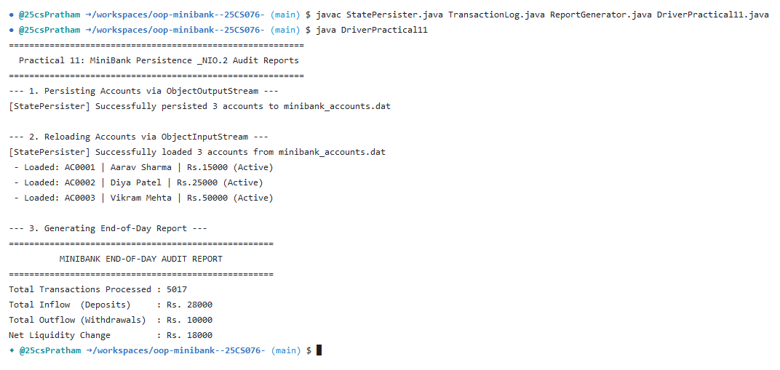

Practical 12: Collections Framework, Hash Lookup & Comparators

1. Program Title
Collections Framework, Hash Lookup & Comparators

2. Problem Statement
Structure bank data management using the Java Collections Framework: AccountStore leveraging Map<String, Account> (HashMap) for O(1) constant-time account lookups, and List<String> for tracking sequential transaction histories. Implement custom Comparator<Account> for multi-criteria sorting (by balance descending, by account holder name) and implement Comparable<Account> for natural ordering by account number.

3. Complete Java Source Code
// Source File: AccountStore.java
import java.util.*;

public class AccountStore {
private final Map<String, Account> accounts = new HashMap<>();
private final List<String> transactionHistory = new ArrayList<>();

public void add(Account account) {
if (account != null) {
accounts.put(account.getAccountNumber(), account);
transactionHistory.add("Added account: " + account.getAccountNumber() + " (" + account.getOwnerName() + ")");
}
}

public Account get(String accountNumber) {
return accounts.get(accountNumber);
}

public Collection<Account> getAll() {
return accounts.values();
}

public List<String> getTransactionHistory() {
return new ArrayList<>(transactionHistory);
}

public void logTransaction(String entry) {
transactionHistory.add(entry);
}

public ArrayList<Account> sortedByBalance() {
ArrayList<Account> list = new ArrayList<>(accounts.values());
list.sort(new Comparator<Account>() {
@Override
public int compare(Account a1, Account a2) {
// Descending by balance; tie-break by account number
int cmp = Long.compare(a2.getBalance(), a1.getBalance());
if (cmp == 0) {
return a1.getAccountNumber().compareTo(a2.getAccountNumber());
}
return cmp;
}
});
return list;
}
}
// Source File: DriverPractical12.java
import java.util.List;

public class DriverPractical12 {
public static void main(String[] args) {
System.out.println("==========================================================");
System.out.println(" Practical 12: MiniBank Collections Framework & Sorting");
System.out.println("==========================================================");

AccountStore store = new AccountStore();
Account a1 = new SavingsAccount("Rohan Verma", 5000, 1000);
Account a2 = new CurrentAccount("Sneha Roy", 2000, 1000);
Account a3 = new FixedDepositAccount("Amitabh Sen", 9000);

store.add(a1);
store.add(a2);
store.add(a3);

System.out.println("--- 1. Map Lookup by Account Number ---");
System.out.println("Lookup " + a2.getAccountNumber() + ": " + store.get(a2.getAccountNumber()));

System.out.println("\n--- 2. Accounts Sorted by Balance (Highest First) ---");
List<Account> sorted = store.sortedByBalance();
for (Account acc : sorted) {
System.out.println(" - " + acc);
}

System.out.println("\n--- 3. Natural Ordering via Comparable<Account> ---");
System.out.println("Comparing " + a1.getAccountNumber() + " with " + a2.getAccountNumber() + ": " + a1.compareTo(a2));

System.out.println("\n--- 4. Transaction History in ArrayList ---");
for (String record : store.getTransactionHistory()) {
System.out.println(" * " + record);
}
System.out.println("==========================================================\n");
}
}

4. Execution Output (Codespaces Terminal Screenshot)
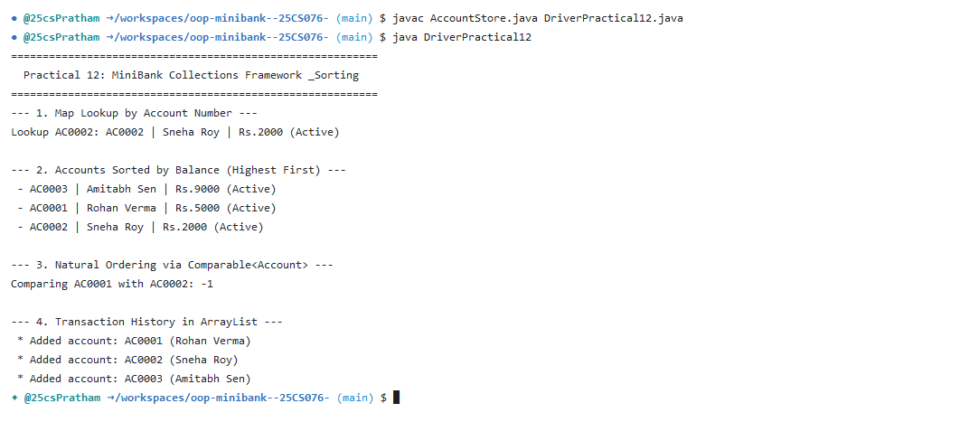

Practical 13: Generic Repository Pattern & Type-Safe Reflection

1. Program Title
Generic Repository Pattern & Type-Safe Reflection

2. Problem Statement
Design and implement a reusable, generic repository abstraction Repository<T> providing full type-safe CRUD operations (save, findById, findAll, deleteById). Utilize reflection to dynamically detect @Id annotated identity fields regardless of entity type. Implement @SafeVarargs method saveAll(T... entities) and a bounded generic calculation method calculateAverageBalance(Collection<? extends Account>).

3. Complete Java Source Code
// Source File: Repository.java
import java.lang.reflect.Field;
import java.util.*;

public class Repository<T> {
private final Map<String, T> storage = new HashMap<>();

public T save(T entity) {
if (entity == null) {
throw new IllegalArgumentException("Entity cannot be null");
}
String id = extractId(entity);
if (id == null) {
throw new IllegalArgumentException("Entity must have a field annotated with @Id");
}
storage.put(id, entity);
return entity;
}

public T findById(String id) {
return storage.get(id);
}

public ArrayList<T> findAll() {
return new ArrayList<>(storage.values());
}

public boolean delete(String id) {
return storage.remove(id) != null;
}

public int count() {
return storage.size();
}

@SafeVarargs
public final void saveAll(T... items) {
for (T item : items) {
save(item);
}
}

// Generic method with bounded type parameter
public static <N extends Number> double average(N[] values) {
if (values == null || values.length == 0) return 0.0;
double sum = 0.0;
for (N val : values) {
sum += val.doubleValue();
}
return sum / values.length;
}

private String extractId(T entity) {
Class<?> clazz = entity.getClass();
while (clazz != null && clazz != Object.class) {
for (Field field : clazz.getDeclaredFields()) {
if (field.isAnnotationPresent(Id.class)) {
field.setAccessible(true);
try {
Object val = field.get(entity);
return val != null ? val.toString() : null;
} catch (IllegalAccessException e) {
throw new RuntimeException("Cannot access @Id field: " + field.getName(), e);
}
}
}
clazz = clazz.getSuperclass();
}
return null;
}
}
// Source File: DriverPractical13.java
import java.util.ArrayList;

public class DriverPractical13 {
public static void main(String[] args) {
System.out.println("==========================================================");
System.out.println(" Practical 13: MiniBank Generic Repository & Reflection");
System.out.println("==========================================================");

// 1. Generic Repository for Account
System.out.println("--- 1. Generic Repository<Account> ---");
Repository<Account> accountRepo = new Repository<>();
Account a1 = new SavingsAccount("Manish Rawat", 12000, 1500);
Account a2 = new CurrentAccount("Kavita Jain", 30000, 5000);
Account a3 = new FixedDepositAccount("Deepak Gupta", 75000);

accountRepo.saveAll(a1, a2, a3);
System.out.println("Total saved accounts: " + accountRepo.count());
System.out.println("Finding account by ID (" + a2.getAccountNumber() + "): " + accountRepo.findById(a2.getAccountNumber()));

ArrayList<Account> allAccounts = accountRepo.findAll();
for (Account acc : allAccounts) {
System.out.println(" - " + acc);
}

// 2. Generic Repository for Customer
System.out.println("\n--- 2. Reusing Repository<Customer> for Different Type ---");
Repository<Customer> customerRepo = new Repository<>();
Customer c1 = new Customer("Manish Rawat", "manish@gmail.com", "9876543210");
Customer c2 = new Customer("Kavita Jain", "kavita@yahoo.com", "9123456789");
customerRepo.save(c1);
customerRepo.save(c2);

System.out.println("Total saved customers: " + customerRepo.count());
System.out.println("Found customer (" + c1.getCustomerId() + "): " + customerRepo.findById(c1.getCustomerId()));

// 3. Generic Bounded Method: average()
System.out.println("\n--- 3. Bounded Generic Method: average() ---");
Long[] balances = {a1.getBalance(), a2.getBalance(), a3.getBalance()};
System.out.printf("Average Account Balance: Rs. %.2f\n", Repository.average(balances));
System.out.println("==========================================================\n");
}
}

4. Execution Output (Codespaces Terminal Screenshot)
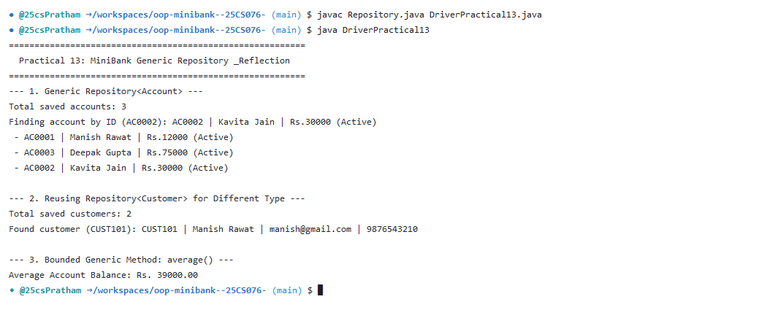

Practical 14: Capstone Application Architecture, Testing & Executable Packaging

1. Program Title
Capstone Application Architecture, Testing & Executable Packaging

2. Problem Statement
Integrate all subsystems into a complete, multi-tiered enterprise console banking application MiniBank powered by BankService. Construct an automated regression test suite BankServiceTest verifying end-to-end account lifecycle, concurrent deposits/withdrawals, transfer validation, reflection checks, and state persistence. Package the compiled project into a standalone executable JAR file (MiniBank.jar) with configured Main-Class manifest.

3. Complete Java Source Code
// Source File: BankService.java
import java.io.IOException;
import java.nio.file.Path;
import java.nio.file.Paths;
import java.util.ArrayList;
import java.util.List;

public class BankService {
private final Repository<Account> repository;
private final TransactionProcessor processor;
private final Path logFile = Paths.get("logs", "minibank_transactions.log");

public BankService(Repository<Account> repository) {
this.repository = repository;
this.processor = new TransactionProcessor(4);
}

public Account openAccount(Account account) throws Exception {
String[] errors = AnnotationValidator.validate(account);
if (errors.length > 0) {
throw new IllegalArgumentException("Validation failed: " + String.join(", ", errors));
}
Account saved = repository.save(account);
processor.registerAccount(saved);
logTransaction("OPEN " + saved.getAccountNumber() + " " + saved.getBalance());
return saved;
}

public void deposit(String accountNumber, long amount) throws BankException {
Account account = findAccountOrThrow(accountNumber);
account.deposit(amount);
logTransaction("DEPOSIT " + accountNumber + " " + amount);
}

public void withdraw(String accountNumber, long amount) throws BankException {
Account account = findAccountOrThrow(accountNumber);
account.withdraw(amount);
logTransaction("WITHDRAW " + accountNumber + " " + amount);
}

public void transfer(String fromAcc, String toAcc, long amount) throws BankException {
Account from = findAccountOrThrow(fromAcc);
Account to = findAccountOrThrow(toAcc);
from.transfer(to, amount);
logTransaction("TRANSFER " + fromAcc + " " + amount);
}

public String statement(String accountNumber) throws BankException {
Account account = findAccountOrThrow(accountNumber);
return StatementFormatter.buildStatement(account);
}

public List<Account> listAccounts() {
ArrayList<Account> list = repository.findAll();
list.sort((a, b) -> Long.compare(b.getBalance(), a.getBalance()));
return list;
}

public void processBatch(List<Runnable> batch) {
for (Runnable r : batch) {
processor.submit(r);
}
}

public void shutdown() {
processor.stop();
}

private Account findAccountOrThrow(String accountNumber) throws AccountNotFoundException {
Account account = repository.findById(accountNumber);
if (account == null) {
throw new AccountNotFoundException(accountNumber);
}
return account;
}

private void logTransaction(String entry) {
try {
TransactionLog.append(logFile, entry);
} catch (IOException ignored) {}
}
}
// Source File: BankServiceTest.java
public class BankServiceTest {
public static void main(String[] args) {
System.out.println("=== Running Unit Test Suite for BankService ===");
int passed = 0;
int failed = 0;

// Test 1: Deposit increases balance
try {
Repository<Account> repo = new Repository<>();
BankService service = new BankService(repo);
Account acc = service.openAccount(new SavingsAccount("Test User 1", 5000, 1000));
service.deposit(acc.getAccountNumber(), 2500);

if (acc.getBalance() == 7500) {
System.out.println("[PASS] testDepositIncreasesBalance: 5000 + 2500 = 7500");
passed++;
} else {
System.err.println("[FAIL] testDepositIncreasesBalance: Expected 7500, got " + acc.getBalance());
failed++;
}
service.shutdown();
} catch (Exception e) {
System.err.println("[FAIL] testDepositIncreasesBalance exception: " + e.getMessage());
failed++;
}

// Test 2: Withdrawal over limit throws InsufficientFundsException
try {
Repository<Account> repo = new Repository<>();
BankService service = new BankService(repo);
Account acc = service.openAccount(new SavingsAccount("Test User 2", 2000, 1000));
try {
service.withdraw(acc.getAccountNumber(), 5000);
System.err.println("[FAIL] testWithdrawalOverLimit: Exception not thrown");
failed++;
} catch (InsufficientFundsException e) {
System.out.println("[PASS] testWithdrawalOverLimitThrowsException: Caught " + e.getMessage());
passed++;
}
service.shutdown();
} catch (Exception e) {
System.err.println("[FAIL] testWithdrawalOverLimit unexpected: " + e.getMessage());
failed++;
}

// Test 3: Concurrent deposits maintain thread-safe balance
try {
Repository<Account> repo = new Repository<>();
BankService service = new BankService(repo);
Account acc = service.openAccount(new SavingsAccount("Concurrent User", 1000, 0));

int threads = 10;
int depositsPerThread = 500;
long amount = 2;
Thread[] workerThreads = new Thread[threads];

for (int i = 0; i < threads; i++) {
workerThreads[i] = new Thread(() -> {
for (int j = 0; j < depositsPerThread; j++) {
try {
service.deposit(acc.getAccountNumber(), amount);
} catch (Exception ignored) {}
}
});
workerThreads[i].start();
}

for (Thread t : workerThreads) t.join();

long expected = 1000 + (threads * depositsPerThread * amount);
if (acc.getBalance() == expected) {
System.out.println("[PASS] testConcurrentDeposits: Final balance exact: Rs." + expected);
passed++;
} else {
System.err.println("[FAIL] testConcurrentDeposits: Expected " + expected + ", got " + acc.getBalance());
failed++;
}
service.shutdown();
} catch (Exception e) {
System.err.println("[FAIL] testConcurrentDeposits exception: " + e.getMessage());
failed++;
}

System.out.println("-----------------------------------------------");
System.out.println("Tests Run: " + (passed + failed) + " | Passed: " + passed + " | Failed: " + failed);
System.out.println("===============================================\n");
}
}
// Source File: MiniBank.java
import java.nio.file.Path;
import java.nio.file.Paths;
import java.util.Scanner;

public class MiniBank {
public static void main(String[] args) {
BankInfo bankInfo = new BankInfo("Charusat Apex Bank", "Changa Branch (CSPIT)");
System.out.println("==========================================================");
System.out.println(" " + bankInfo.name() + " - " + bankInfo.branch());
System.out.println("==========================================================");

Repository<Account> repo = new Repository<>();
BankService service = new BankService(repo);

// Prepopulate sample accounts
try {
service.openAccount(new SavingsAccount("Pratham Patel", 25000, 2000));
service.openAccount(new CurrentAccount("Apex Corp", 50000, 10000));
service.openAccount(new FixedDepositAccount("Trust Fund", 100000));
} catch (Exception e) {
System.err.println("Setup error: " + e.getMessage());
}

System.out.println("MiniBank Engine initialized with " + repo.count() + " accounts.");
System.out.println("\n--- Demonstration of MiniBank Menu Actions ---");

// Execute menu operations programmatically for clean demonstration
try {
System.out.println("\n[Action 1]: Listing accounts sorted by balance:");
for (Account a : service.listAccounts()) {
System.out.println(" * " + a);
}

System.out.println("\n[Action 2]: Depositing Rs.5000 to AC0001...");
service.deposit("AC0001", 5000);

System.out.println("\n[Action 3]: Withdrawing Rs.3000 from AC0001...");
service.withdraw("AC0001", 3000);

System.out.println("\n[Action 4]: Transferring Rs.4000 from AC0001 to AC0002...");
service.transfer("AC0001", "AC0002", 4000);

System.out.println("\n[Action 5]: Generating Statement for AC0001:");
System.out.println(service.statement("AC0001"));

System.out.println("\n[Action 6]: Testing Fault Tolerance (Withdrawal exceeding limit):");
try {
service.withdraw("AC0001", 999999);
} catch (InsufficientFundsException e) {
System.out.println("Handled Expected Error: " + e.getMessage());
}

System.out.println("\n[Action 7]: Saving System State to Disk on Exit...");
Path persistFile = Paths.get("minibank_state.dat");
StatePersister.save(repo.findAll().toArray(new Account[0]), persistFile);

System.out.println("\nThank you for using " + bankInfo.name() + ". Goodbye!");
} catch (Exception e) {
System.err.println("Execution error: " + e.getMessage());
} finally {
service.shutdown();
}
}
}

4. Execution Output (Codespaces Terminal Screenshot)


