Practical - 1
Practical Title: Project Initiation, Requirement Analysis, Sitemap, Wireframe, and GitHub Setup

Problem Definition: Initiate the semester-long StudentHub portal by identifying the problem scope, user roles, key modules, navigation flow, and minimum 10 pages. Create a sitemap, low-fidelity wireframe, project folder structure, README file, and GitHub repository.

Theory

What is URL and parts of URL?
Answer: A URL is the address of a resource and it tells the web browser where a webpage or file is located and access it and display the requested webpage.
Protocol http/https
Domain Name: www.example.com
Path: /products/item.html
Query String: id=101
Fragment: reviews
Example URL:
https://www.example.com/products/item.html?id=101#reviews

How does HTML file process in web browser?
Answer: Answer:
When an HTML file is opened, the web browser reads the HTML code, creates the webpage structure (DOM), applies CSS for styling, runs JavaScript if present, and displays the webpage on the screen.
Browser reads the HTML file.
Creates the page structure (DOM).
Applies CSS styles.
Runs JavaScript.
Displays the webpage.

3. How will page navigation flow managed among all HTML pages?
Answer: Page navigation is managed by using links (<a> tags) between HTML pages. Every page has a navigation menu with links like Home, About, Contact, and Services. When the user clicks a link, the browser opens the selected page.

4. How will GitHub commits be maintained after each practical?
Answer: GitHub commits will be maintained by making a new commit after every practical. Each commit will have a short and clear message describing the changes made. This helps to keep track of the project and its progress.

Implementation/ Output/Result
The webpage displays a Student HUB dashboard with a navigation menu, timetable, attendance, fee details, university results, and a footer.

Evidence of Work (Screenshots)
LOGIN PAGE
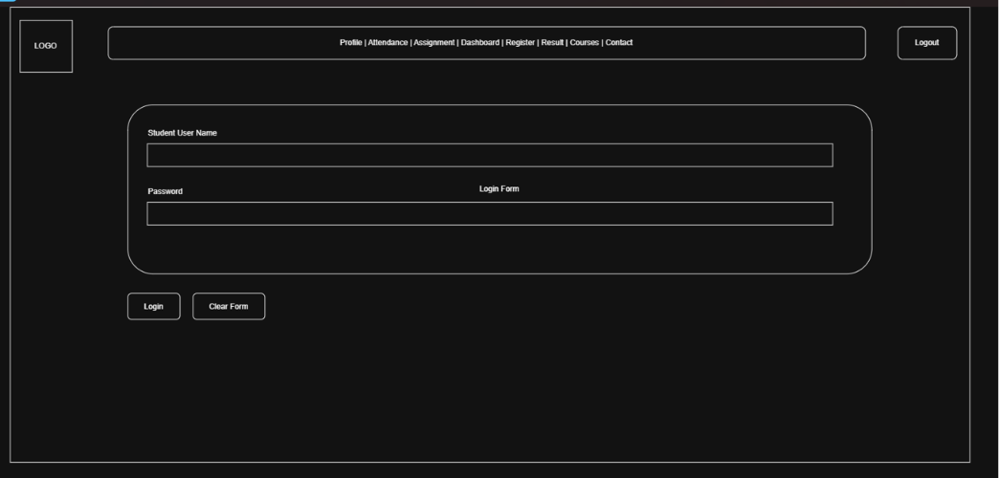
Description: wireframe
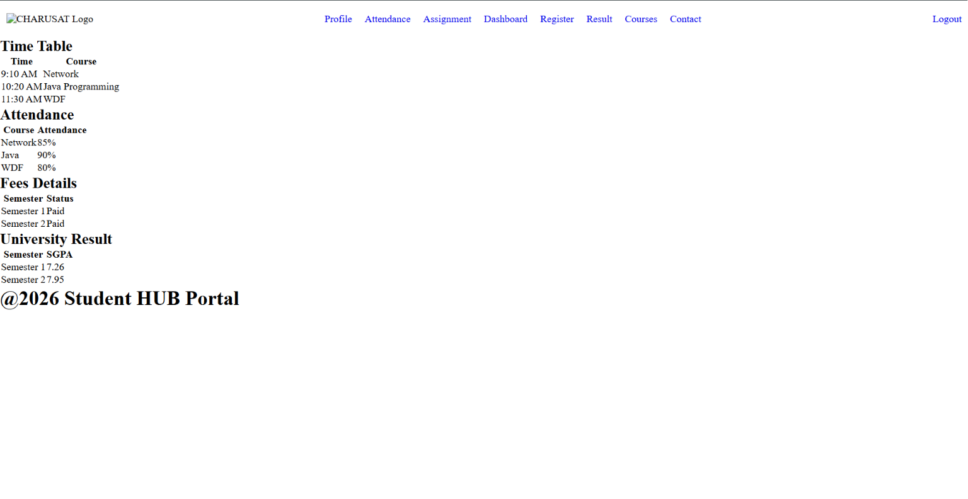
INDEX PAGE
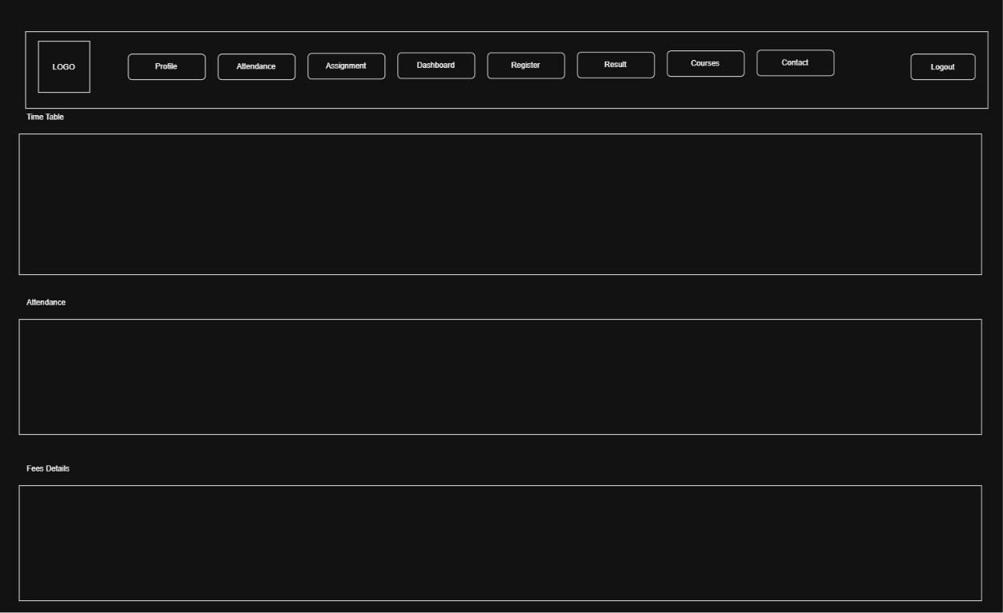
PROFILE PAGE
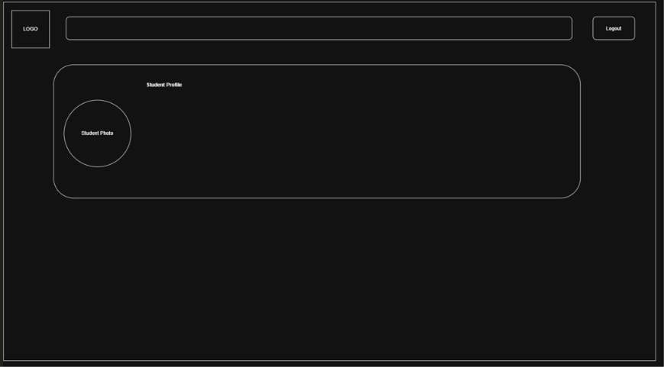

ATTENDANCE PAGE
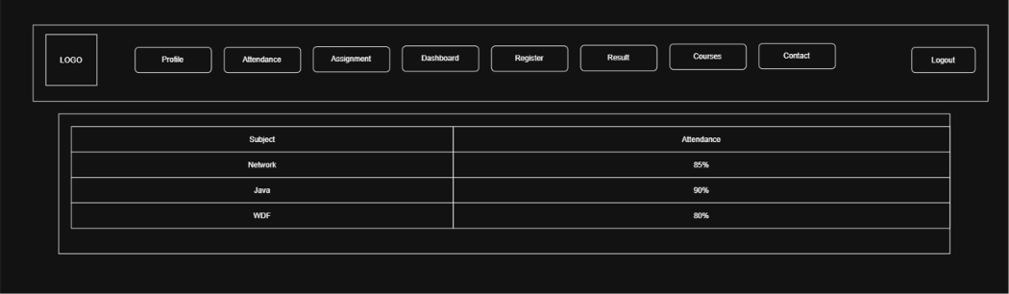
REGISTRATION PAGE
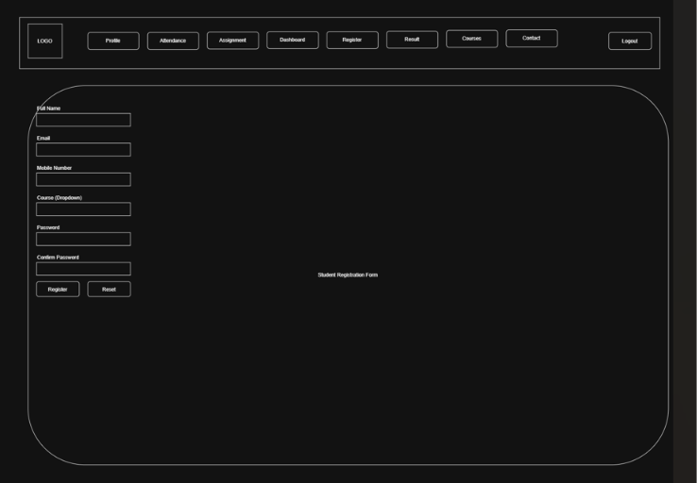

RESULT PAGE
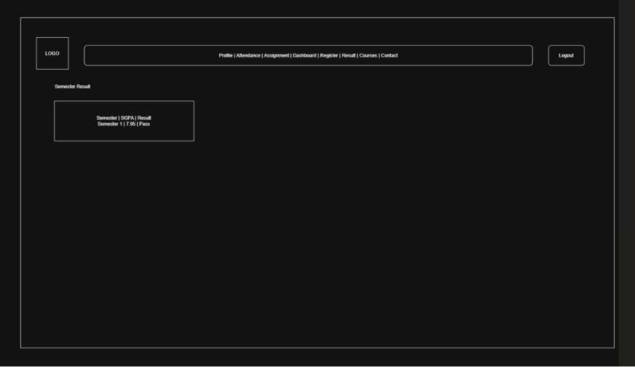
COURSE PAGE
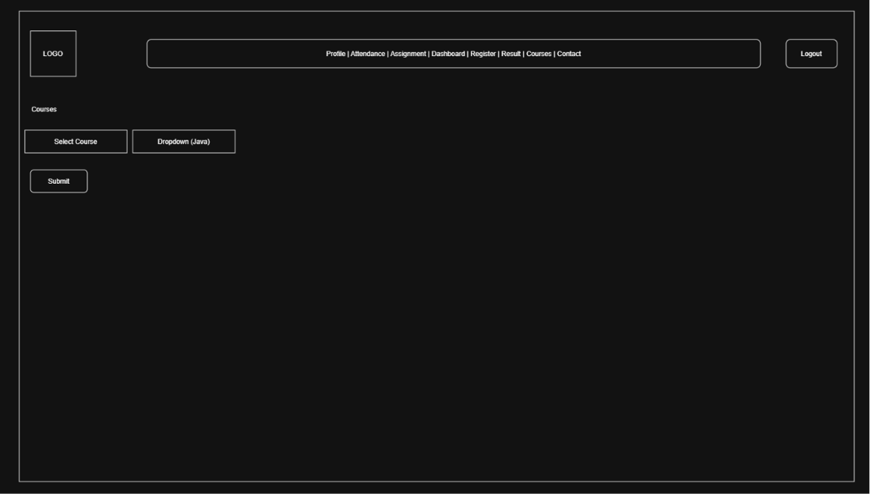

CONTACT PAGE
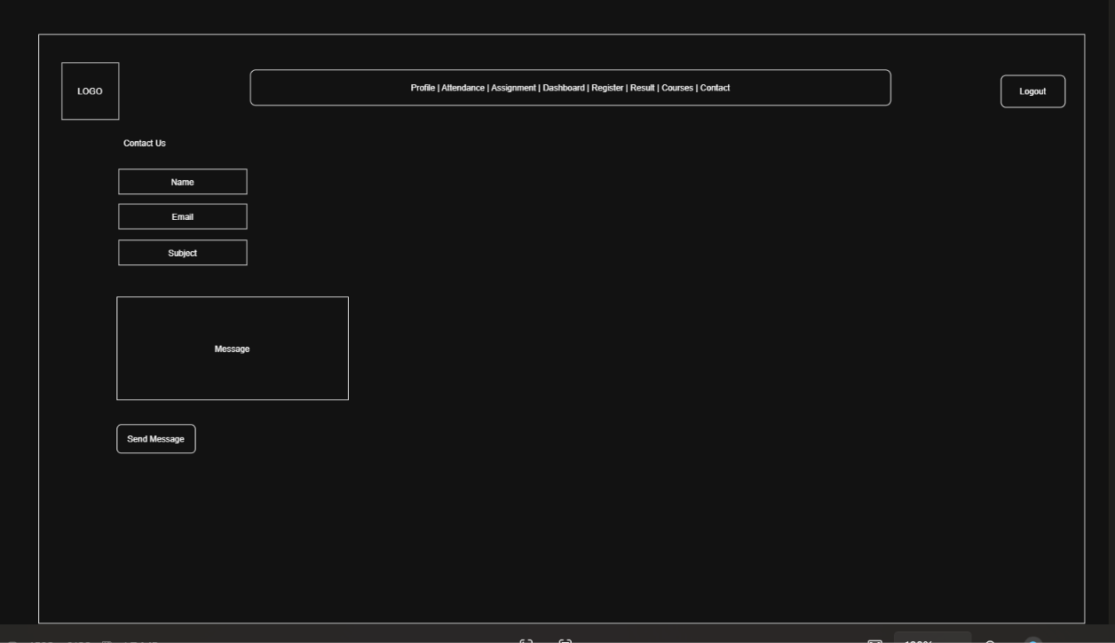

Description: Index.html

GitHub Repository Link:

https://github.com/25dce003-jpg/WDF.git

Challenges Faced:
Make a wireframe in draw.io

Learning Outcomes:
Learned the basic structure of an HTML webpage, how to create and link multiple HTML pages, Learned to use tables to display data, Learned to create a simple Student HUB Portal, Learned the basics of GitHub for project management, GitHub, sitemap, wireframe.

Faculty Remarks:

Practical – 2
Semantic HTML5 Pages with Accessibility-Ready Structure

Develop static HTML5 skeletons for at least 10 StudentHub pages such as Home, About, Register, Login, Dashboard, Events, Profile, Contact, Admin, FAQ, and Feedback. Use semantic tags and accessibility-friendly structure.
- Are semantic tags such as header, nav, main, section, article, aside, and footer used properly?
Answer: Yes. I used semantic tags like header, nav, main, section, and footer to organize the webpage. This makes the code simple and easy to understand.

2. Are form labels, headings, image alt text, and navigation links accessible?
Answer:
Yes. I added labels for form fields, used proper headings, gave images alt text, and provided navigation links so users can easily use the website.
3. Is the page structure consistent across all pages?
Answer:
Yes. All pages have the same header, navigation menu, main content area, and footer. This keeps the website neat and easy to use.

- Implementation/ Output/Result (Keep only one option which is suitable to practical)
The Student HUB Portal was developed using HTML5 semantic elements. All pages use semantic tags such as <header>, <nav>, <main>, <section>, and <footer>. A common navigation menu is provided to link all pages. Images include alt text, and forms use proper labels for better accessibility.
Pages Created:
- Home
- About
- Register
- Login
- Dashboard
- Events
- Profile
- Contact
- Admin
- FAQ
- Feedback
Output:
All HTML pages are linked correctly and display a consistent layout with a header, navigation menu, main content, and footer. The website is easy to navigate and follows basic HTML5 accessibility guidelines.

- Evidence of Work (Screenshots)
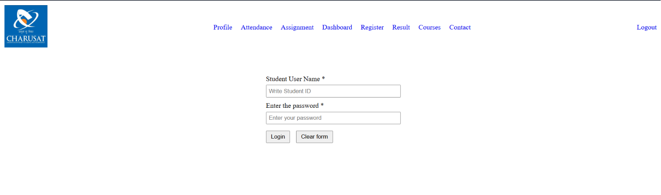 Description: login page
Screenshot 2
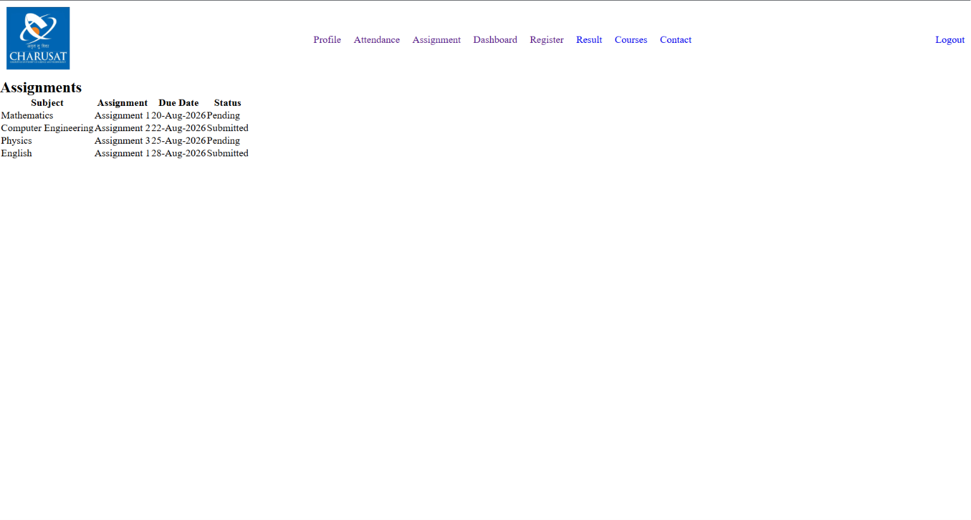
Description: Assignment page
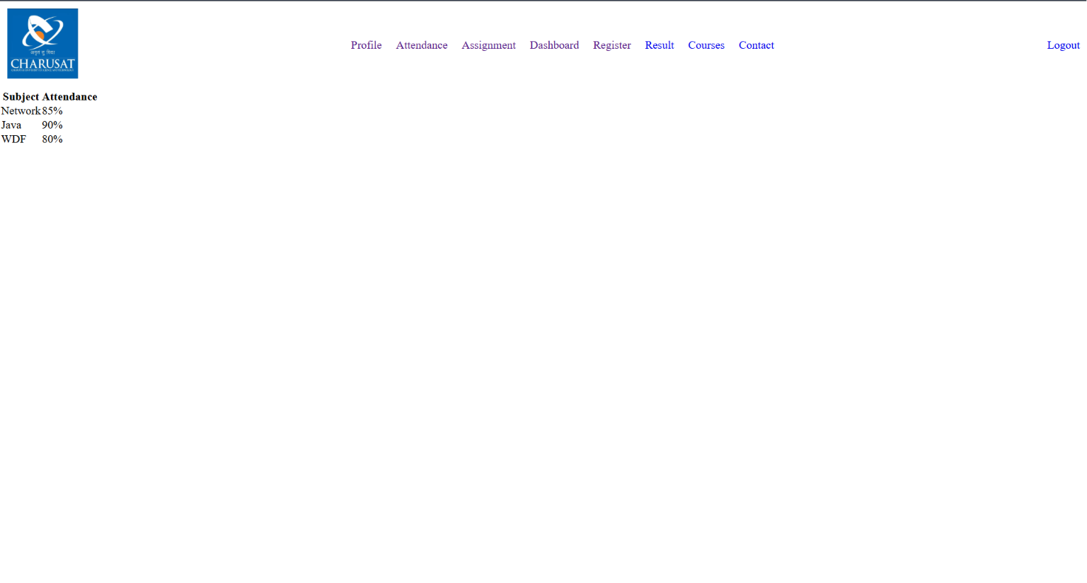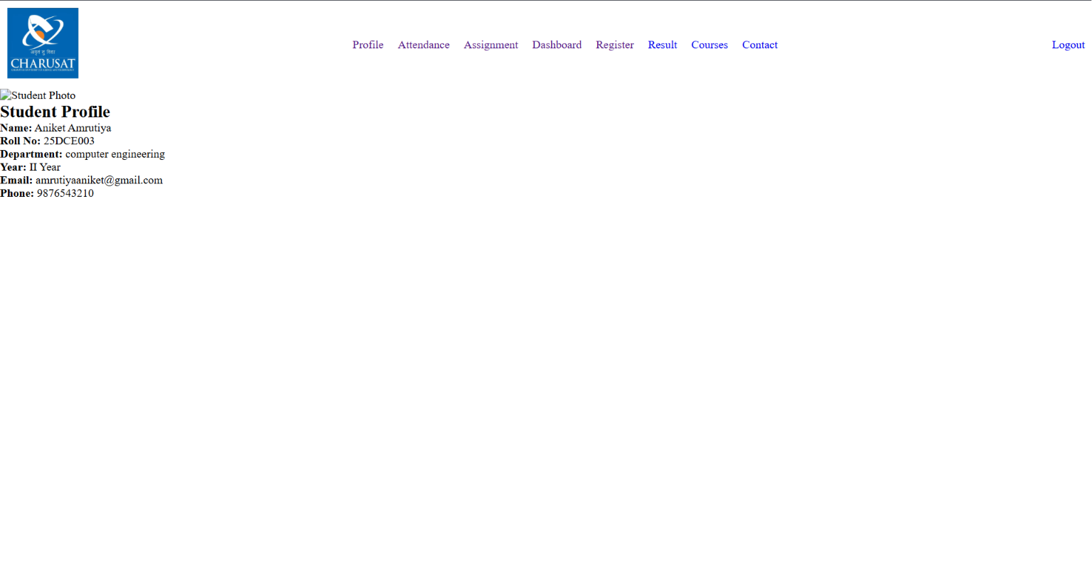
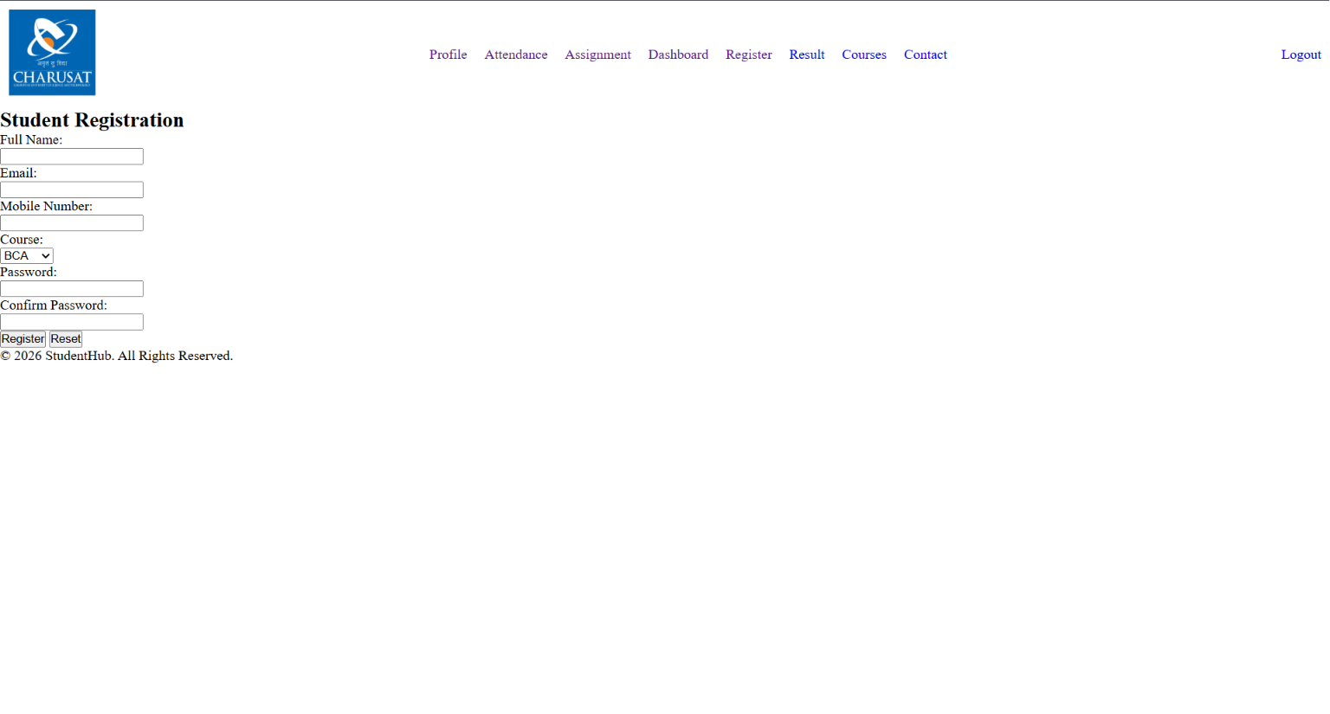
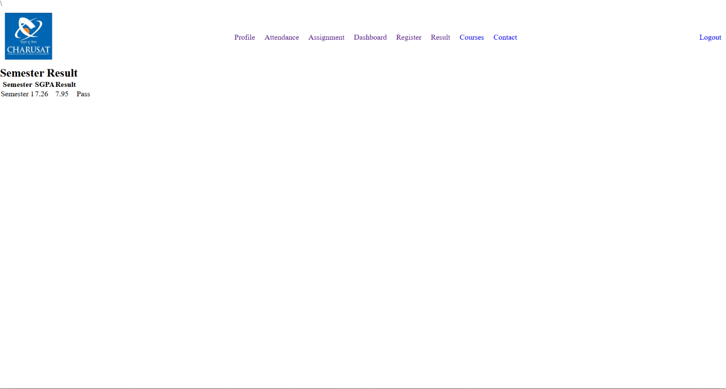
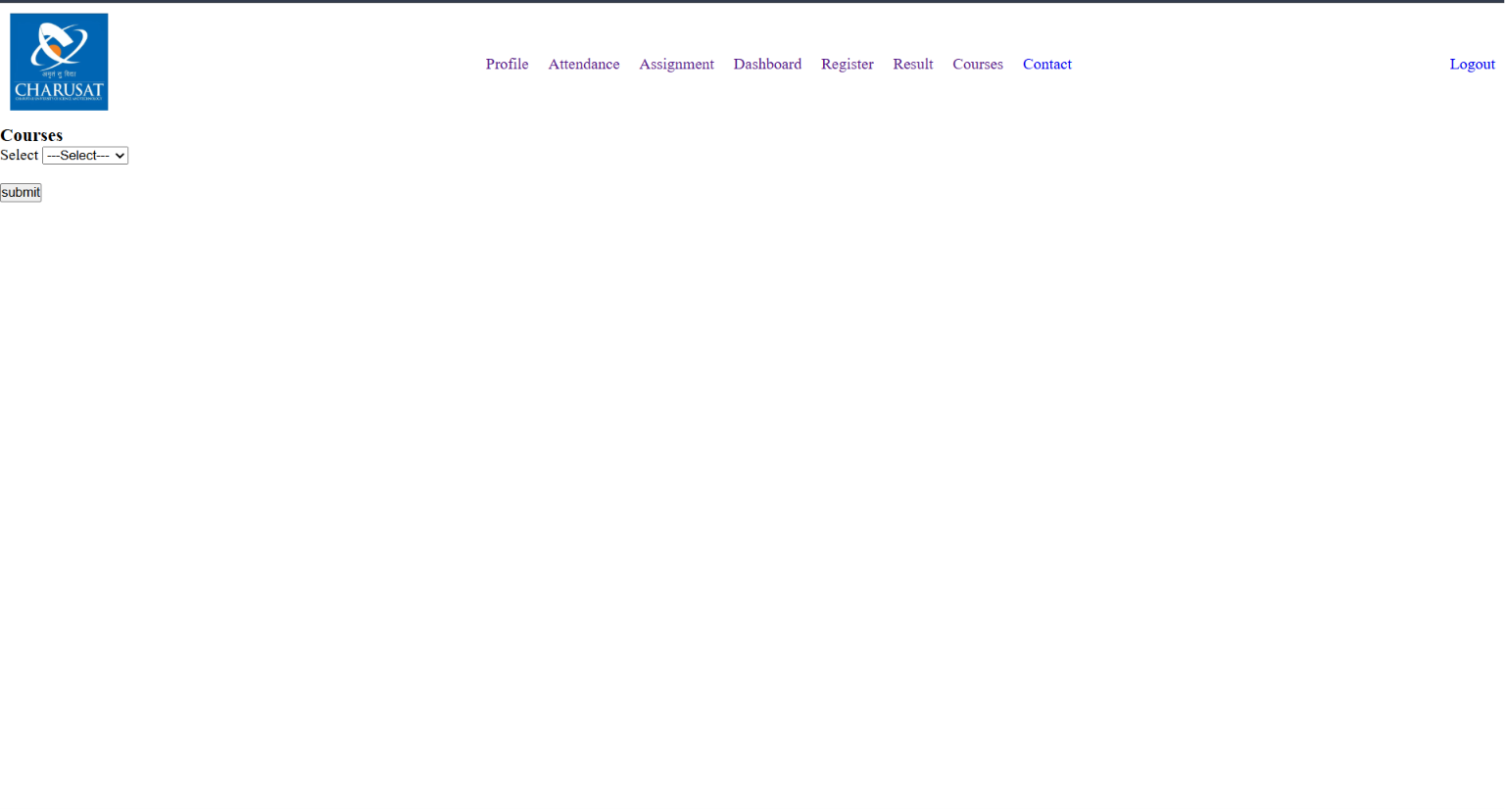
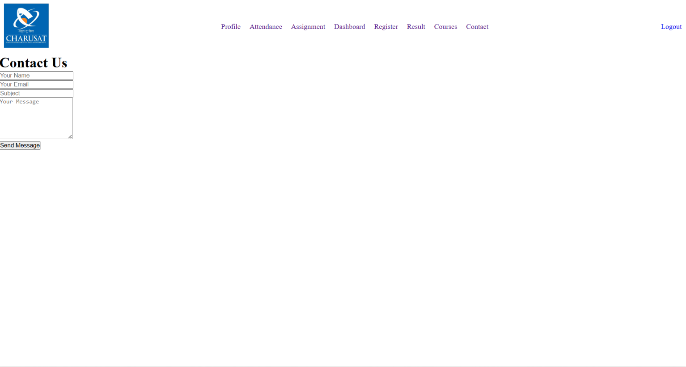

- GitHub Repository Link:
https://github.com/25dce003-jpg/WDF.git
Linking all HTML pages correctly, Using semantic HTML5 tags properly, Keeping the same layout on every page, adding proper labels and alt text for accessibility, Organizing project files and folders.

- Learning Outcomes:
In this practical, I learned how to create a website using HTML5 semantic tags. I also learned how to link multiple pages together and keep the same layout on every page. I understood the importance of accessibility by using labels, headings, and image alt text. This practical improved my HTML coding skills and helped me understand how to build a simple and well-organized website.

Faculty Remarks:

Practical - 3
Practical Title: Responsive UI Design using CSS Grid, Flexbox, and Bootstrap/Tailwind
Problem Definition: Design responsive layouts for Home, About, Registration, Dashboard, and Events pages using CSS Grid and Flexbox. Optional to use CSS framework such as Bootstrap or Tailwind. Ensure mobile-first responsiveness
1. How does the layout adapt for mobile, tablet, and desktop screens?
Answer:
The layout changes according to the screen size. On mobile, the content is displayed in one column. On tablets and desktops, the content is arranged in multiple columns for better viewing.

2. Which layout technique is used and why?
Answer:
I used CSS Flexbox and Grid because they help create a responsive layout. They make it easy to align items and adjust the page for different screen sizes.
3. Are typography, spacing, colors, and contrast readable?
Answer:
Yes. I used simple fonts, proper spacing, and clear colors so the content is easy to read on all devices.

4. Is the framework used consistently without unnecessary inline CSS?
Answer:
Yes. I used the CSS framework consistently and avoided unnecessary inline CSS. Most of the styling is written in the CSS file.

B . Implementation/ Output/Result (Keep only one option which is suitable to practical)
I created the Student HUB Portal using HTML and CSS. I used Flexbox and Grid to make the pages responsive. The website works properly on mobile, tablet, and desktop screens with a simple and clean layout.
Output:
The pages are responsive, easy to use, and display correctly on different screen sizes.

C. Evidence of Work (Screenshots)
Screenshot 1
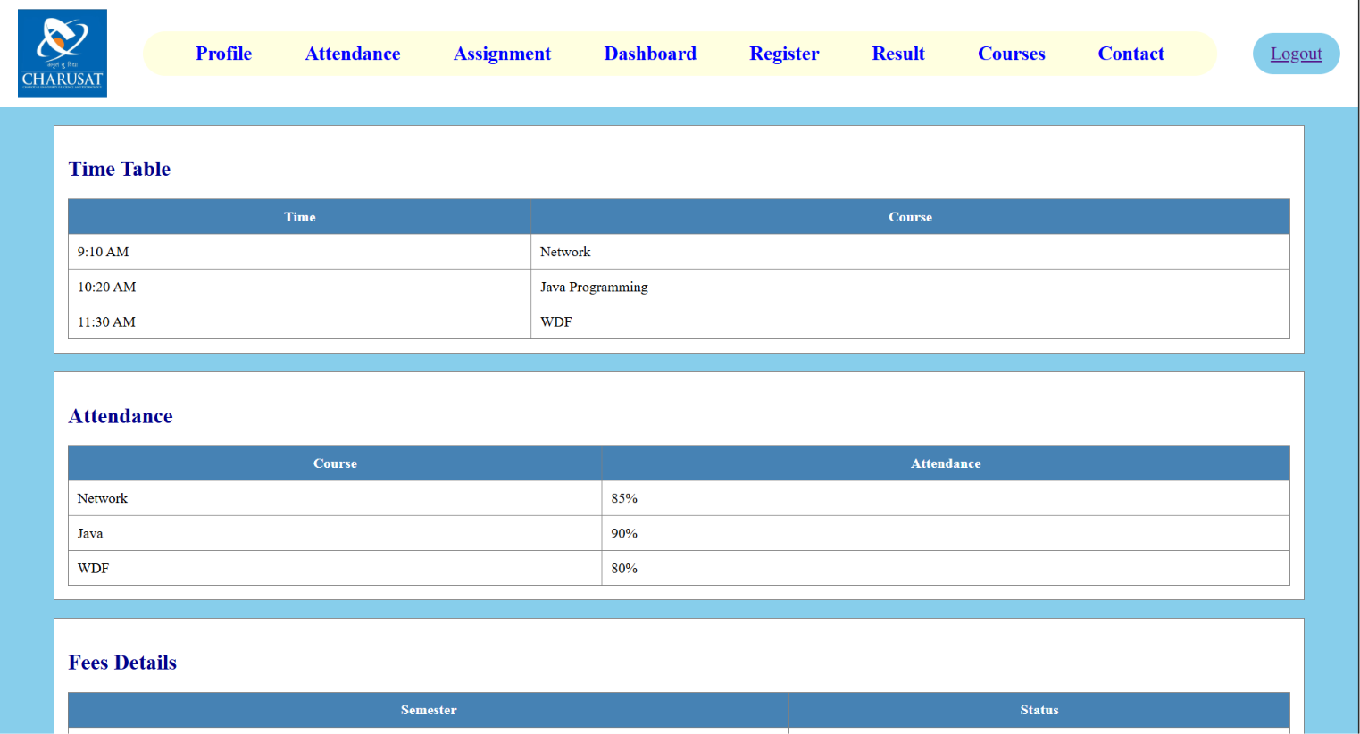
Description: Home page

Screenshot 2
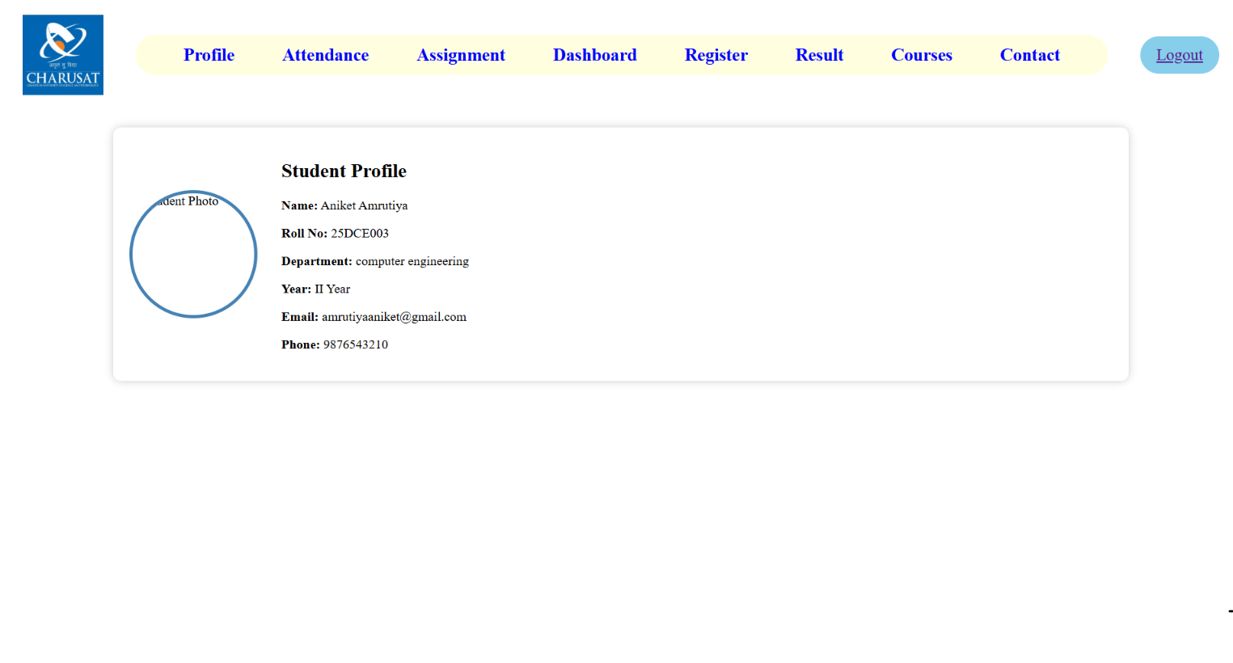
Description: Profile page
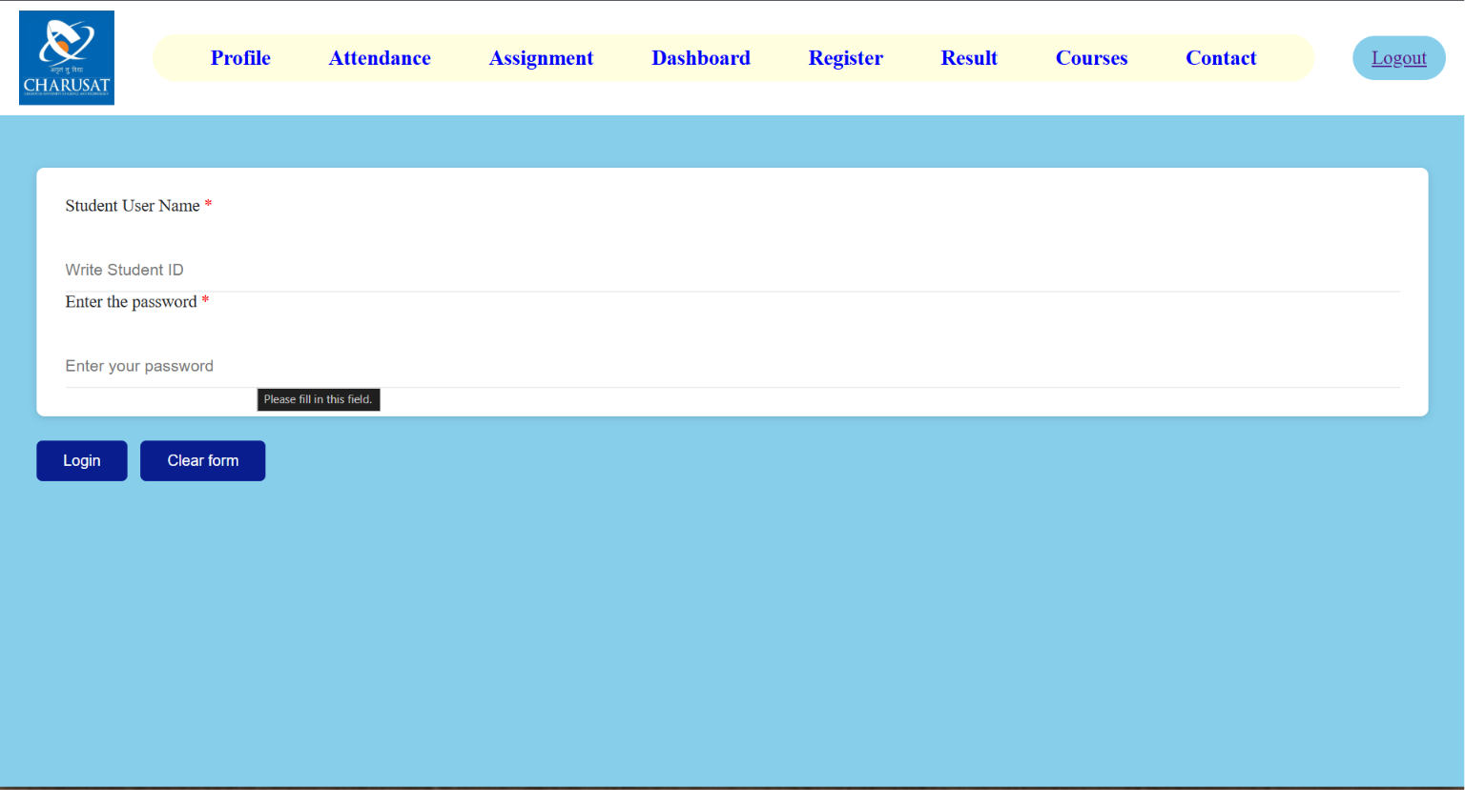
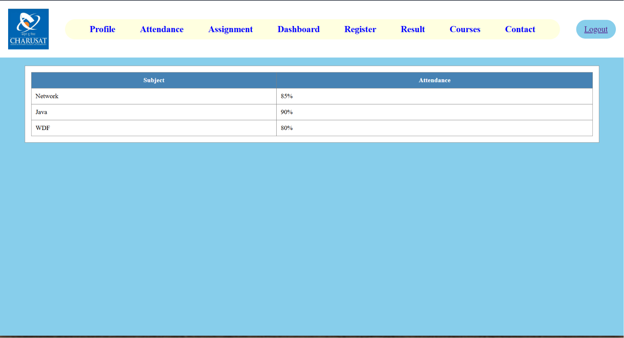
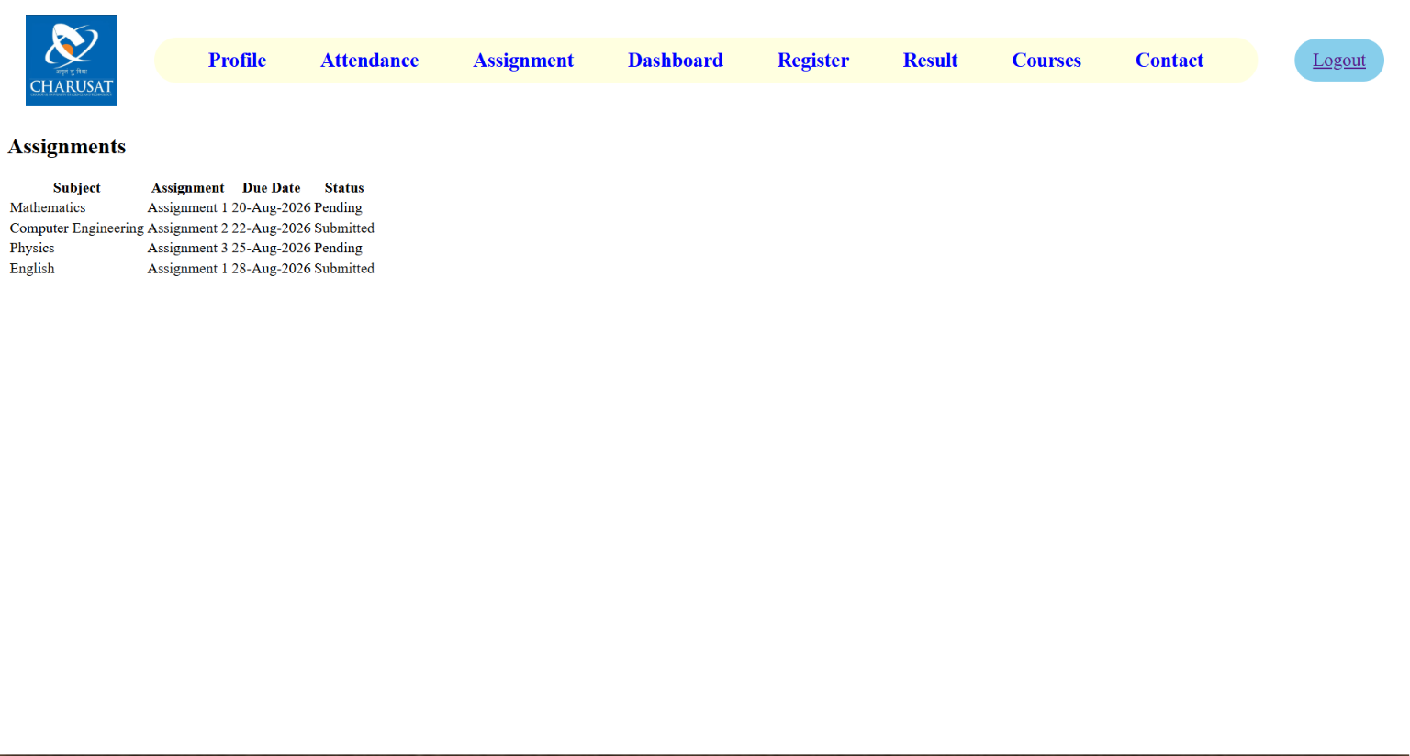
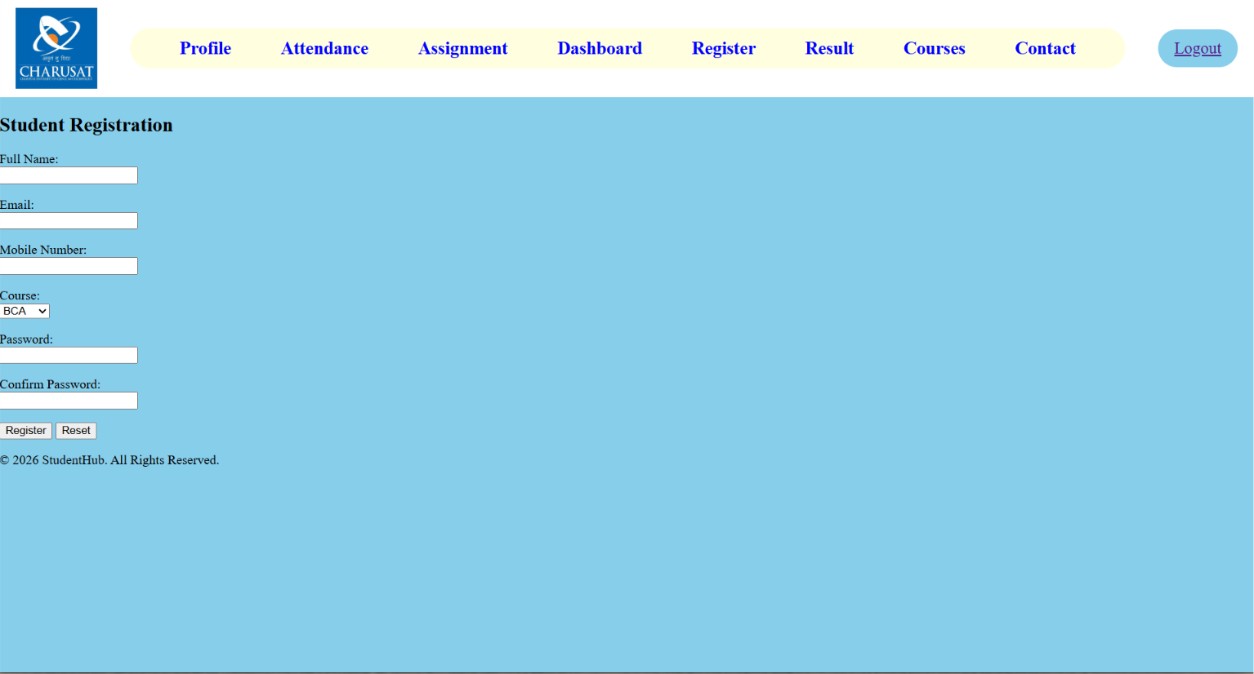
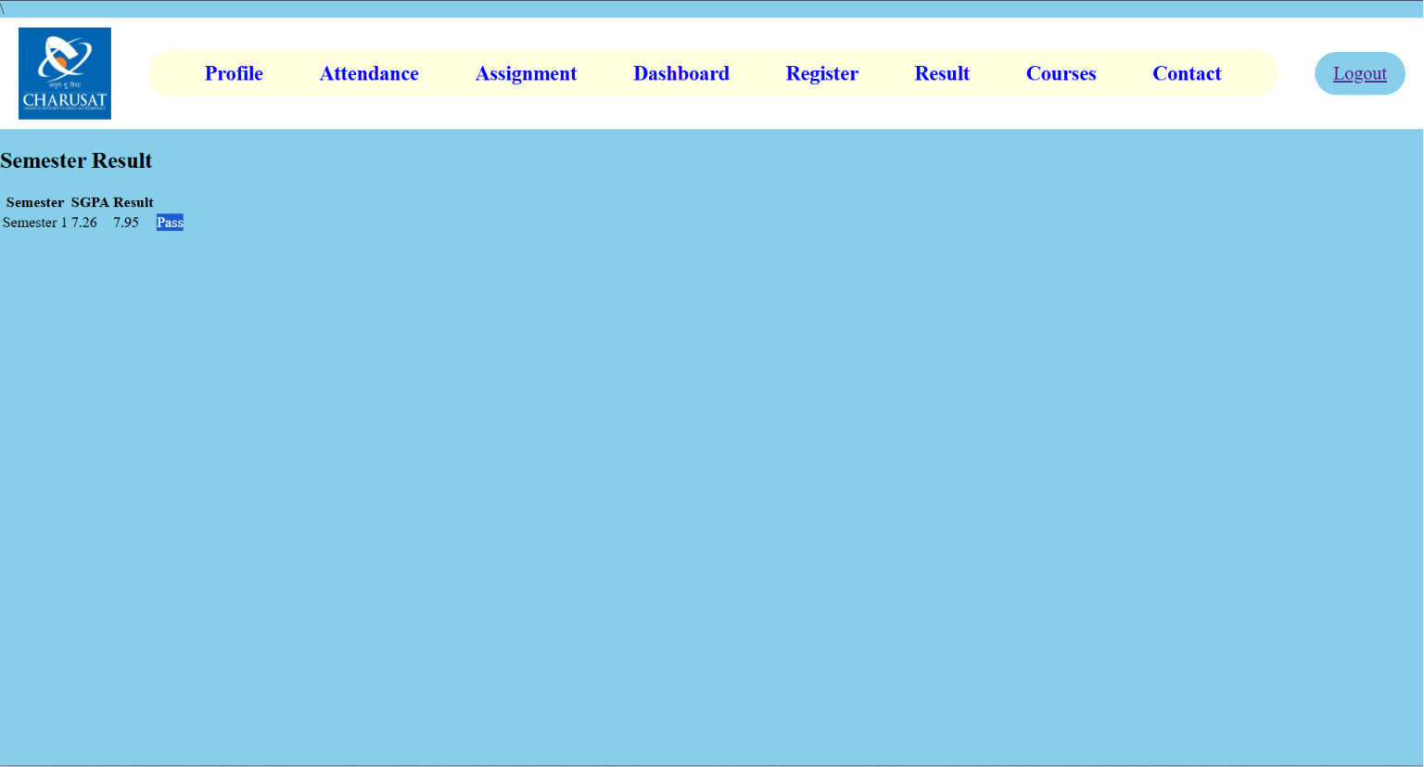
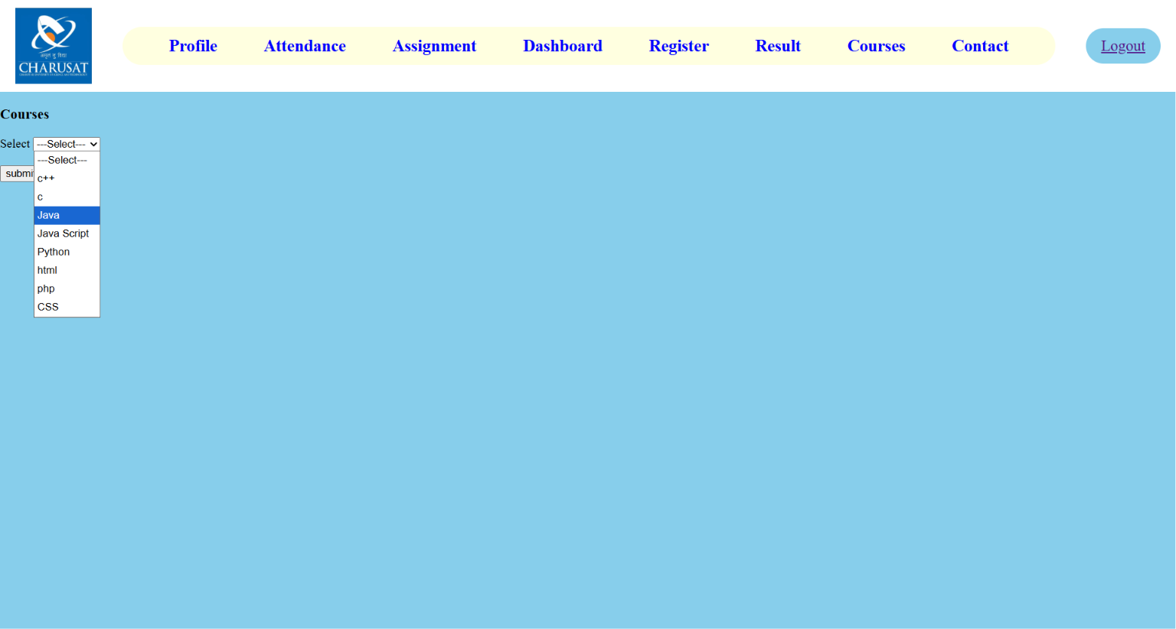
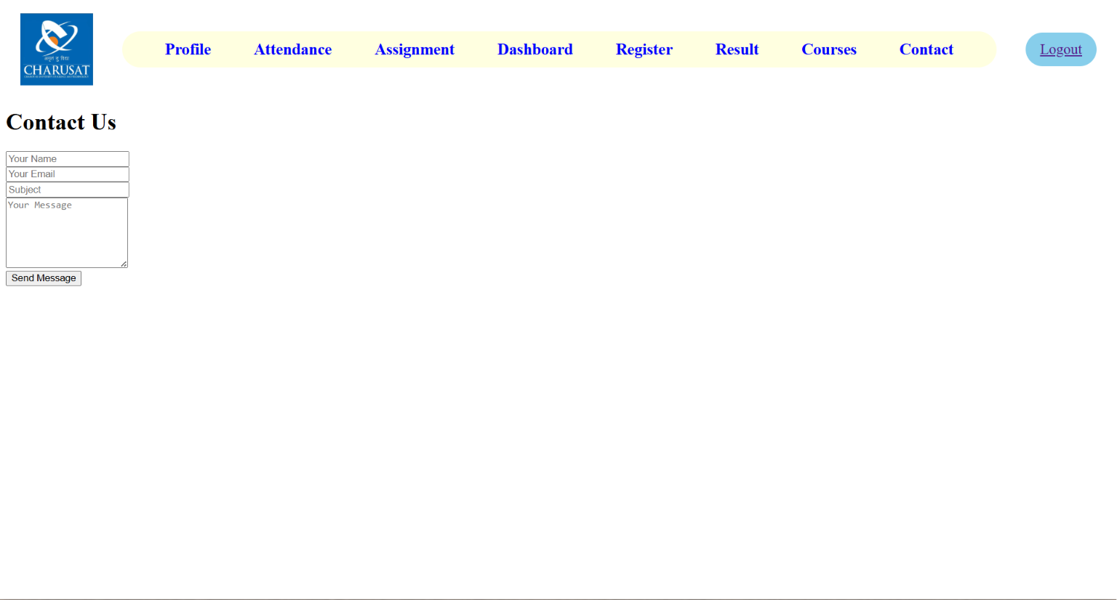

D. GitHub Repository Link: https://github.com/25dce003-jpg/WDF.git

- Challenges Faced:
While creating the responsive website, I faced some problems with page alignment and responsive layout. I also had to adjust the spacing and test the website on different screen sizes to make sure it worked properly.
- Learning Outcomes:
In this practical, I learned how to create a responsive website using CSS Flexbox and Grid. I also learned how to make web pages work on mobile, tablet, and desktop screens. This practical improved my CSS skills and helped me design a simple and user-friendly interface.

Faculty Remarks:

Practical - 4
Practical Title: JavaScript DOM Manipulation, Event Handling, and UI Interactivity
Problem Definition: Add dynamic UI components such as collapsible FAQ, modal popup, image/content slider, notification banner, hamburger menu, and light/dark theme switcher using JavaScript.

Theory :
1. How are DOM elements selected and modified?

DOM elements are selected using methods like getElementById() or querySelector(). After selecting an element, JavaScript can change its content, style, attributes, or other properties dynamically.

2. Are event listeners attached correctly?

Yes, event listeners are properly used with addEventListener(). They allow JavaScript to respond to actions like clicking a button, submitting a form, or moving the mouse.

3. Is localStorage used for remembering theme choice?

Yes, localStorage is used to save the selected theme in the browser. When the user opens the website again, JavaScript reads the saved value and applies the same Light or Dark theme automatically.
4. Does interactivity improve usability without breaking accessibility?

Yes. Interactivity improves usability when features such as buttons, notifications, menus, and forms make the website easier to use. Accessibility should be maintained by using proper HTML elements, keyboard support, readable text, clear messages, and sufficient contrast so all users can interact with the website.

Implementation/ Output/Result
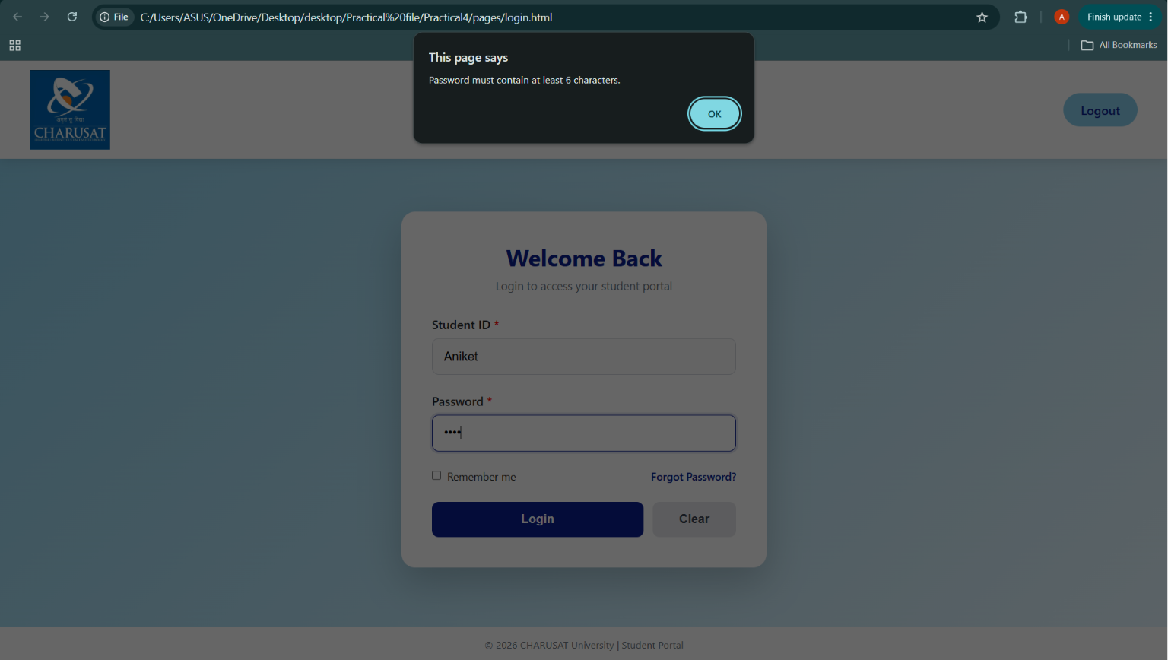

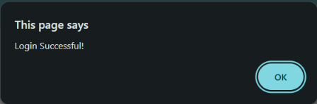

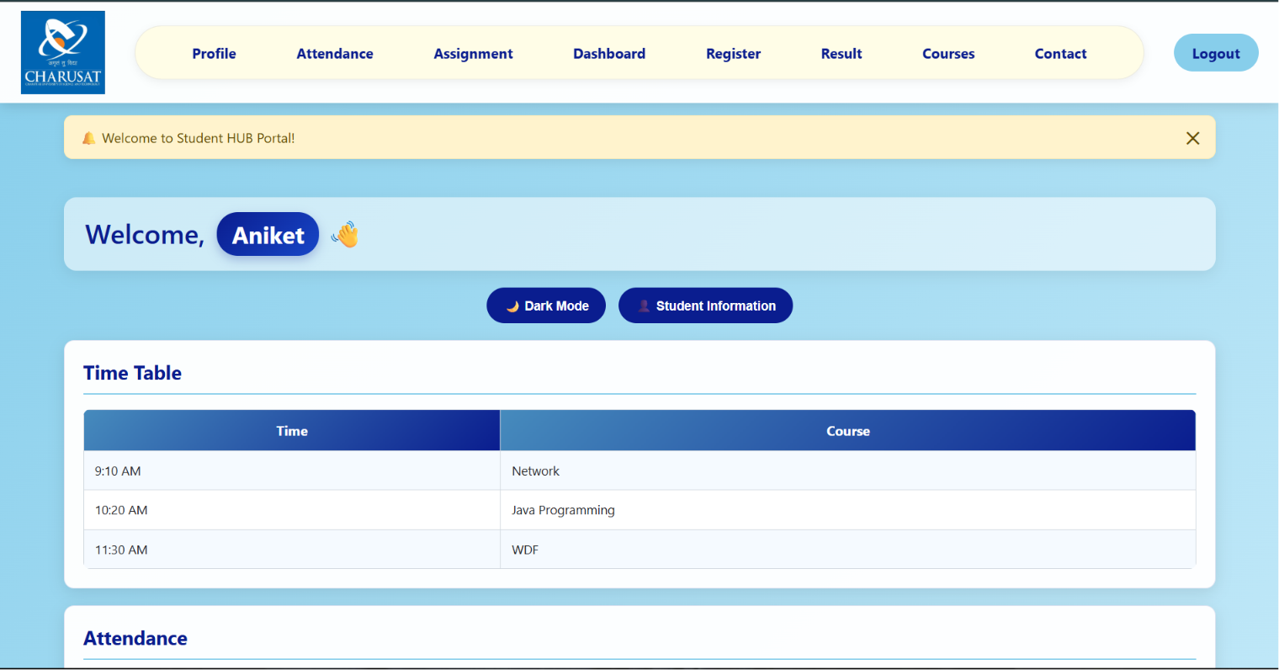


In this Welcome, Aniket the Aniket is change according to user enter name, id
And password have atleast 6 word or number.

Dark Mode
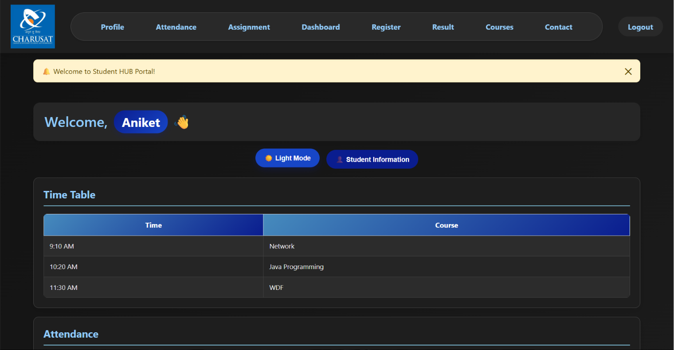

If i click on student information button then the this popes
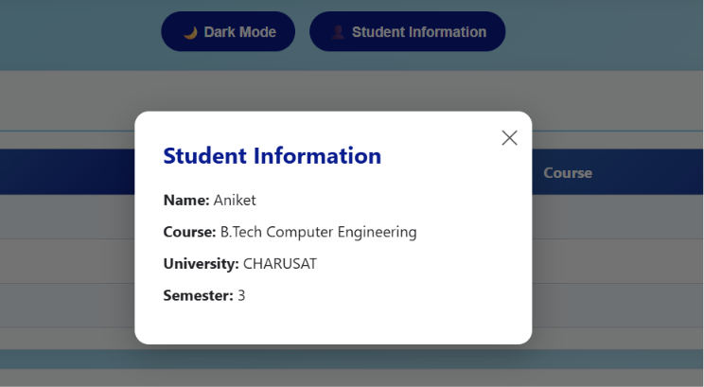
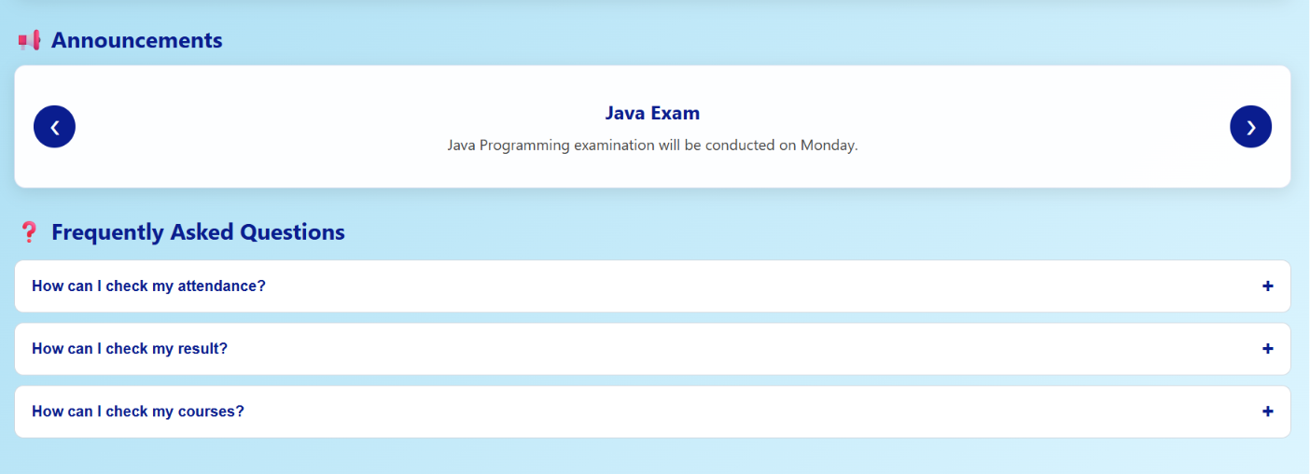

GitHub Repository Link:

https://github.com/25dce003-jpg/WDF

Challenges Faced:
The Password and confirm password are different then the register is done
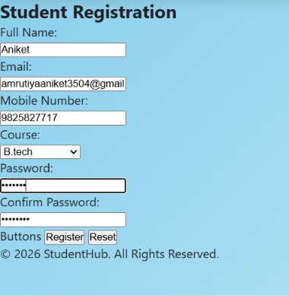

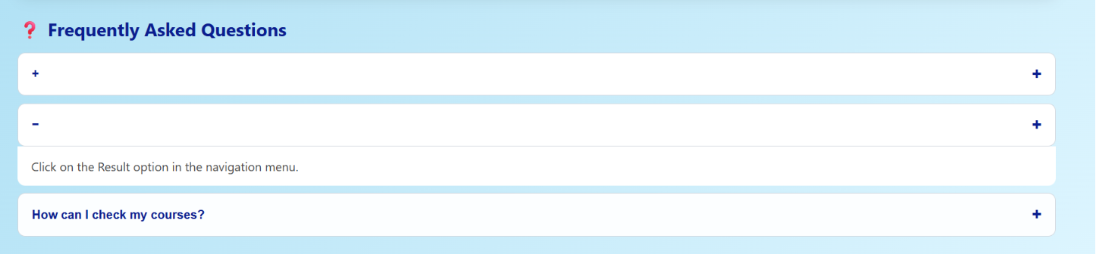
If I click – then the content is hide

Learning Outcomes:
- Use JavaScript DOM manipulation
- Handle user events like clicks and form submissions
- Create interactive UI components
- Implement dark/light theme switching
- Use localStorage to remember user preferences
- Improve the website's usability and interactivity.

Faculty Remarks: (Keep this blank for faculty)

Practical – 5
Practical Title: Registration Form with Frontend Validation and User-Friendly Error Handling
Problem Definition: Create a student registration form with HTML5 input types and JavaScript
validation for name, email, mobile number, password, confirm password, course, year, gender, and terms acceptance. Use Regular Expression for validations.

Theory :
1. Are correct input types and attributes used?

Yes, correct HTML5 input types like text, email, tel, password, and select are used. The required attribute is also used to make sure important fields are not left empty.

2. Are validation errors displayed near the relevant fields?

Yes, validation errors are displayed to inform the user when incorrect data is entered. The messages can be shown near the relevant fields to make it easy for the user to correct them.

3. Is password strength checked?

Yes, password strength is checked using JavaScript. It verifies the password length and checks for uppercase, lowercase, numbers, and special characters using a Regular Expression.

4. Is the form accessible using keyboard and screen-reader-friendly labels?

Yes, the form uses proper labels connected to input fields, making it easy to use with a keyboard. These labels also help screen readers understand each field.

Implementation/ Output/Result
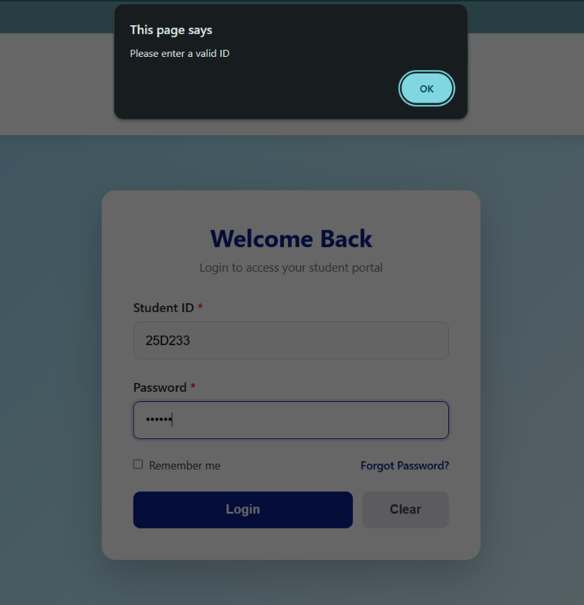
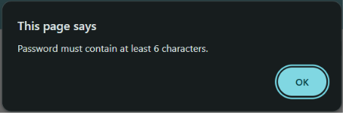

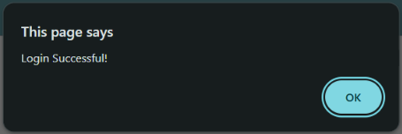

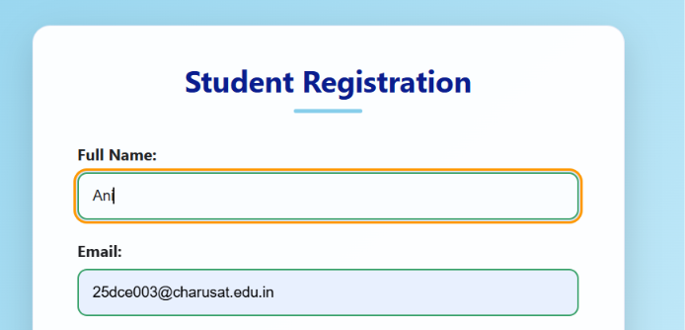
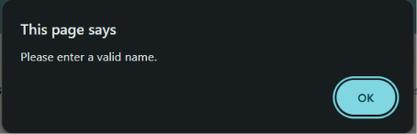
Name > 3
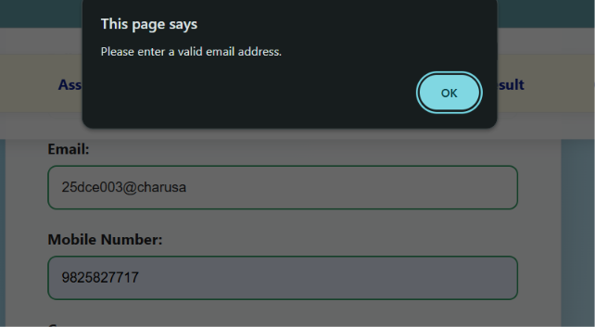
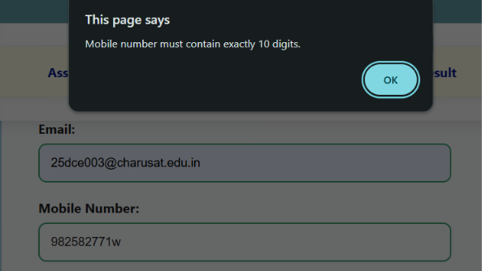
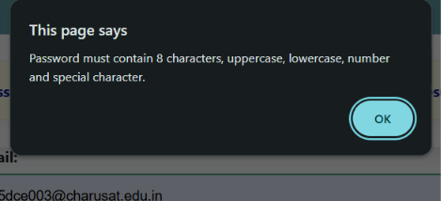
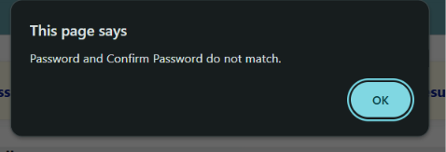
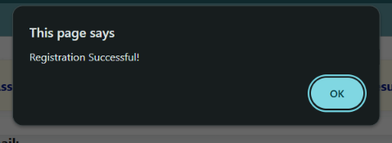

GitHub Repository Link:

https://github.com/25dce003-jpg/WDF

Challenges Faced:
emailPattern = /^[A-Za-z0-9._%+-]+@[A-Za-z0-9.-]+\.[A-Za-z]{2,}$/;
Not right correct

Learning Outcomes:
I learned how to create a student registration form using HTML5.
I learned how to use JavaScript and Regular Expressions for form validation.
I learned how to provide user-friendly error messages and check password strength.

Faculty Remarks: (Keep this blank for faculty)

Practical – 6
Practical Title: PHP Form Processing with Server-Side Validation and CSV/JSON File Storage
Process submitted registration/contact form data using PHP. Validate and sanitize inputs on the server side and store records in CSV or JSON file format. Display success/error messages.

Theory :
1. Is the form submitted using POST?

JSON is fetched using fetch(), converted into JavaScript data using response.json(), and then displayed dynamically on the webpage using JavaScript.

2. Are inputs validated and sanitized server side?

filter() is used for search/filter, sort() for sorting, map() for displaying data, and slice() for pagination.

3. Is file writing handled safely?

A loading message is shown while data is being fetched. If there is any problem, an error message is displayed using .catch().

4. Are success and error responses displayed clearly?

Code is divided into separate functions or JavaScript files for fetching data, searching, filtering, sorting, and rendering. This makes the code easy to manage and reuse.

Implementation/ Output/Result

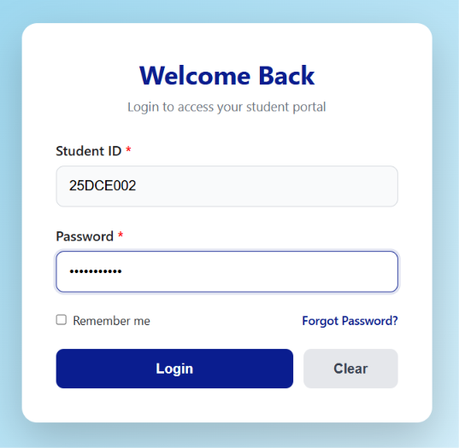
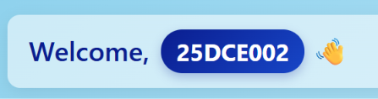
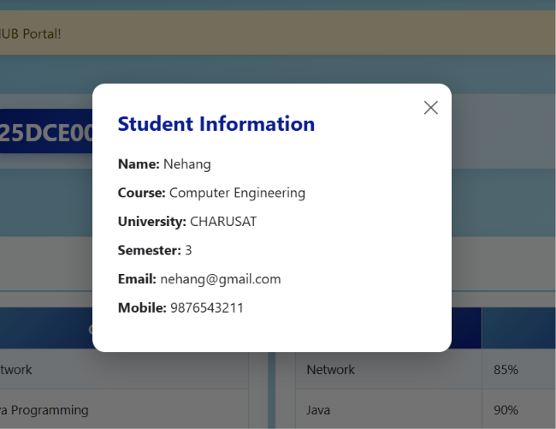
This is the data fetch according to the ID for example 25DCE002 login then the data is fetch according to 002 . If we change the 002 to 003 ID then the Data is change according to it.
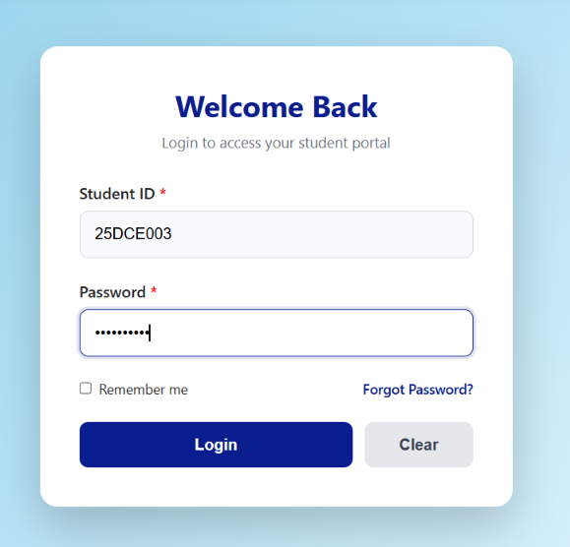
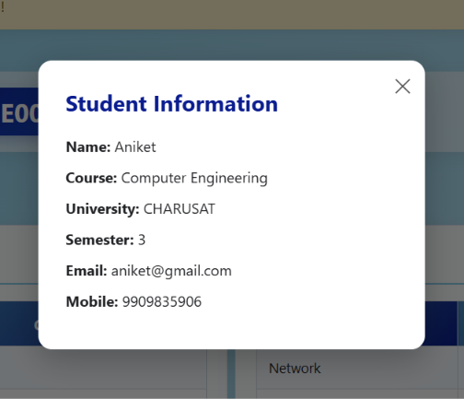

GitHub Repository Link:

https://github.com/25dce003-jpg/WDF

Challenges Faced:
First the data is not fetch so error in the code and after I fetch the data there the practical is over but I have add specific data are fetch so I learn from on online and I do

Learning Outcomes:
I will learn to fetch JSON data using Fetch API and display it dynamically on a webpage. They will also learn search, filter, sort, and pagination using JavaScript array methods.

Faculty Remarks: (Keep this blank for faculty)

Practical – 7
Practical 7: PHP Form Processing with Server-Side Validation and CSV/JSON File Storage

Problem Definition: Process submitted registration/contact form data using PHP. Validate and sanitize inputs on the server side and store records in CSV or JSON file format. Display success/error messages.

Theory :
1. Is the form submitted using POST?
Yes. The form uses the POST method, so the data is sent securely to the PHP file for processing.

2. Are inputs validated and sanitized server side?
Yes. PHP checks the name, email, mobile, course, and password before storing the data. The inputs are also sanitized before saving.

3. Is file writing handled safely?
Yes. The data is written to a CSV file using fputcsv(), which stores each value properly in separate columns.

4. Are success and error responses displayed clearly?
Yes. The PHP program displays a clear message such as “Registration Successful!” or shows the reason when there is an error.

Implementation/ Output/Result
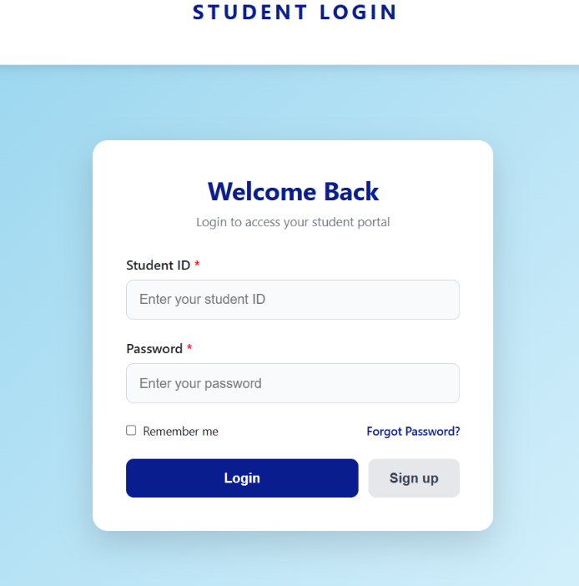
In this I am add sign up and remove the clear button if we click this button it open the register page is page is full of php . start the XAMPP apacha
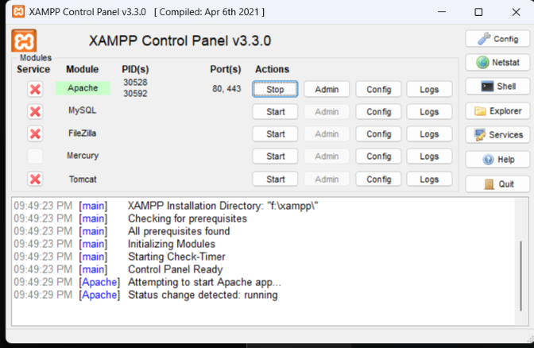
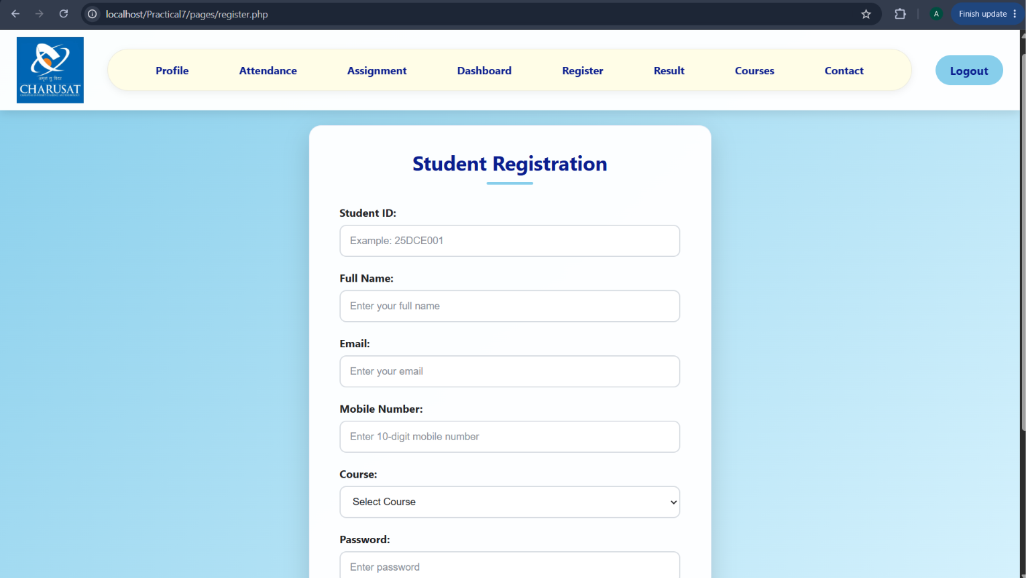
I am enter the data 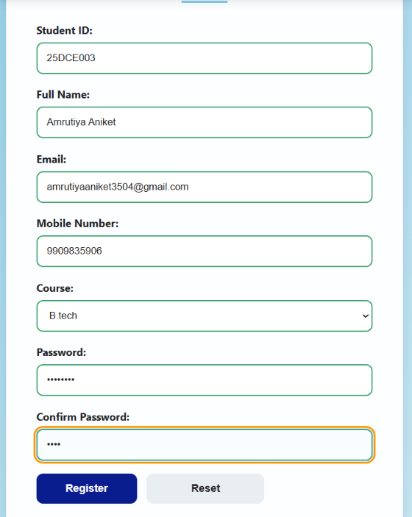
If all detail is valid for example id must be first two number after 3 letter after three number 25DCE003 like this sample we do with all number, email, password, etc after the data valid the Registration Successful! Come.

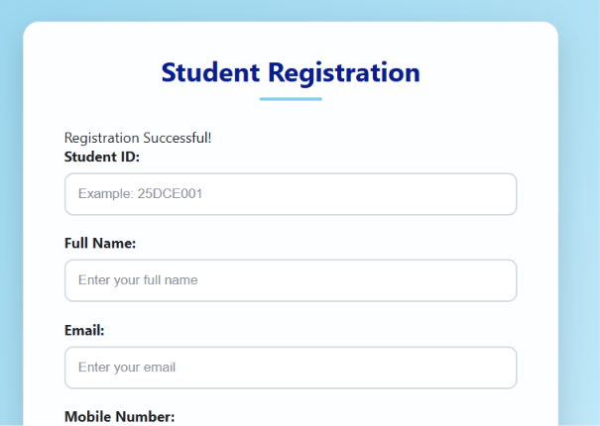
And this data are store in students.csv
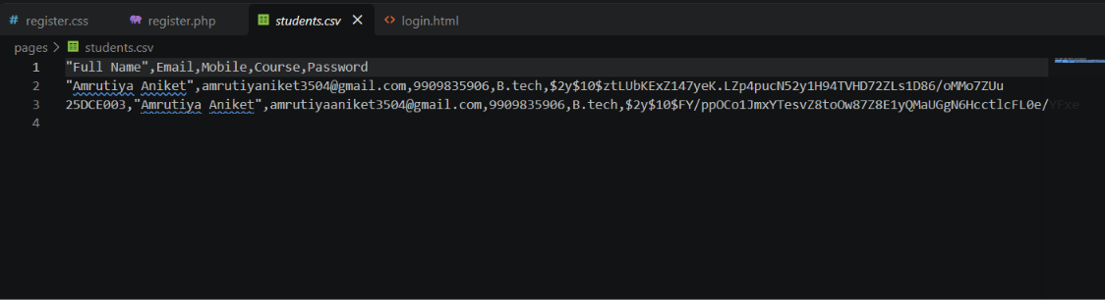
First I the id come in this I after add this.

GitHub Repository Link:

https://github.com/25dce003-jpg/WDF

Challenges Faced:
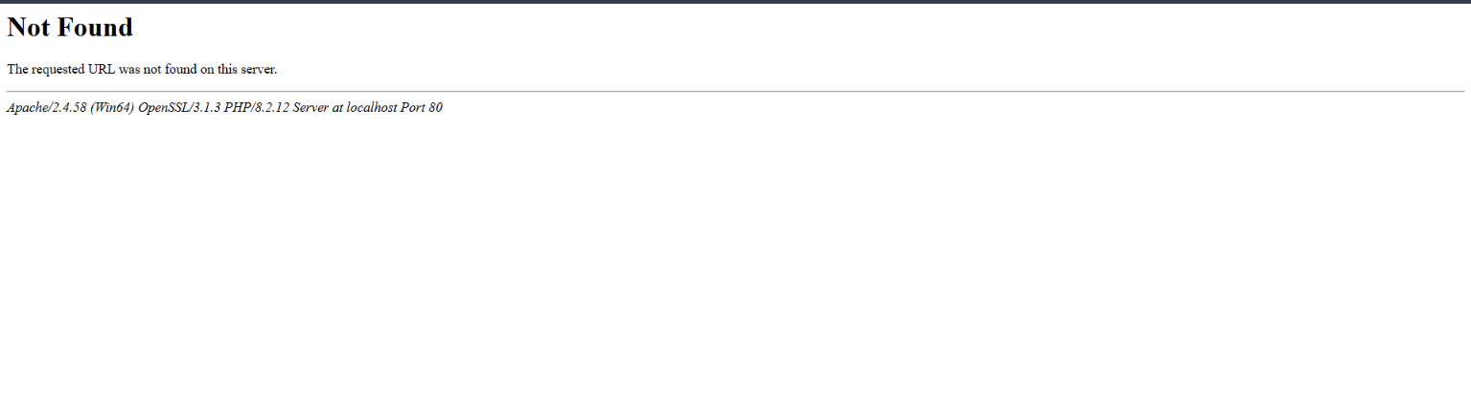
Some pages is not found 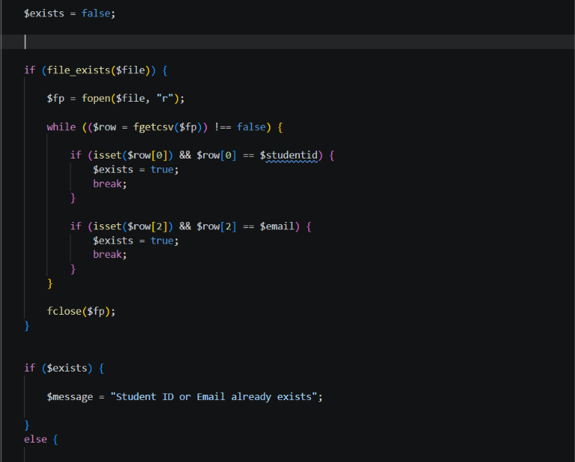
In this I not know about the isset exits so this are the some problem or challenges Faces

Learning Outcomes:
After completing this practical, I learned to:
Create a registration form using HTML and Use PHP to process form data using the POST method and Perform server-side validation for Student ID, name, email, mobile, and password and Sanitize user input before storing it and Store student information in a CSV file using PHP and Check duplicate Student ID and email before registration and Display success and error messages based on the form input and Use password hashing to store passwords more securely.

Faculty Remarks: (Keep this blank for faculty)

Practical – 8
Practical 8: MySQL Schema Design, ER Model, PDO Connectivity, and Prepared Statements

Problem Definition: Design the database for StudentHub with students, events and registrations. Create PHP database connection using MYSQL statements.

Theory :
1. Is the schema normalized properly?
Yes. The database is divided into separate Students, Events, and Registrations tables, which reduces duplicate data and keeps the data organized.

2Are primary keys and foreign keys correctly defined?
Yes. Each table has a primary key, and the Registrations table uses foreign keys to connect students and events correctly.

3. Is the database connection handled securely?
Yes. PHP PDO and prepared statements are used for secure database connection and to prevent SQL injection.

Implementation/ Output/Result
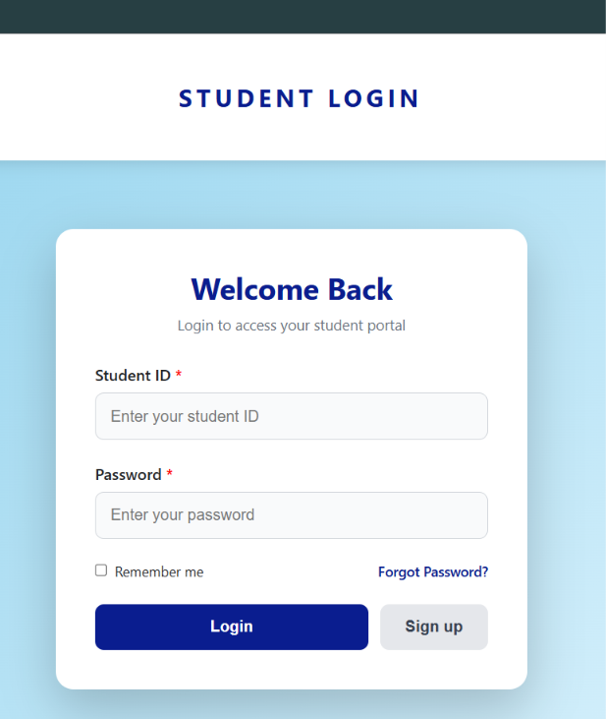
In this I am add sign up button in which you can sign up or enter you detail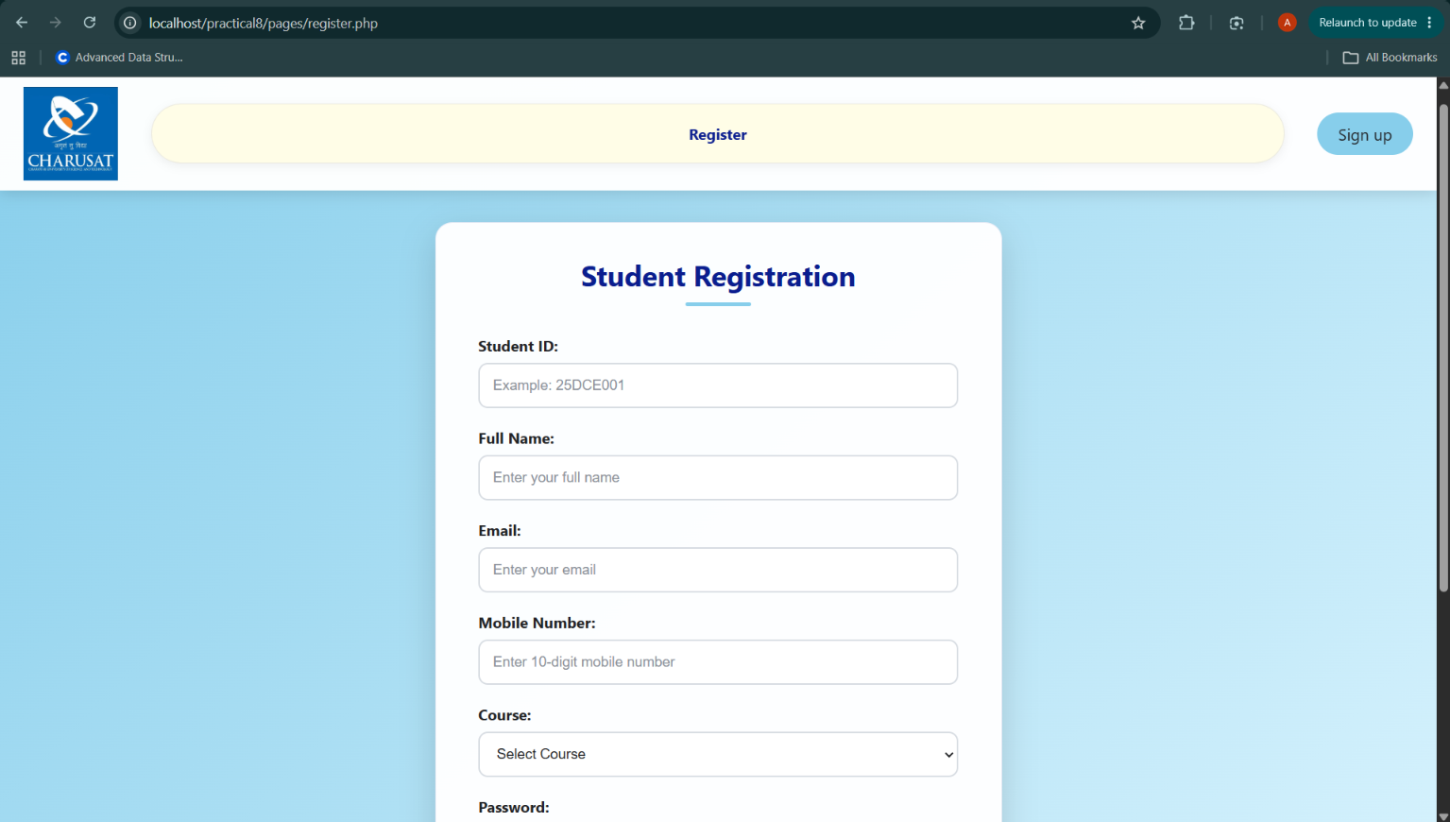
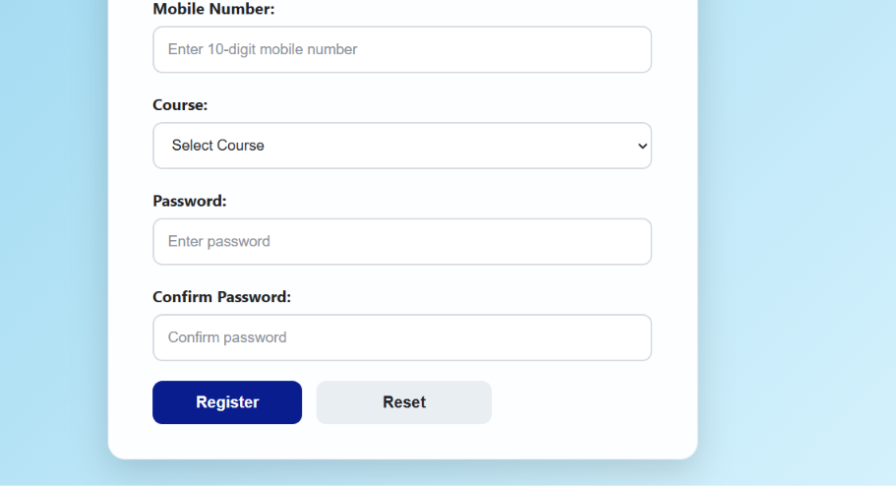
Enter the detail according to ask Id name email enter perfect then and only you data is store to database
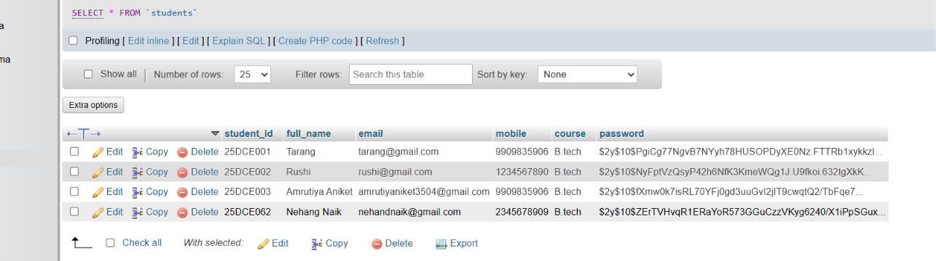
Like this you data is store
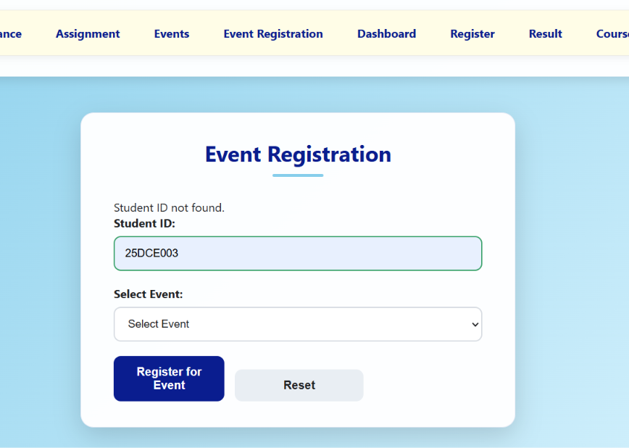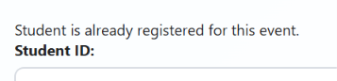
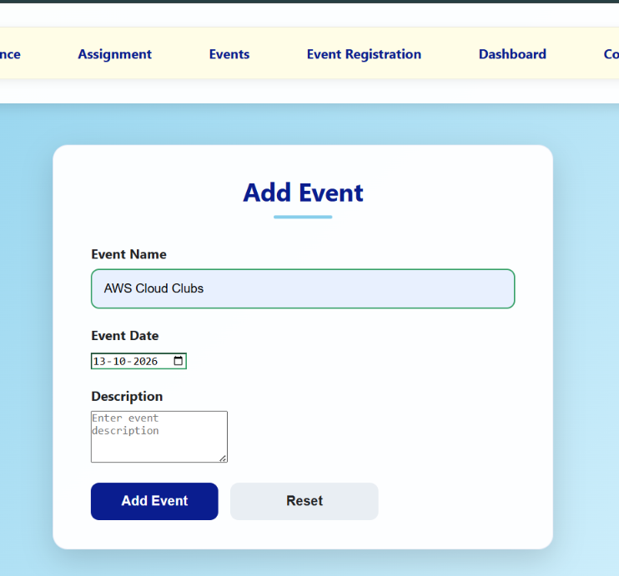
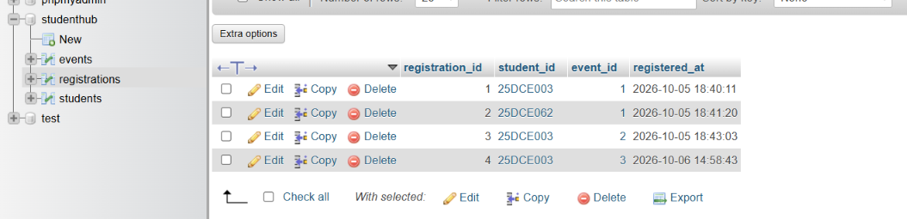
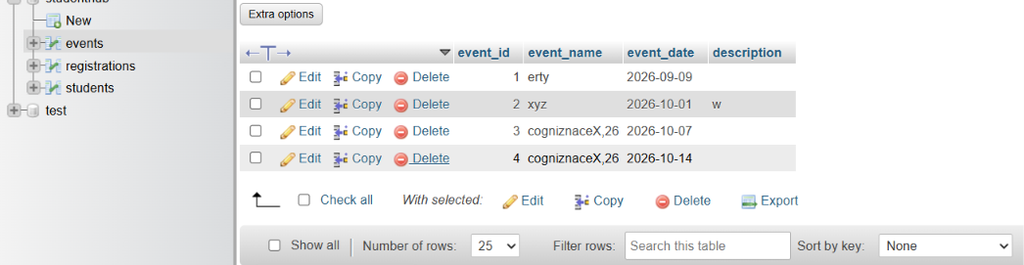
In this i add two extra page of events and event registration
In event you add the event and in registration through you register the page

In login page you id and passwrd must be correct you enter that sign up pge enter

https://github.com/25dce003-jpg/WDF

Learning Outcomes:
I am learned how to design a normalized database using MySQL. They understood the use of primary keys and foreign keys to maintain data relationships. They also learned to connect PHP with MySQL using PDO. Prepared statements were used to improve security and prevent SQL injection.

Faculty Remarks: (Keep this blank for faculty)

Practical – 9
Practical 9: Secure User Registration with Database Insert, Duplicate Email Check, and Password Hashing

Implement secure user registration by inserting user details into MySQL using MYSQLi. Validate input on frontend and backend, check duplicate email/username, hash passwords using password_hash(), and display appropriate messages.

Theory :
1. Is password_hash() used before storing passwords?

Yes. The password is hashed using password_hash() before saving it in the database.

2 Is duplicate email/username checked?

Yes. The system checks whether the email or username already exists before inserting a new user.

3. Are frontend and backend validations consistent?

Yes. The input is checked on both the frontend and backend to make sure valid data is entered.

Implementation/ Output/Result

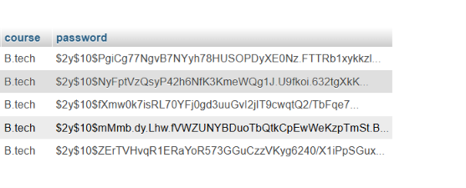
Store in hash – password
If I enter the same gmail then it give already exist in student register page.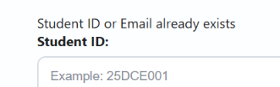
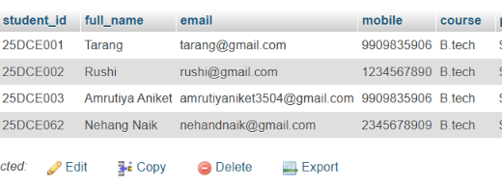

Learning Outcomes:

Create a secure user registration system.

Store user details in a MySQL database.

Hash passwords securely using password_hash().

Check for duplicate email or username.

Validate user input on both frontend and backend.

GitHub Repository Link:

https://github.com/25dce003-jpg/WDF

Challenges Faced:
In the email some problem I face only nothing else problem

Faculty Remarks: (Keep this blank for faculty)

Practical – 10
Practical 10: Secure Login/Logout with Sessions, Role-Based Access, Timeout, and Remember-Me Token

Develop secure login and logout functionality using PHP sessions. Verify password using password_verify(), regenerate session ID after login, restrict dashboard access, implement role-based redirection, session timeout, and optional secure remember-me token.

Theory :
1. Are sessions started and destroyed securely? Yes. session_start() starts the session, and session_destroy() destroys it during logout. The session ID is regenerated after login for better security.
2. Is password_verify() used correctly? Yes. password_verify() checks the entered password against the hashed password stored in the database.
3. Is unauthorized dashboard access blocked? Yes. The dashboard checks whether the user is logged in. If not, the user is redirected to the login page.
4. Is session timeout implemented? Yes. If the user remains inactive for a specified time, the session expires, and the user must log in again.
5. Are admin and student users redirected to appropriate dashboards? Yes. Role-based access redirects admin users to the admin dashboard and student users to the student dashboard.

Implementation/ Output/Result

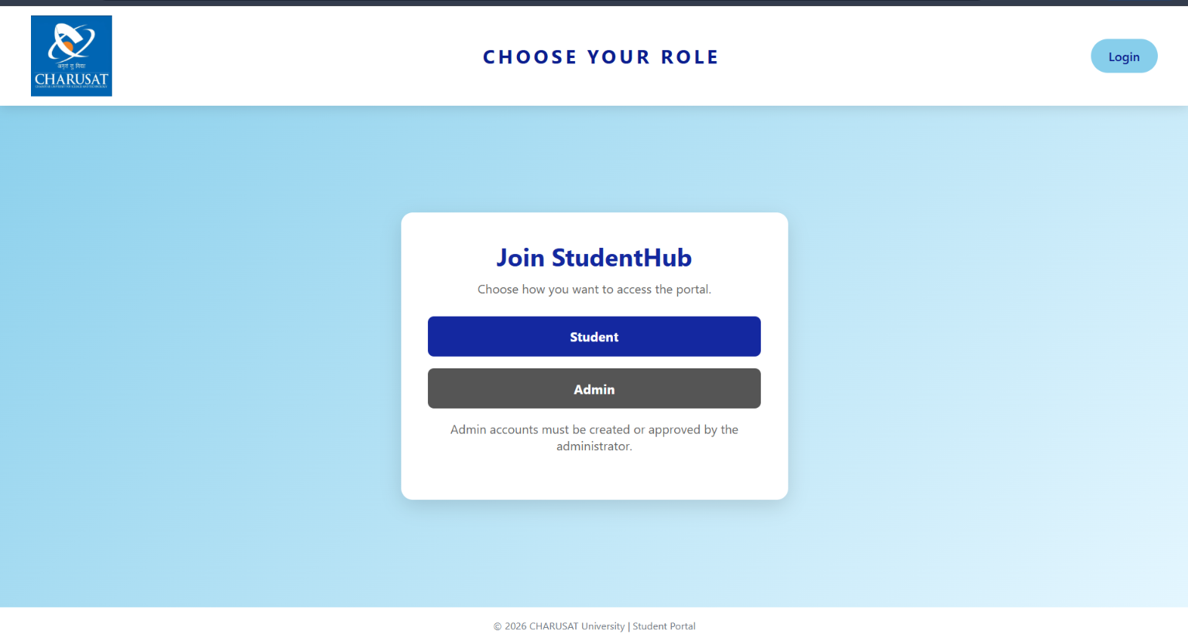
In this if not user of this website you want to sign up and choose role student or admin. And for both there is a different dashboard. 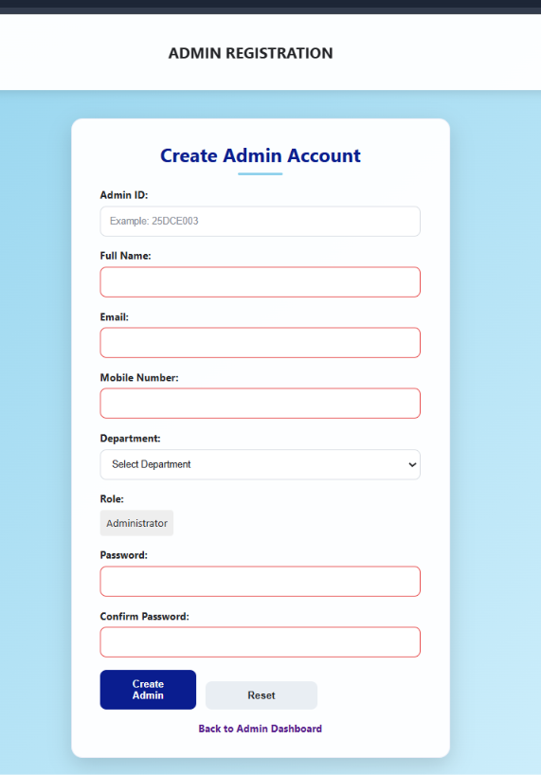
In this you can register as admin
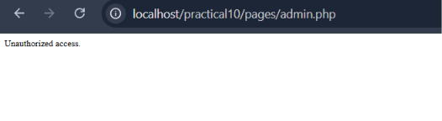
If u login as student and you open admin.php to it is not open Unauthorized access.
And also if u open any page for example index.php so it not open it direct open login.php
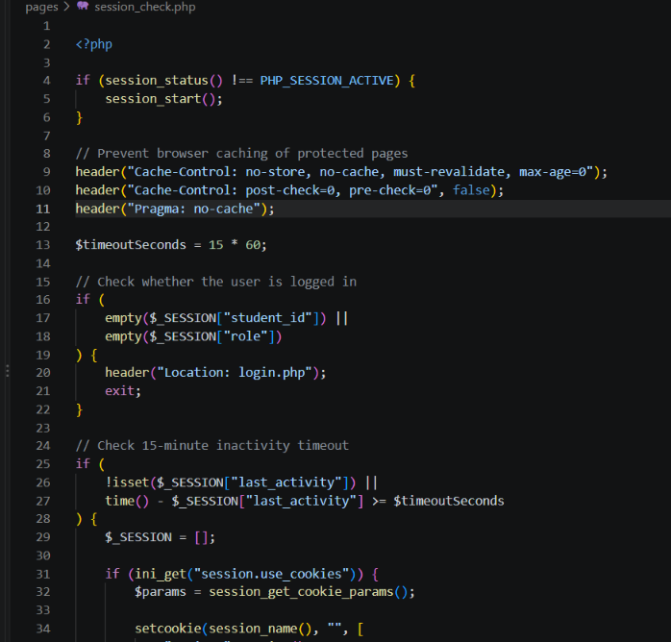
This is session_check.php some code I give sime of 15 min.
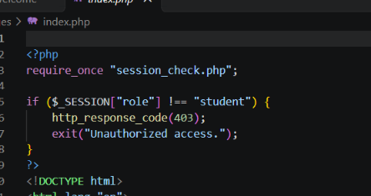
This code authorized access are add the top part of code all pages.

Learning Outcomes:

I learn to implement secure login and logout using PHP sessions, password verification, role-based access control, and session timeout.

GitHub Repository Link:

https://github.com/25dce003-jpg/WDF

Challenges Faced:
Unauthorized problem and also in this session time so waste the time in only session check

Faculty Remarks: (Keep this blank for faculty)

Practical – 11
Practical 11: Student Management CRUD with Search and Filter

Create a student management module to add, view, edit, delete, search and filter student records. All database operations must use MYSQLi statements and clear success/failure messages.

Theory :
1. Are SELECT, INSERT, UPDATE, and DELETE operations working?

Yes. These operations are used to view, add, edit, and delete student records in the database.

2. Is search by name/email/course implemented?

Yes. Users can search student records by name, email, or course to find specific information easily.

3. Are delete operations confirmed before execution?

Yes. A confirmation message is displayed before deleting a student record to prevent accidental deletion.

Implementation/ Output/Result
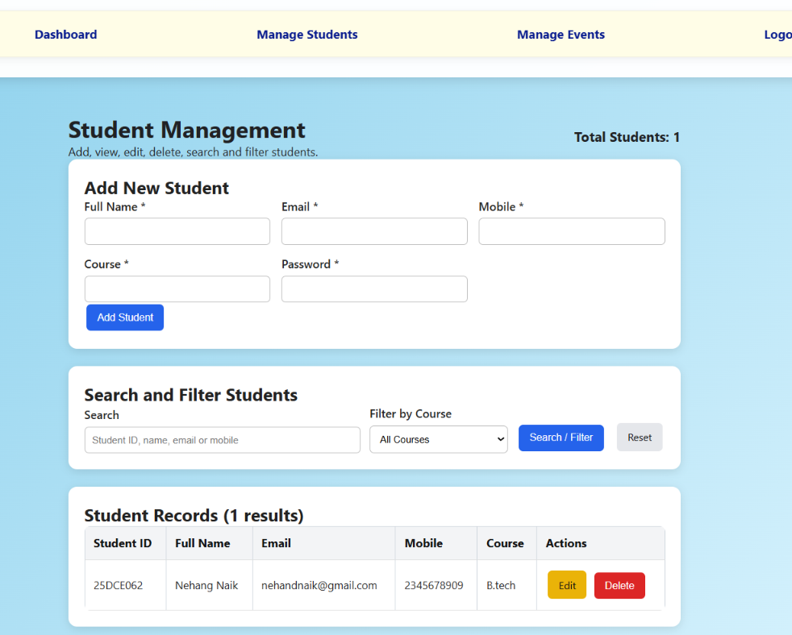

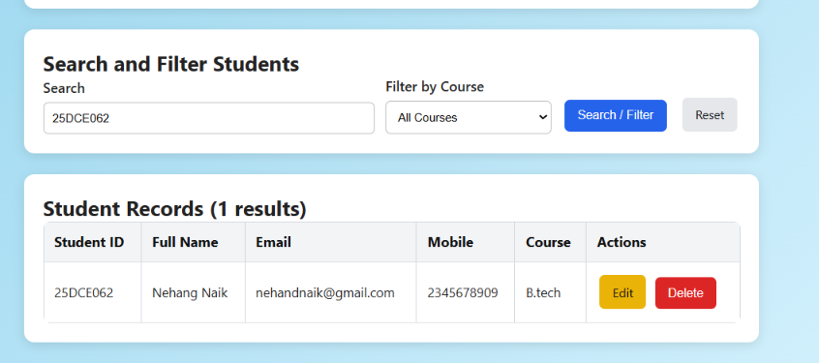
In this you can also Add, view, edit, delete, search and filter students.
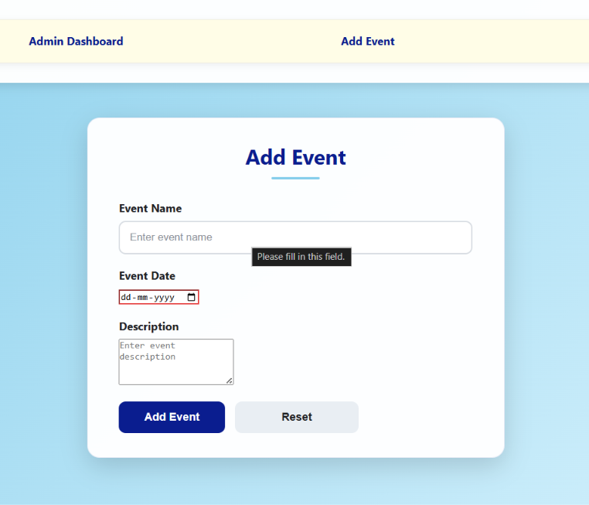
In this you can also add events.

Learning Outcomes:

I learn to develop a secure student management system using PHP and MySQLi to add, view, update, delete, search, and filter student records.

GitHub Repository Link:

https://github.com/25dce003-jpg/WDF

Challenges Faced:
I faced some difficulties connecting PHP with MySQL, writing CRUD queries, implementing search and filter functionality, and handling success or error messages.

Faculty Remarks: (Keep this blank for faculty)

Practical – 12
Practical 12 Event Management CRUD with Poster Upload and File Validation Student Management CRUD with Search and Filter

Develop event management functionality for admin users. Admin can add, view, update, delete, and upload event posters with file type and file size validation.

Theory :
1. Are add, update, and delete functionalities implemented correctly?

Yes. Admin can add new events, update existing event details, and delete events from the database.
2. Is the UI linked with the database correctly?

Yes. The PHP interface is connected to MySQL to store, retrieve, update, and delete event records.
3. Are poster uploads validated for type and size?

Yes. The system checks the poster's file type and size before uploading it to prevent invalid files.
4. Are success and failure messages displayed?

Yes. Success messages appear when an operation is completed, and error messages appear when an operation fails.

Implementation/ Output/Result
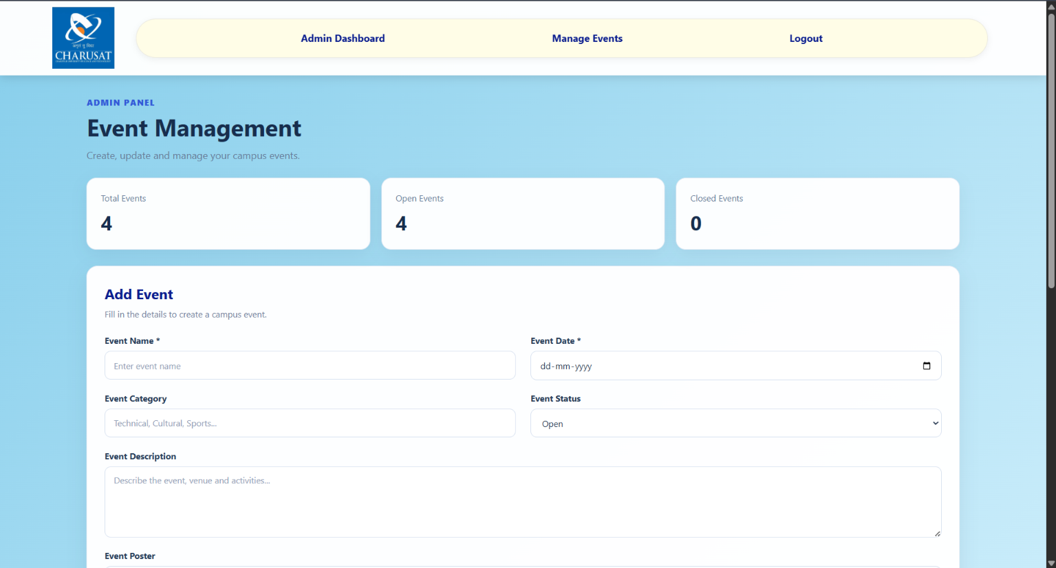
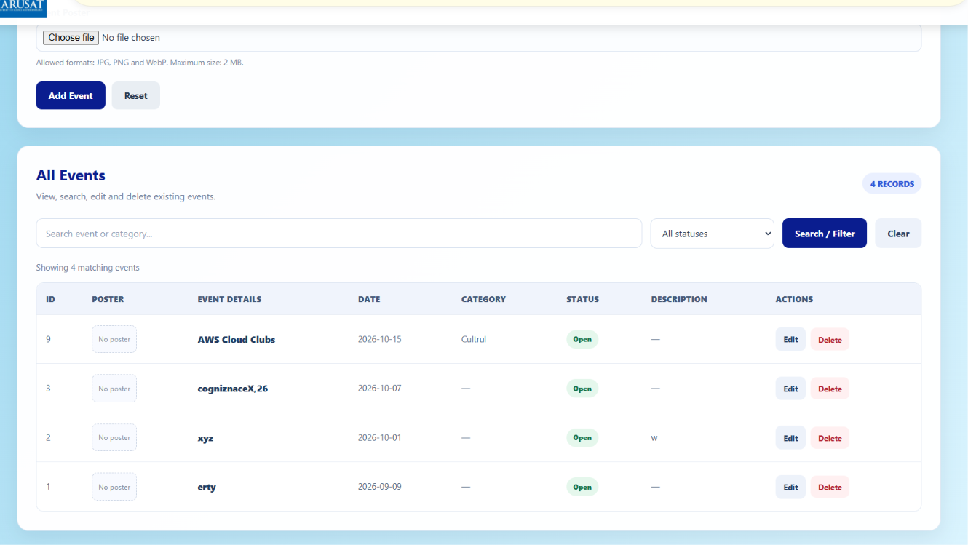
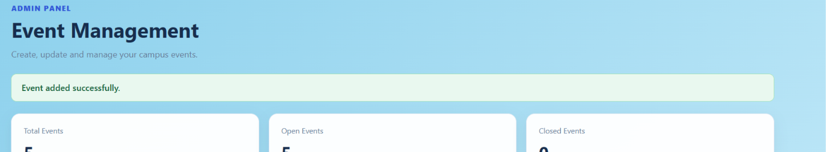
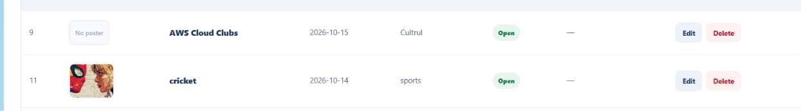
Poster is also add in this website
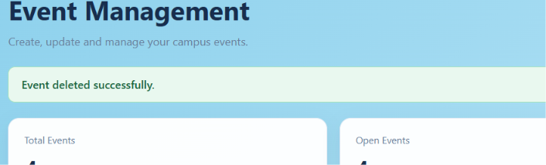
Delete event

Learning Outcomes:
I will learn to develop a secure event management system using PHP and MySQL with CRUD operations and validated poster uploads.

GitHub Repository Link:

https://github.com/25dce003-jpg/WDF

Challenges Faced:

I faced difficulties connecting PHP with MySQL, validating poster file types and sizes, handling file uploads, and displaying proper success and error messages.

Faculty Remarks: (Keep this blank for faculty)

Practical – 13
Practical 13: PHP JSON API and AJAX/Fetch-Based CRUD without Page Reload

Create simple PHP JSON API endpoints for events or students and consume them using Fetch API. Perform list, add, update, and delete operations asynchronously without full page reload.

Theory :
1. Do PHP endpoints return valid JSON responses?

Yes. PHP endpoints return data in JSON format, which JavaScript can easily read and process.

2. Are GET and POST requests handled properly?

Yes. GET is used to retrieve data, while POST is used to send data to the server for processing.

3. Are loading, success, and error states shown on the frontend?

Yes. The frontend displays loading messages, success messages, and error messages based on the API response.

4. Is input validation performed before database operations?

Yes. User inputs are validated before database operations to prevent invalid data and improve security.

Implementation/ Output/Result
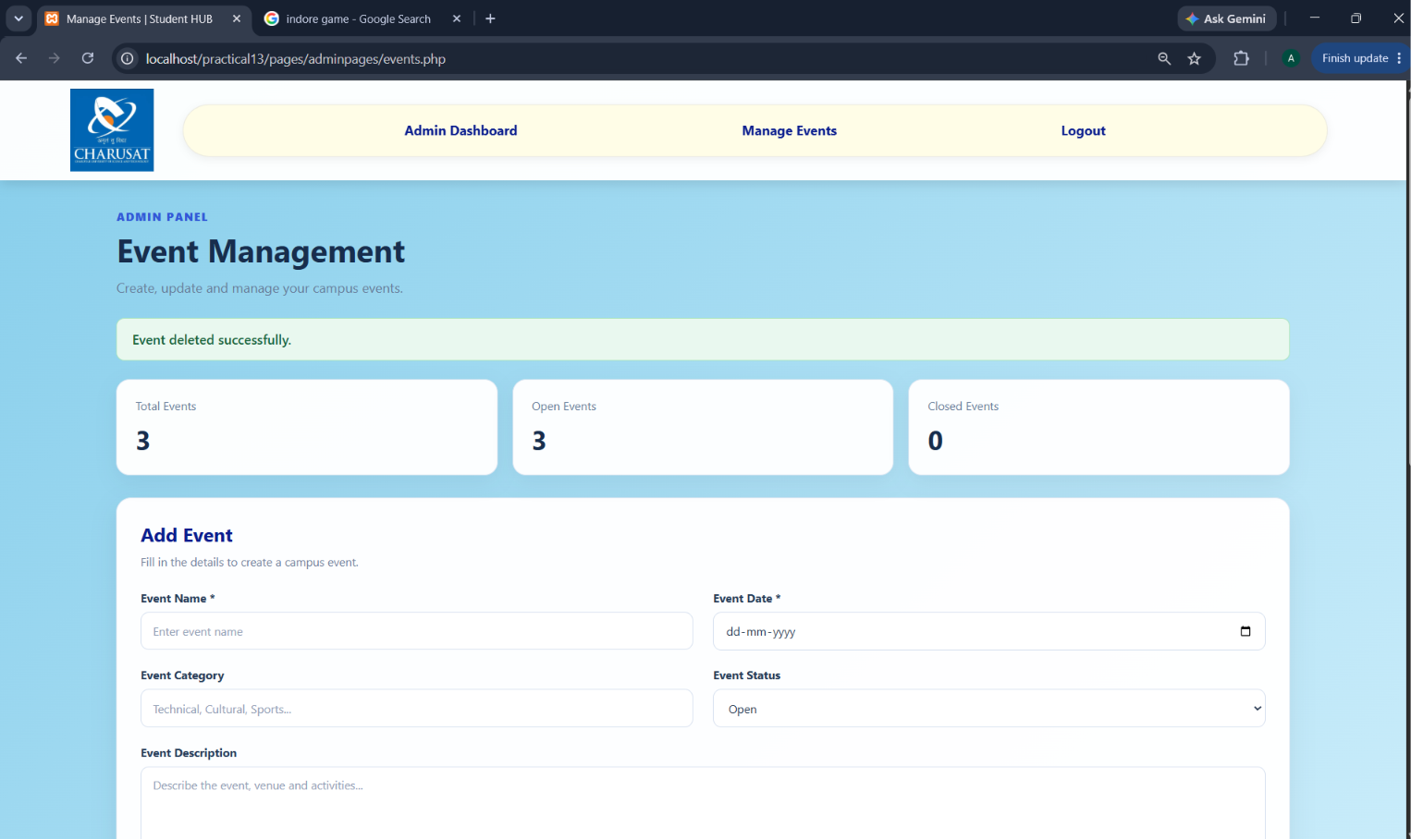 add event without refreshing and also delete without refreshing 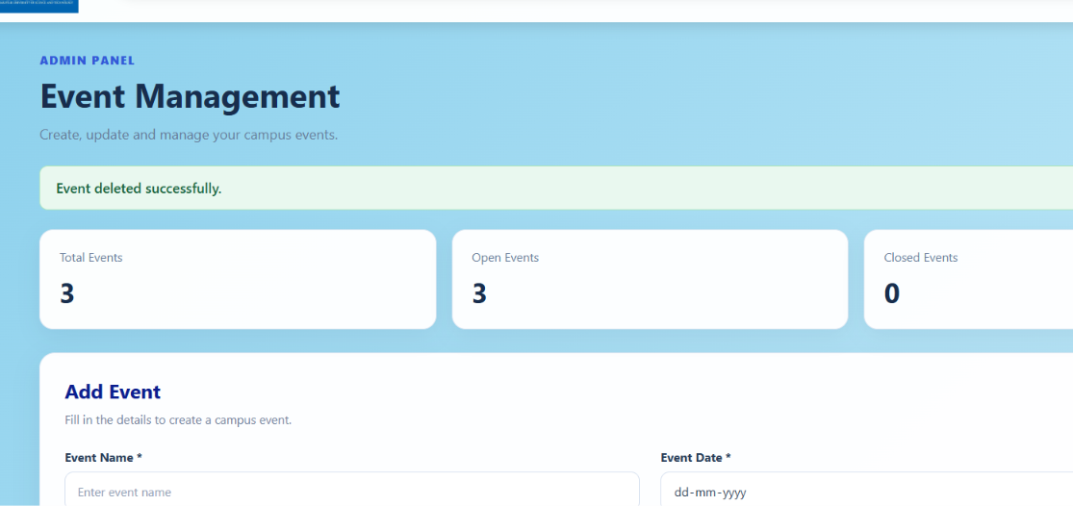
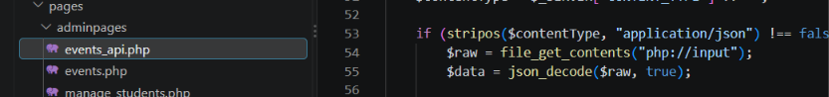
This is done with the help of event api
Code events_api.php
// Add a student without page refresh
fetch("api.php", {
method: "POST",
headers: {
"Content-Type": "application/json"
},
body: JSON.stringify({
name: "Rahul",
email: "rahul@example.com"
})
})
.then(response => response.json())
.then(data => {
alert(data.message);
loadStudents(); // Refresh only the student list
})
.catch(error => console.error(error));

Learning Outcomes:

GitHub Repository Link:
Students will learn to connect JavaScript with PHP JSON APIs and perform CRUD operations asynchronously without reloading the page.

https://github.com/25dce003-jpg/WDF

Challenges Faced:

I faced difficulties handling JSON responses, using the Fetch API, managing asynchronous requests, validating user inputs, and displaying proper error messages.

Faculty Remarks: (Keep this blank for faculty)

Practical – 14
Practical 14: Admin Dashboard with Role-Based Access Control, Dynamic Menu, and Audit Log

Develop an admin dashboard that displays user statistics, student count, event count and latest registrations. Restrict access to admin users only and show dynamic menu options based on role.

Theory :
1. Are dashboard values loaded dynamically from the database?

Yes. Dashboard statistics, such as student count, event count, user count, and latest registrations, are fetched dynamically from MySQL.

2. Is access restricted to admin users?

Yes. Only users with the admin role can access the admin dashboard. Unauthorized users are redirected.
3. Are role-based menus working?

Yes. Menu options are displayed according to the user's role, so admins and students see different options.

4. Are important admin actions recorded in audit_logs?

Yes. Important actions, such as adding, updating, or deleting records, are stored in the audit_logs table for tracking.

Implementation/ Output/Result
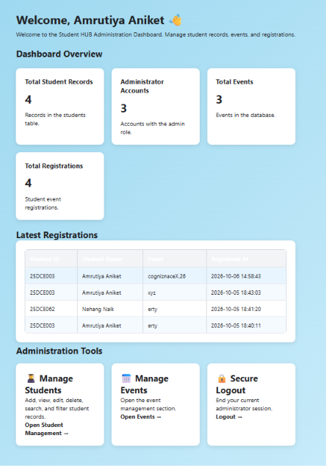

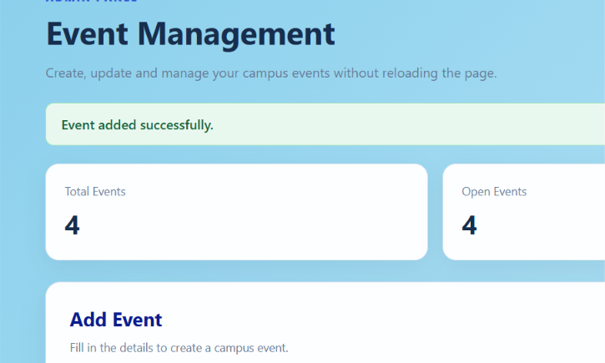
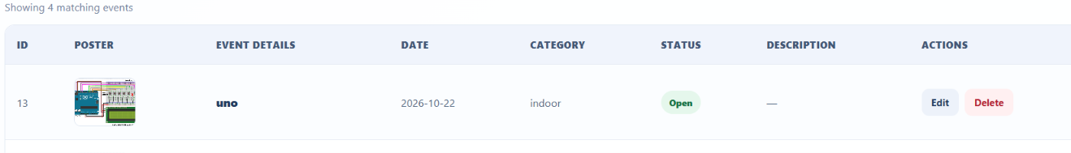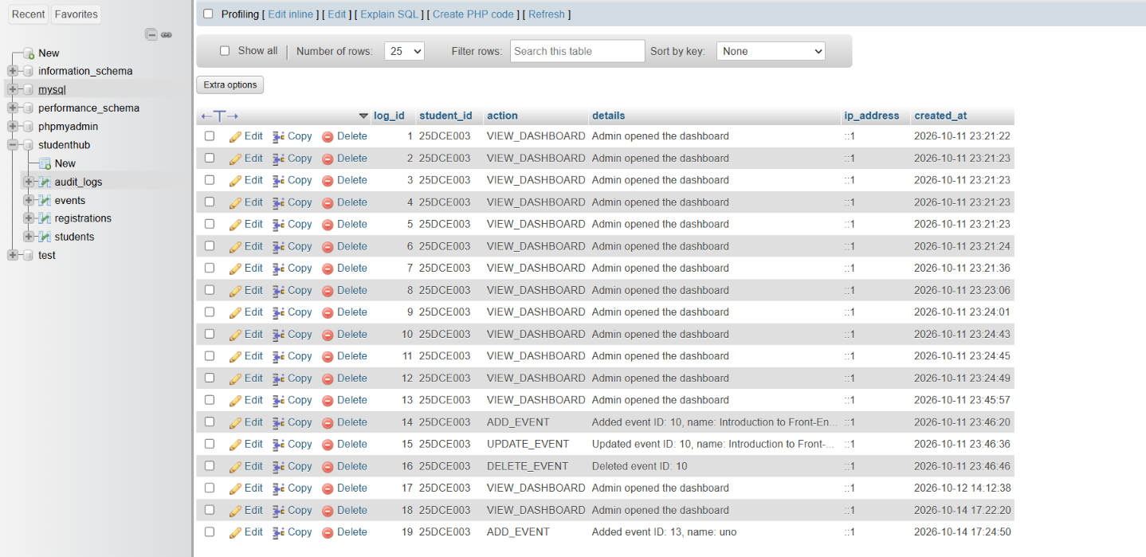

Learning Outcomes:
Students will learn to build a secure admin dashboard with role-based access, dynamic statistics, menus, and audit logging.

GitHub Repository Link:

https://github.com/25dce003-jpg/WDF

Challenges Faced:
I faced difficulties fetching dashboard statistics from MySQL, restricting access based on user roles, displaying dynamic menus, and recording admin activities in the audit log.

Faculty Remarks: (Keep this blank for faculty)

