Practical - 1
Practical Title: Project Initiation, Requirement Analysis, Sitemap, Wireframe, and GitHub Setup

Problem Definition: Initiate the semester-long StudentHub portal by identifying the problem scope, user roles, key modules, navigation flow, and minimum 10 pages. Create a sitemap, low-fidelity wireframe, project folder structure, README file, and GitHub repository.

Theory

What is URL and parts of URL?
Answer: A URL is the address of a resource and it tells the web browser where a webpage or file is located and access it and display the requested webpage.
Protocol http/https
Domain Name: www.example.com
Path: /products/item.html
Query String: id=101
Fragment: reviews
Example URL:
https://www.example.com/products/item.html?id=101#reviews

How does HTML file process in web browser?
Answer: Answer:
When an HTML file is opened, the web browser reads the HTML code, creates the webpage structure (DOM), applies CSS for styling, runs JavaScript if present, and displays the webpage on the screen.
Browser reads the HTML file.
Creates the page structure (DOM).
Applies CSS styles.
Runs JavaScript.
Displays the webpage.

3. How will page navigation flow managed among all HTML pages?
Answer: Page navigation is managed by using links (<a> tags) between HTML pages. Every page has a navigation menu with links like Home, About, Contact, and Services. When the user clicks a link, the browser opens the selected page.

4. How will GitHub commits be maintained after each practical?
Answer: GitHub commits will be maintained by making a new commit after every practical. Each commit will have a short and clear message describing the changes made. This helps to keep track of the project and its progress.

Implementation/ Output/Result
The webpage displays a Student HUB dashboard with a navigation menu, timetable, attendance, fee details, university results, and a footer.

Evidence of Work (Screenshots)
LOGIN PAGE
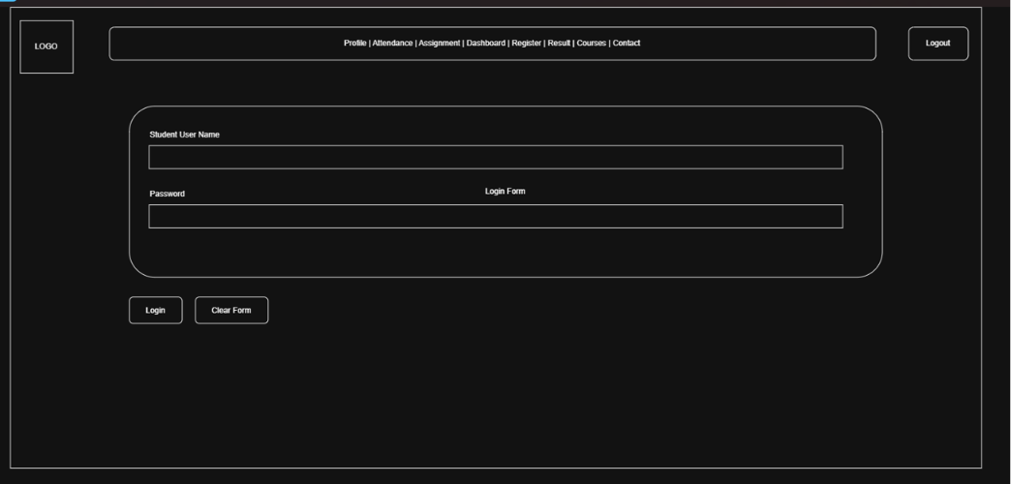
Description: wireframe
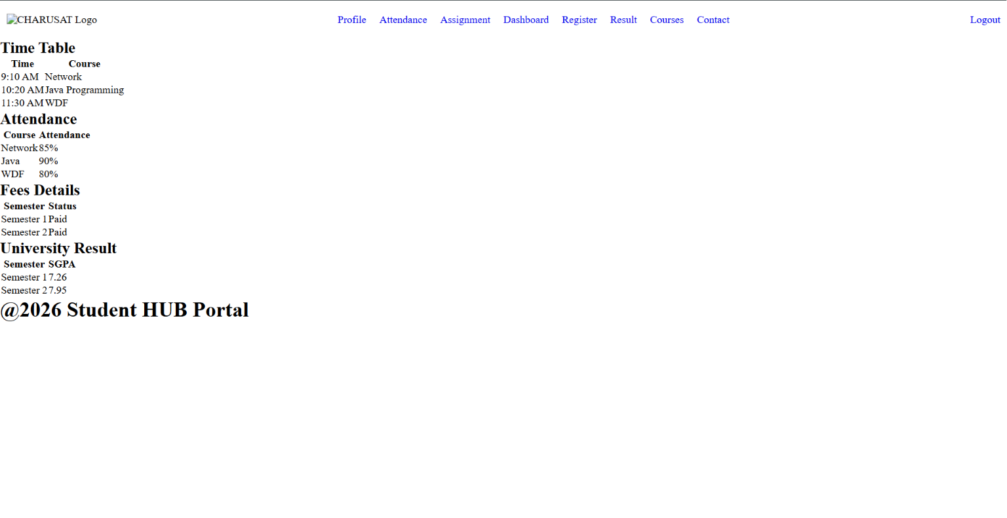
INDEX PAGE
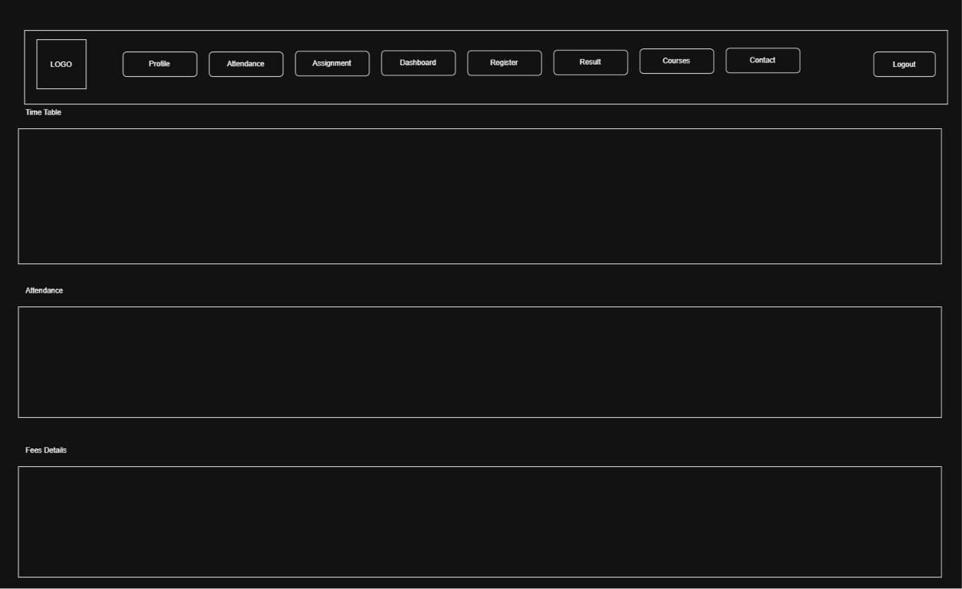
PROFILE PAGE
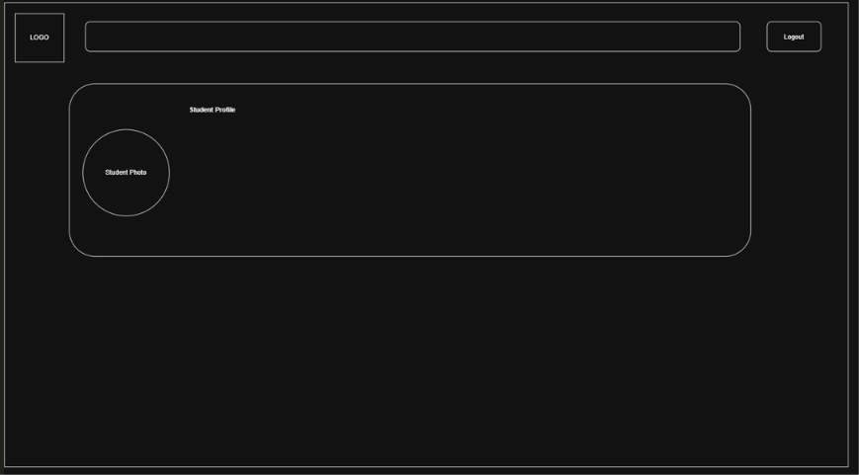

ATTENDANCE PAGE
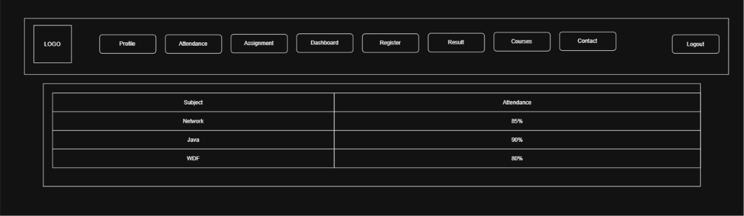
REGISTRATION PAGE
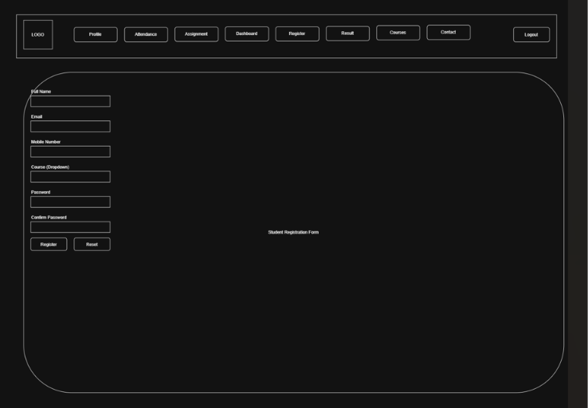

RESULT PAGE
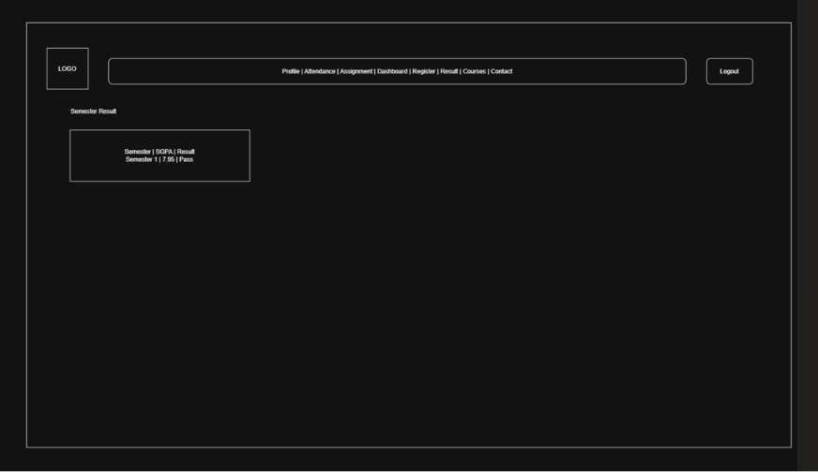
COURSE PAGE
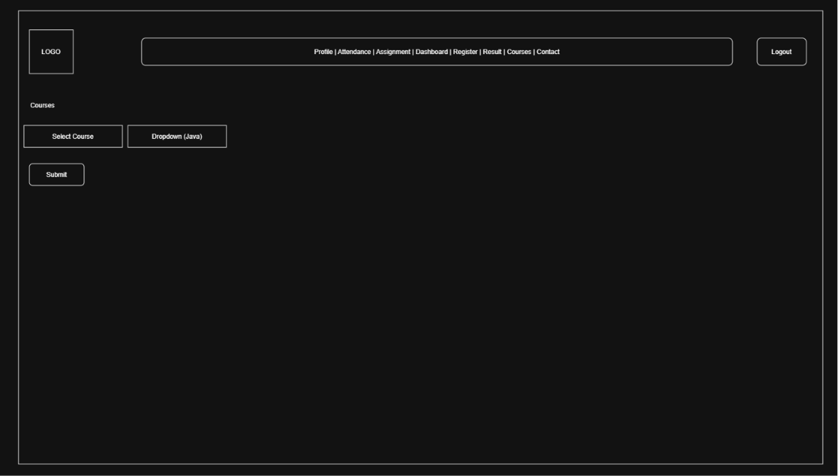

CONTACT PAGE
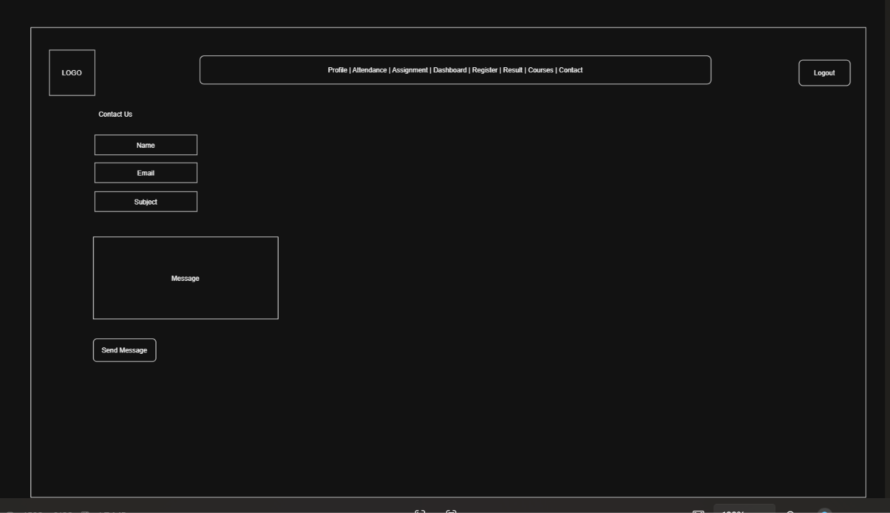

Description: Index.html

GitHub Repository Link:

https://github.com/25dce003-jpg/WDF.git

Challenges Faced:
Make a wireframe in draw.io

Learning Outcomes:
Learned the basic structure of an HTML webpage, how to create and link multiple HTML pages, Learned to use tables to display data, Learned to create a simple Student HUB Portal, Learned the basics of GitHub for project management, GitHub, sitemap, wireframe.

Faculty Remarks:

