Practical – 10
Practical 10: Secure Login/Logout with Sessions, Role-Based Access, Timeout, and Remember-Me Token

Develop secure login and logout functionality using PHP sessions. Verify password using password_verify(), regenerate session ID after login, restrict dashboard access, implement role-based redirection, session timeout, and optional secure remember-me token.

Theory :
1. Are sessions started and destroyed securely? Yes. session_start() starts the session, and session_destroy() destroys it during logout. The session ID is regenerated after login for better security.
2. Is password_verify() used correctly? Yes. password_verify() checks the entered password against the hashed password stored in the database.
3. Is unauthorized dashboard access blocked? Yes. The dashboard checks whether the user is logged in. If not, the user is redirected to the login page.
4. Is session timeout implemented? Yes. If the user remains inactive for a specified time, the session expires, and the user must log in again.
5. Are admin and student users redirected to appropriate dashboards? Yes. Role-based access redirects admin users to the admin dashboard and student users to the student dashboard.

Implementation/ Output/Result

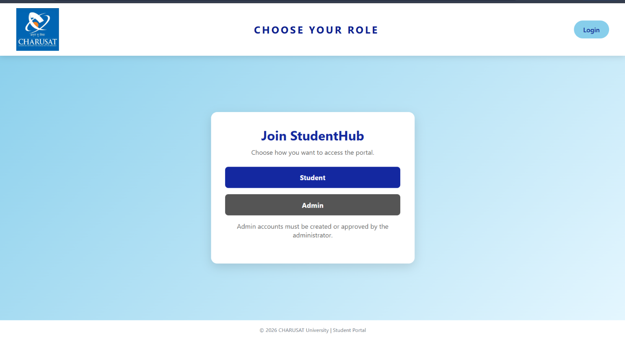
In this if not user of this website you want to sign up and choose role student or admin. And for both there is a different dashboard. 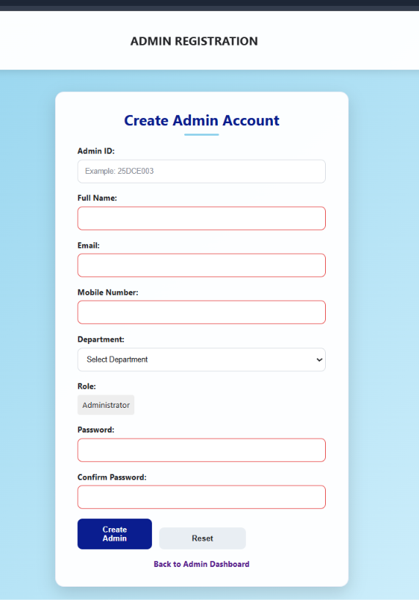
In this you can register as admin
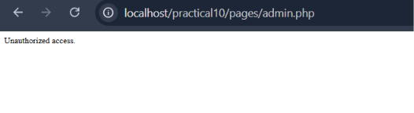
If u login as student and you open admin.php to it is not open Unauthorized access.
And also if u open any page for example index.php so it not open it direct open login.php
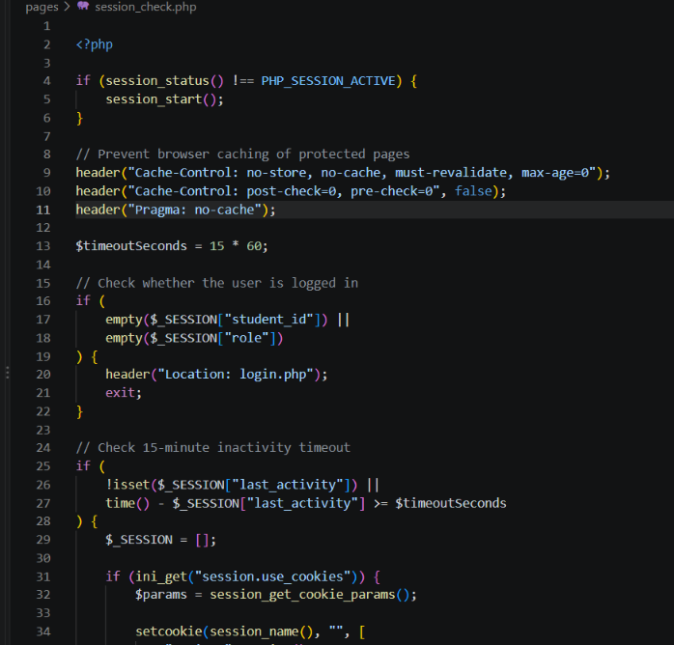
This is session_check.php some code I give sime of 15 min.
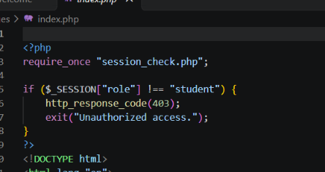
This code authorized access are add the top part of code all pages.

Learning Outcomes:

I learn to implement secure login and logout using PHP sessions, password verification, role-based access control, and session timeout.

GitHub Repository Link:

https://github.com/25dce003-jpg/WDF

Challenges Faced:
Unauthorized problem and also in this session time so waste the time in only session check

Faculty Remarks: (Keep this blank for faculty)

