Practical – 11
Practical 11: Student Management CRUD with Search and Filter

Create a student management module to add, view, edit, delete, search and filter student records. All database operations must use MYSQLi statements and clear success/failure messages.

Theory :
1. Are SELECT, INSERT, UPDATE, and DELETE operations working?

Yes. These operations are used to view, add, edit, and delete student records in the database.

2. Is search by name/email/course implemented?

Yes. Users can search student records by name, email, or course to find specific information easily.

3. Are delete operations confirmed before execution?

Yes. A confirmation message is displayed before deleting a student record to prevent accidental deletion.

Implementation/ Output/Result
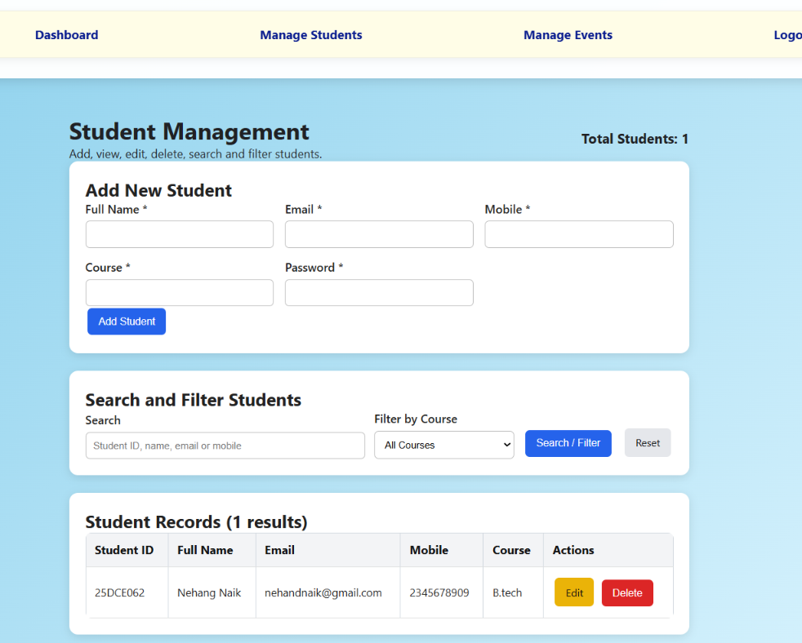

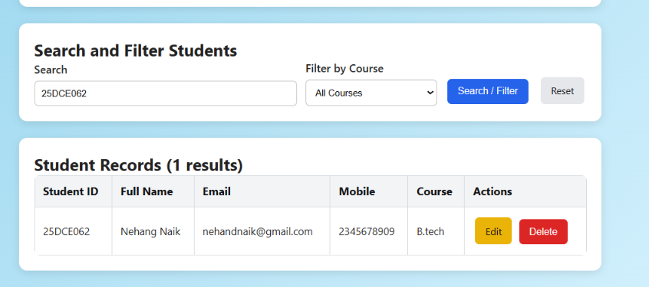
In this you can also Add, view, edit, delete, search and filter students.
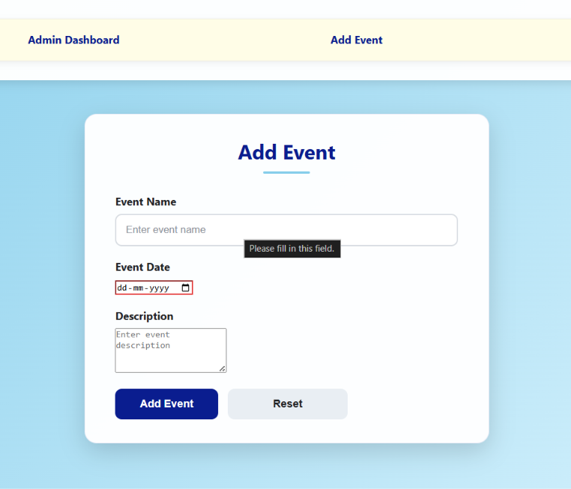
In this you can also add events.

Learning Outcomes:

I learn to develop a secure student management system using PHP and MySQLi to add, view, update, delete, search, and filter student records.

GitHub Repository Link:

https://github.com/25dce003-jpg/WDF

Challenges Faced:
I faced some difficulties connecting PHP with MySQL, writing CRUD queries, implementing search and filter functionality, and handling success or error messages.

Faculty Remarks: (Keep this blank for faculty)

