Practical – 12
Practical 12 Event Management CRUD with Poster Upload and File Validation Student Management CRUD with Search and Filter

Develop event management functionality for admin users. Admin can add, view, update, delete, and upload event posters with file type and file size validation.

Theory :
1. Are add, update, and delete functionalities implemented correctly?

Yes. Admin can add new events, update existing event details, and delete events from the database.
2. Is the UI linked with the database correctly?

Yes. The PHP interface is connected to MySQL to store, retrieve, update, and delete event records.
3. Are poster uploads validated for type and size?

Yes. The system checks the poster's file type and size before uploading it to prevent invalid files.
4. Are success and failure messages displayed?

Yes. Success messages appear when an operation is completed, and error messages appear when an operation fails.

Implementation/ Output/Result
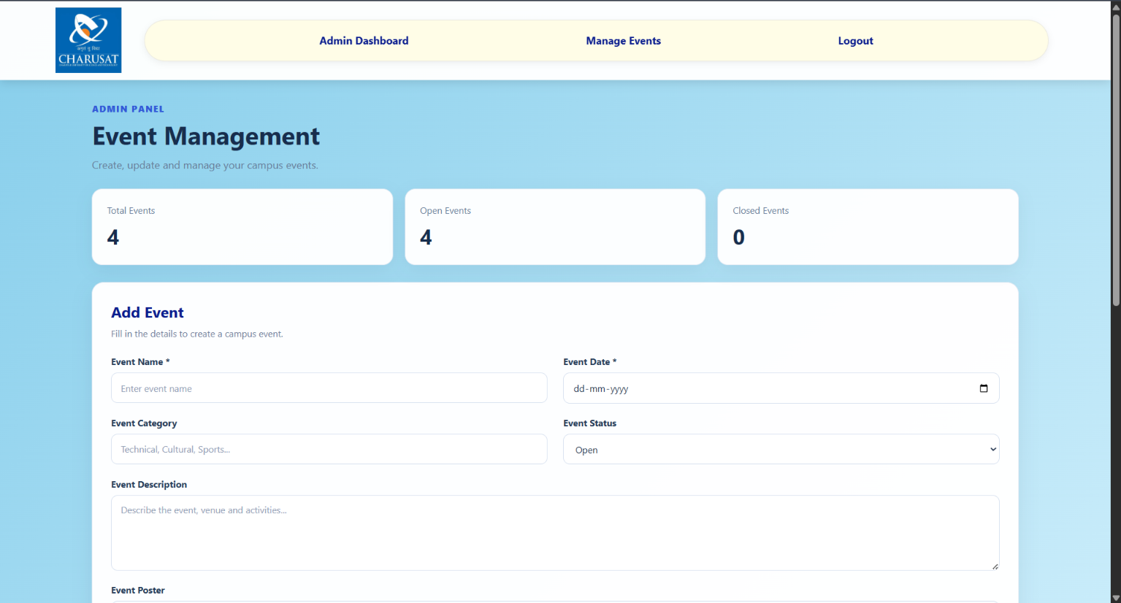
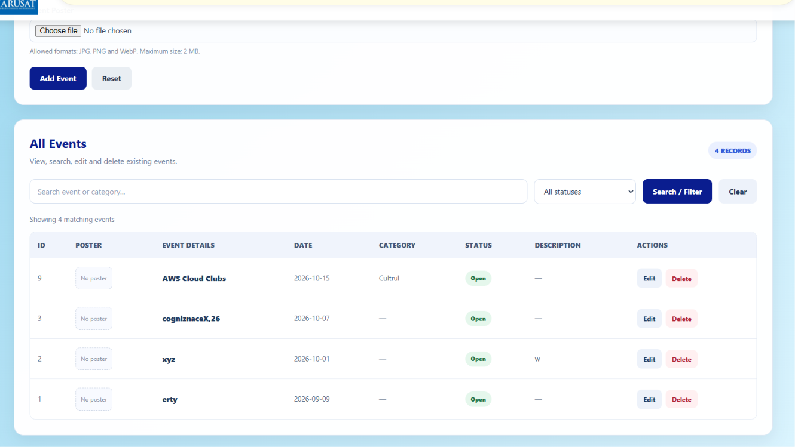


Poster is also add in this website

Delete event

Learning Outcomes:
I will learn to develop a secure event management system using PHP and MySQL with CRUD operations and validated poster uploads.

GitHub Repository Link:

https://github.com/25dce003-jpg/WDF

Challenges Faced:

I faced difficulties connecting PHP with MySQL, validating poster file types and sizes, handling file uploads, and displaying proper success and error messages.

Faculty Remarks: (Keep this blank for faculty)

