Practical – 13
Practical 13: PHP JSON API and AJAX/Fetch-Based CRUD without Page Reload

Create simple PHP JSON API endpoints for events or students and consume them using Fetch API. Perform list, add, update, and delete operations asynchronously without full page reload.

Theory :
1. Do PHP endpoints return valid JSON responses?

Yes. PHP endpoints return data in JSON format, which JavaScript can easily read and process.

2. Are GET and POST requests handled properly?

Yes. GET is used to retrieve data, while POST is used to send data to the server for processing.

3. Are loading, success, and error states shown on the frontend?

Yes. The frontend displays loading messages, success messages, and error messages based on the API response.

4. Is input validation performed before database operations?

Yes. User inputs are validated before database operations to prevent invalid data and improve security.

Implementation/ Output/Result
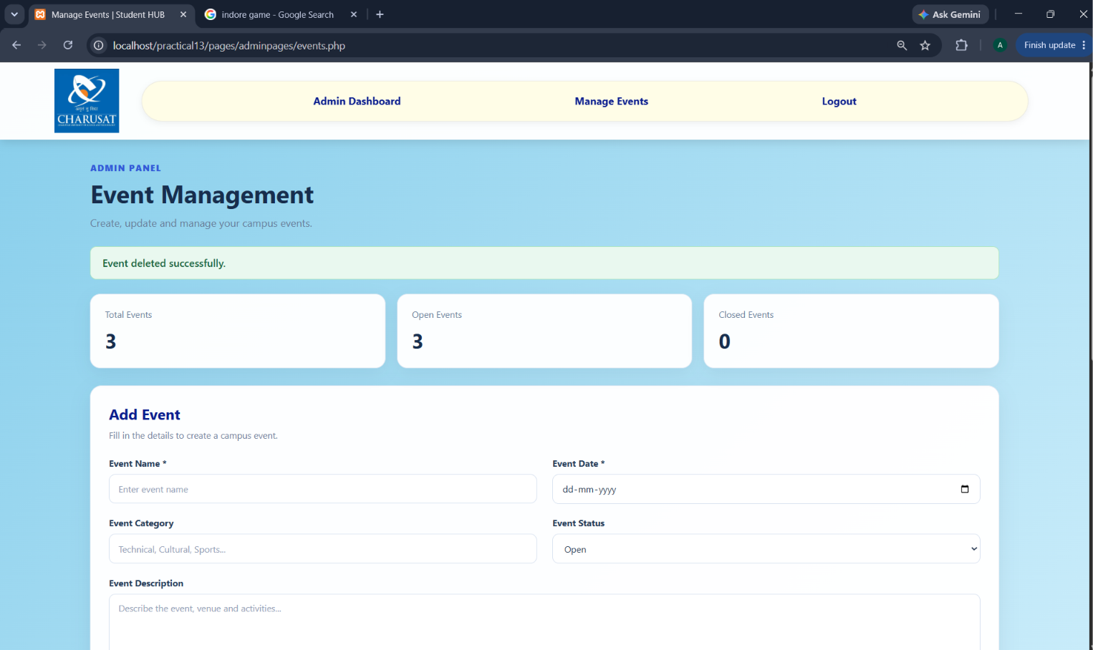 add event without refreshing and also delete without refreshing 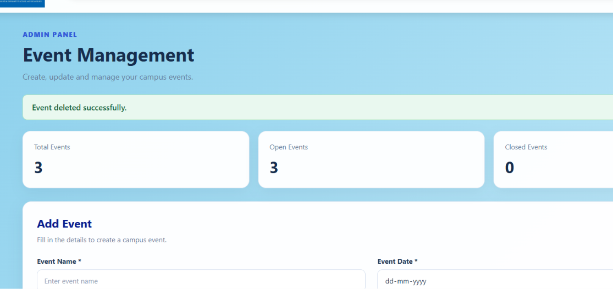
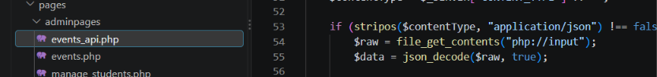
This is done with the help of event api
Code events_api.php

// Add a student without page refresh
fetch("api.php", {
method: "POST",
headers: {
"Content-Type": "application/json"
},
body: JSON.stringify({
name: "Rahul",
email: "rahul@example.com"
})
})
.then(response => response.json())
.then(data => {
alert(data.message);
loadStudents(); // Refresh only the student list
})
.catch(error => console.error(error));

Learning Outcomes:

GitHub Repository Link:
Students will learn to connect JavaScript with PHP JSON APIs and perform CRUD operations asynchronously without reloading the page.

https://github.com/25dce003-jpg/WDF

Challenges Faced:

I faced difficulties handling JSON responses, using the Fetch API, managing asynchronous requests, validating user inputs, and displaying proper error messages.

Faculty Remarks: (Keep this blank for faculty)

