Practical – 14
Practical 14: Admin Dashboard with Role-Based Access Control, Dynamic Menu, and Audit Log

Develop an admin dashboard that displays user statistics, student count, event count and latest registrations. Restrict access to admin users only and show dynamic menu options based on role.

Theory :
1. Are dashboard values loaded dynamically from the database?

Yes. Dashboard statistics, such as student count, event count, user count, and latest registrations, are fetched dynamically from MySQL.

2. Is access restricted to admin users?

Yes. Only users with the admin role can access the admin dashboard. Unauthorized users are redirected.
3. Are role-based menus working?

Yes. Menu options are displayed according to the user's role, so admins and students see different options.

4. Are important admin actions recorded in audit_logs?

Yes. Important actions, such as adding, updating, or deleting records, are stored in the audit_logs table for tracking.

Implementation/ Output/Result
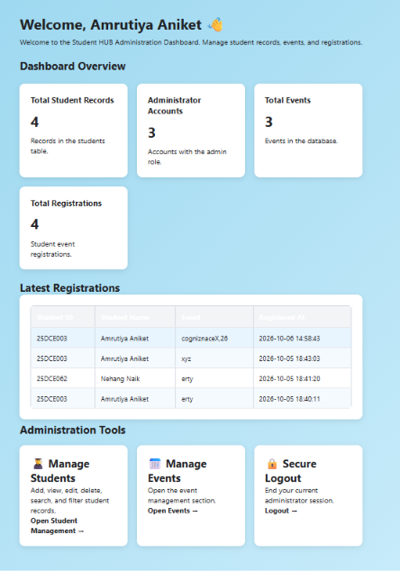

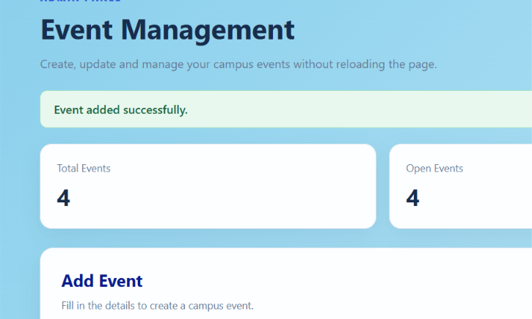
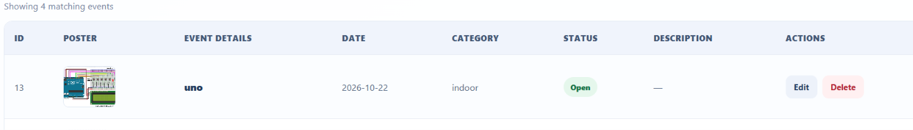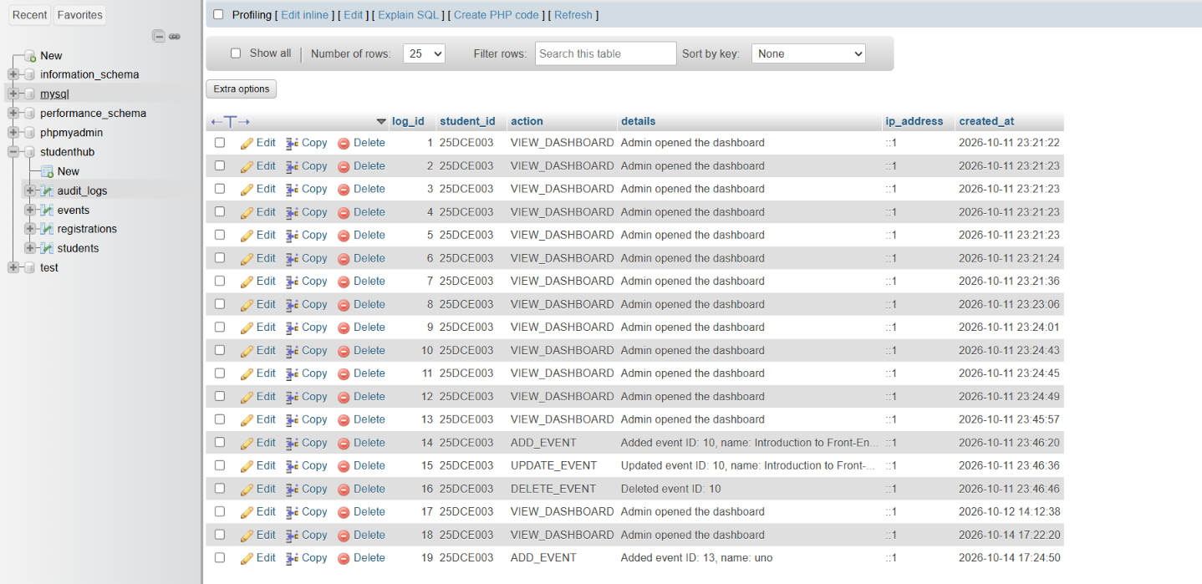

Learning Outcomes:
Students will learn to build a secure admin dashboard with role-based access, dynamic statistics, menus, and audit logging.

GitHub Repository Link:

https://github.com/25dce003-jpg/WDF

Challenges Faced:
I faced difficulties fetching dashboard statistics from MySQL, restricting access based on user roles, displaying dynamic menus, and recording admin activities in the audit log.

Faculty Remarks: (Keep this blank for faculty)

