Practical – 2
Semantic HTML5 Pages with Accessibility-Ready Structure

Develop static HTML5 skeletons for at least 10 StudentHub pages such as Home, About, Register, Login, Dashboard, Events, Profile, Contact, Admin, FAQ, and Feedback. Use semantic tags and accessibility-friendly structure.
- Are semantic tags such as header, nav, main, section, article, aside, and footer used properly?
Answer: Yes. I used semantic tags like header, nav, main, section, and footer to organize the webpage. This makes the code simple and easy to understand.

2. Are form labels, headings, image alt text, and navigation links accessible?
Answer:
Yes. I added labels for form fields, used proper headings, gave images alt text, and provided navigation links so users can easily use the website.
3. Is the page structure consistent across all pages?
Answer:
Yes. All pages have the same header, navigation menu, main content area, and footer. This keeps the website neat and easy to use.

- Implementation/ Output/Result (Keep only one option which is suitable to practical)
The Student HUB Portal was developed using HTML5 semantic elements. All pages use semantic tags such as <header>, <nav>, <main>, <section>, and <footer>. A common navigation menu is provided to link all pages. Images include alt text, and forms use proper labels for better accessibility.
Pages Created:
- Home
- About
- Register
- Login
- Dashboard
- Events
- Profile
- Contact
- Admin
- FAQ
- Feedback
Output:
All HTML pages are linked correctly and display a consistent layout with a header, navigation menu, main content, and footer. The website is easy to navigate and follows basic HTML5 accessibility guidelines.

- Evidence of Work (Screenshots)
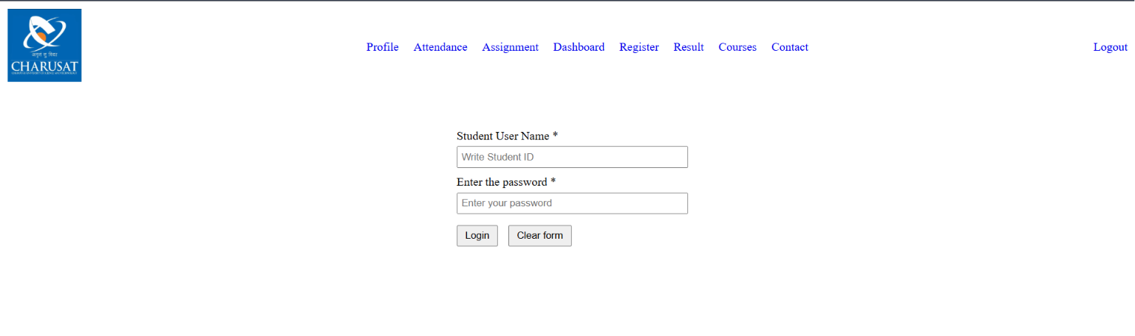 Description: login page
Screenshot 2
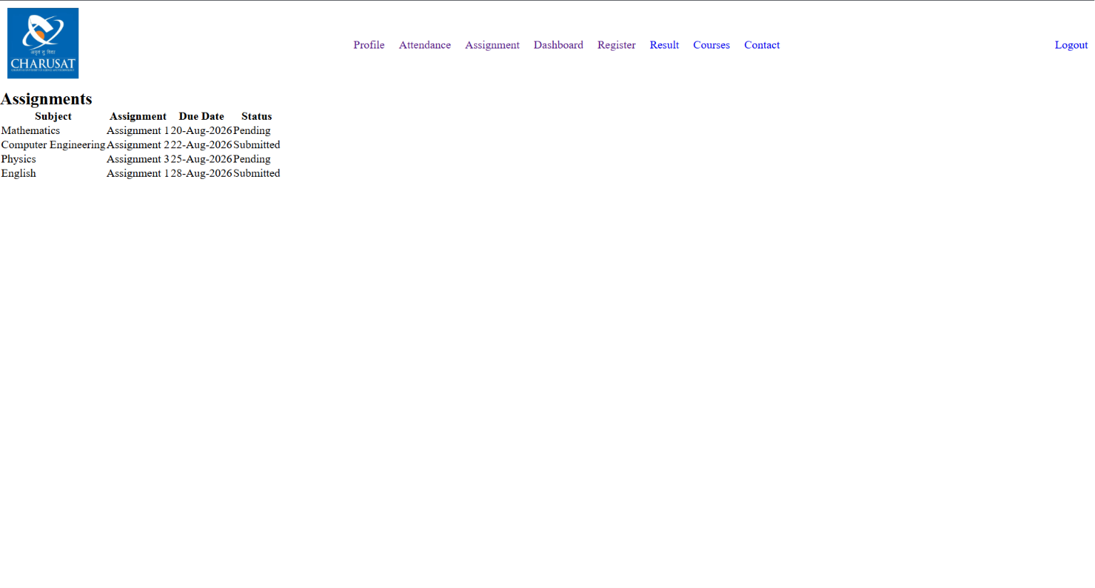
Description: Assignment page
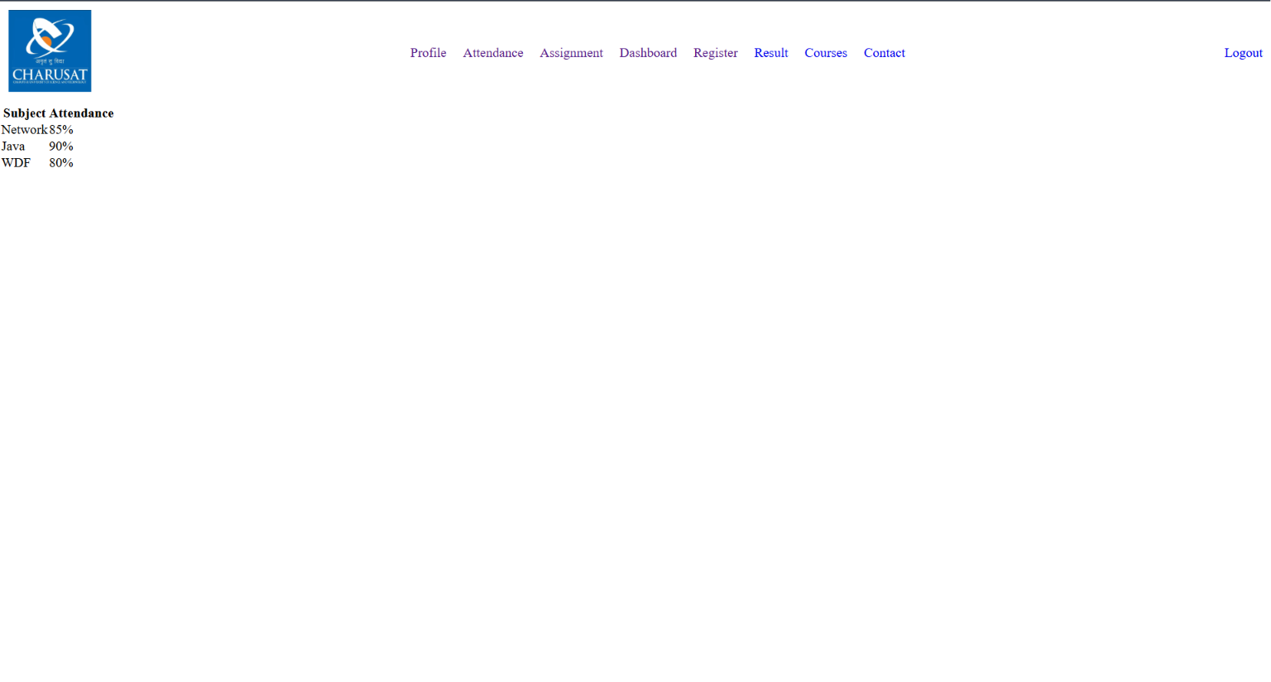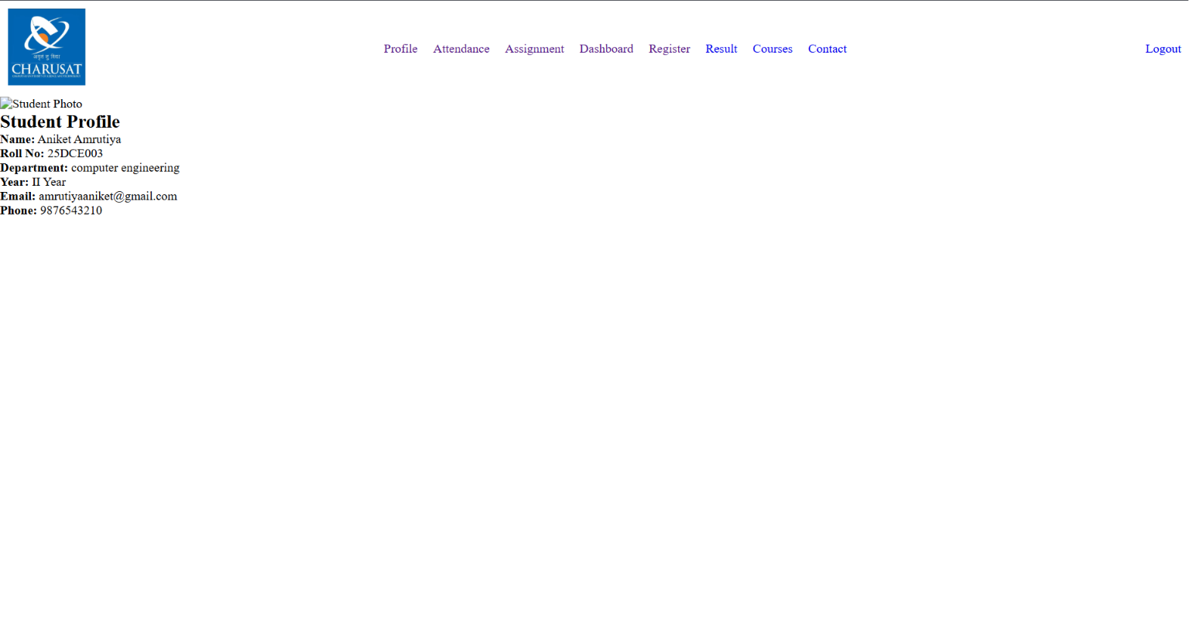
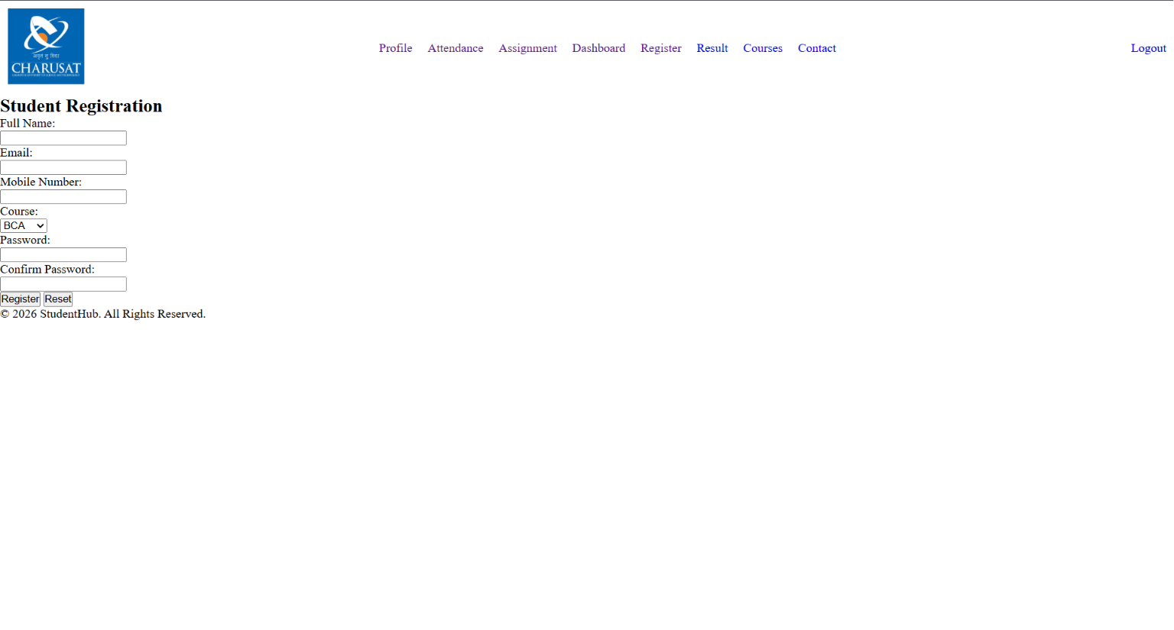
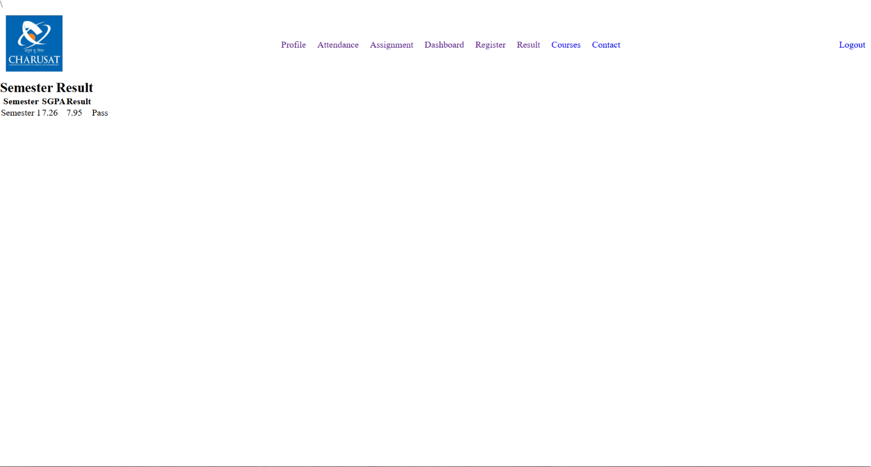
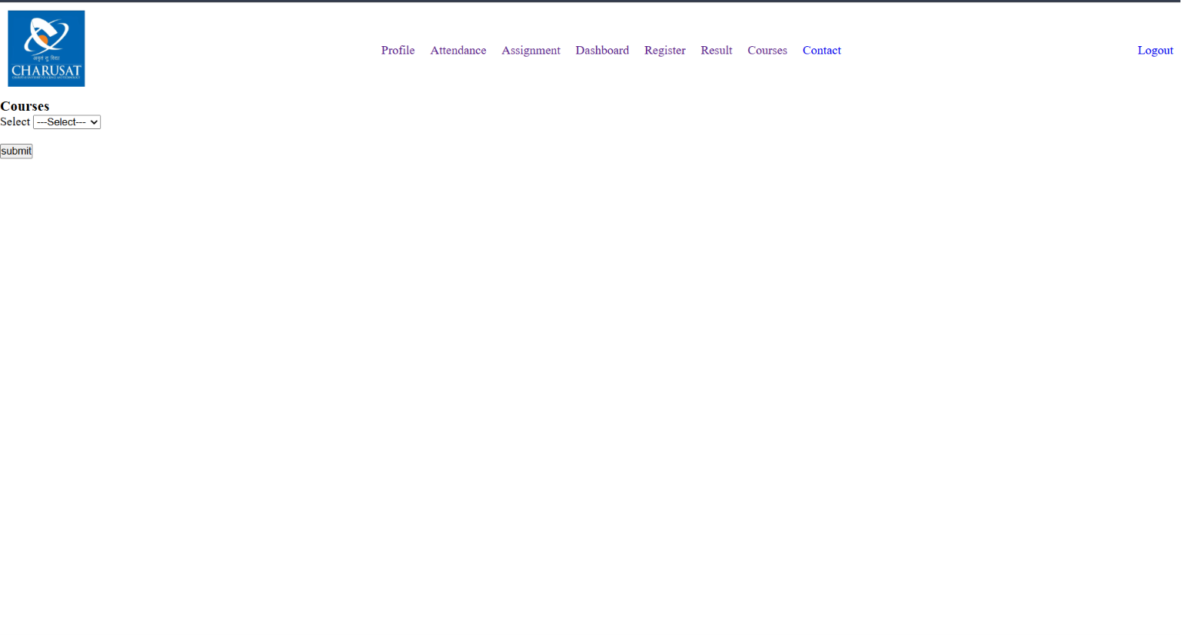
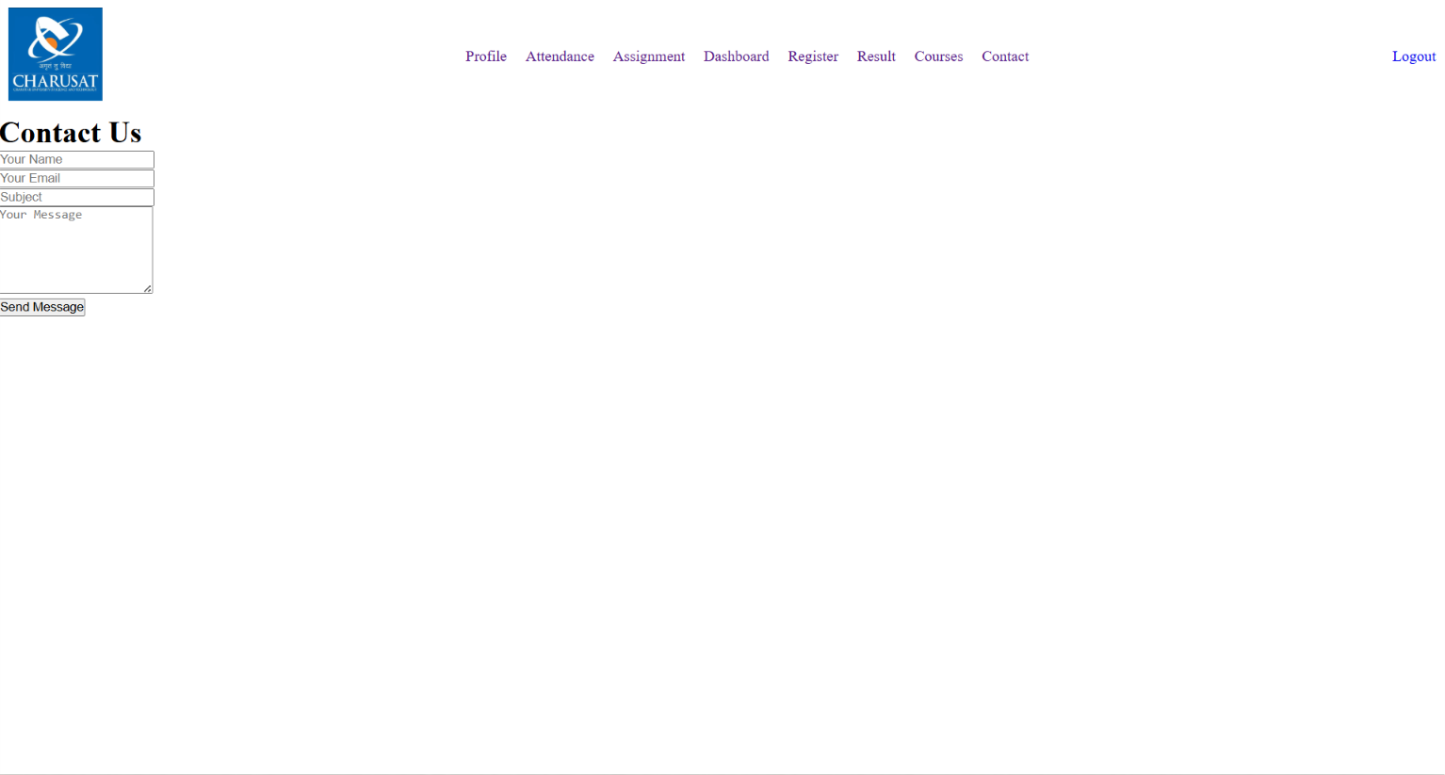

- GitHub Repository Link:
https://github.com/25dce003-jpg/WDF.git
Linking all HTML pages correctly, Using semantic HTML5 tags properly, Keeping the same layout on every page, adding proper labels and alt text for accessibility, Organizing project files and folders.

- Learning Outcomes:
In this practical, I learned how to create a website using HTML5 semantic tags. I also learned how to link multiple pages together and keep the same layout on every page. I understood the importance of accessibility by using labels, headings, and image alt text. This practical improved my HTML coding skills and helped me understand how to build a simple and well-organized website.

Faculty Remarks:

