Practical - 3
Practical Title: Responsive UI Design using CSS Grid, Flexbox, and Bootstrap/Tailwind
Problem Definition: Design responsive layouts for Home, About, Registration, Dashboard, and Events pages using CSS Grid and Flexbox. Optional to use CSS framework such as Bootstrap or Tailwind. Ensure mobile-first responsiveness
1. How does the layout adapt for mobile, tablet, and desktop screens?
Answer:
The layout changes according to the screen size. On mobile, the content is displayed in one column. On tablets and desktops, the content is arranged in multiple columns for better viewing.

2. Which layout technique is used and why?
Answer:
I used CSS Flexbox and Grid because they help create a responsive layout. They make it easy to align items and adjust the page for different screen sizes.
3. Are typography, spacing, colors, and contrast readable?
Answer:
Yes. I used simple fonts, proper spacing, and clear colors so the content is easy to read on all devices.

4. Is the framework used consistently without unnecessary inline CSS?
Answer:
Yes. I used the CSS framework consistently and avoided unnecessary inline CSS. Most of the styling is written in the CSS file.

B . Implementation/ Output/Result (Keep only one option which is suitable to practical)
I created the Student HUB Portal using HTML and CSS. I used Flexbox and Grid to make the pages responsive. The website works properly on mobile, tablet, and desktop screens with a simple and clean layout.
Output:
The pages are responsive, easy to use, and display correctly on different screen sizes.

C. Evidence of Work (Screenshots)
Screenshot 1
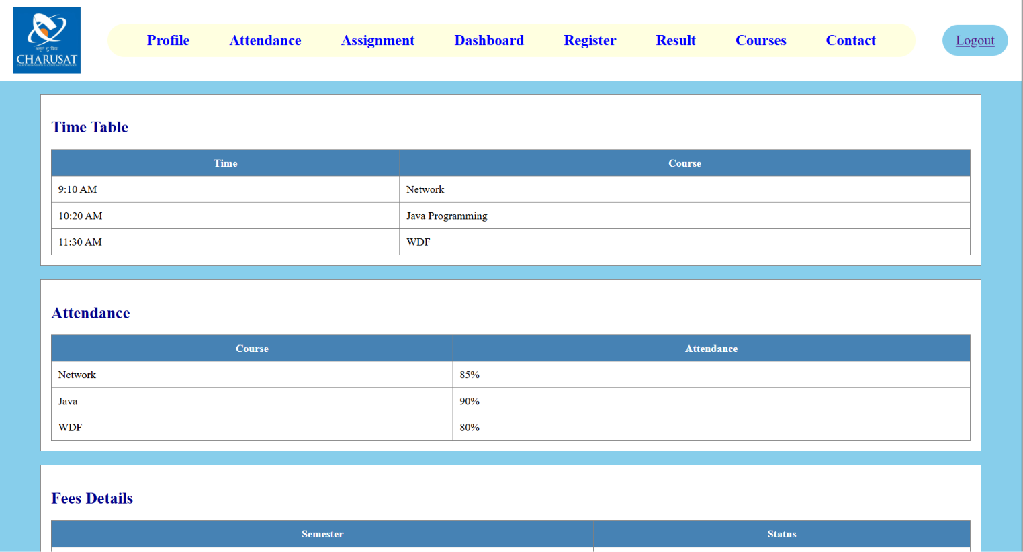
Description: Home page

Screenshot 2
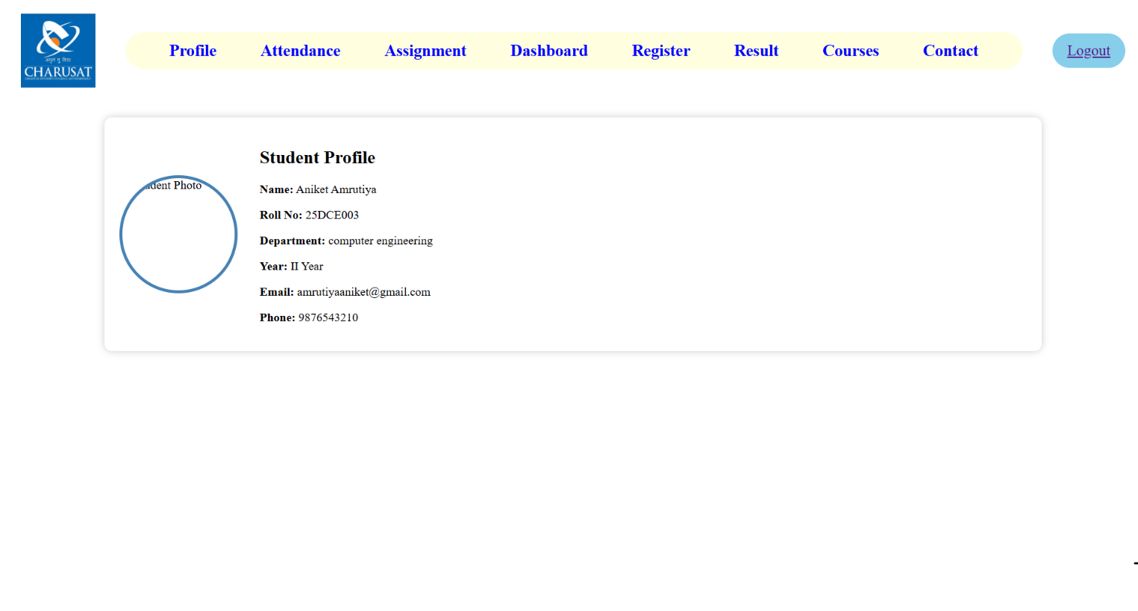
Description: Profile page
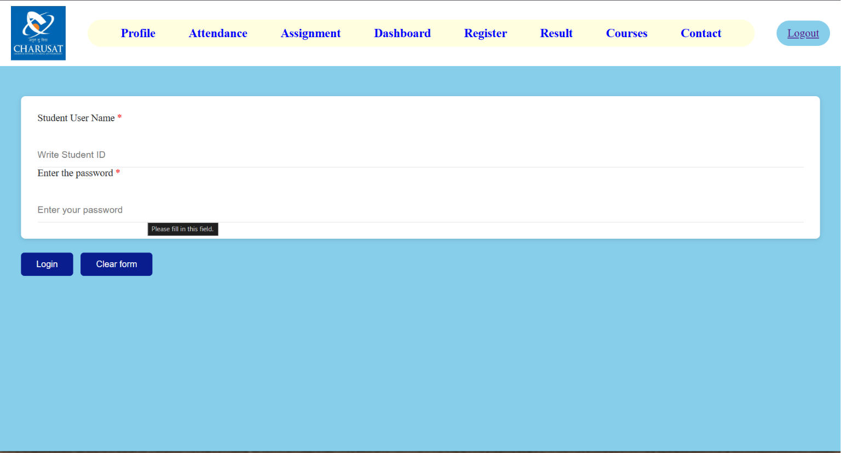
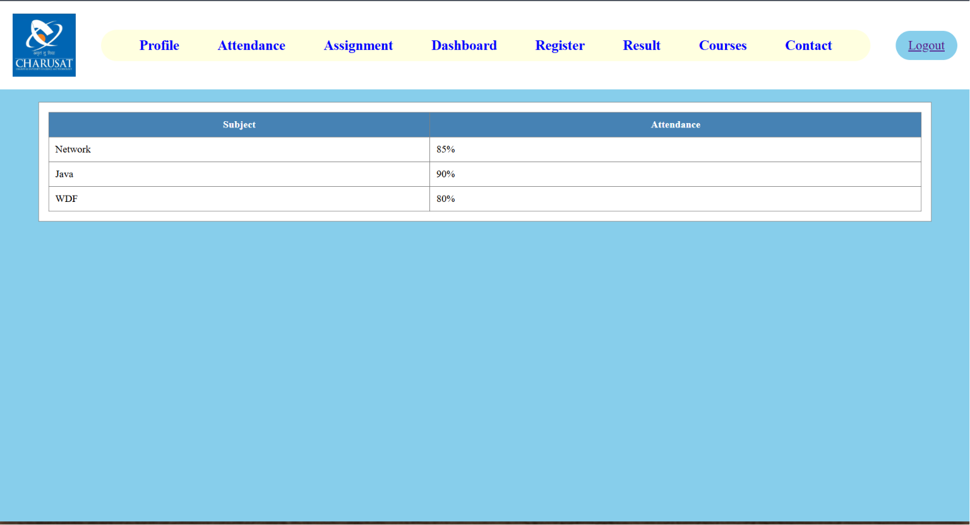
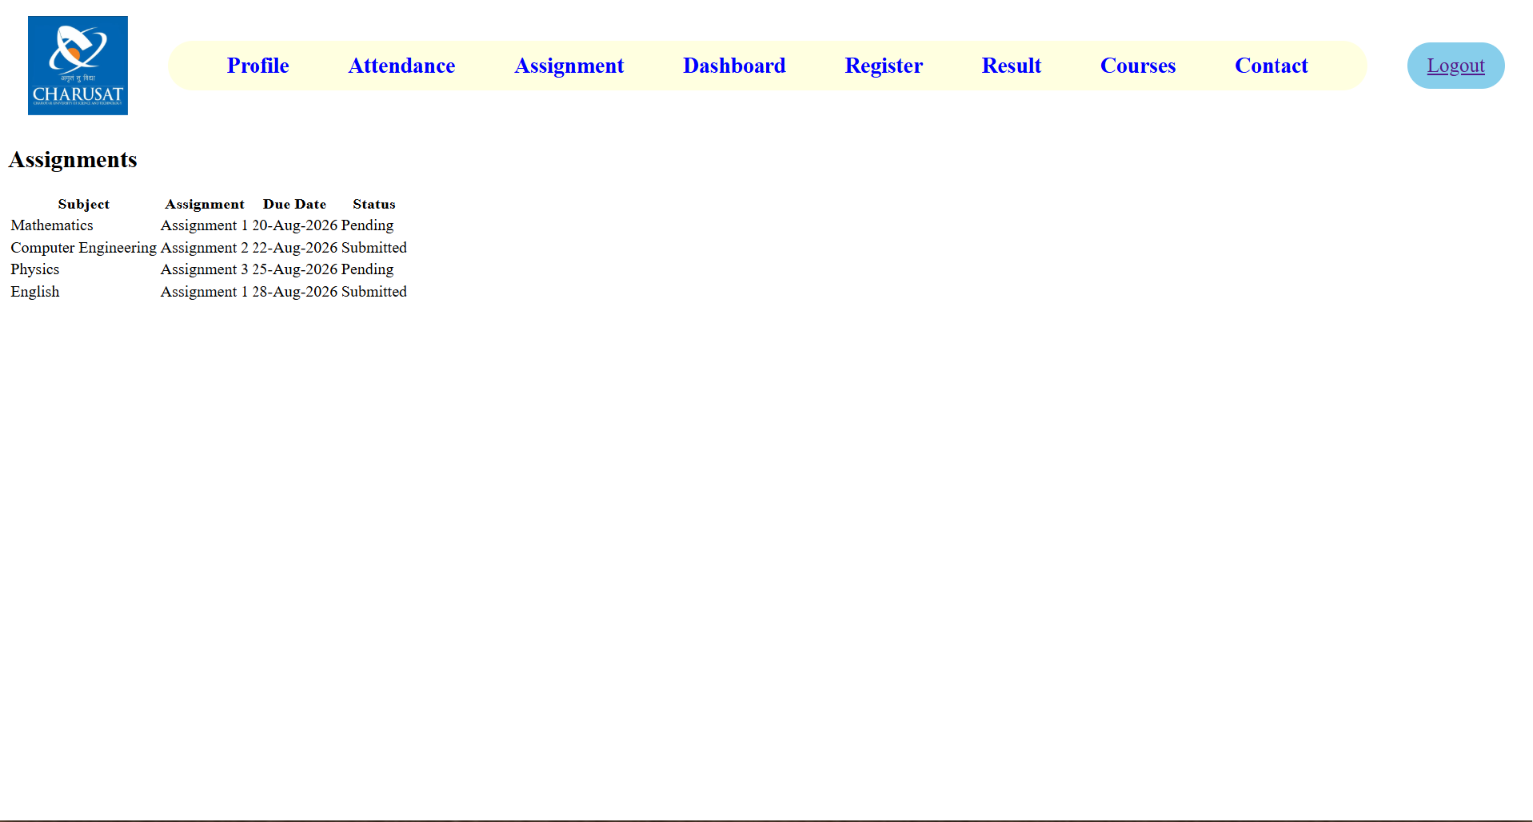
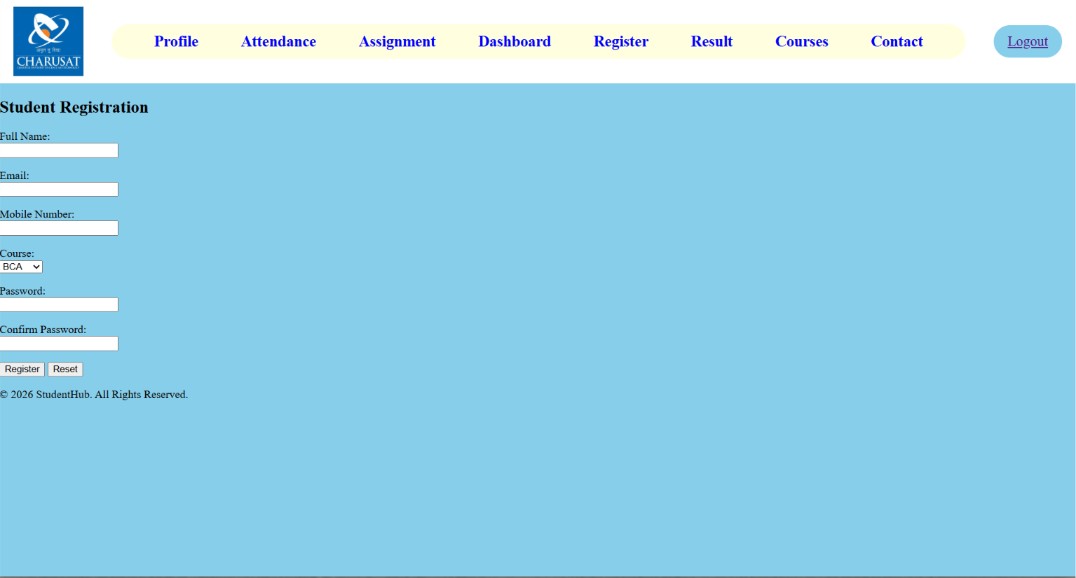
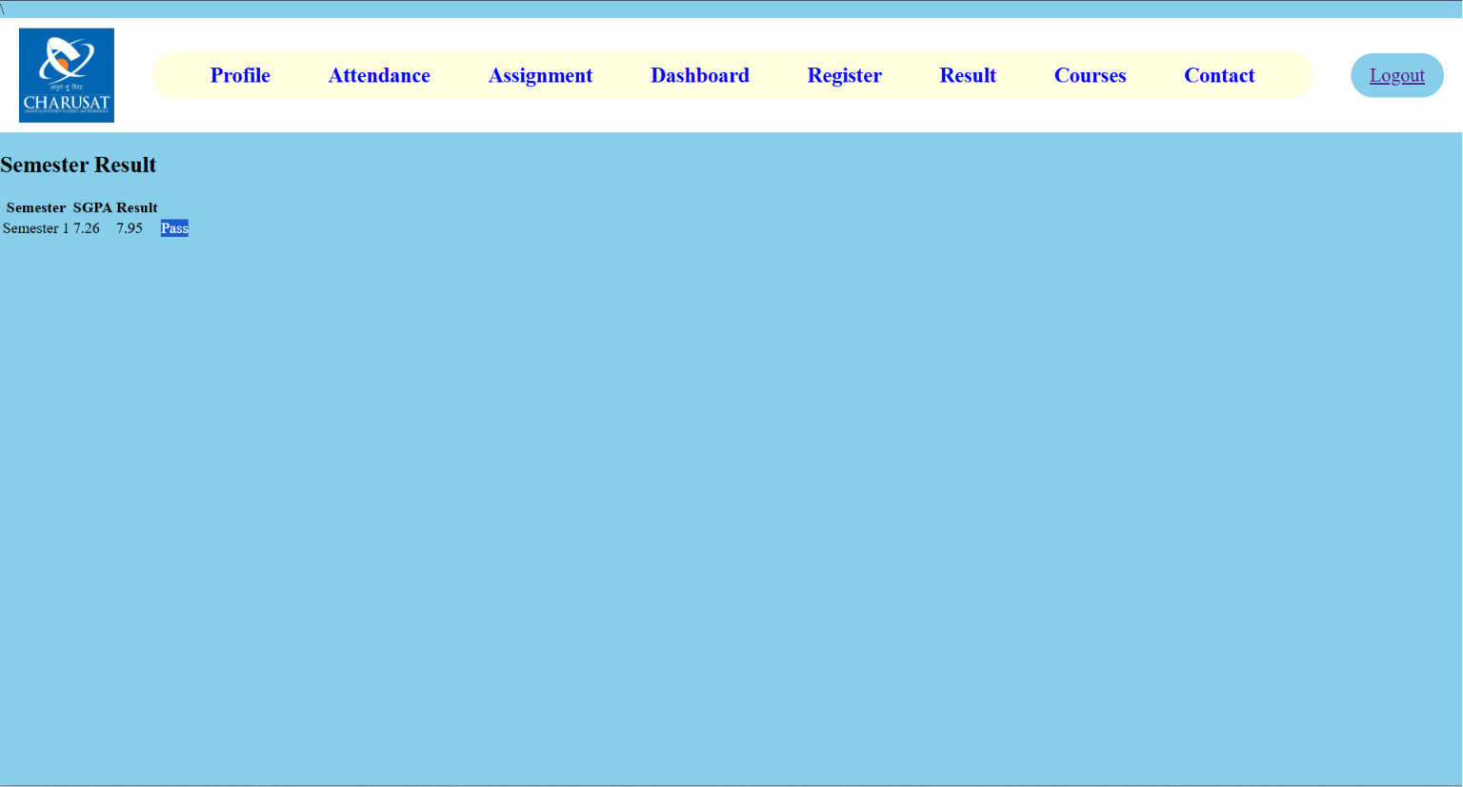
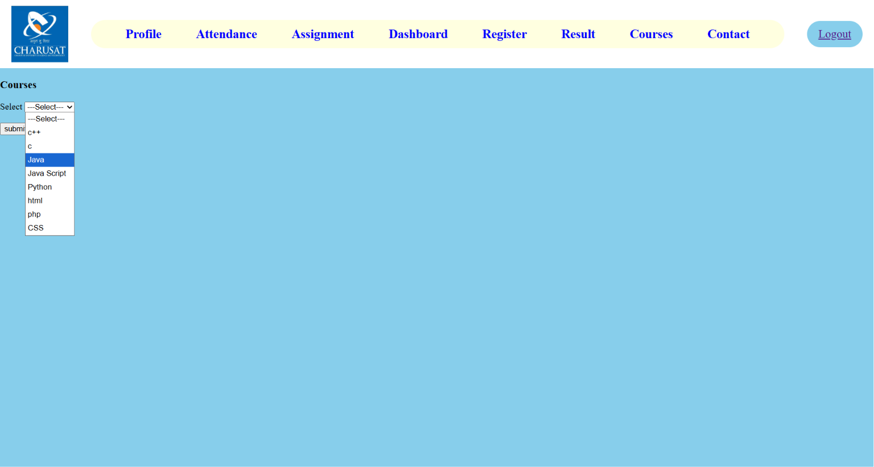
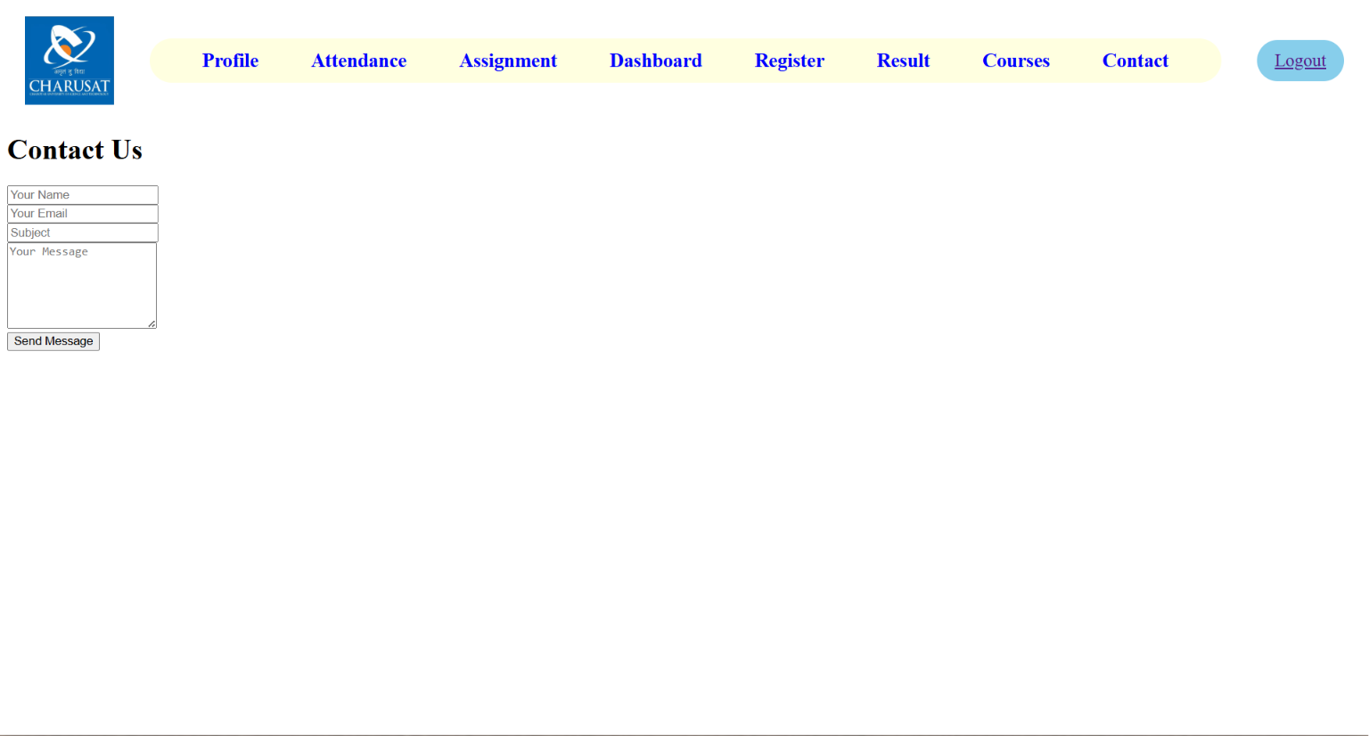

D. GitHub Repository Link: https://github.com/25dce003-jpg/WDF.git

- Challenges Faced:
While creating the responsive website, I faced some problems with page alignment and responsive layout. I also had to adjust the spacing and test the website on different screen sizes to make sure it worked properly.
- Learning Outcomes:
In this practical, I learned how to create a responsive website using CSS Flexbox and Grid. I also learned how to make web pages work on mobile, tablet, and desktop screens. This practical improved my CSS skills and helped me design a simple and user-friendly interface.

Faculty Remarks:

