Practical - 4
Practical Title: JavaScript DOM Manipulation, Event Handling, and UI Interactivity
Problem Definition: Add dynamic UI components such as collapsible FAQ, modal popup, image/content slider, notification banner, hamburger menu, and light/dark theme switcher using JavaScript.

Theory :
1. How are DOM elements selected and modified?

DOM elements are selected using methods like getElementById() or querySelector(). After selecting an element, JavaScript can change its content, style, attributes, or other properties dynamically.

2. Are event listeners attached correctly?

Yes, event listeners are properly used with addEventListener(). They allow JavaScript to respond to actions like clicking a button, submitting a form, or moving the mouse.

3. Is localStorage used for remembering theme choice?

Yes, localStorage is used to save the selected theme in the browser. When the user opens the website again, JavaScript reads the saved value and applies the same Light or Dark theme automatically.
4. Does interactivity improve usability without breaking accessibility?

Yes. Interactivity improves usability when features such as buttons, notifications, menus, and forms make the website easier to use. Accessibility should be maintained by using proper HTML elements, keyboard support, readable text, clear messages, and sufficient contrast so all users can interact with the website.

Implementation/ Output/Result
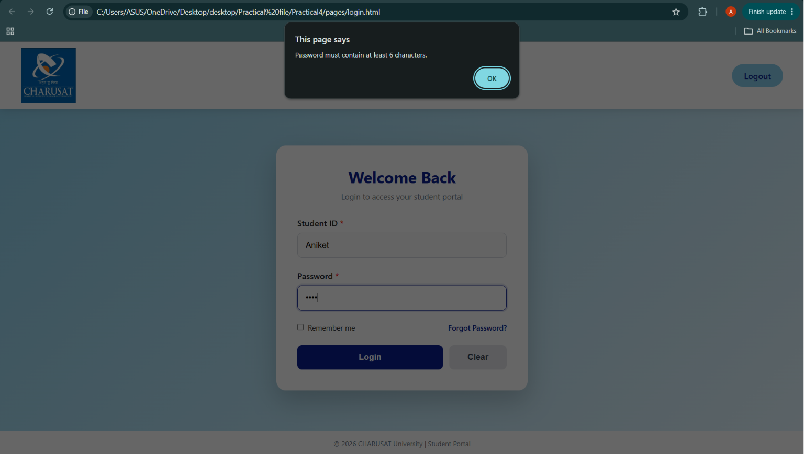

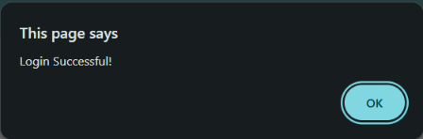

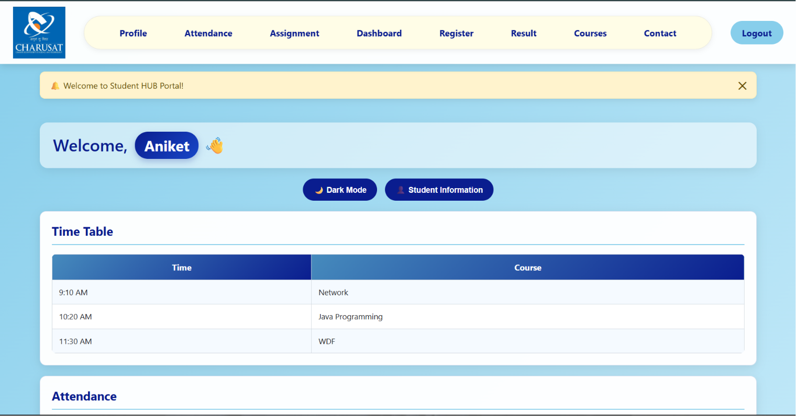


In this Welcome, Aniket the Aniket is change according to user enter name, id
And password have atleast 6 word or number.

Dark Mode
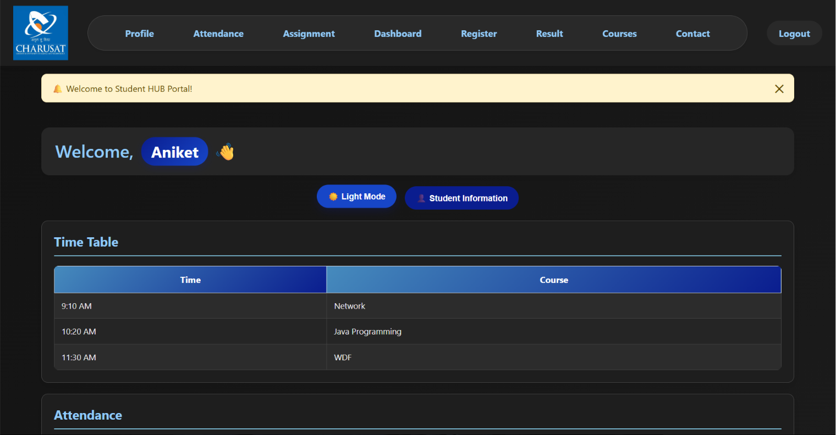

If i click on student information button then the this popes
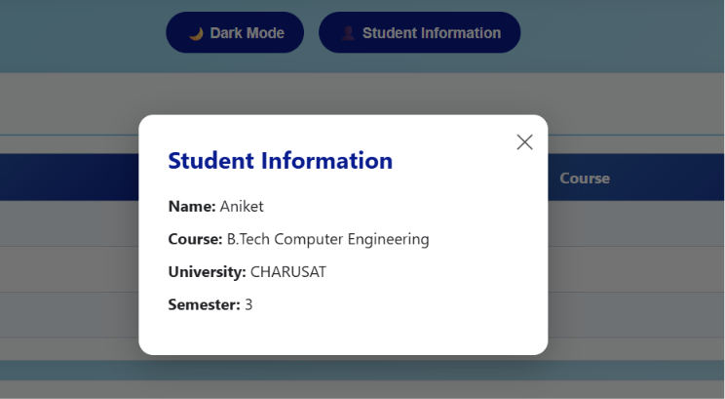
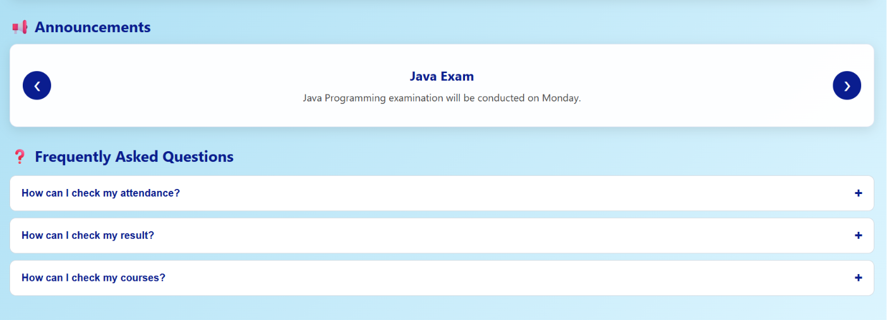

GitHub Repository Link:

https://github.com/25dce003-jpg/WDF

Challenges Faced:
The Password and confirm password are different then the register is done
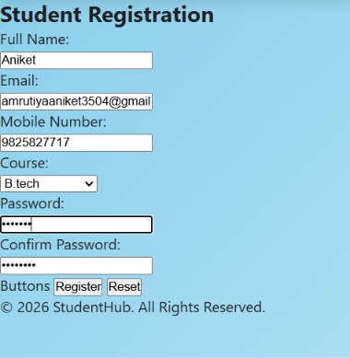

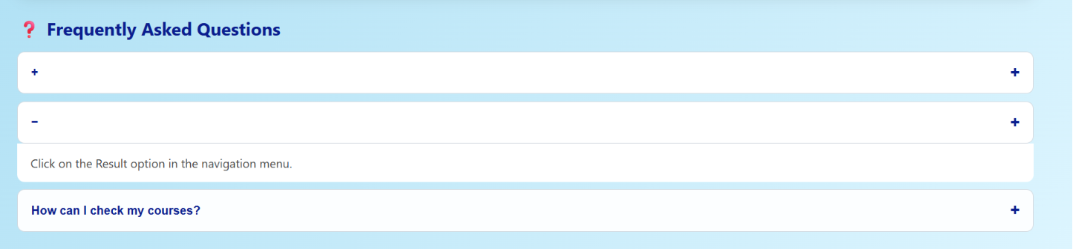
If I click – then the content is hide

Learning Outcomes:
- Use JavaScript DOM manipulation
- Handle user events like clicks and form submissions
- Create interactive UI components
- Implement dark/light theme switching
- Use localStorage to remember user preferences
- Improve the website's usability and interactivity.

Faculty Remarks: (Keep this blank for faculty)

