Practical – 5
Practical Title: Registration Form with Frontend Validation and User-Friendly Error Handling
Problem Definition: Create a student registration form with HTML5 input types and JavaScript
validation for name, email, mobile number, password, confirm password, course, year, gender, and terms acceptance. Use Regular Expression for validations.

Theory :
1. Are correct input types and attributes used?

Yes, correct HTML5 input types like text, email, tel, password, and select are used. The required attribute is also used to make sure important fields are not left empty.

2. Are validation errors displayed near the relevant fields?

Yes, validation errors are displayed to inform the user when incorrect data is entered. The messages can be shown near the relevant fields to make it easy for the user to correct them.

3. Is password strength checked?

Yes, password strength is checked using JavaScript. It verifies the password length and checks for uppercase, lowercase, numbers, and special characters using a Regular Expression.

4. Is the form accessible using keyboard and screen-reader-friendly labels?

Yes, the form uses proper labels connected to input fields, making it easy to use with a keyboard. These labels also help screen readers understand each field.

Implementation/ Output/Result
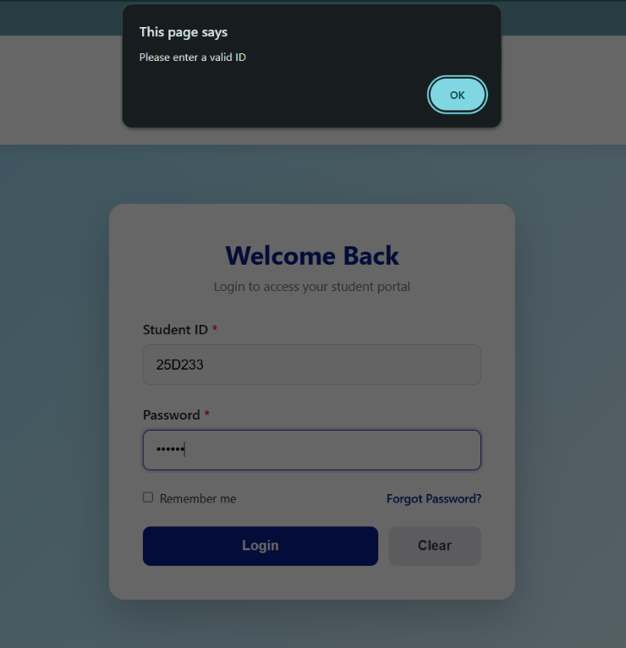
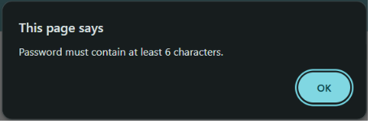

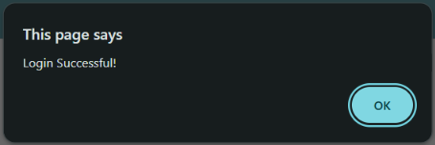

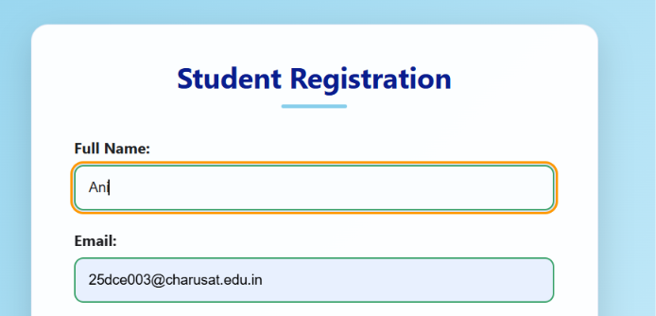
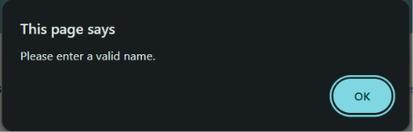
Name > 3
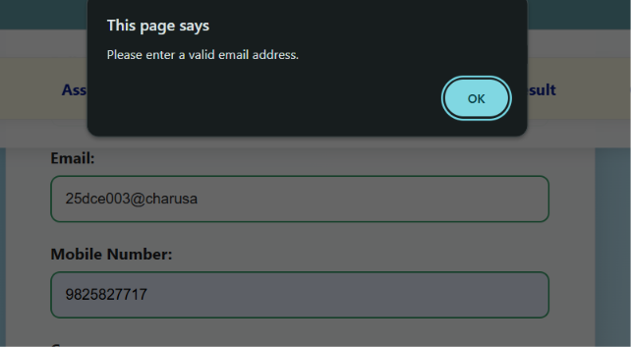
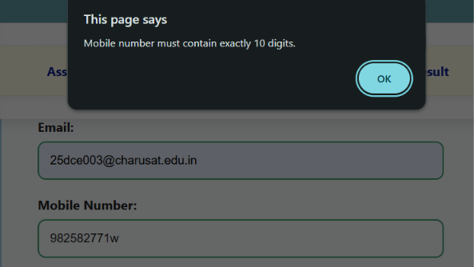
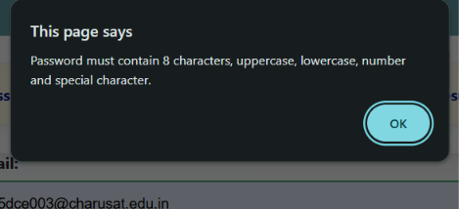
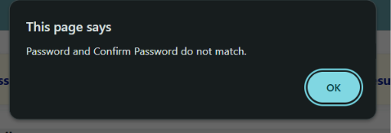
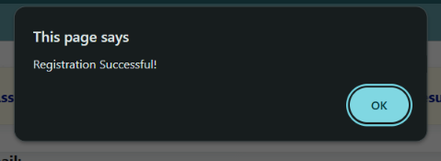

GitHub Repository Link:

https://github.com/25dce003-jpg/WDF

Challenges Faced:
emailPattern = /^[A-Za-z0-9._%+-]+@[A-Za-z0-9.-]+\.[A-Za-z]{2,}$/;
Not right correct

Learning Outcomes:
I learned how to create a student registration form using HTML5.
I learned how to use JavaScript and Regular Expressions for form validation.
I learned how to provide user-friendly error messages and check password strength.

Faculty Remarks: (Keep this blank for faculty)

