Practical – 6
Practical Title: PHP Form Processing with Server-Side Validation and CSV/JSON File Storage
Process submitted registration/contact form data using PHP. Validate and sanitize inputs on the server side and store records in CSV or JSON file format. Display success/error messages.

Theory :
1. Is the form submitted using POST?

JSON is fetched using fetch(), converted into JavaScript data using response.json(), and then displayed dynamically on the webpage using JavaScript.

2. Are inputs validated and sanitized server side?

filter() is used for search/filter, sort() for sorting, map() for displaying data, and slice() for pagination.

3. Is file writing handled safely?

A loading message is shown while data is being fetched. If there is any problem, an error message is displayed using .catch().

4. Are success and error responses displayed clearly?

Code is divided into separate functions or JavaScript files for fetching data, searching, filtering, sorting, and rendering. This makes the code easy to manage and reuse.

Implementation/ Output/Result

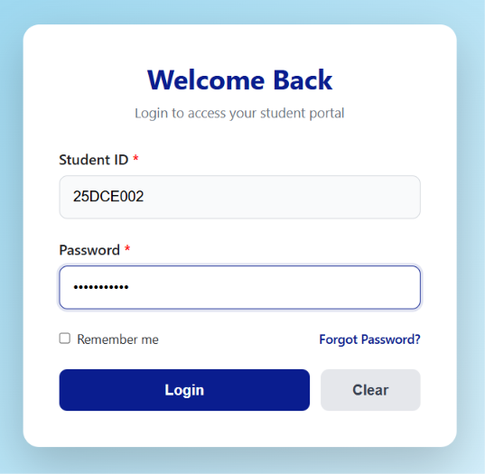

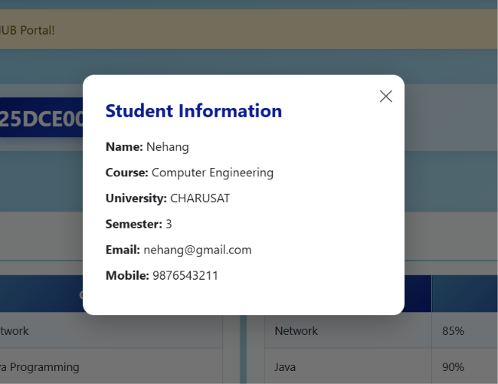
This is the data fetch according to the ID for example 25DCE002 login then the data is fetch according to 002 . If we change the 002 to 003 ID then the Data is change according to it.
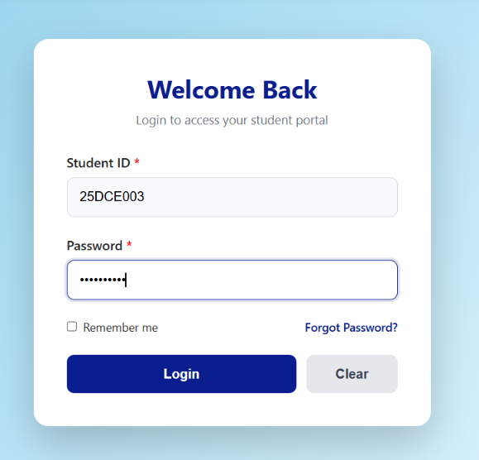


GitHub Repository Link:

https://github.com/25dce003-jpg/WDF

Challenges Faced:
First the data is not fetch so error in the code and after I fetch the data there the practical is over but I have add specific data are fetch so I learn from on online and I do

Learning Outcomes:
I will learn to fetch JSON data using Fetch API and display it dynamically on a webpage. They will also learn search, filter, sort, and pagination using JavaScript array methods.

Faculty Remarks: (Keep this blank for faculty)

