Practical – 7
Practical 7: PHP Form Processing with Server-Side Validation and CSV/JSON File Storage

Problem Definition: Process submitted registration/contact form data using PHP. Validate and sanitize inputs on the server side and store records in CSV or JSON file format. Display success/error messages.

Theory :
1. Is the form submitted using POST?
Yes. The form uses the POST method, so the data is sent securely to the PHP file for processing.

2. Are inputs validated and sanitized server side?
Yes. PHP checks the name, email, mobile, course, and password before storing the data. The inputs are also sanitized before saving.

3. Is file writing handled safely?
Yes. The data is written to a CSV file using fputcsv(), which stores each value properly in separate columns.

4. Are success and error responses displayed clearly?
Yes. The PHP program displays a clear message such as “Registration Successful!” or shows the reason when there is an error.

Implementation/ Output/Result
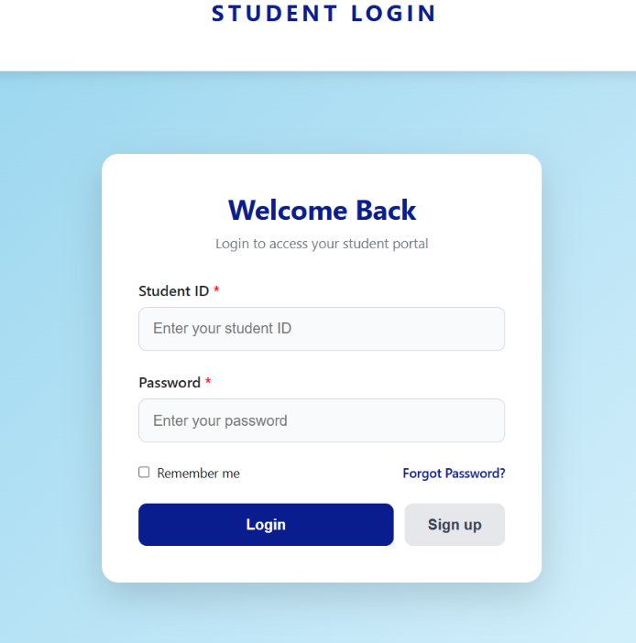
In this I am add sign up and remove the clear button if we click this button it open the register page is page is full of php . start the XAMPP apacha
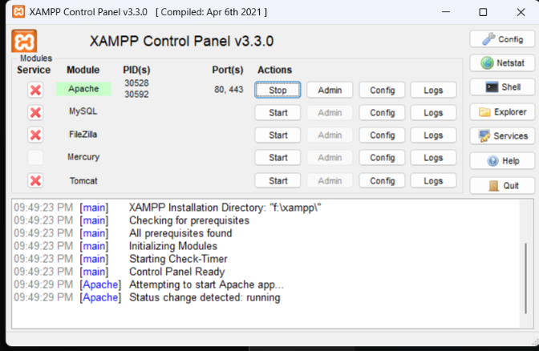
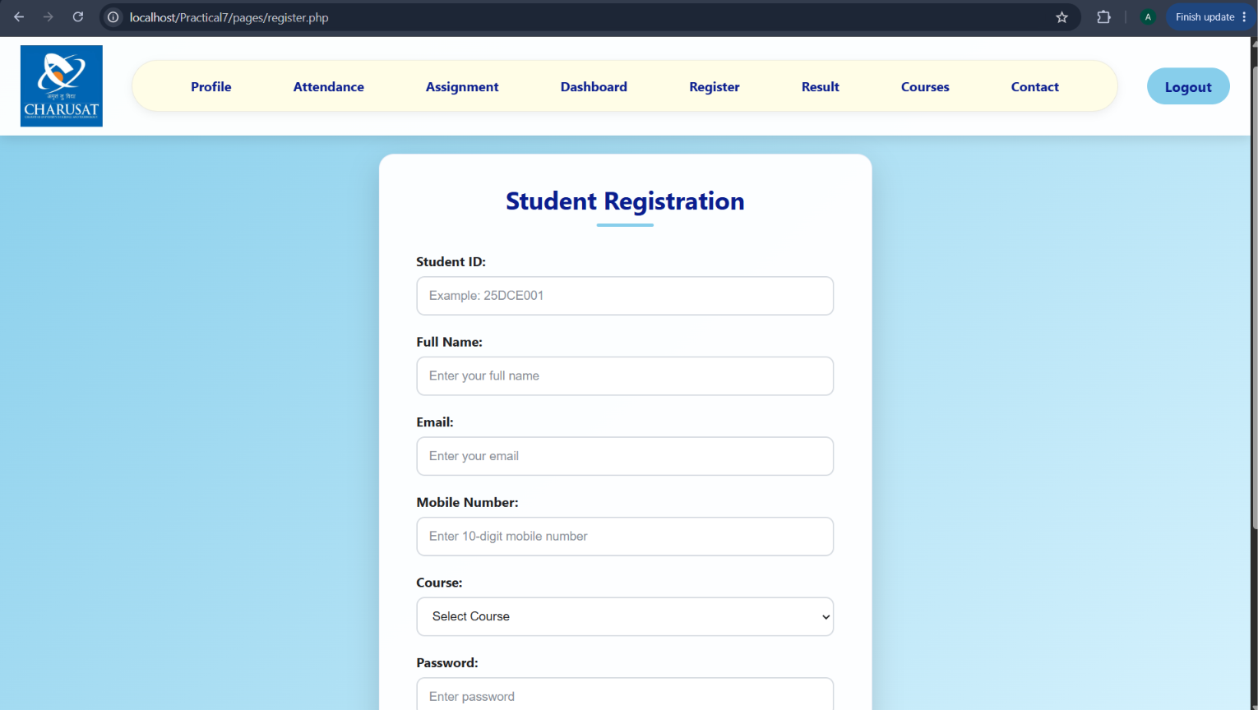
I am enter the data 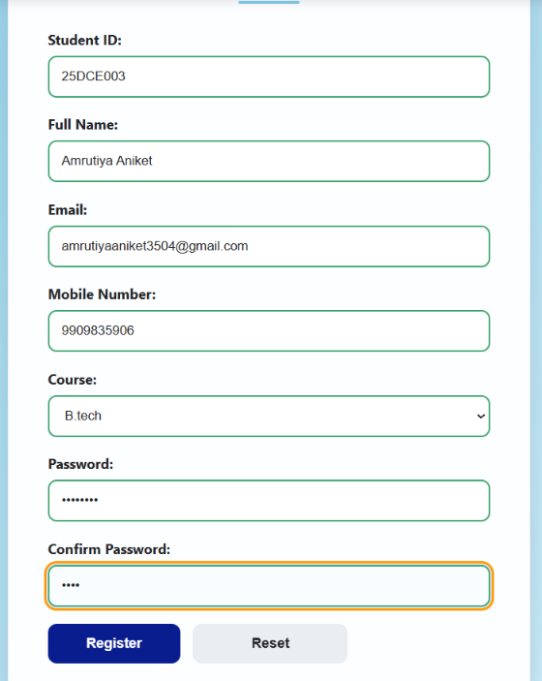
If all detail is valid for example id must be first two number after 3 letter after three number 25DCE003 like this sample we do with all number, email, password, etc after the data valid the Registration Successful! Come.

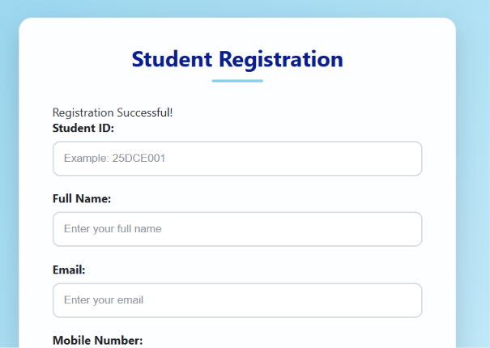
And this data are store in students.csv
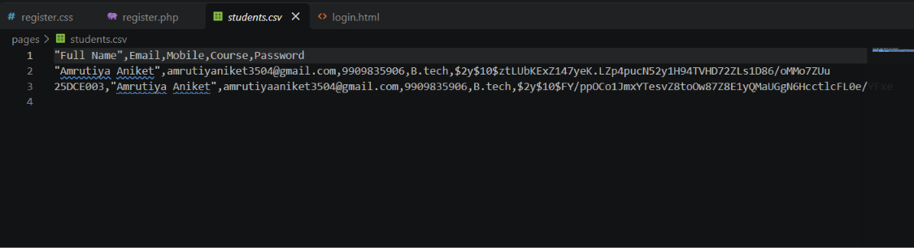
First I the id come in this I after add this.

GitHub Repository Link:

https://github.com/25dce003-jpg/WDF

Challenges Faced:

Some pages is not found 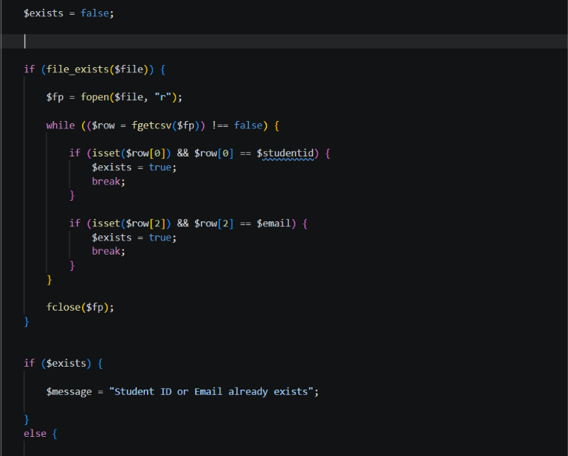
In this I not know about the isset exits so this are the some problem or challenges Faces

Learning Outcomes:
After completing this practical, I learned to:
Create a registration form using HTML and Use PHP to process form data using the POST method and Perform server-side validation for Student ID, name, email, mobile, and password and Sanitize user input before storing it and Store student information in a CSV file using PHP and Check duplicate Student ID and email before registration and Display success and error messages based on the form input and Use password hashing to store passwords more securely.

Faculty Remarks: (Keep this blank for faculty)

