Practical – 8
Practical 8: MySQL Schema Design, ER Model, PDO Connectivity, and Prepared Statements

Problem Definition: Design the database for StudentHub with students, events and registrations. Create PHP database connection using MYSQL statements.

Theory :
1. Is the schema normalized properly?
Yes. The database is divided into separate Students, Events, and Registrations tables, which reduces duplicate data and keeps the data organized.

2Are primary keys and foreign keys correctly defined?
Yes. Each table has a primary key, and the Registrations table uses foreign keys to connect students and events correctly.

3. Is the database connection handled securely?
Yes. PHP PDO and prepared statements are used for secure database connection and to prevent SQL injection.

Implementation/ Output/Result
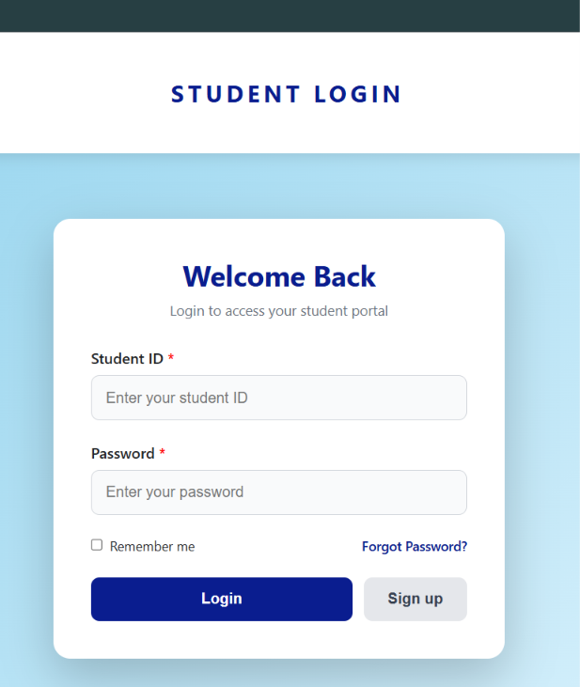
In this I am add sign up button in which you can sign up or enter you detail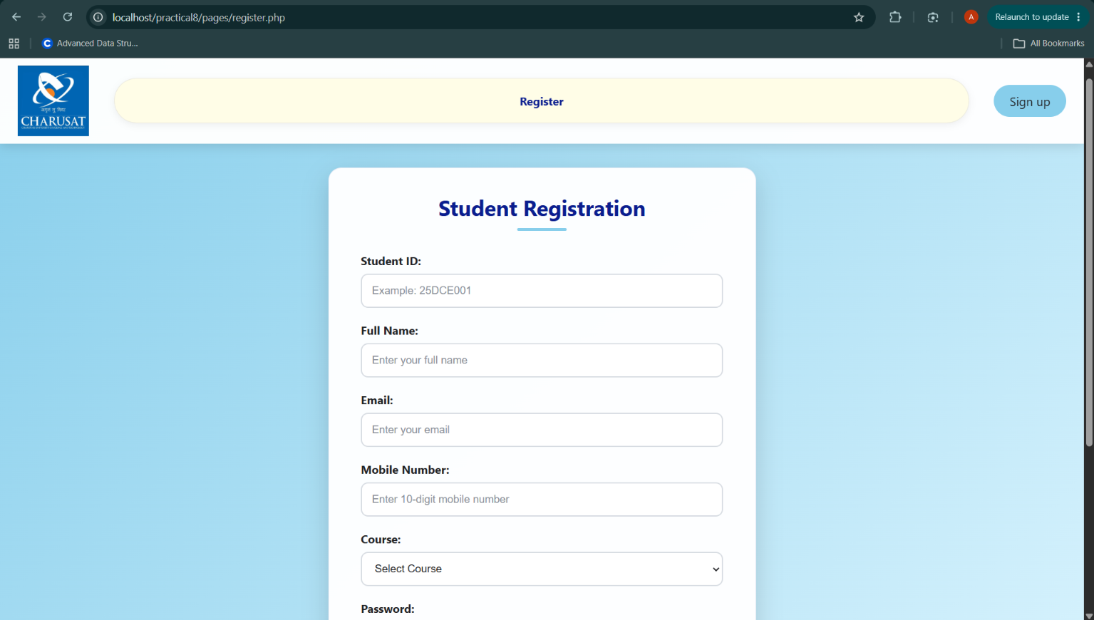
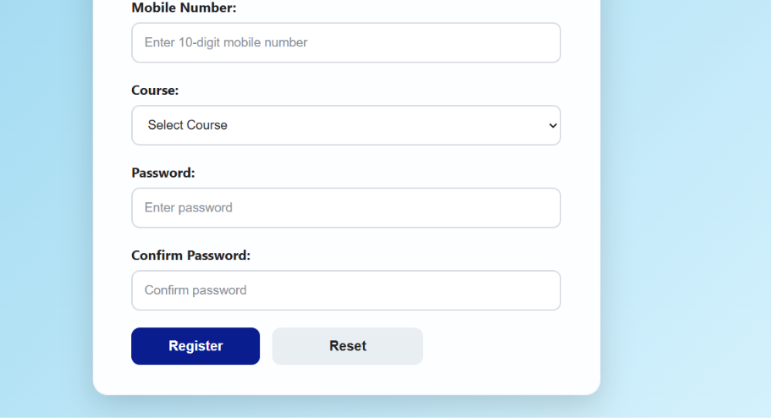
Enter the detail according to ask Id name email enter perfect then and only you data is store to database
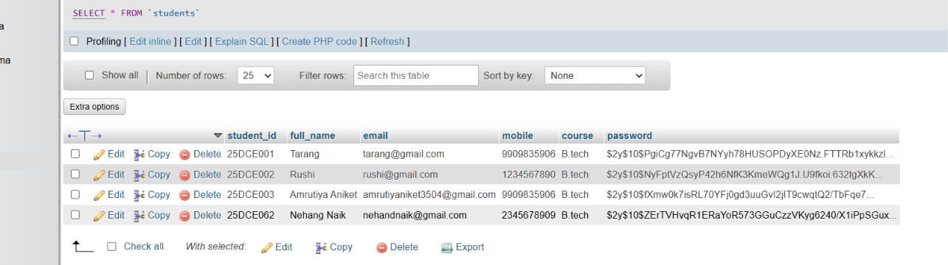
Like this you data is store
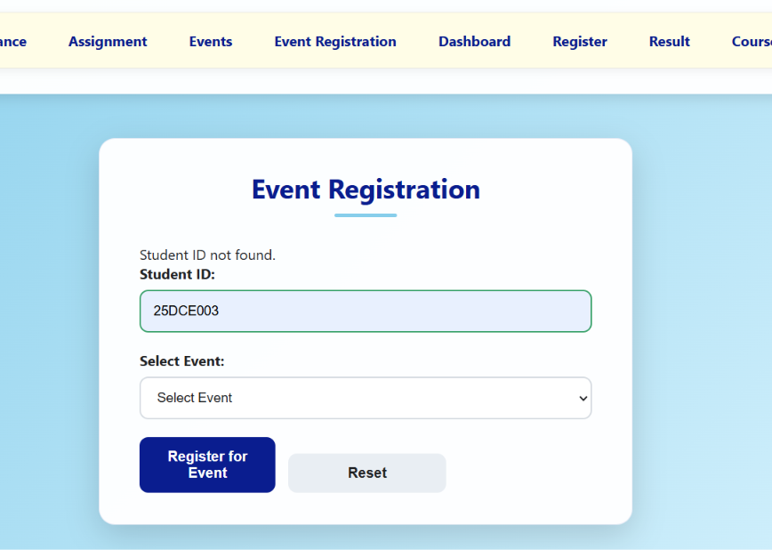
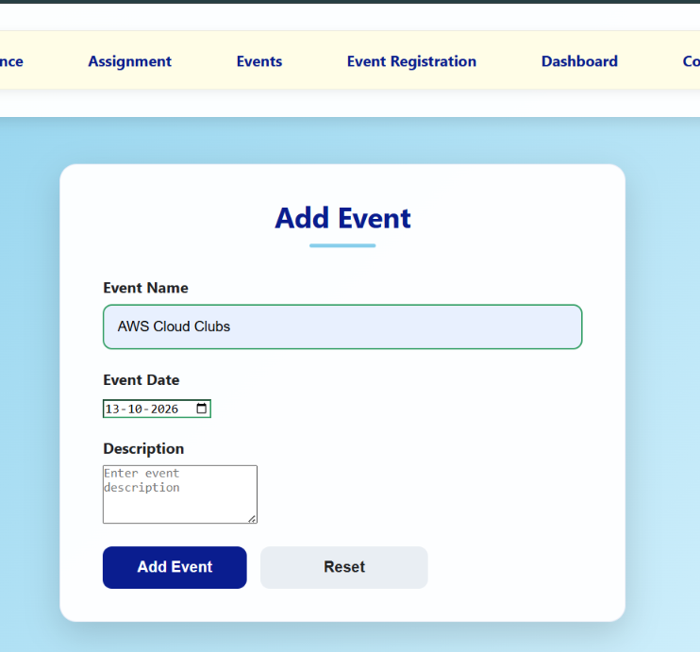
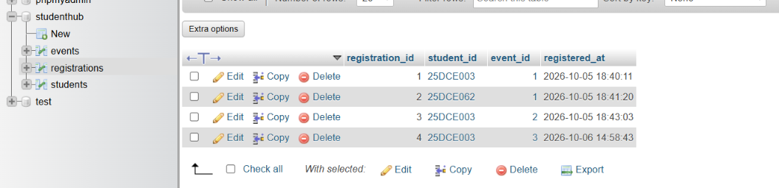
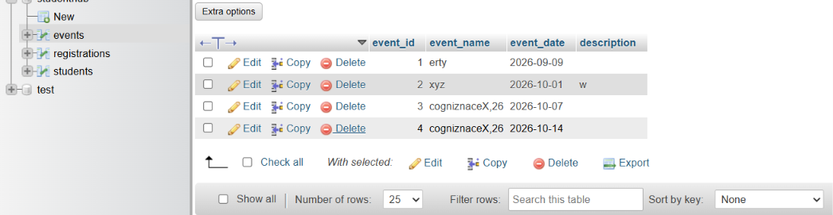
In this i add two extra page of events and event registration
In event you add the event and in registration through you register the page

In login page you id and passwrd must be correct you enter that sign up pge enter

https://github.com/25dce003-jpg/WDF

Learning Outcomes:
I am learned how to design a normalized database using MySQL. They understood the use of primary keys and foreign keys to maintain data relationships. They also learned to connect PHP with MySQL using PDO. Prepared statements were used to improve security and prevent SQL injection.

Faculty Remarks: (Keep this blank for faculty)

