Practical – 9
Practical 9: Secure User Registration with Database Insert, Duplicate Email Check, and Password Hashing

Implement secure user registration by inserting user details into MySQL using MYSQLi. Validate input on frontend and backend, check duplicate email/username, hash passwords using password_hash(), and display appropriate messages.

Theory :
1. Is password_hash() used before storing passwords?

Yes. The password is hashed using password_hash() before saving it in the database.

2 Is duplicate email/username checked?

Yes. The system checks whether the email or username already exists before inserting a new user.

3. Are frontend and backend validations consistent?

Yes. The input is checked on both the frontend and backend to make sure valid data is entered.

Implementation/ Output/Result
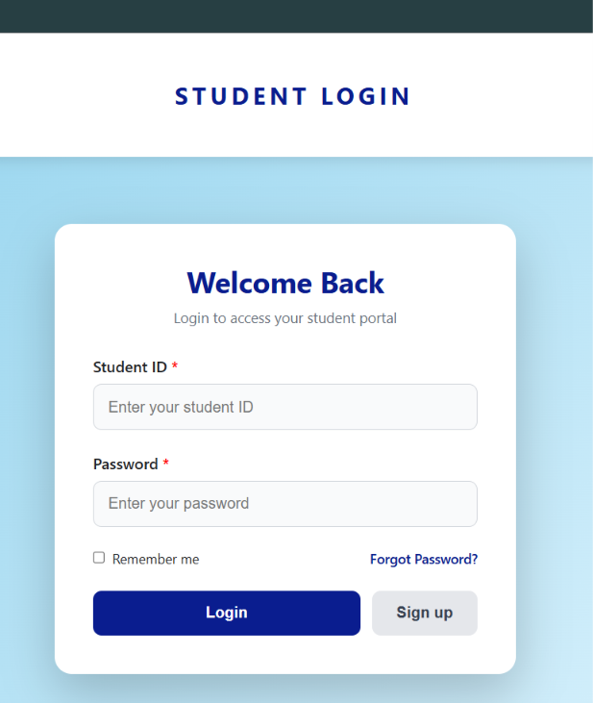

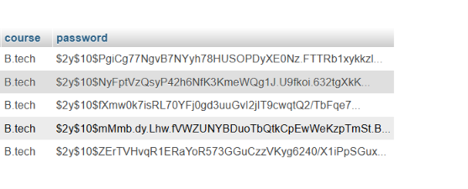
Store in hash – password
If I enter the same gmail then it give already exist in student register page.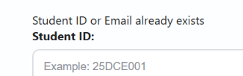
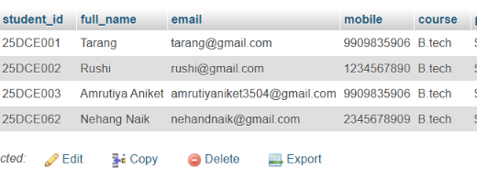

Learning Outcomes:

Create a secure user registration system.

Store user details in a MySQL database.

Hash passwords securely using password_hash().

Check for duplicate email or username.

Validate user input on both frontend and backend.

GitHub Repository Link:

https://github.com/25dce003-jpg/WDF

Challenges Faced:
In the email some problem I face only nothing else problem

Faculty Remarks: (Keep this blank for faculty)

