CHAROTAR UNIVERSITY OF SCIENCE AND TECHNOLOGY (CHARUSAT)
FACULTY OF TECHNOLOGY AND ENGINEERING
SUBJECT: WEB DEVELOPMENT FRAMEWORKS (ITUE203)
SEMESTER: 3RD, 2026-27 (ODD)

Practical - 12
Event Management CRUD with Poster Upload and File Validation
Problem Definition: Develop event management functionality for admin users. Admin can add, view, update, delete, and upload event posters with file type and file size validation.

A. Theory
1. What is event management CRUD?
Answer: It lets authorized administrators create, view, update, and delete event records such as title, date, venue, description, and status.
2. Why validate uploaded files on the server?
Answer: Client-side checks can be bypassed. Server-side validation checks the actual file type, size, upload status, and destination.
3. Why rename poster files?
Answer: A generated unique filename reduces collisions and avoids trusting user-controlled names.
4. What is the purpose of an upload directory restriction?
Answer: It helps prevent uploaded files from being executed as scripts and limits direct access to stored content.

B. Implementation / Procedure
1. Database setup
Create an events table with id, title, description, event_date, venue, category, status, poster_path, and created_at.
2. Add and view events
Use an admin-only form and prepared INSERT statement. Display records with SELECT and safely escape output.
3. Update and delete
Validate the event ID, use prepared UPDATE/DELETE statements, and show a confirmation before deletion.
4. Upload form
Use enctype="multipart/form-data" and check PHP's $_FILES error code. Set a small maximum size appropriate for the lab.
5. Validate and store poster
Allow only chosen image MIME types such as JPEG and PNG, inspect MIME using finfo_file(), generate a random filename, and move the file into a non-executable upload directory.
6. Error handling
Do not store a database path until the upload succeeds. Handle invalid type, oversized file, upload failure, and database failure with clear messages.

C. Test Cases
Test Case | Input / Action | Expected Result
Valid poster | Upload a small JPEG/PNG | Poster is stored with a generated filename
Invalid type | Upload a PHP/text file | Upload is rejected
Oversized file | Upload file above configured limit | Upload is rejected with a clear message
Update event | Edit title or date | Updated event appears
Delete event | Confirm deletion | Event is removed or deactivated

D. Key Questions / Analysis / Interpretation
1. Are add, update, and delete functionalities implemented correctly?
Answer: Create adds a new event, Read lists event details, Update edits an event, and Delete removes or deactivates an event. Each action should show a clear status message.
2. Is the UI linked with the database correctly?
Answer: Forms submit to PHP handlers, PHP performs validated MySQL operations, and the page displays the current records returned by the database.
3. Are poster uploads validated for type and size?
Answer: The server checks the upload error code, size limit, and actual MIME type. It should not trust the filename or browser-supplied content type.
4. Are success and failure messages displayed?
Answer: The interface reports completed operations and validation failures without exposing sensitive server or filesystem details.

M. Evidence of Work (Screenshots)
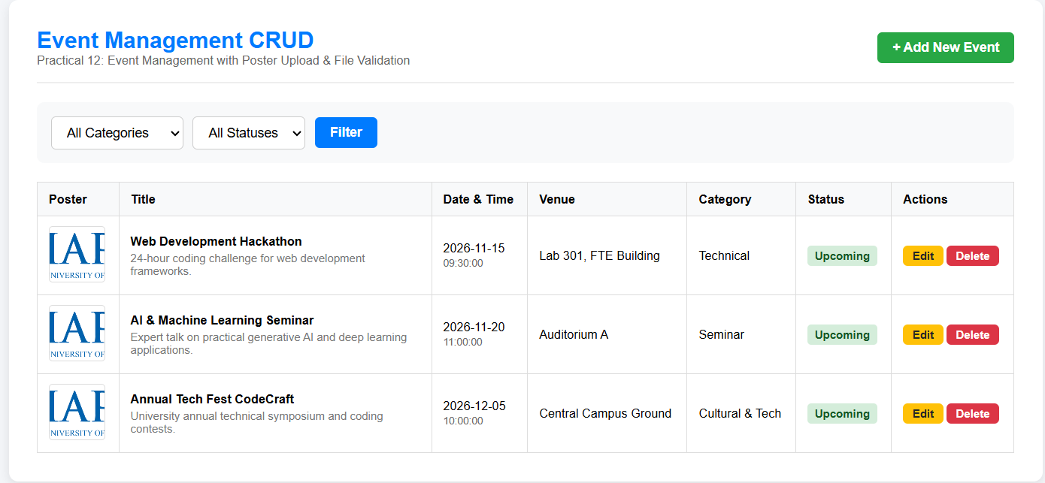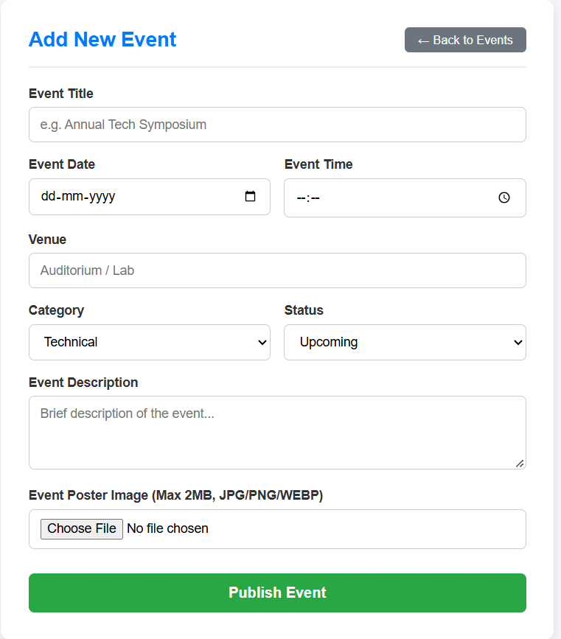

N. GitHub Repository Link
https://github.com/25dce015-heet/Web-Development-WDF-

