Practical - 3

Practical Title: Responsive UI Design using CSS Grid, Flexbox, and Bootstrap/Tailwind
Problem Definition: Design responsive layouts for Home, About, Registration, Dashboard, and Events pages using CSS Grid and Flexbox. Optional to use CSS framework such as Bootstrap or Tailwind. Ensure mobile-first responsiveness.

Theory
  - How does the layout adapt for mobile, tablet, and desktop screens?
Answer: The layout changes using responsive CSS and media queries so it fits different screen sizes.

  - How does Which layout technique is used and why?
Answer: CSS Grid are used because they make layouts flexible, responsive, and easy to manage.

  - Are typography, spacing, colors, and contrast readable?
Answer: Yes. Proper font size, spacing, colors, and contrast make the content easy to read.

Implementation/ Output/Result

Style.css
* {
margin: 0;
padding: 0;
box-sizing: border-box;
font-family: Arial, sans-serif;
}
.bth{
width: 10%;
height: 10%;
align-items: flex-start;
text-size-adjust:inherit
}

html, body {
margin: 0;
padding: 0;
font-family: Arial, sans-serif;
}

body {
background: #eef4ff;
padding: 30px;
}

h1 {
margin: 0 auto 18px auto;
}

a {
color: black;
text-decoration: none;
align-items: center;
text-align: center;
background-size: cover;
background-attachment: fixed;
}

button {
height: 35px; width: 160px; padding: 0; font-size: 10px;
border: 2px solid black; margin-bottom: 10px; margin-left: 30px; margin-right: 30px; background: white; border-radius: 8px; cursor: pointer; transition: 0.3s;
box-sizing: border-box;
text-align: center;
box-shadow: 0px 4px 10px rgba(0, 0, 0, 0.25);
}

button:hover {
transform: scale(1.05);
background: #2563EB;
}

button:hover a {
color: white;
}

table {
border-collapse: collapse;
border: 3px solid white;
}

label {
font-size: 18px;
font-weight: bold;
}

input {
width: 230px; height: 38px; margin-top: 8px;
border: 1px solid #999; border-radius: 5px; padding: 8px;
font-size: 16px; outline: none; transition: 0.3s;
}

input:focus {
border-color: #2563EB;
box-shadow: 0 0 5px rgba(37, 99, 235, 0.4);
}

footer {
color: white; font-size: 18px; margin: 10px;
}

.container {
width: 100%;
max-width: 1200px;
margin: auto;
}

.title {
width: 250px;
margin: 0 auto 40px;
padding: 12px; text-align: center; font-size: 32px; font-weight: bold; color: #fff;
background: linear-gradient(#2f86f6, #0a5fc8);
border-radius: 15px;
box-shadow: 0 5px 10px rgba(0, 0, 0, 0.2);
}

.Logo {
width: 90px;
height: 90px; border-radius: 50%; object-fit: cover;
border: 2px solid #090700;
margin-left: 5%; align-items: center; transition: 0.3s;
}

.Logo:hover {
transform: scale(1.1);
}
.Home {
background: linear-gradient(to right, #dbeafe, #bfdbfe);
}

.sitemap {
display: flex;
flex-wrap: wrap; justify-content: center; gap: 20px;
}

.card {
width: 180px;
min-height: 150px; background: #fff; border-radius: 15px; overflow: hidden;
box-shadow: 0 5px 12px rgba(0, 0, 0, 0.18);
transition: 0.3s;
}

.card:hover {
transform: translateY(-5px);
}
.card h2 {
background: linear-gradient(#2f86f6, #0a5fc8);
}

.card ul {
list-style: none;
padding: 12px;
}

.card ul li {
font-size: 15px;
padding: 6px 0 6px 10px; border-left: 3px solid #0a5fc8; color: #222;
}

.card ul li:not(:last-child) {
border-bottom: 1px solid #ddd;
}

.main {
display: flex;
flex-direction: row; justify-content: center; align-items: center;
min-height: calc(100vh - 40px);
padding: 20px; white-space: initial; gap: 10px;
}

.Link {
flex: 1;
width: 20%;
height: 1%;
}

.Link a {
display: block; margin: 10px 0; font-size: 15px;
}

.paragraph {
width: 85%;
height: 100%; border: none; border-radius: 20px; align-items: center; text-align: center;
background-color: #ffffff; background-size: cover; background-position: center; background-repeat: no-repeat;
box-shadow: 0 20px 45px rgba(0, 0, 0, 0.25), 0 4px 10px rgba(0, 0, 0, 0.1);
}

.student_hub {
border-radius: 40px; align-items: end; text-align: center;
border: 3px solid rgb(0, 0, 8);
width: 85%;
background-size: cover;
justify-content: space-between;
display: flex;
margin-left: 15%;
margin-top: 0%;
background: #ffffff;
box-shadow: 0 7px 25px rgba(0, 0, 0, 0.15);
}

.i {
position: relative;
top: 80px;
}

.banner {
width: 100%;
min-height: 100vh;
height: 400px;
background-image: url("https://static.vecteezy.com/system/resources/thumbnails/014/468/621/small/abstract-digital-technology-background-with-concept-security-vector.jpg");
background-size: cover; background-position: center; background-repeat: no-repeat; display: flex;
align-items: center;
justify-content: flex-start;
}

.maini {
width: 500px; background: #ffffff; border: 2px solid black; border-radius: 20px; text-align: center;
box-shadow: 0 10px 25px rgba(0, 0, 0, 0.3);
overflow: hidden;
margin-left: 120px;
}

.login_heading { background: #355291; color: white;
padding: 15px; text-align: center; border-radius: 5%;
border: 3px solid #0a0c0c;
}

.login_heading h2 {
color: #F8FAFC;
}

form {
padding: 35px;
text-align: center;
}

.but {
align-items: center; justify-content: center; text-align: center; border-radius: 5%;
margin: 20px 10px 10px;
transform: scale(1.05);
}

@media (max-width: 768px) {
.card {
width: 160px;
}

.title {
width: 220px;
font-size: 28px;
}

.banner {
justify-content: center;
padding: 20px;
}

.maini {
width: 90%;
margin-left: 0;
}

.login_heading h2 {
font-size: 28px;
}

input, button {
width: 90%;
}
}

.assignment {
align-items: center; align-content: center; background-size: cover;
background-repeat: no-repeat;
margin: 0%;
height: 100vh;
border: 3px solid #0a0c0c; border-collapse: collapse; background: #eef4ff; padding: 20px;
}

.assignment h1 { text-align: center; font-size: 45px;
margin-bottom: 25px;
}

.assignment table { width: 95%; margin: auto;
border: 1px solid #0a0c0c; border-collapse: collapse; background: #f7f9fc;
}

.assignment th,
.assignment td {
border: 1px solid #0b0000;
padding: 15px; text-align: center; height: 80px;
}

.assignment th { background: #dce7f7; font-size: 22px;
font-weight: bold;
}

.assignment select {
padding: 6px 12px;
border-radius: 5px;
}

.assignment input[type="file"] {
padding: 5px;
}

.assignment p {
text-align: center; font-size: 18px; margin-top: 10px;
}

.h_assignment {
border: 3px solid #090700;
border-radius: 30%;
align-items: center;
}

.attandence { background: #eef4ff; padding: 20px;
}
.attandence h1 { text-align: center; font-size: 45px;
margin-bottom: 20px;
}

.attandence input[type="date"] {
width: 280px; height: 45px; padding: 8px; font-size: 22px;
border: 1px solid #999; border-radius: 6px; margin-bottom: 30px;
}

.attandence table { width: 95%; margin: auto;
border-collapse: collapse;
background: #f8faff;
}

.attandence th,
.attandence td {
border: 1px solid rgb(14, 1, 1);
padding: 10px;
text-align: center;
}

.attandence th { background: #dce7f7; font-size: 22px;
}

.attandence tr {
height: 45px;
}

.attandence p {
text-align: center; font-size: 20px; margin-top: 10px;
}

.contact {
background: #eef4ff;
padding: 25px;
}
.contact h2 {
text-align: center; font-size: 42px; margin-bottom: 25px;
}

.contact table { width: 90%; margin: auto;
border-collapse: collapse;
background: #f8faff;
}

.contact th,
.contact td {
border: 1px solid white;
padding: 15px;
text-align: left;
}

.contact th { background: #dce7f7; text-align: center; font-size: 22px;
}

.contact fieldset { width: 90%; margin: 30px auto; padding: 20px;
border: 2px solid #bfcde8; border-radius: 10px; background: #ffffff;
}

.contact legend { font-size: 22px; font-weight: bold; padding: 0 10px;
}

.contact label {
font-size: 18px;
font-weight: bold;
}

.contact input[type="text"],
.contact input[type="email"],
.contact input[type="tel"],
.contact textarea {
width: 100%;
max-width: 500px; padding: 10px; margin-top: 8px;
border: 1px solid #999; border-radius: 5px; font-size: 16px;
}

.contact textarea,
.feedback textarea {
resize: vertical;
}

.contact input[type="submit"],
.contact input[type="reset"],
.feedback input[type="submit"],
.feedback input[type="reset"] {
border: none;
border-radius: 8px; background: #2563EB; color: white;
font-size: 16px; cursor: pointer; transition: 0.3s;
}

.contact input[type="submit"],
.contact input[type="reset"] {
width: 150px;
padding: 10px;
margin: 10px 10px 0 0;
}

.contact input[type="reset"],
.feedback input[type="reset"],
.register input[type="reset"],
.Settings input[type="reset"] {
background: #6b7280;
}

.contact input[type="submit"]:hover,
.feedback input[type="submit"]:hover,
.contact input[type="reset"]:hover,
.feedback input[type="reset"]:hover,
.Profile input[type="submit"]:hover,
.Profile input[type="reset"]:hover,
.register input[type="submit"]:hover,
.register input[type="reset"]:hover,
.Settings input[type="submit"]:hover,
.Settings input[type="reset"]:hover {
background: #1d4ed8;
}

.contact input[type="reset"]:hover,
.feedback input[type="reset"]:hover,
.register input[type="reset"]:hover,
.Settings input[type="reset"]:hover {
background: #4b5563;
}

.contact hr {
margin: 30px 0;
}

.contact h3,
.contact p {
text-align: center;
}

.course {
background: #eef4ff;
padding: 20px;
}
.course h1 {
text-align: center; font-size: 42px; margin-bottom: 25px;
}

.course .table_course,
.table_course {
margin-top: 100px;
}

.course table {
width: 90%;
max-width: 1100px;
margin: auto;
border-collapse: collapse;
background: #f8faff;
}

.course th,
.course td {
border: 1px solid rgb(7, 5, 5);
padding: 15px;
text-align: center;
}

.course th { background: #dce7f7; font-size: 20px;
font-weight: bold;
}

.course tr:hover {
background: #edf4ff;
}

.course p {
text-align: center; font-size: 18px; margin-top: 10px;
}

.event {
background: #eef4ff;
padding: 20px;
}

.event h1 {
text-align: center;
font-size: 42px;
margin-bottom: 20px;
}

.event .container {
width: 90%;
max-width: 900px;
margin: auto;
}

.event .container .event { background: #ffffff; border: 2px solid #dce7f7; border-radius: 10px; padding: 20px;
margin-bottom: 20px;
box-shadow: 0 5px 12px rgba(0, 0, 0, 0.15);
}

.event .container .event h2 {
color: #00030a;
margin-bottom: 10px;
}

.event .container .event p {
margin: 8px 0;
font-size: 18px;
}

.event .container .event a { display: inline-block; margin-top: 10px; padding: 10px 20px; background: #2563EB; color: white;
text-decoration: none; border-radius: 6px; transition: 0.3s;
}

.event .container .event a:hover {
background: #1d4ed8;
}

.event hr,
.feedback hr {
margin: 20px 0;
}

.event > p {
text-align: center;
font-size: 20px; margin-top: 20px; font-weight: bold;
}

.feedback { background: #eef4ff; padding: 20px;
text-align: center;
}

.feedback h1 {
font-size: 42px;
margin-bottom: 20px;
}

.feedback fieldset {
width: 90%;
max-width: 700px; margin: 20px auto; padding: 20px;
border: 2px solid #dce7f7; border-radius: 10px; background: #ffffff;
}

.feedback legend { font-size: 20px; font-weight: bold;
}

.feedback label { display: block; margin-top: 15px; font-weight: bold; font-size: 17px;
}

.feedback input[type="text"],
.feedback input[type="email"],
.feedback input[type="number"],
.feedback select,
.feedback textarea {
width: 100%;
max-width: 400px; padding: 10px; margin-top: 8px;
border: 1px solid #999; border-radius: 5px; font-size: 16px;
}

.feedback input[type="radio"] {
margin: 10px;
}

.feedback input[type="submit"],
.feedback input[type="reset"] {
width: 140px; padding: 10px; margin: 20px 10px;
}

.feedback p {
text-align: center;
font-size: 18px;
}

.Profile {
background: #eef4ff;
font-family: Arial, sans-serif;
padding: 30px;
}

.Profile h1 {
text-align: center; color: #1e3a8a; margin-bottom: 20px;
}

.profile-box { width: 1000px; margin: auto; background: #fff; padding: 25px;
border-radius: 10px;
box-shadow: 0 5px 15px rgba(0, 0, 0, 0.2);
}

.Profile label { display: block; font-weight: bold;
margin: 12px 0 5px;
}

.Profile input[type="text"],
.Profile input[type="file"],
.Profile select,
.Profile textarea {
width: 100%;
padding: 10px; border: 1px solid #ccc; border-radius: 6px; font-size: 15px; margin-bottom: 10px;
}

.Profile textarea,
.register textarea {
resize: none;
}

.gender {
display: flex;
justify-content: center; align-items: center; gap: 25px;
margin: 15px 0;
}

.gender label,
.hobbies label {
display: flex;
align-items: center;
font-weight: normal;
}

.gender label {
gap: 5px;
}

.hobbies {
display: flex;
flex-direction: column; align-items: flex-start; width: 200px;
margin: auto;
}

.hobbies label { gap: 8px; margin: 5px 0;
}

.Profile input[type="submit"],
.Profile input[type="reset"] {
width: 120px; padding: 10px; margin: 15px 5px 0; background: #2563eb;
color: white; border: none; border-radius: 6px; cursor: pointer;
}

.Profile p {
text-align: center;
margin-top: 20px;
}

.pro {
background-image: url(https://t4.ftcdn.net/jpg/09/27/94/25/360_F_927942540_BwvsR4YD6jftMa83x1cte33w Dg7SY6bj.jpg);
}

.register,
.result,
.Settings {
background: #eef4ff;
font-family: Arial, sans-serif;
margin: 0;
padding: 30px;
}
.register,
.result {
text-align: center;
}

.register h1,
.result h1,
.Settings h1,
.Settings legend {
color: #0a3d91;
}

.register h1,
.result h1 {
margin-bottom: 20px;
}

.register form { width: 500px; margin: 30px auto;
background: #ffffff; padding: 30px; border-radius: 15px;
box-shadow: 0 8px 20px rgba(0, 0, 0, 0.15);
}

.register label { display: block; font-size: 18px; font-weight: bold; margin-top: 15px;
margin-bottom: 6px;
}

.register input[type="text"],
.register input[type="email"],
.register input[type="tel"],
.register select,
.register textarea { width: 100%; padding: 10px;
border: 1px solid #999; border-radius: 8px; font-size: 16px;
}

.register input[type="submit"],
.register input[type="reset"],
.Settings input[type="submit"],
.Settings input[type="reset"],
.Settings button { width: 170px; padding: 10px; border: none; border-radius: 8px; font-size: 16px; cursor: pointer; transition: 0.3s;
}

.register input[type="submit"],
.register input[type="reset"] { margin: 20px 10px 0; background: #2563eb; color: white;
}

.register a {
display: inline-block; margin-top: 20px; text-decoration: none; color: #2563eb;
font-weight: bold;
}
.register a:hover {
color: #0a3d91;
text-decoration: underline;
}

.register p {
text-align: center;
margin: 8px 0;
}

.result label,
.Settings legend { font-size: 18px; font-weight: bold;
}

.result select { width: 180px; padding: 8px;
margin: 15px 0 25px; border: 1px solid #999; border-radius: 8px; font-size: 16px;
}
.result table {
width: 90%;
max-width: 1000px; margin: 20px auto; border-collapse: collapse; background: #ffffff;
box-shadow: 0 6px 15px rgba(0, 0, 0, 0.15);
}

.result th {
background: #8d9bbb;
color: white;
padding: 12px;
}

.result td {
padding: 10px;
}

.result th,
.result td {
border: 1px solid #ddd;
text-align: center;
}
.result tr:nth-child(even) {
background: #f8f9ff;
}

.result tr:hover {
background: #dbeafe;
}

.sgpa {
width: 300px !important;
margin-top: 20px;
}

.sgpa td {
font-size: 20px;
font-weight: bold;
}

.Settings h1 {
text-align: center;
margin-bottom: 25px;
}

.Settings form {
width: 800px;
margin: auto; background: #ffffff; padding: 25px; border-radius: 15px;
box-shadow: 0 8px 20px rgba(0, 0, 0, 0.15);
}

.Settings fieldset {
border: 2px solid #2563eb; border-radius: 10px; padding: 20px;
margin-bottom: 20px;
}

.Settings label {
font-weight: bold;
}

.Settings input[type="text"],
.Settings input[type="email"],
.Settings input[type="password"],
.Settings select { width: 100%; padding: 10px; margin-top: 8px;
border: 1px solid #999; border-radius: 8px; font-size: 16px;
margin-bottom: 12px;
}

.Settings input[type="radio"],
.Settings input[type="checkbox"] {
margin-right: 8px;
margin-top: 10px;
}

.Settings input[type="submit"],
.Settings input[type="reset"],
.Settings button {
margin: 15px 10px 0;
}

.Settings input[type="submit"] {
background: #2563eb;
color: white;
}

.Settings input[type="reset"] {
color: white;
}

.Settings button {
background: #dc2626;
}

.Settings button:hover {
background: #b91c1c;
}

.Settings button a {
color: white;
text-decoration: none;
display: block;
}

.Settings p {
text-align: center;
margin-top: 20px;
}
/* ===== Shared Sidebar (Logo + Heading + Navbar) ===== */
.sidebar { position: fixed; top: 0;
left: 0;
width: 220px; height: 100vh; overflow-y: auto; background: #ffffff;
border-right: 3px solid #000000;
padding: 20px 15px;
box-shadow: 4px 0 15px rgba(0, 0, 0, 0.12);
z-index: 100;
}

.sidebar .brand {
display: flex;
flex-direction: column; align-items: center; gap: 10px;
margin-bottom: 25px;
text-align: center;
}

.sidebar .Logo { width: 70px; height: 70px; margin-left: 0;
}
.sidebar .brand h1 {
margin: 0;
font-size: 20px;
}

.navbar {
display: flex;
flex-direction: column;
gap: 8px;
}

.navbar a {
display: block; padding: 10px 12px; border: 2px solid black; border-radius: 8px; background: white; color: black;
font-weight: bold; font-size: 14px; text-align: center;
box-shadow: 0px 4px 10px rgba(0, 0, 0, 0.2);
transition: 0.3s;
}
.navbar a:hover { background: #2563EB; color: white; transform: scale(1.05);
}

.navbar a.active { background: #2563EB; color: white;
}

/* Push page content right so it clears the fixed sidebar */
body.with-sidebar {
padding-left: 260px;
}

@media (max-width: 900px) {
.sidebar { position: static; width: 100%; height: auto;
border-right: none;
border-bottom: 3px solid #000000;
}
.sidebar .brand {
flex-direction: row;
justify-content: center;
}

.navbar {
flex-direction: row; flex-wrap: wrap; justify-content: center;
}

body.with-sidebar {
padding-left: 30px;
}
}

Evidence of Work (Screenshots)
  - index
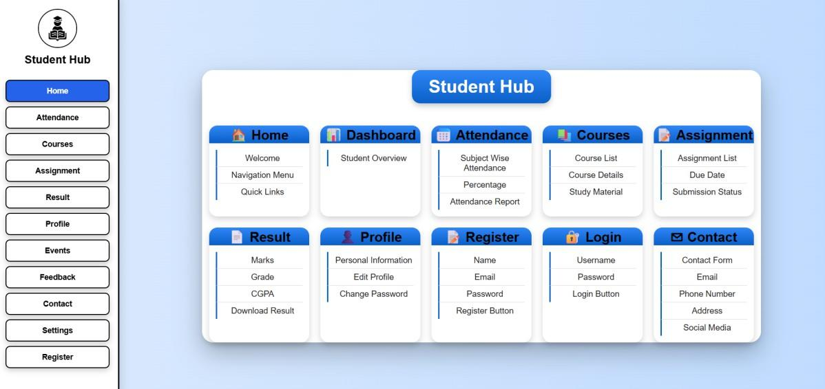
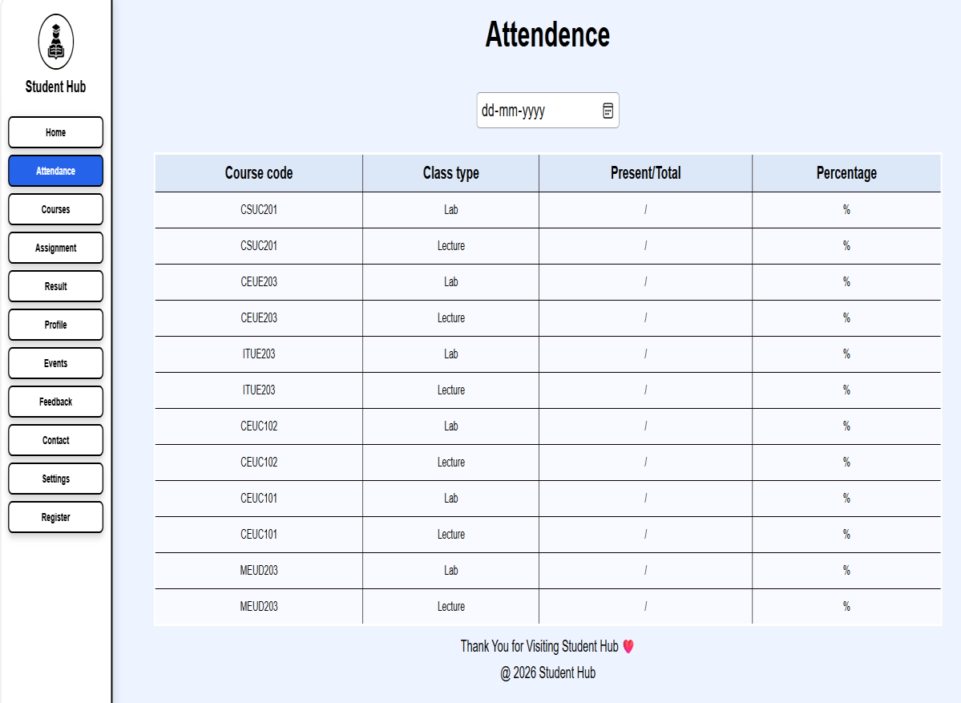
  - Attendance

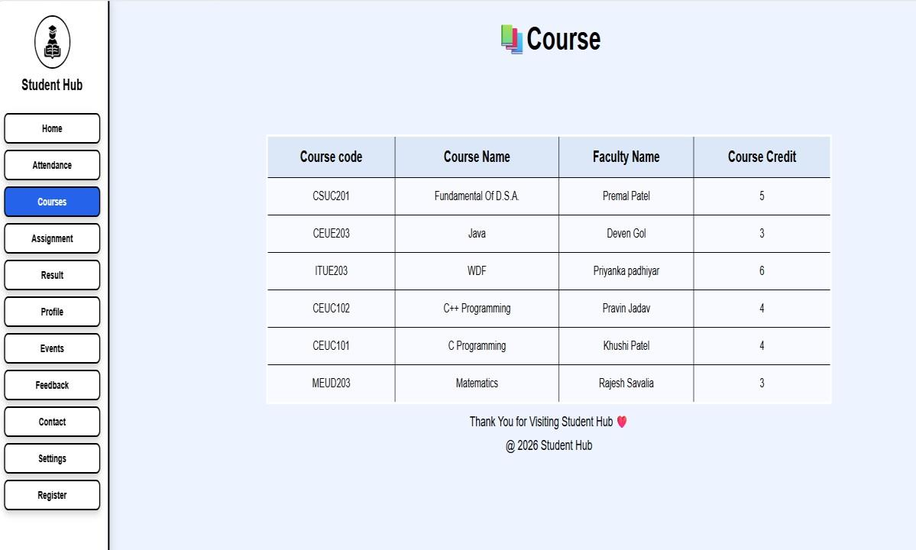
  - Courses
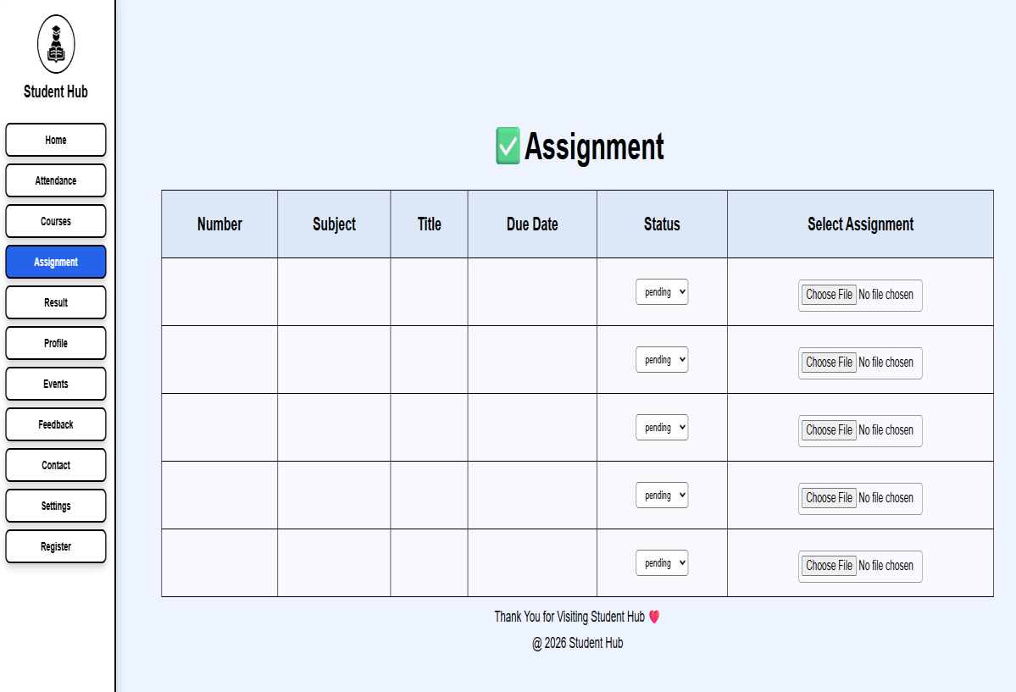
  - Assignment

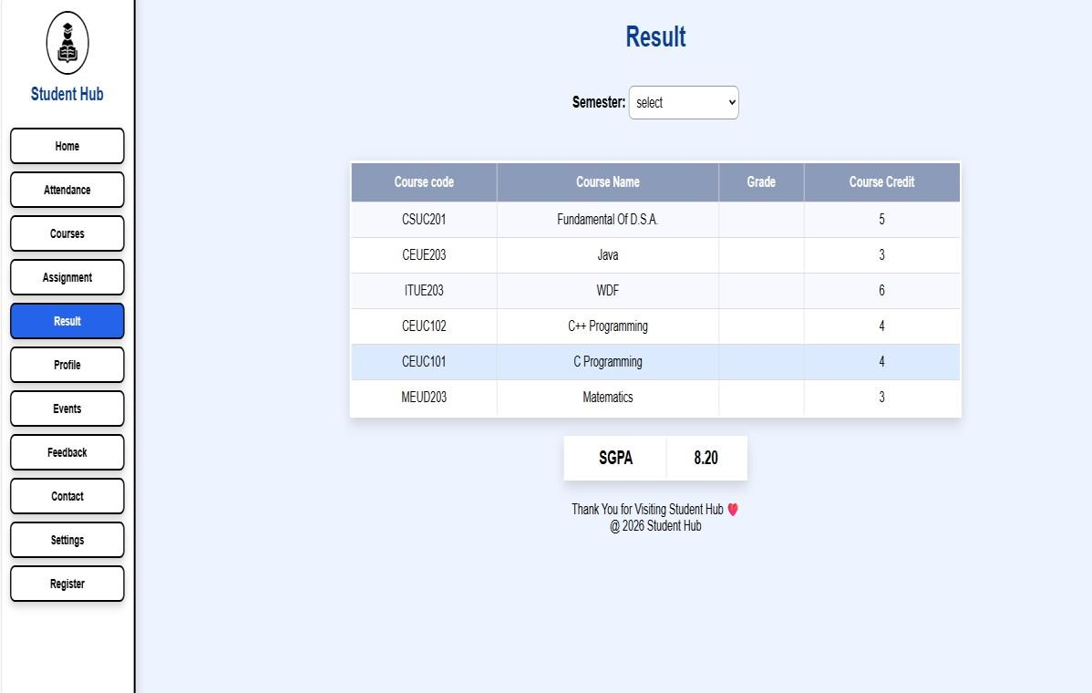
  - Result
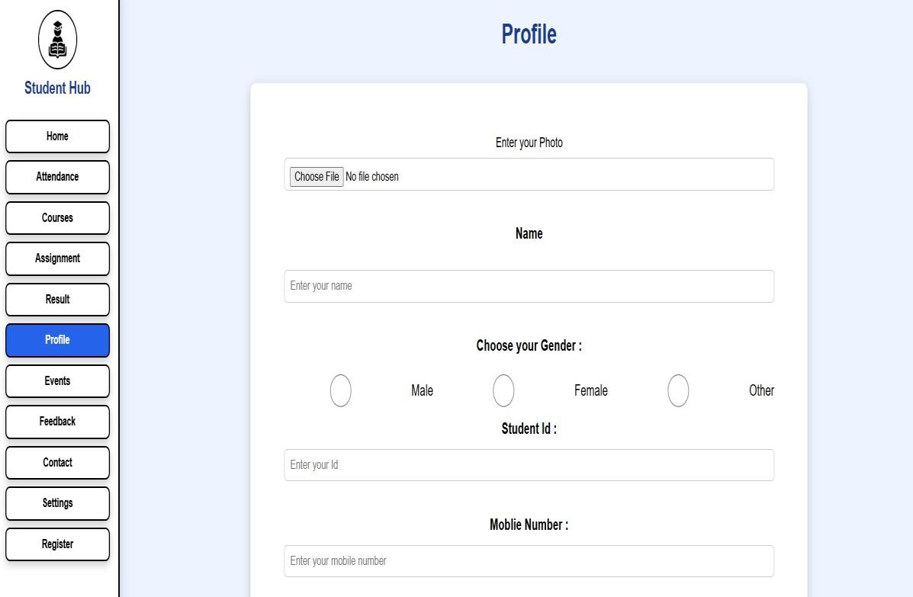
  - Profile

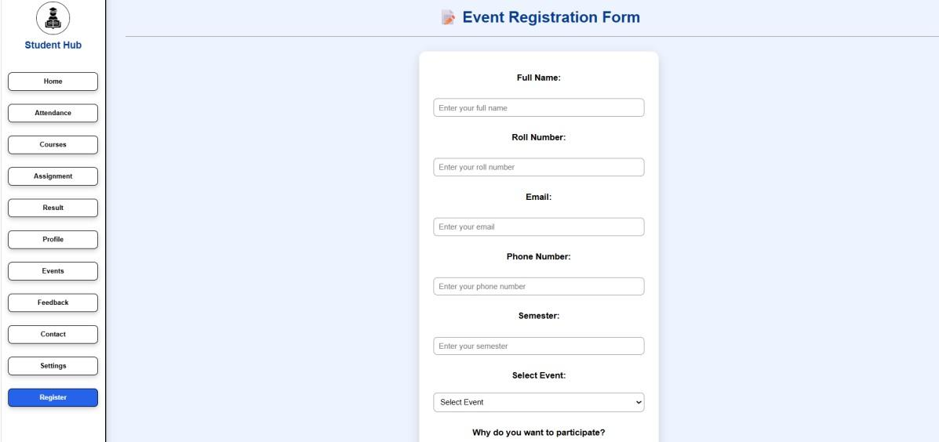
  - Register

  - Login



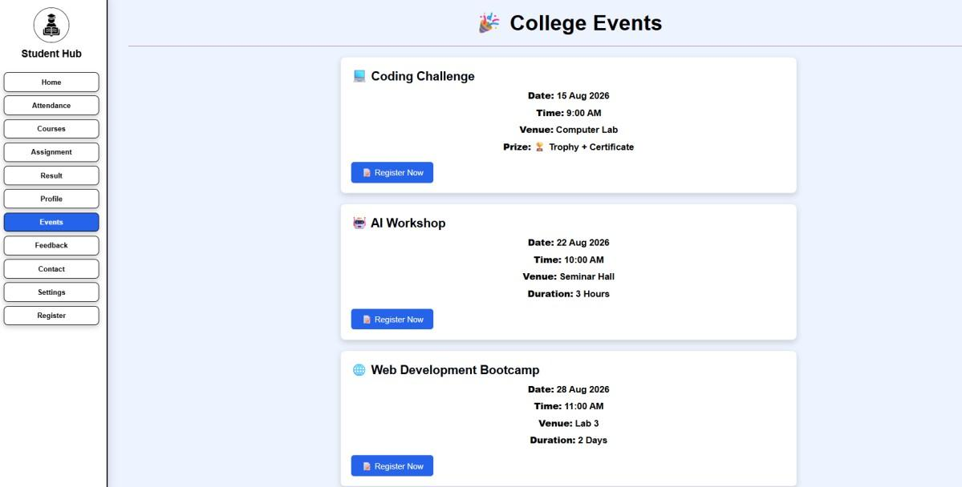
  - Event

- FeedBack

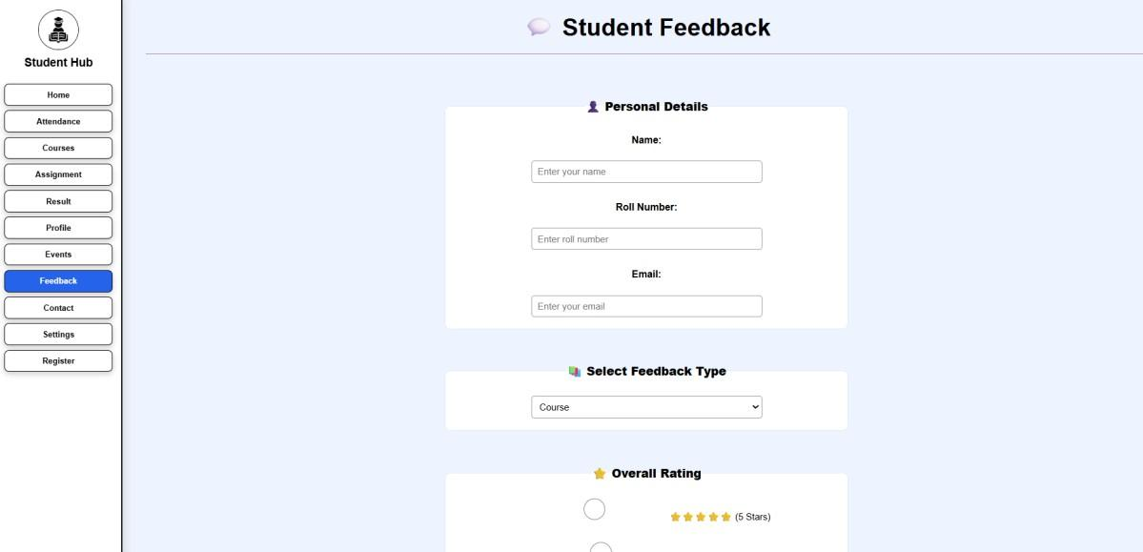
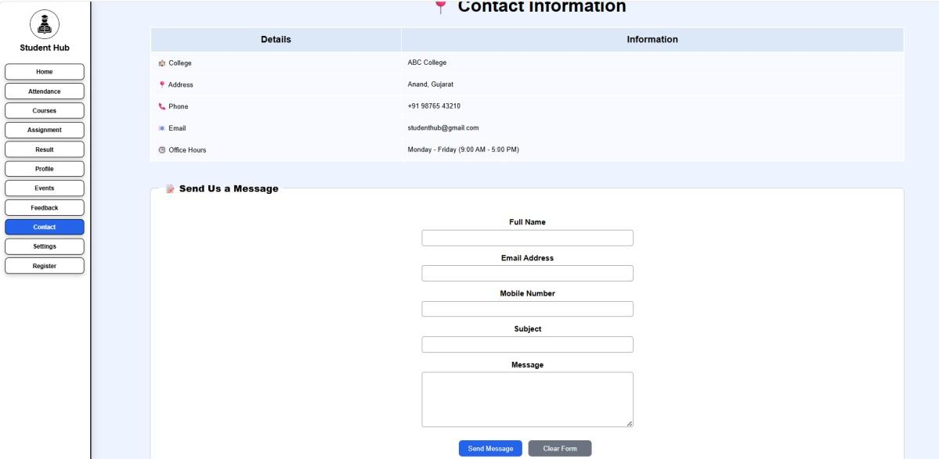
- Contact

- GitHub Repository Link:
https://github.com/Avi4522/Student-Hub

- Challenges Faced:
I faced some difficulty in applying the same CSS to all pages. I also had to fix alignment, spacing, and colors. After making changes, all pages looked consistent.

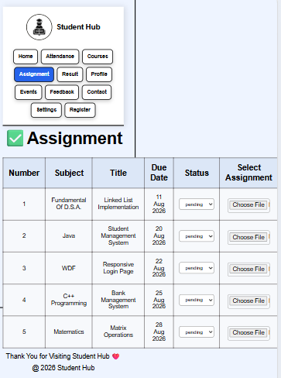
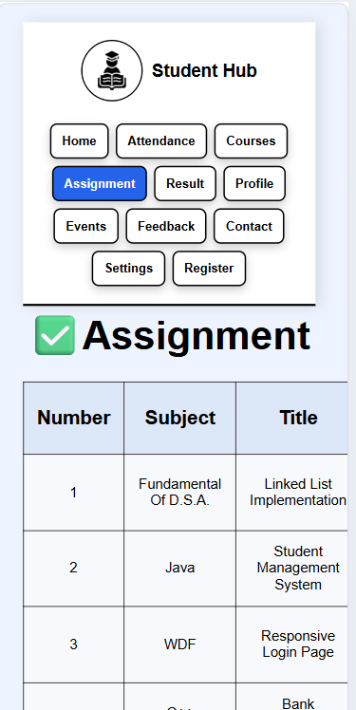
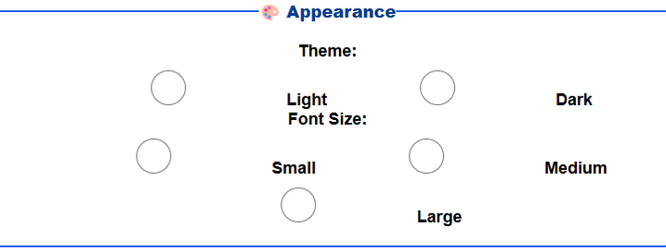

Learning Outcomes:
I learned how to use the same CSS on multiple pages. I also learned to keep the design consistent and make the website look clean and user-friendly.
Faculty Remarks:

