Practical 14: Admin Dashboard with Role-Based Access Control, Dynamic Menu, and Audit Log
Problem Definition
Develop an admin dashboard that displays user statistics, student count, event count and latest registrations. Restrict access to admin users only and show dynamic menu options based on role.
A. Theory
1. Are dashboard values loaded dynamically from the database?
Answer: Yes. Dashboard values are loaded dynamically from the database using SQL queries.
2. Is access restricted to admin users?
Answer: Yes. Access to the dashboard is restricted to users with the admin role.
3. Are role-based menus working?
Answer: Yes. Role-based menus display the appropriate options according to the user's role.
4. Are important admin actions recorded in audit_logs?
Answer: Yes. Important admin actions are recorded in the audit_logs table for tracking.
B. Implementation / Output / Result
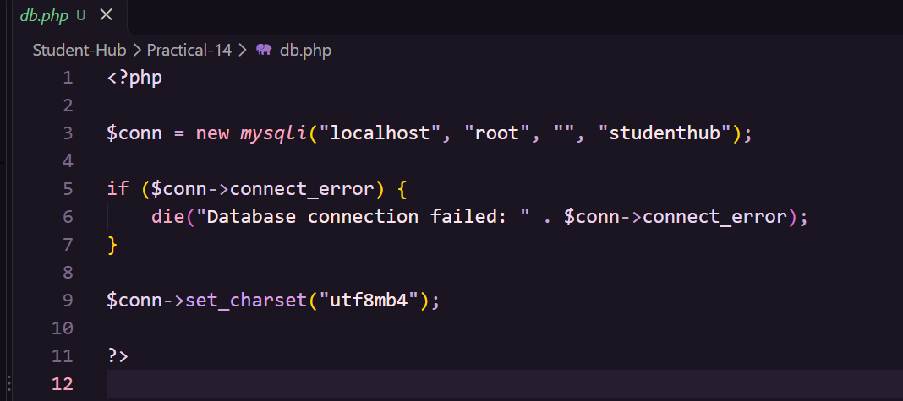
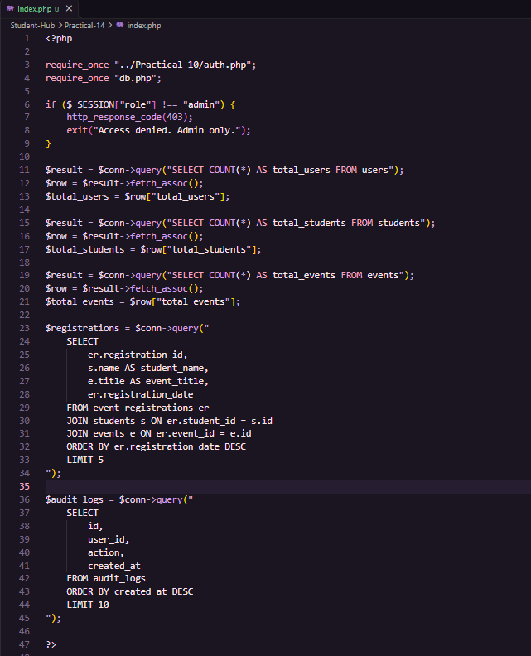
C. Evidence of Work (Screenshots)

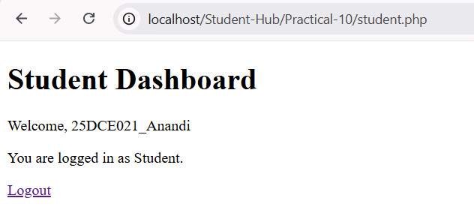
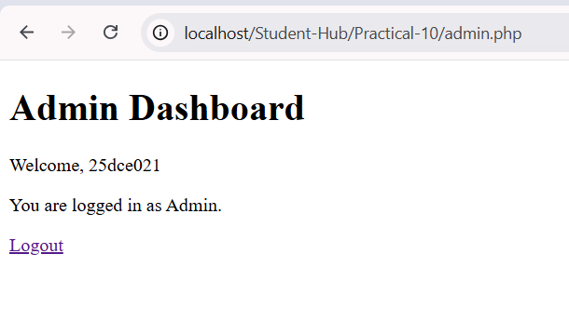
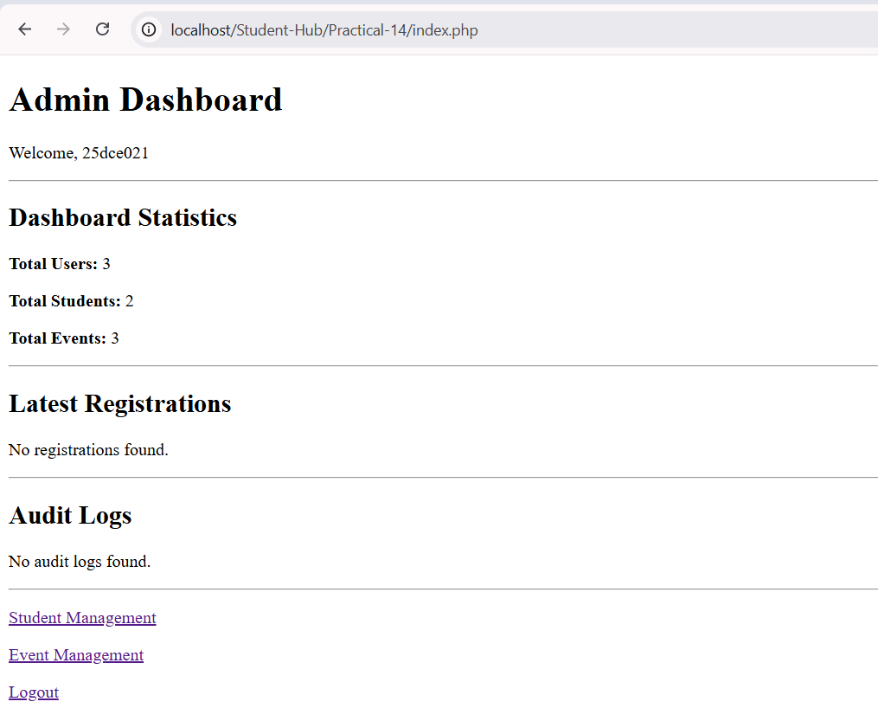
D. GitHub Repository Link
https://github.com/Avi4522/StudentHub/tree/main/Practical-14
E. Challenges Faced
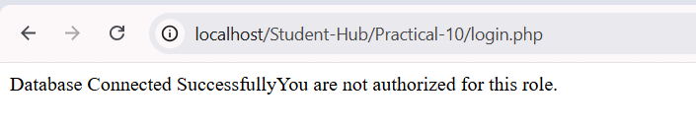
F. Learning Outcomes
I will learn to develop an admin dashboard with role-based access control, dynamic database statistics, role-based menus, latest registrations, and audit log management.
Faculty Remarks:

