Practical 10: Secure Login/Logout with Sessions, Role-Based Access, Timeout, and Remember-Me Token
Problem Definition | Develop secure login and logout functionality using PHP sessions. Verify password using password_verify(), regenerate session ID after login, restrict dashboard access, implement role-based redirection, session timeout, and optional secure remember-me token.
A. Theory
1. Are sessions started and destroyed securely?
Answer: Yes. Sessions are started securely, the session ID is regenerated after login, and logout destroys the session.
2. Is password_verify() used correctly?
Answer: Yes. password_verify() is used to verify the entered password against the hashed password stored in the database.
3. Is unauthorized dashboard access blocked?
Answer: Yes. The authentication and role checks prevent unauthorized users from accessing the admin or student dashboard.
4. Is session timeout implemented?
Answer: Yes. A session inactivity timeout is implemented, and the user is redirected to the login page after the timeout.
5. Are admin and student users redirected to appropriate dashboards?
Answer: Yes. Admin users are redirected to admin.php, while student users are redirected to student.php according to their role.
B. Implementation / Output / Result
The login system was implemented using PHP sessions, password_verify(), role-based access control, session regeneration, logout, and session timeout. Successful and failed login cases were tested.

Login . php :
<?php
session_start();
require_once "../Practical-8/db.php";
$email = trim($_POST["email"] ?? "");
$password = $_POST["password"] ?? "";
$stmt = $pdo->prepare("SELECT * FROM users WHERE email = :email");
$stmt->execute(["email" => $email]);
$user = $stmt->fetch(PDO::FETCH_ASSOC);
echo "Email received: " . htmlspecialchars($email) . "<br>";
if (!$user) {
echo "USER NOT FOUND";
exit;
}
echo "USER FOUND<br>";
if (password_verify($password, $user["password"])) {
echo "PASSWORD CORRECT<br>";
echo "Login check successful!";
}
else {
echo "PASSWORD WRONG";
}
?>

C. Evidence of Work (Screenshots)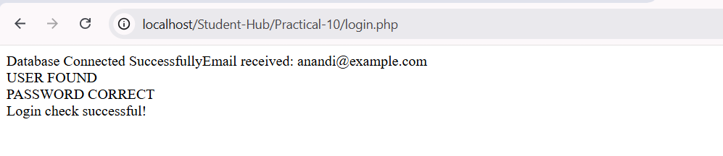
D. GitHub Repository Link
https://github.com/Avi4522/StudentHub/tree/main/Practical-10
E. Challenges Faced
The entered password was showing as incorrect during login.
I created a temporary reset_password.php file to reset the password.
After changing the password, I tested the login again successfully.
The temporary reset file was removed after completing the password reset.
F. Learning Outcomes
I learned how to implement secure login and logout using PHP sessions. I also learned password verification using password_verify(), session regeneration, role-based access control, session timeout, and secure authentication flow.
Faculty Remarks:

