Practical-7
PHP Form Processing with Server-Side Validation and CSV/JSON File Storage
Theory
- Is the form submitted using POST?
Answer: yes,form submitting using POST Method.

Are inputs validated and sanitized server side?
Answer: Yes, inputs are validated and sanitized on the server side using PHP before storing them.

Is file writing handled safely?
Answer: Yes, file writing is handled safely using PHP, with validated data written to the file.

Are success and error responses displayed clearly?
Answer: Yes, success and error messages are displayed clearly to the user.

Result:

Evidence of Work (Screenshots):

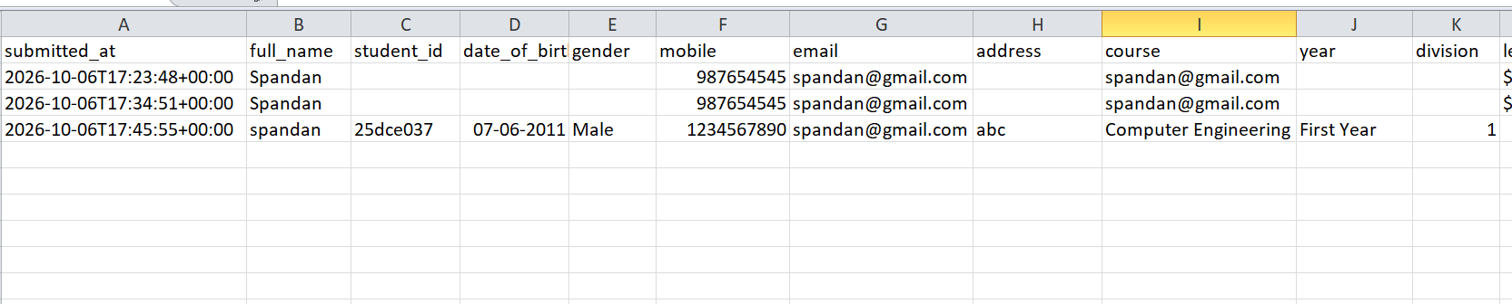
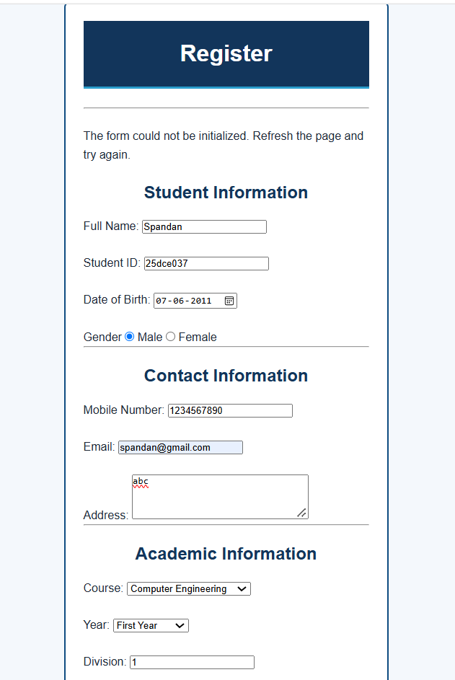

GitHub Repository Link:

https://github.com/25dce037-tech/Student-Hub-Portal.git

For XAMMP Server Link:-

http://localhost/Student%20Hub%20Portal/pages/Register.html

Challenges Faced:

  - I did not know much about PHP at the beginning.
  - I had difficulty understanding PHP syntax.
  - I was confused about how to connect my HTML pages with PHP.
  - I did not know how to run my project using the XAMPP server.
  - I faced problems with placing my files correctly inside the htdocs folder.
  - I found it difficult to store the form data in CSV/JSON files.
  - I faced errors while connecting the HTML form with the PHP file.
  - Updating my existing HTML and JavaScript pages to work with PHP was challenging.
  - Understanding server-side validation and sanitization was also new for me..

Learning Outcome:-

I learned how to use PHP for server-side form processing, validate and sanitize form data, connect my HTML forms with PHP using XAMPP, and store submitted data in CSV/JSON files. I also understood how backend processing works with a website.

Faculty Remarks:

