Ian Lim Teon Keng, DSO National Laboratories, LTeonKen@dso.org.sg Edx username: Ian_desx

Proposal Report: Mach Zehnder Interferometer
Abstract— This proposal presents the design and simulation of a Mach-Zehnder Interferometer (MZI) for photonic integrated circuit applications using Lumerical MODE and INTERCONNECT. Waveguide characteristics such as effective refractive index, mode confinement will be analyzed in MODE, while device-level performance including insertion loss and transmission response will be evaluated in INTERCONNECT. The study aims to establish an optimized MZI design and provide insights into the relationship between waveguide properties and interferometric performance.

INTRODUCTION
Silicon photonics has emerged as a key enabling technology for next-generation optical systems, offering the ability to integrate optical and electronic functionalities on a common silicon platform using mature complementary metal-oxide-semiconductor (CMOS) manufacturing processes. This approach enables compact, low-cost, and highly scalable photonic devices while supporting the increasing demand for high-bandwidth and energy-efficient data transmission. Recent advancements in silicon photonics have demonstrated its potential across telecommunications, data communications, sensing, and integrated optical computing applications. [1], [2]
The development of Photonic Integrated Circuits (PICs) has further accelerated the adoption of silicon photonics by integrating multiple optical components, such as waveguides, couplers, modulators, filters, and photodetectors, onto a single chip. Compared to discrete optical assemblies, PICs offer reduced size, weight, power consumption, and overall system complexity. As a result, PICs have become essential in applications including optical communications, data center interconnects, LiDAR, optical sensing, microwave photonics, quantum technologies, and advanced defense systems. [2], [3]
Among the fundamental building blocks of PICs, the Mach-Zehnder Interferometer (MZI) is one of the most widely utilized devices due to its versatility and robust operating principle. An MZI function by splitting an optical signal into two separate paths, introducing a relative phase difference, and subsequently recombining the signals to generate constructive or destructive interference. This structure forms the basis of numerous photonic functions, including optical modulation, switching, filtering, sensing, and signal processing. Owing to its simplicity and effectiveness, the MZI remains a cornerstone component in modern silicon photonic circuits. [4]
This design proposal focuses on the simulation and analysis of a silicon photonic MZI using Ansys Lumerical MODE and INTERCONNECT. The work aims to investigate key waveguide properties, including modal profiles and effective refractive indices, through MODE simulations, while evaluating circuit-level performance metrics such as transmission response, insertion loss, and extinction ratio using INTERCONNECT. The ultimate goal is to establish an optimized MZI design and develop a simulation framework that can support future photonic integrated circuit development and electro-optic device implementations.
.

Theory
MZI can be visualized into as a splitter, and a combiner with a certain path length between them. The path length difference ΔL = L₁ - L₂ will result in the phase difference where L₁ and L₂ represent path 1 and path 2 respectively.

Assuming an input optical field $E_{i}$is launched into an ideal 3-dB splitter, the optical field is equally divided between the two arms such that
$E_{1}=\frac{E_{i}}{\sqrt{2}}e^{-jβL_{1}}$ (1)
$E_{2}=\frac{E_{i}}{\sqrt{2}}e^{-jβL_{2}}$ (2)
where $β$is the propagation constant of the waveguide, given by
$β=\frac{2πn_{\text{eff}}}{λ}$ (3)
with $n_{\text{eff}}$ being the effective refractive index and $λ$ the operating wavelength.
At the output combiner, the two optical fields interfere coherently, producing a total output field
$E_{o}=E_{1}+E_{2}$ (4)
$E_{o}=\frac{E_{i}}{\sqrt{2}}\left(e^{-jβL_{1}}+e^{-jβL_{2}}\right)$ (5)
Factoring out $e^{-jβL_{2}}$,
$E_{o}=\frac{E_{i}}{\sqrt{2}}e^{-jβL_{2}}\left(1+e^{-jβΔL}\right)$ (6)
The output intensity is proportional to the squared magnitude of the output field:
$I_{o}=\frac{1}{2}I_{i}{∣1+e^{-jβΔL}∣}^{2}$ (7)
Expanding the magnitude term,
$I_{o}=\frac{1}{2}I_{i}\left(2+2cos⁡\left(βΔL\right)\right)$ (8)
Therefore, the output intensity of the Mach-Zehnder Interferometer can be expressed as
$I_{o}=\frac{I_{i}}{2}\left[1+cos⁡\left(βΔL\right)\right]$ (9)

where $I_{i}$is the input optical intensity and $βΔL$ represents the accumulated phase difference between the two interferometer arms. The output intensity periodically varies between constructive and destructive interference as the phase difference changes.

The other property to consider is the Free Spectral Range (FSR). It is the distance between two consecutive peaks in a output intensity vs wavelength graph.
$FSR=\frac{λ^{2}}{n_{g}ΔL}$ (10)
n_{g} = n​−λ $\frac{dn}{dλ}$ (11)

Simulation

Waveguide
A strip waveguide of 500nm width and 220nm height was used to simulate the waveguide mode profiles. Below are the figures.
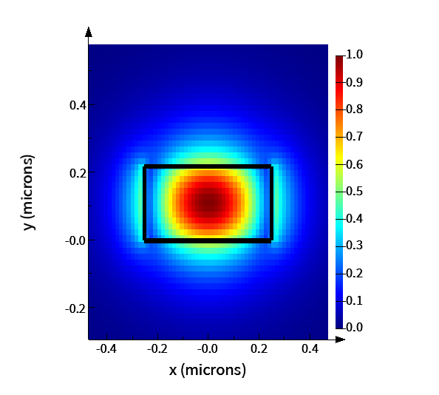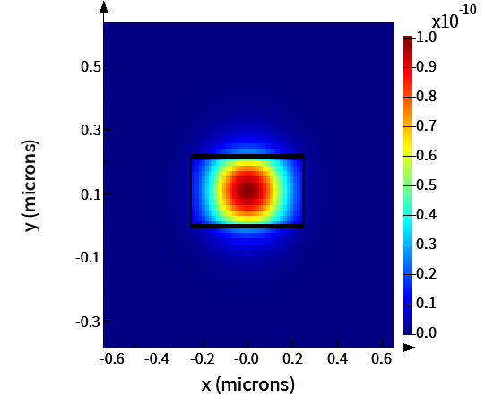
Fig 1. On the Left: Electric field intensity of TE mode in the waveguide. On the Right: Electric density, properly confined
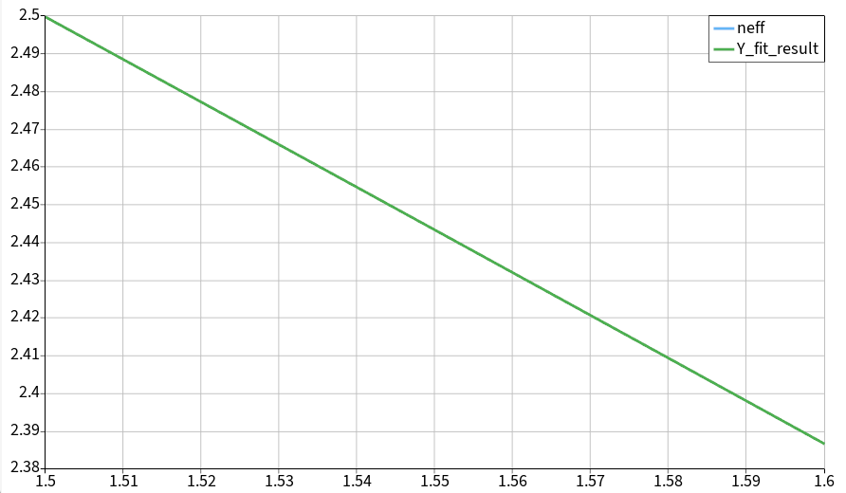
Fig 2. Curve fitting performed for Effective index vs Wavelength for first TE mode

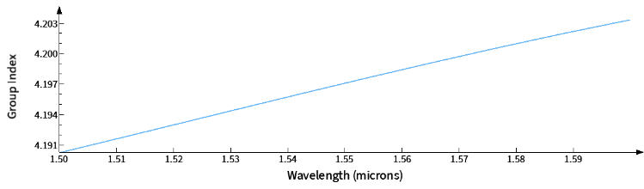
Fig 3. Group index vs Wavelength of first TE mode

The effective index and group index values obtained were 2.44325 and 4.197013 at 1550nm.

A compact waveguide model is used to represent the effective index as a function of wavelength without requiring repeated electromagnetic simulations. The effective index obtained from Lumerical MODE can be fitted using a polynomial:
n_{eff} (λ) = n₁ + n₂(λ-λ₀) +n₃(λ-λ₀)² (12)
Where $n_{\text{eff}}$ is the effective refractive index, λ₀ is 1550nm wavelength. This polynomial serves as the compact model and can subsequently be imported into INTERCONNECT for circuit-level simulations. Based on the simulation run, the values obtained for n₁ = 2.44325, n₂ = -1.13146, n₃ = -0.0426982. From here, we can also extract the dispersion, D where:
D = (-2λ₀n₃)/ c (13)

The value for dispersion reflected from (13) is around 0.442n s/m².

From (3) & (9),
T(λ)=21​[1 + cos(2π ΔL ​(n₁ + n₂(λ-λ₀) +n₃(λ-λ₀)²) λ⁻¹)] (14)

This transfer function describes the periodic transmission spectrum of the MZI and can be used determine key performance metrics such as the FSR.

Mach Zehnder Interferometer
Based on the found group index value, FSR with different path lengths in the design is shown in Table 1. Using (10), the group index value is consistent at 4.19 across different path difference and FSR.

Path Difference, $ΔL$(µm) | FSR (nm)
100 | 5.734
120 | 4.778
140 | 4.096
160 | 3.584
180 | 3.186
200 | 2.867

Table 1. FSR with different path lengths
MZI simulations were conducted using Lumerical INTERCONNECT. The SiEPIC-EBeam-PDK was used. A couple of components were characterized and simulated on the software to visualize insertion loss. The Y splitter from Fig 3. Displays around 3.18dB of loss and the grating coupler from Fig 4 shows a loss of around 2.4dB at 1550nm mark. The combined schematic is shown in Fig 5.

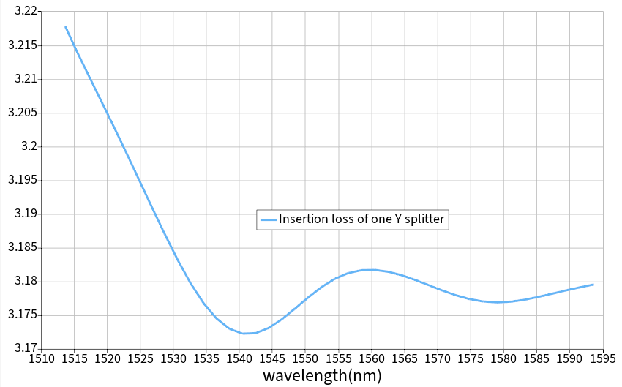
Fig 3. Insertion loss of Y splitter
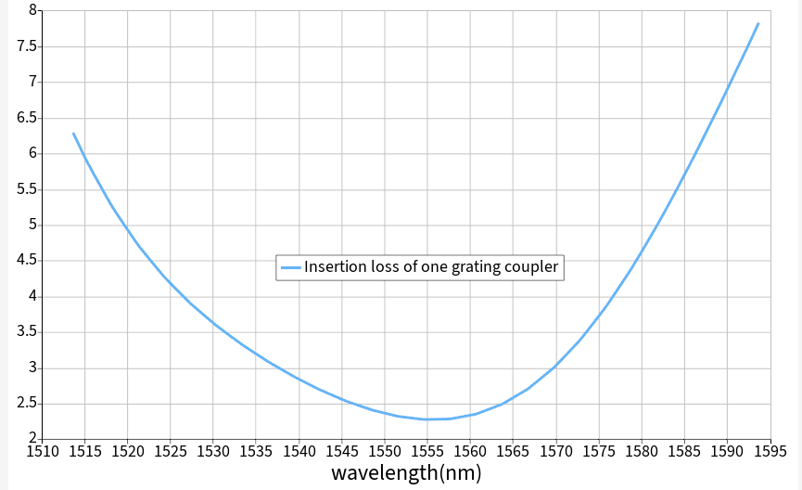
Fig 4. Insertion loss of grating coupler

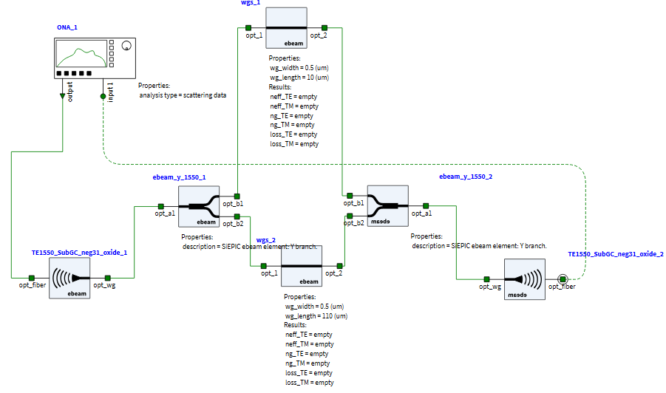
Fig 5. Schematic of the MZI layout on Lumerical INTERCONNECT
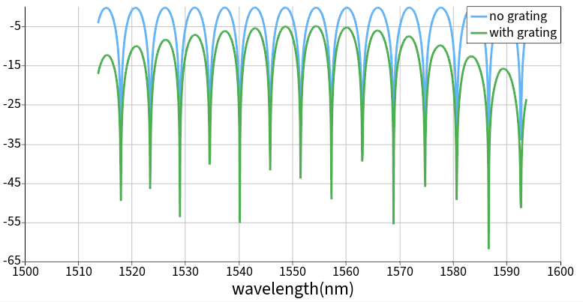
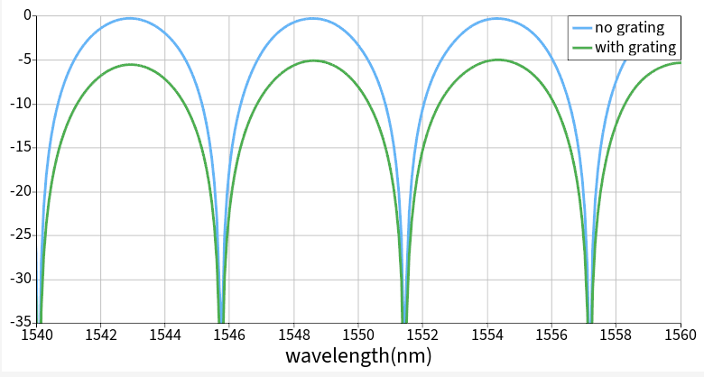
Fig 6. Spectrum of MZI with path difference L = 100 μm
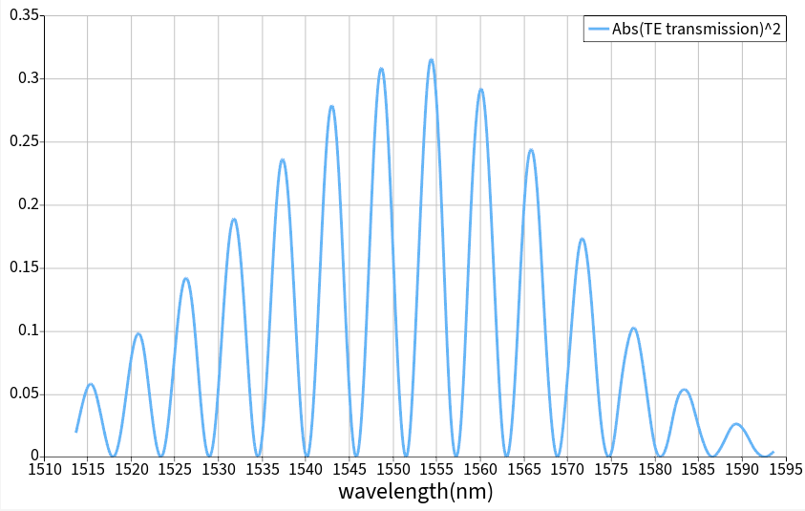
Fig 7. Transmission of MZI with two grating couplers

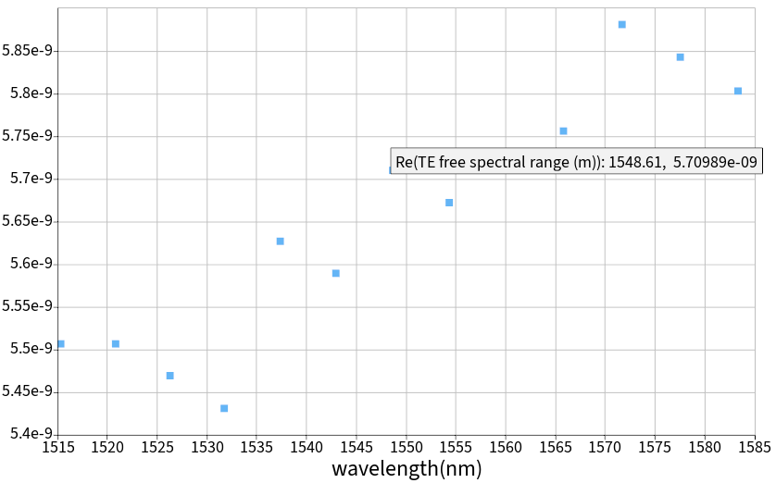
Fig 8. Free Spectral Range vs Wavelength of MZI with a pathlength difference of 100µm as seen from Optical Network Analyzer (ONA) in Lumerical INTERCONNECT
Fig 6 shows the expected sinusoidal behavior of the MZI vs wavelength, with FSR at about 5.7 at 1550nm as seen from Fig 8.

Based on the simulated result from Lumerical INTERCONNECT, we have verified that there is consistency with the values attained via Lumerical MODE and indicated from Table 1. This allows us to perform a sanity check on the MZI’s performance.

References
- A. B. Adisa and L. N. Abdulkadir, “Silicon Photonics: An Overview,” IntechOpen, 2026.
- W. Li and D. Huang, “Silicon Photonics Devices and Integrated Circuits,” Photonics, vol. 12, no. 3, 2025.
- A. N. Bozovich, “Photonic Integrated Circuits (PICs) for Next Generation Space Applications,” NASA NEPP Electronics Technology Workshop, 2020.
- W. Bogaerts, “Introduction to Silicon Photonics Circuit Design,” Optical Fiber Communication Conference (OFC) Short Course, 2018.

