Roll No: 25ec405
Name: SANJAY D S
Class: Ece – F
Experiment No: 2

Title : CSS Enhancements - Shadows, Borders, Backgrounds.

Aim :
Enhance Web Elements with CSS : shadows, Rounded Border and Multiple Background.

Procedure :
- Open any text editor such as Notepad or VS Code.
- Create a new file and save it with the name index.html.
- Write the HTML structure including <html>, <head>, and <body> tags.
- Inside the <style> tag, add CSS properties to style the webpage.
- Apply multiple background images to the body using the background-image property.
- Use box-shadow and text-shadow properties to create shadow effects for elements like the header, card, and text.
- Apply border-radius to create rounded borders for the card, image, and footer.
- Design a card layout with an image, heading, and paragraph to display the styled elements.
- Save the file and open it in any web browser such as Chrome or Edge.
- Verify that the webpage displays shadows, rounded borders, and multiple background effects correctly.

Program:
<!DOCTYPE html>
<html lang="en">
<head>
<meta charset="UTF-8">
<meta name="viewport" content="width=device-width, initial-scale=1.0">
<title>CSS Enhancements - Shadows, Borders, Backgrounds</title>

<style>
/* Multiple background images */
body {
background-image: url('https://www.transparenttextures.com/patterns/cubes.png'),
linear-gradient(to right, #a1c4fd, #c2e9fb);
background-repeat: repeat, no-repeat;
background-size: auto, cover;
font-family: 'Segoe UI', Tahoma, Geneva, Verdana, sans-serif;

}

/* Header styling with text-shadow */
header {
text-align: center;
padding: 30px;
background-color: rgba(255, 255, 255, 0.8);
box-shadow: 0 4px 10px rgba(0, 0, 0, 0.2);
}

header h1 {
color: #333;
text-shadow: 2px 2px 4px rgba(0, 0, 0, 0.3);
font-size: 34px;
}

/* Card Box with shadow and rounded border */
.card {
background-color: white;
border-radius: 15px;
box-shadow: 0 8px 16px rgba(0, 0, 0, 0.25);
max-width: 600px;
margin: 50px auto;
padding: 30px;
text-align: center;
}

.card img {
width: 150px;
height: 150px;
border-radius: 50%;
box-shadow: 0 4px 10px rgba(0, 0, 0, 0.3);
margin-bottom: 20px;
}

.card p {
font-size: 17px;
color: #555;
}

/* Footer styling */
footer {
text-align: center;
background-color: rgba(0, 0, 0, 0.7);
color: white;
padding: 10px;
font-size: 16px;
border-top-left-radius: 10px;
border-top-right-radius: 10px;
}

footer p {
margin: 0;
}
</style>
</head>

<body>
<header>
<h1>CSS Enhancements Demo</h1>
</header>

<div class="card">
<img src="https://cdn-icons-png.flaticon.com/512/147/147144.png" alt="User Avatar">
<h2 style="color:#3366cc;">Welcome to CSS Styling</h2>
<p>This webpage demonstrates <b>shadows</b>, <b>rounded borders</b>,
and <b>multiple background images</b> using CSS3.
</p>
</div>
<footer>
<p>&copy; 2025 Application Development Practices Lab</p>
</footer>
</body>
</html>
OUTPUT SCREENSHOT:
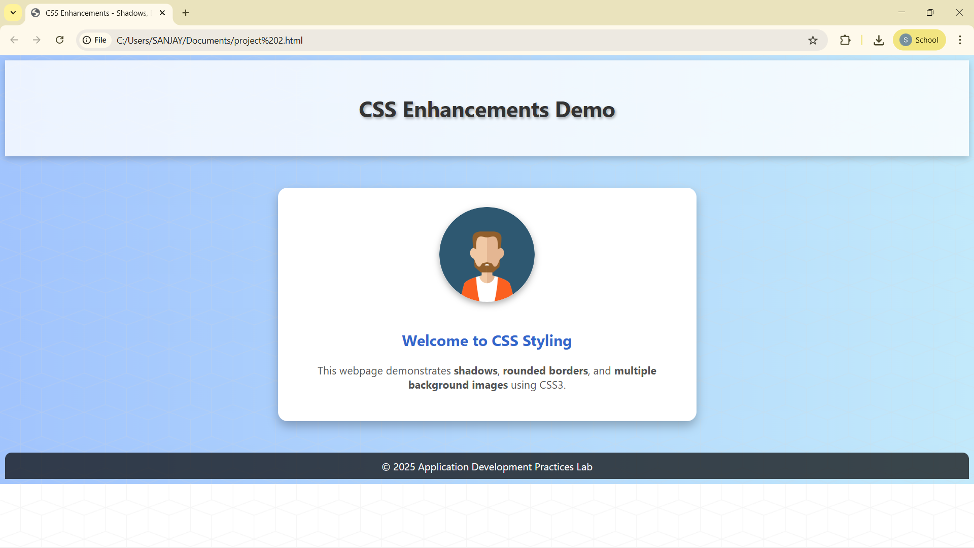

RESULT:
properties such as shadows, rounded borders, and multiple backgrounds, Thus, the web page was successfully created and enhanced using CSS improving the visual appearance and layout of the webpage.

25ec405
Sanjay ds.

