Roll No: 25ec405
Name: SANJAY D S
Class: Ece – F
Experiment No: 8

TITLE : PowerShell Script – Basic File Management.

AIM :

Write a Linux shell script to automate file management tasks. Follow the below execute the commands and submit procedure and output.

PROCEDURE :

Step 1: Open Terminal
Open Windows PowerShell
Type:
wsl
This opens the Linux (WSL) terminal

Step 2: Move to Home Directory
cd ~

Step 3: Create Script File
nano file_management.sh

Step 4: Enter the Script
Paste the given shell script inside the nano editor

Step 5: Save the File
Press CTRL + X
Press Y
Press ENTER

Step 6: Provide Execute Permission
chmod +x file_management.sh

Step 7: Execute the Script
./file_management.sh

Step 8: Verify Output
ls -R
PROGRAM :
Shell Script for File Management Automation:

#!/bin/bash

echo "----- FILE MANAGEMENT AUTOMATION STARTED -----"

# Create folders
mkdir -p Project/Source
mkdir -p Project/Backup

# Create sample files
echo "This is file 1" > Project/Source/file1.txt
echo "This is file 2" > Project/Source/file2.txt
echo "This is file 3" > Project/Source/file3.txt

# Copy files
cp Project/Source/file1.txt Project/Backup/
cp Project/Source/file2.txt Project/Backup/

# Move file
mv Project/Source/file3.txt Project/Backup/

# Delete a file
rm Project/Backup/file2.txt

# Display file list
echo "Source Folder:"
ls Project/Source

echo "Backup Folder:"
ls Project/Backup

echo "----- AUTOMATION COMPLETED -----"

SCREENSHOT :
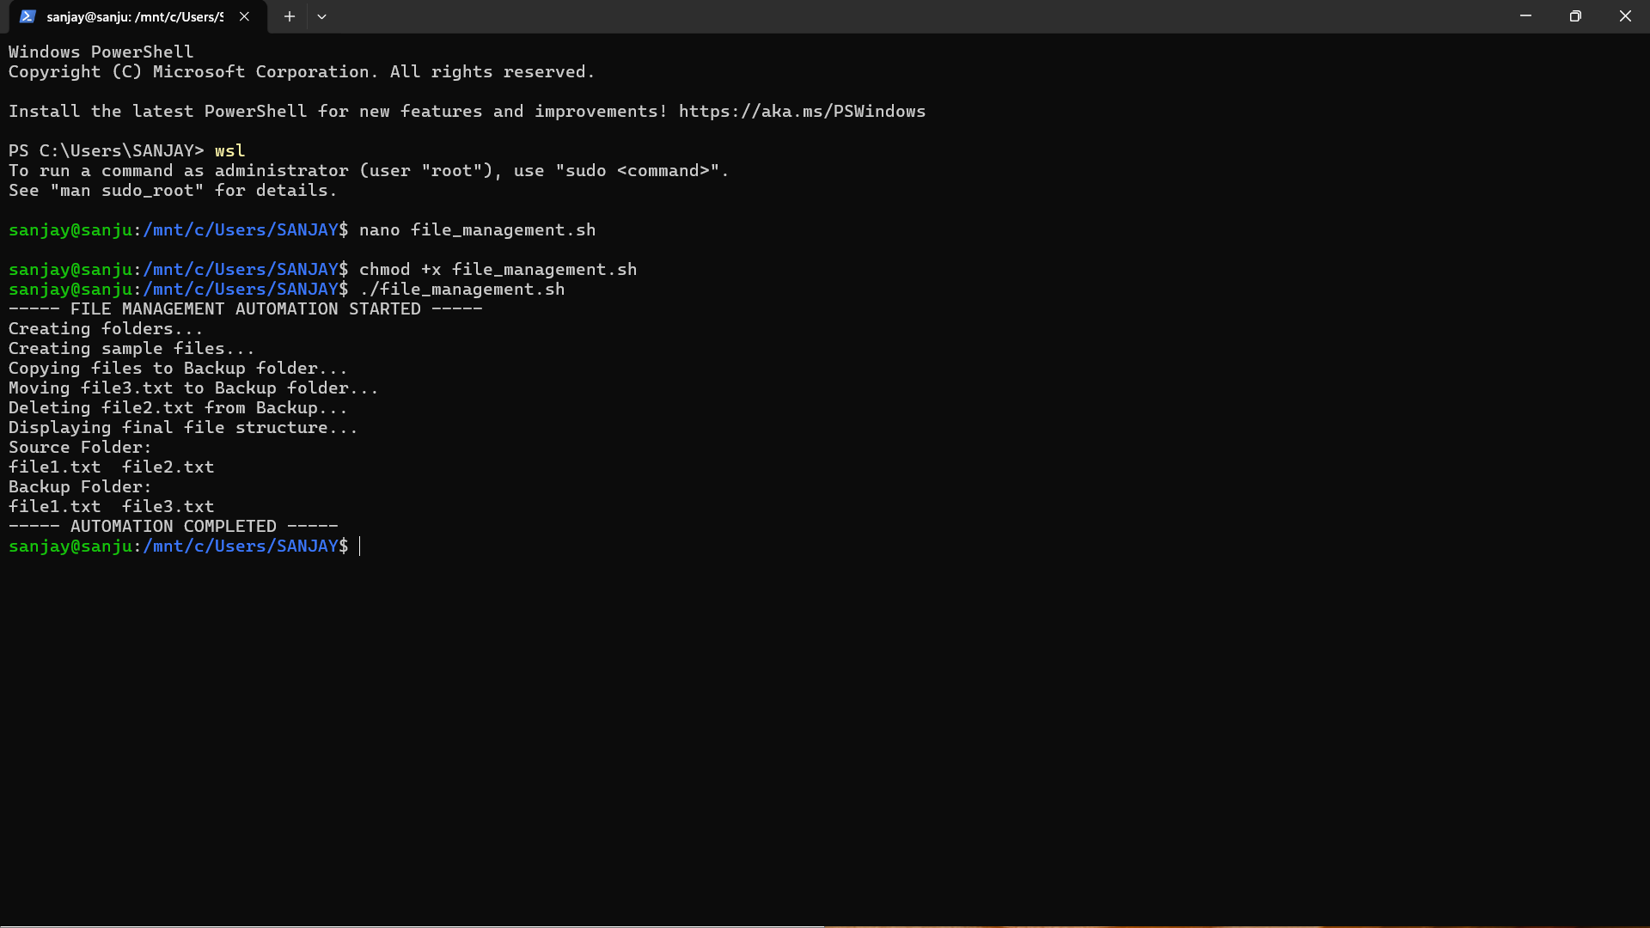

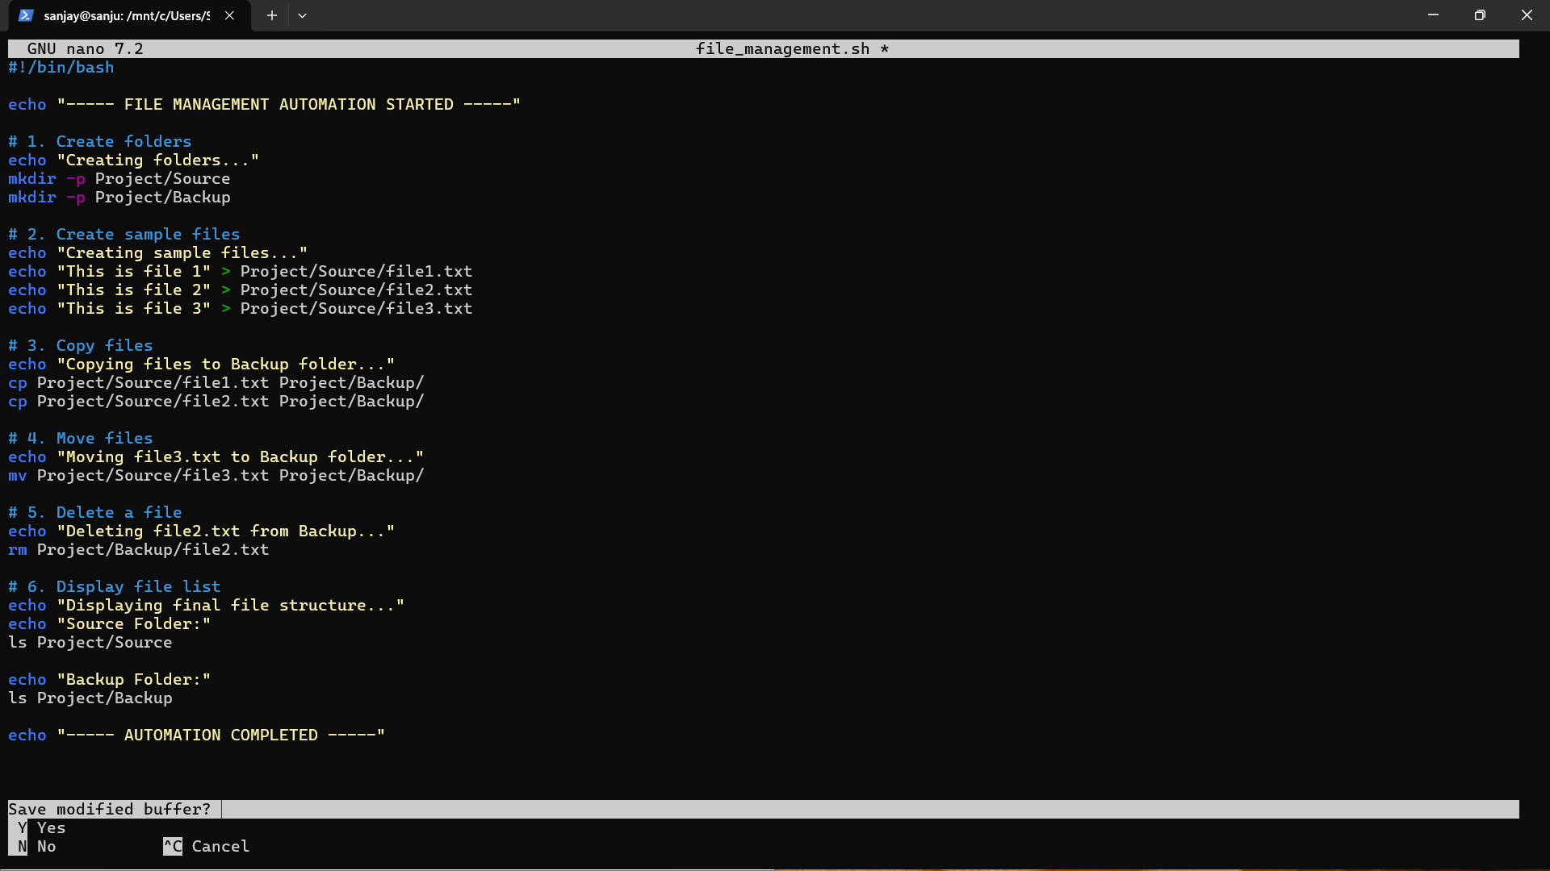
RESULT :
The shell script executed successfully and performed file operations like create, copy, move, delete, and display.

25ec405
-SANJAY D S

