Register number:25ec405
Name : SANJAY D S
Class : Ece - f
Experiment No: 1
TITLE: RESPONSIVE WEBPAGE

AIM : Create a Responsive Webpage with Registration form using HTML, CSS, bootsrap grid system.

PROCEDURE:
- Open a text editor such as Notepad or Visual Studio Code.

- Create a new file and save it as registration.html.

- Write the basic HTML structure including <html>, <head>, and <body> tags.

- Add the Bootstrap CDN link inside the <head> section to use Bootstrap styles and grid system.

- Use a Bootstrap container class to keep the form content centered on the webpage.

- Create a row and divide it into columns using Bootstrap grid classes like col-md-6 for responsive layout.

- Add form elements such as Name, Email, Password, Phone Number, Gender, and Address using HTML input fields.

- Apply Bootstrap classes such as form-control, form-label, and form-check to style the form elements.

- Add a Submit/Register button using Bootstrap button classes.

- Use CSS styling to improve the appearance of the webpage if required.

- Save the file and open it in a web browser to view the responsive registration form.

PROGRAM:

<!DOCTYPE html>
<html lang="en">
<head>
<meta charset="UTF-8">
<meta name="viewport" content="width=device-width, initial-scale=1.0">
<title>Responsive Registration Form</title>

<!-- Bootstrap 5 CDN -->
<link
href="https://cdn.jsdelivr.net/npm/bootstrap@5.3.3/dist/css/bootstrap.min.css"
rel="stylesheet">

<!-- Custom CSS -->
<style>
body {
background: linear-gradient(135deg, #74ABE2, #5563DE);

}
.form-container {
background-color: white;
border-radius: 15px;
box-shadow: 0 4px 10px rgba(0, 0, 0, 0.2);
padding: 30px;
width: 100%;
max-width: 500px;
}
h2 {
text-align: center;
margin-bottom: 20px;
color: #333;
}
</style>
</head>

<body>
<div class="container">
<div class="row justify-content-center">
<div class="col-md-8 col-lg-6">
<div class="form-container">
<h2>Registration Form</h2>
<form>
<!-- Full Name -->
<div class="mb-3">
<label for="fullname" class="form-label">Full Name</label>
<input type="text" class="form-control" id="fullname" placeholder="Enter your full name" required>
</div>

<!-- Email -->
<div class="mb-3">
<label for="email" class="form-label">Email address</label>
<input type="email" class="form-control" id="email" placeholder="Enter your email" required>
</div>

<!-- Password -->
<div class="mb-3">
<label for="password" class="form-label">Password</label>
<input type="password" class="form-control" id="password" placeholder="Enter password" required>
</div>

<!-- Gender -->
<div class="mb-3">
<label class="form-label">Gender</label><br>
<div class="form-check form-check-inline">
<input class="form-check-input" type="radio" name="gender" id="male" value="male" required>
<label class="form-check-label" for="male">Male</label>
</div>
<div class="form-check form-check-inline">
<input class="form-check-input" type="radio" name="gender" id="female" value="female">
<label class="form-check-label" for="female">Female</label>
</div>
</div>

<!-- Course -->
<div class="mb-3">
<label for="course" class="form-label">Course</label>
<select class="form-select" id="course" required>
<option value="">Select Course</option>
<option value="B.Tech">B.Tech</option>
<option value="M.Tech">M.Tech</option>
<option value="MBA">MBA</option>
</select>
</div>
<!-- Phone -->
<div class="mb-3">
<label for="phone" class="form-label">Phone Number</label>
<input type="tel" class="form-control" id="phone" pattern="[0-9]{10}" placeholder="Enter 10-digit number" required>
</div>
<!-- Submit Button -->
<div class="d-grid">
<button type="submit" class="btn btn-primary">Register</button>
</div>
</form>
</div>
</div>
</div>
</div>
<!-- Bootstrap JS -->
<script src="https://cdn.jsdelivr.net/npm/bootstrap@5.3.3/dist/js/bootstrap.bundle.min.js"></script>
</body>
</html>

OUTPUT SCREENSHOT:

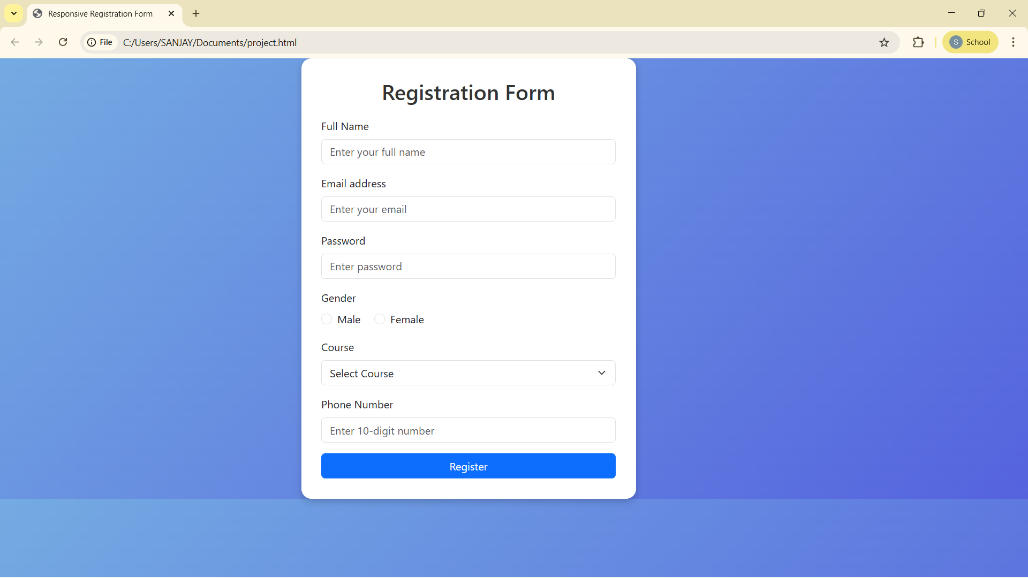

RESULT:

A responsive is created using html with bootstrap.

