Roll No: 25ec405
Name: SANJAY D S
Class: Ece – F
Experiment No: 6

TITLE : Simple Weather App.

AIM :

Work with APIs and fetch data asynchronously using JavaScript.

PROCEDURE :
- Create a new HTML file and save it as weather.html.
- Write the basic HTML structure using <html>, <head>, and <body> tags.
- Add a heading to display the title “Weather App (Async JavaScript)”.
- Create an input field using <input> to allow the user to enter a city name.
- Add a button using <button> and link it to a JavaScript function getWeather() using the onclick event.
- Create a <p> tag with an id result to display the weather output.
- Inside the <script> tag, define an async function named getWeather().
- Retrieve the city name entered by the user using document.getElementById().value.
- Provide your API key from OpenWeatherMap (replace "YOUR_API_KEY" with a valid key).
- Construct the API URL using the city name, API key, and metric units.
- Use the fetch() method with await to request weather data from the API.
- Convert the response into JSON format using response.json().
- Extract temperature and weather description from the JSON data.
- Display the result in the webpage using innerHTML.
- Use a try-catch block to handle errors and display an error message if the request fails.
- Save the file and open it in a web browser.
- Enter a city name and click the button to view the weather details.

PROGRAM :
<!DOCTYPE html>
<html>
<head>
<title>Simple Weather App</title>
</head>
<body>
<h2>Weather App (Async JavaScript)</h2>
<input type="text" id="city" placeholder="Enter city name">
<button onclick="getWeather()">Get Weather</button>
<p id="result"></p>
<script>
async function getWeather() {
let city = document.getElementById("city").value;
let apiKey = "YOUR_API_KEY";
let url = https://api.openweathermap.org/data/2.5/weather?q=${city}&appid=${apiKey}&units=metric;
try {
let response = await fetch(url);
let data = await response.json();
let temp = data.main.temp;
let weather = data.weather[0].description;
document.getElementById("result").innerHTML =
"Temperature: " + temp + " °C <br> Weather: " + weather;
}
catch(error) {
document.getElementById("result").innerHTML = "Error fetching data";
}
}
</script>
</body>
</html>

OUTPUT SCREENSHOT :
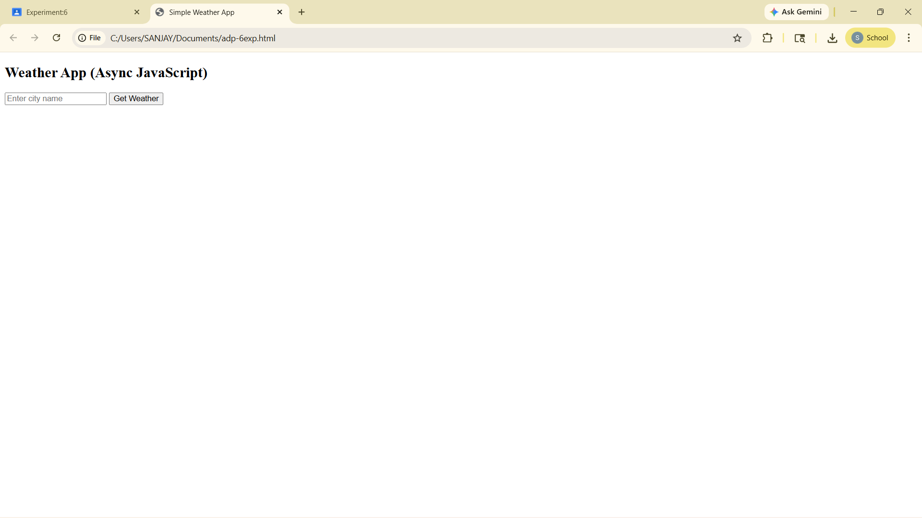

RESULT :
- The Weather App was successfully implemented using HTML and Async JavaScript.
On entering a valid city name, the application fetches real-time weather data from the OpenWeatherMap API and displays:
- Temperature in Celsius
- Weather description (e.g., clear sky, cloudy, rain)
- If an invalid city name is entered or an error occurs, an appropriate error message is displayed.

