Roll No: 25ec405
Name: SANJAY D S
Class: Ece – F
Experiment No: 4

TITLE : Simple Form Validation.

AIM :

Implement a JavaScript based form validation for user input fields.

PROCEDURE :

1. Create an HTML form with input fields for name, email, and phone number.
2. Design the form using CSS for a simple and neat appearance.
3. Use JavaScript to read the values entered by the user.
4. Check whether all fields are filled.
5. Validate the email format using a pattern.
6. Validate the phone number to ensure it contains exactly 10 digits.
7. Display alert messages for invalid inputs.
8. Show a success message when all entered data is correct.
9. Add buttons to display entered data and clear the form.

PROGRAM :
<!DOCTYPE html>
<html>
<head>
<title>Simple Form Validation</title>

<style>
body {
font-family: Arial;
background-color: #f2f2f2;
}

.container {
width: 350px;
margin: 50px auto;
background: white;
padding: 20px;
border-radius: 10px;
box-shadow: 0 4px 8px rgba(0,0,0,0.2);
}

input {
width: 100%;
padding: 8px;
margin: 8px 0;
}

button {
width: 100%;
padding: 8px;
margin-top: 5px;
background-color: #3366cc;
color: white;
border: none;
cursor: pointer;
}

button:hover {
background-color: #254a99;
}
</style>

<script>
function validateForm() {
let name = document.getElementById("name").value;
let email = document.getElementById("email").value;
let phone = document.getElementById("phone").value;

// Simple email pattern
let emailPattern = /^[^ ]+@[^ ]+\.[a-z]{2,3}$/;

// Simple phone number pattern (10 digits)
let phonePattern = /^[0-9]{10}$/;

if (name === "" || email === "" || phone === "") {
alert("All fields are mandatory!");
}
else if (!email.match(emailPattern)) {
alert("Please enter a valid email address!");
}
else if (!phone.match(phonePattern)) {
alert("Phone number must contain exactly 10 digits!");
}
else {
alert("Validation successful!");
}
}

function showData() {
let name = document.getElementById("name").value;
let email = document.getElementById("email").value;
let phone = document.getElementById("phone").value;

alert(
"Name: " + name + "\n" +
"Email: " + email + "\n" +
"Phone: " + phone
);
}

function clearForm() {
document.getElementById("name").value = "";
document.getElementById("email").value = "";
document.getElementById("phone").value = "";
}
</script>
</head>

<body>

<div class="container">
<h3 align="center">Registration Form</h3>

<input type="text" id="name" placeholder="Enter Name">
<input type="email" id="email" placeholder="Enter Email">
<input type="text" id="phone" placeholder="Enter Phone Number">

<button onclick="validateForm()">Validate</button>
<button onclick="showData()">Show Data</button>
<button onclick="clearForm()">Clear</button>
</div>
</body>
</html>

OUTPUT SCREENSHOT :
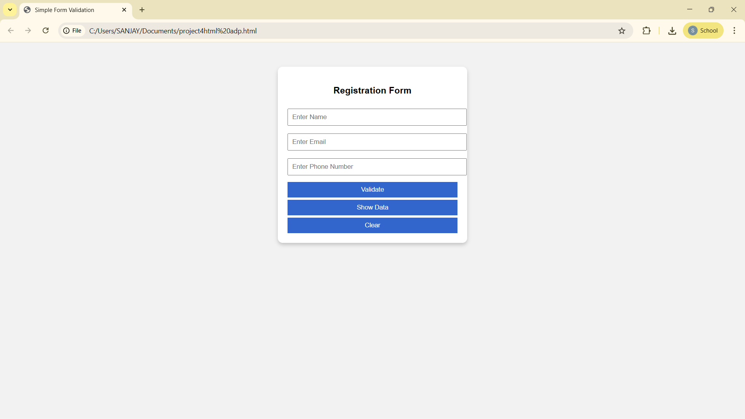

RESULT :
The program successfully validates user input fields using JavaScript and provides feedback through alert messages.

25ec405
Sanjay ds

