EXP NO: 10 Perform Git version control operations: cloning, committing, branching, and merging.

AIM:
To understand and perform basic Git operations such as cloning a repository, committing changes, creating branches, and merging them.

ALGORITHM:
- Install Git on the system.
- Create a repository on GitHub.
- Clone the repository to the local system.
- Add a sample file and make changes.
- Stage and commit the changes.
- Create a new branch.
- Switch to the new branch and modify files.
- Commit changes in the branch.
- Switch back to the main branch.
- Merge the branch with the main branch.
- Push changes to the remote repository.

CODING:
# Clone repository git clone https://github.com/username/repository.git

# Move into folder cd repository
# Create a file
echo "Hello Git" > file.txt

# Add file git add file.txt
# Commit changes
git commit -m "Initial commit"
# Create a new branch git branch feature-branch

# Switch to branch git checkout feature-branch
# Modify file echo "This is a new feature" >> file.txt
# Add and commit again
git add file.txt
git commit -m "Updated in feature branch"

# Switch back to main branch git checkout main

# Merge branch git merge featurebranch
# Push to GitHub git push origin main

OUTPUT:
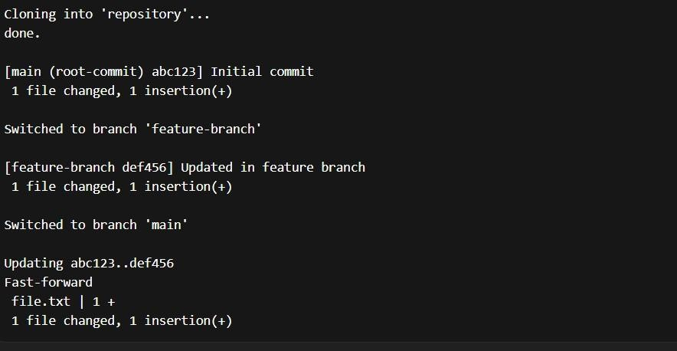

RESULT:
The Git version control operations such as cloning, committing, branching, and merging were successfully performed. This experiment helped in understanding how multiple versions of a project can be managed efficiently using Git.

