Experiment 9. Schedule Background Jobs using Linux Cron and Batch Scripting:

AIM:
To automate and schedule background tasks in Linux using cron and batch scripting.

ALGORITHM:
- Create a shell script file.
- Write commands inside the script.
- Make the script executable.
- Open crontab using crontab -e.
- Add a cron job entry.
- Save and exit.
- Verify scheduled jobs.

#!/bin/bash

# create output file and write message
echo "Hello, this is a scheduled job" >> output.txt
# make script executable
chmod +x
test.sh
# schedule job (runs every minute)
(crontab -l 2>/dev/null; echo "* * * * * $(pwd)/test.sh") | crontab -

OUTPUT:
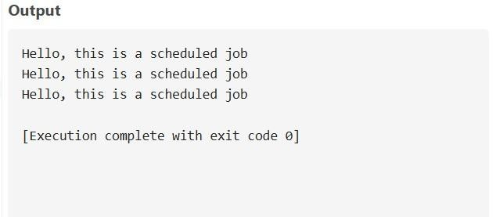

RESULT:
The background job was successfully scheduled and executed using cron.

