Roll No: 25ec405
Name: SANJAY D S
Class: Ece – F
Experiment No: 3

TITLE : Bootstrap Responsive Layout.

AIM :

Implement a CSS Grid Based layout to create a responsive web page.

PROCEDURE :
- Open a text editor such as Notepad or VS Code.
- Create a new file and save it as bootstrap_layout.html.
- Write the basic HTML structure using <html>, <head>, and <body> tags.
- Link the Bootstrap CSS library using the CDN link inside the <head> section.
- Create a container using the Bootstrap container class to hold the webpage layout.
- Use the Bootstrap grid system with row and col classes to divide the page into sections.
- Design the header, navigation bar, main content, sidebar, and footer using Bootstrap columns.
- Apply custom CSS styles for background colors, padding, and alignment to improve appearance.
- Save the file and open it in any web browser such as Chrome or Edge.
- Resize the browser window to verify that the layout adjusts automatically for different screen sizes, demonstrating responsive design.

PROGRAM :
<!DOCTYPE html>
<html lang="en">
<head>
<meta charset="UTF-8">
<meta name="viewport" content="width=device-width, initial-scale=1.0">
<title>Bootstrap Responsive Layout</title>

<link href="https://cdn.jsdelivr.net/npm/bootstrap@5.3.8/dist/css/bootstrap.min.css" rel="stylesheet">

<style>
body {
background-color: #f4f6f8;
}

header {
background-color: #3366cc;
color: white;
padding: 20px;
text-align: center;
}

nav {
background-color: #99ccff;
padding: 15px;
text-align: center;
}

main {
background-color: white;
padding: 20px;
}

aside {
background-color: #e6f0ff;
padding: 20px;
}

footer {
background-color: #333;
color: white;
text-align: center;
padding: 10px;
}
</style>
</head>

<body>

<div class="container my-3"><!--my- margin vertical top and bottom-->

<!-- Header -->
<div class="row">
<div class="col-12">
<header>
<h1>Bootstrap Layout</h1>
<p>Responsive Web Page</p>
</header>
</div>
</div>

<!-- Navigation -->
<div class="row">
<div class="col-12">
<nav>
<a href="#" class="mx-2">Home</a><!--mx-margin hoerizontal left and right-->
<a href="#" class="mx-2">About</a>
<a href="#" class="mx-2">Services</a>
<a href="#" class="mx-2">Contact</a>
</nav>
</div>
</div>

<!-- Content + Sidebar -->
<div class="row mt-2"> <!--mt -margin top -->
<div class="col-12 col-md-9">
<main>
<h2>Main Content</h2> <p>
This section contains the main content of the webpage.
Bootstrap grid makes layout responsive automatically.
</p>
<p> On smaller screens, content and sidebar stack vertically.
</p>
</main>
</div>
<div class="col-12 col-md-3">
<aside>
<h3>Sidebar</h3>
<ul>
<li>Latest News</li>
<li>Updates</li>
<li>Resources</li>
</ul>
</aside>
</div>
</div>
<!-- Footer -->
<div class="row mt-2">
<div class="col-12">
<footer>
<p>&copy; 2025 Application Development Practices Lab</p>
</footer>
</div>
</div>
</div>
</body>
</html>
OUTPUT SCREENSHOT :
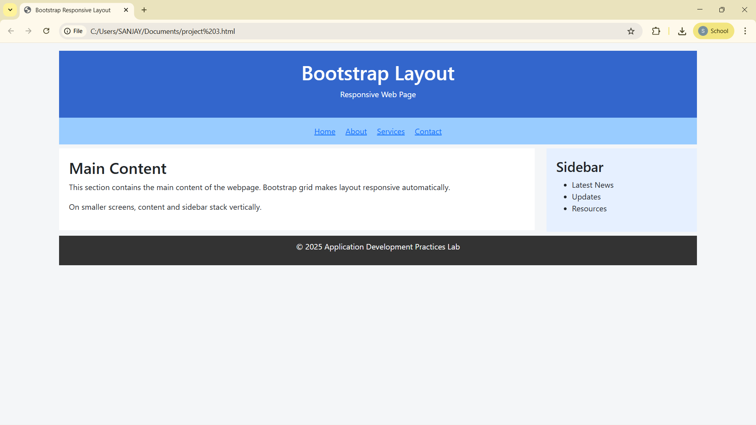

RESULT :
Thus, a responsive web page layout was successfully created using the Bootstrap grid system, where the content adjusts automatically based on the screen size, ensuring proper display on different devices.

25ec405
Sanjay ds

