Roll No: 25ec405
Name: SANJAY D S
Class: Ece – F
Experiment No: 5

TITLE : dynamic web page.

AIM :

Develop a dynamic web page using Javascript DOM manipulation.

PROCEDURE :

- Create a basic HTML structure using <!DOCTYPE html>, <html>, <head>, and <body> tags.
- Add a heading and a paragraph element with an id attribute (id="message") to display text.
- Design the webpage using CSS:
  - Set font style and alignment for the body.
  - Style the paragraph text.
  - Add styles for buttons including color, padding, and hover effect.
- Inside the <script> tag, define JavaScript functions:
  - changeText() to modify the paragraph content using innerHTML.
  - changeColor() to change the text color using style.color.
  - resetContent() to restore the original text and color.
- Create three buttons:
  - “Change Text” → calls changeText()
  - “Change Color” → calls changeColor()
  - “Reset” → calls resetContent()
- Use the onclick attribute in buttons to trigger the respective JavaScript functions.
- Save the file with a .html extension and open it in a web browser.
- Click the buttons to verify:
  - Text changes correctly
  - Color updates properly
  - Reset restores original content

PROGRAM :
<!DOCTYPE html>
<html>
<head>
<title>DOM Manipulation - Multiple Buttons</title>

<style>
body {
font-family: Arial;
text-align: center;
margin-top: 50px;
}

p {
font-size: 18px;
}

button {
padding: 10px 15px;
margin: 5px;
background-color: #3366cc;
color: white;
border: none;
cursor: pointer;
}

button:hover {
background-color: #254a99;
}
</style>

<script>
function changeText() {
document.getElementById("message").innerHTML =
"The text has been changed using JavaScript!";
}

function changeColor() {
document.getElementById("message").style.color = "red";
}

function resetContent() {
document.getElementById("message").innerHTML =
"Click the buttons to perform operations.";
document.getElementById("message").style.color = "black";
}
</script>
</head>

<body>

<h2>JavaScript DOM Manipulation</h2>

<p id="message">Click the buttons to perform operations.</p>

<button onclick="changeText()">Change Text</button>
<button onclick="changeColor()">Change Color</button>
<button onclick="resetContent()">Reset</button>

</body>
</html>
OUTPUT SCREENSHOT :
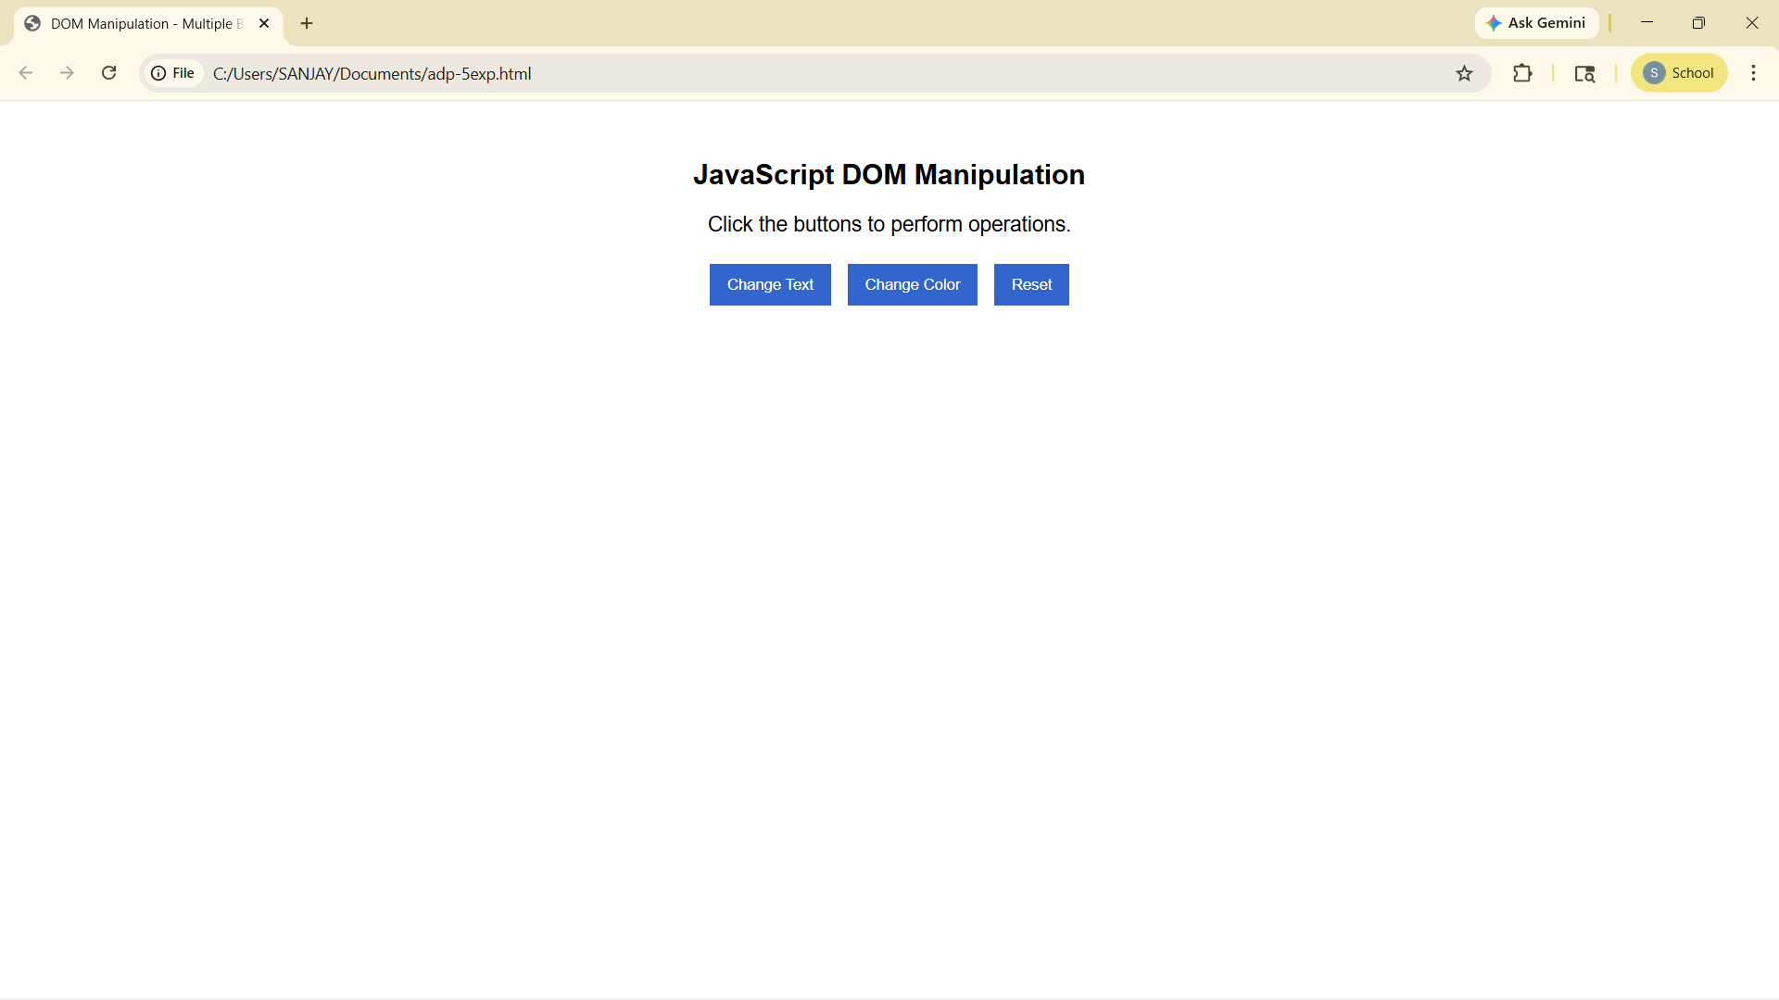

RESULT :
The program is successfully executed and the output is obtained.

