App Dev II Project Report

Placement Portal Application V2 (PPA-V2)

1. Student Details
Name: Kshitiz Singh
Roll Number: 25f1001872
Email: 25f1001872@ds.study.iitm.ac.in
About Me: I am a student at IIT Madras BS Degree program with a strong interest in full-stack web application development. I enjoy building practical, real-world applications that solve institutional problems and demonstrate modern software engineering principles.

2. Project Details
Project Title: Placement Portal Application V2 (PPA-V2)
Problem Statement:
To design and build a modern, role-based web application that digitizes and streamlines the campus recruitment process — replacing manual spreadsheets and email chains with a structured, centralized platform for students, companies, and administrators.
Approach:
The application was built as a full-stack SPA (Single Page Application) with a RESTful Flask backend and a Vue.js frontend. The system was migrated and upgraded from a previously built MAD-I Flask/Jinja2 application into a modern decoupled architecture. Redis was integrated for caching and as a message broker for Celery background jobs. JWT-based authentication was implemented for secure, stateless role-based access control across three user roles: Admin, Company, and Student.

3. AI/LLM Declaration
I used Claude (Anthropic) to assist in architectural suggestions, identifying bug locations, generating targeted code snippets for boilerplate sections, and providing guidance on Flask-JWT-Extended configuration.
The extent of AI/LLM usage is around 30-40%, limited to code suggestions, debugging hints, and documentation guidance. All final implementation logic, business decisions, debugging, and integration were done manually by me.

4. Technologies and Frameworks Used
Technology / Library | Purpose
Flask | Core backend REST API framework
Vue.js (CDN + Vite) | Single Page Application frontend framework
SQLite + SQLAlchemy | Database and ORM for data persistence
Bootstrap 5 | Frontend styling and responsive UI components
Flask-JWT-Extended | JWT-based stateless authentication and RBAC
Flask-CORS | Cross-origin request handling between Vue and Flask
Redis (Memurai on Windows) | Caching layer and Celery message broker
Celery | Asynchronous background job processing
Celery Beat | Periodic task scheduler for reminders and reports
Flask-Mail | Email notifications for reminders and reports
Axios | HTTP client for Vue to Flask API communication
Vue Router | Client-side routing and navigation guards

5. Database Schema / ER Diagram
Tables:
- User — id, name, email, password_hash, role (admin/company/student), is_active, created_at
- StudentProfile — id, user_id (FK), education, skills, experience, contact, resume_path, is_blacklisted, created_at
- CompanyProfile — id, user_id (FK), company_description, industry, location, website, approval_status, is_blacklisted, created_at
- PlacementDrive — id, company_id (FK), job_title, job_description, skills_required, eligibility, salary, benefits, deadline, status, approval_status, created_at
- Application — id, student_id (FK), drive_id (FK), status (Applied/Shortlisted/Interview/Offer/Rejected/Placed), applied_at
- Placement — id, student_id (FK), company_id (FK), drive_id (FK), salary, joining_date, created_at
Relationships:
- One-to-One → User → StudentProfile / CompanyProfile
- One-to-Many → CompanyProfile → PlacementDrive
- One-to-Many → StudentProfile → Application
- One-to-Many → PlacementDrive → Application
- One-to-Many → Application → Placement (created when status = Placed)
- Unique Constraint on (student_id, drive_id) in Application — prevents duplicate applications
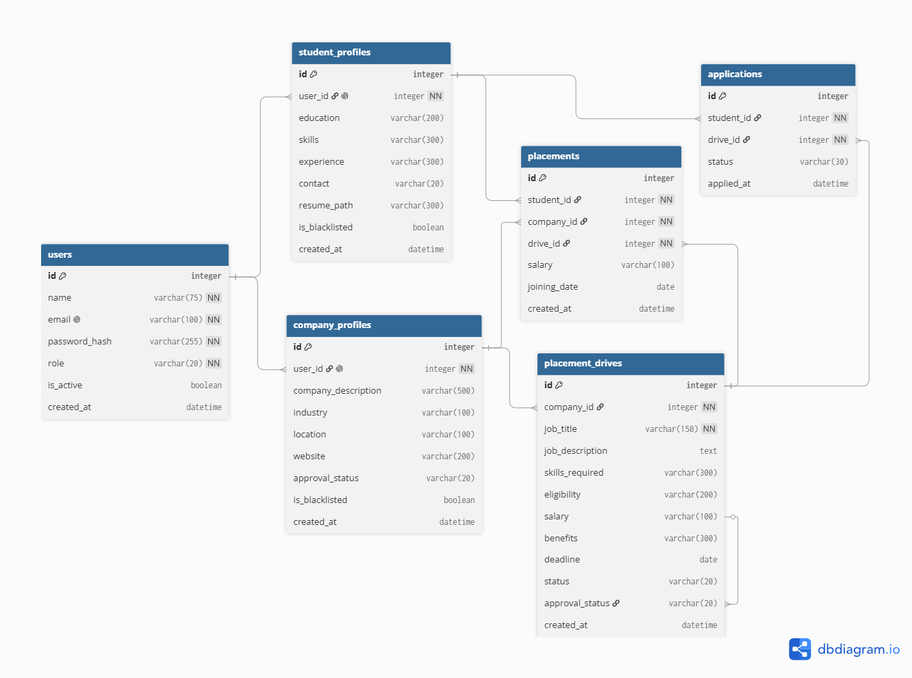

6. API Resource Endpoints
Endpoint | Method | Description
/api/auth/login | POST | Login for all roles, returns JWT token
/api/auth/register/student | POST | Student self-registration
/api/auth/register/company | POST | Company registration (pending approval)
/api/admin/dashboard | GET | Admin stats — total students, companies, drives, applications
/api/admin/companies | GET | List all companies with search by name/industry
/api/admin/companies/:id/approve | POST | Approve company registration
/api/admin/companies/:id/blacklist | POST | Toggle company blacklist status
/api/admin/drives/:id/approve | POST | Approve placement drive
/api/admin/students/:id/blacklist | POST | Toggle student blacklist status
/api/company/dashboard | GET | Company dashboard with upcoming/closed drives
/api/company/drives | POST | Create new placement drive
/api/company/drives/:id/applications | GET | View all applications for a drive
/api/company/applications/:id/status | POST | Update application status
/api/student/dashboard | GET | Student dashboard with companies and applied drives
/api/student/drives | GET | Browse approved active drives with search
/api/student/drives/:id/apply | POST | Apply to a placement drive
/api/student/applications | GET | View complete application history
/api/student/profile | PUT | Update student profile
/api/tasks/send-reminders | POST | Trigger interview reminder emails (Admin)
/api/tasks/monthly-report | POST | Trigger monthly placement report emails (Admin)
/api/tasks/export/student | GET | Export student applications as CSV
/api/tasks/export/company | GET | Export company applications as CSV

7. Architecture and Features
Architecture Overview:
The application follows a decoupled client-server architecture. The Flask backend exposes a REST API consumed by the Vue.js SPA frontend via Axios HTTP calls. JWT tokens handle authentication without server-side sessions.
Backend Structure (Flask):
- run.py — application entry point
- app/__init__.py — app factory, initializes db, jwt, mail, celery, registers blueprints
- app/extensions.py — db, jwt, mail, celery instances (avoids circular imports)
- app/config.py — configuration for DB, JWT, Redis, Mail
- app/models/ — SQLAlchemy models: User, StudentProfile, CompanyProfile, PlacementDrive, Application, Placement
- app/routes/ — Flask Blueprints: auth_routes, admin_routes, company_routes, student_routes, tasks_routes
- app/tasks/jobs.py — Celery tasks: send_interview_reminders, generate_monthly_report, export_student_csv, export_company_csv
- app/utils/cache.py — Redis cache helpers: get_cache, set_cache, delete_cache, delete_pattern
- celery_worker.py — Celery worker entry point
Frontend Structure (Vue.js):
- src/main.js — Vue app entry, mounts router
- src/App.vue — root component with RouterView
- src/router/index.js — routes with auth guards (requiresAuth, role-based)
- src/utils/api.js — Axios instance with JWT Bearer token interceptor
- src/views/ — page components: HomePage, LoginPage, RegisterStudent, RegisterCompany
- src/views/admin/ — AdminDashboard.vue
- src/views/company/ — CompanyDashboard.vue, CreateDrive.vue, DriveApplications.vue
- src/views/student/ — StudentDashboard.vue
Implemented Features:
- JWT-based authentication with role-based access control (Admin, Company, Student)
- Admin dashboard: stats, company approval/rejection, drive approval, blacklisting, search
- Company dashboard: create drives, view applicants, update application status through full pipeline
- Student dashboard: browse and search drives, apply, track application status, update profile
- Full application status pipeline: Applied → Shortlisted → Interview → Offer → Rejected → Placed
- Automatic Placement record creation when application status is set to Placed
- Duplicate application prevention via DB-level UniqueConstraint
- Redis caching on high-traffic endpoints with 5-minute TTL and cache invalidation on mutations
- Celery + Redis background jobs: interview reminders, monthly reports, CSV exports
- Celery Beat scheduling: daily reminders at 9am, monthly reports on 1st of each month
- Email notifications via Flask-Mail + Gmail SMTP
- Asynchronous CSV export for students and companies

8. Milestones Completed
# | Milestone | Git Commit Message
M0 | GitHub Repository Setup | Milestone-0 PPA-V2 Setup
M1 | Database Models and Schema Setup | Milestone-1 Database Models and Schema Setup
M2 | Authentication and Role-Based Access | Milestone-2 Authentication and Role-Based Access JWT Vue
M3 | Admin Dashboard and Management | Milestone-3 Admin Dashboard and Management Flask Vue
M4 | Company Dashboard and Job/Application Management | Milestone-4 Company Dashboard Job Application Management Flask Vue
M5 | Student Dashboard and Job Application System | Milestone-5 Student Dashboard Job Application System Flask Vue
M6 | Job Application History and Status Tracking | Milestone-6 Application History Status Tracking Flask Vue
M7 | Backend Jobs — Celery + Redis | Milestone-7 Celery Redis Background Jobs Interview Reminders CSV Export
M8 | API Performance Optimization and Caching | Milestone-8 Redis Caching API Performance Optimization

9. Challenges Faced
- JWT Identity Format: Flask-JWT-Extended v4.x requires identity to be a string or int, not a dict. Fixed by using create_access_token(identity=str(user.id), additional_claims={"role": user.role}) and reading role via get_jwt() instead of get_jwt_identity().
- Circular Imports: Solved by creating extensions.py to hold db, jwt, mail, celery instances separately, imported into __init__.py and routes independently.
- Celery on Windows: Celery requires --pool=solo flag on Windows to avoid multiprocessing issues.
- Redis Cache Invalidation: Implemented delete_pattern() to clear stale cache keys when company approval status or drive data changes.
- CORS: Flask-CORS configured to allow Vue dev server (localhost:5173) to communicate with Flask (localhost:5000).
- Schema Migration from MAD-I: Dropped denormalized FK columns (student_name, company_name in Application/Drive tables), expanded Application status from 3 to 6 states, added approval_status to PlacementDrive.

10. Video Presentation
Drive Link: LINK

