MODERN APPLICATION DEVELOPMENT – I
PROJECT REPORT
Placement Portal Application
A Role-Based Full-Stack Web Application for Campus Recruitment
Kshitiz Kumar Singh | Roll: 25f1001872 | 25f1001872@ds.study.iitm.ac.in
IIT Madras Online Degree Programme | Data Science & Applications | 2026

1 AUTHOR
Full Name | Kshitiz Kumar Singh
Roll Number | 25f1001872
Email | 25f1001872@ds.study.iitm.ac.in
Programme | B.S. in Data Science & Applications — IIT Madras Online Degree
About | Currently pursuing Civil Engineering alongside the Data Science & Applications programme from IIT Madras. Primary interests include finance, algorithmic trading, and quantitative investing. Actively developing analytical and problem-solving skills to build a career in data-driven financial domains.

2 AI / LLM USAGE
Tool(s) Used | ChatGPT (OpenAI GPT-4)
Extent of Use | 12–20% of total development effort
Areas Assisted | Flask route boilerplate, debugging, project structure, HTML structure ,CSS Styling Ideas, and generating inline documentation/comments.
Code Ownership | All core logic — authentication flow, role-based access, schema design, and business constraints — was designed and implemented independently. AI was used only as a productivity aid, not as a primary author.

3 PROJECT DESCRIPTION
The Placement Portal is a role-based, full-stack web application built to modernize and centralize the campus recruitment process. It replaces manual spreadsheet-and-email coordination with a structured digital workflow that serves three distinct user roles: Admin, Company, and Student.
The Admin acts as gatekeeper — approving company registrations, overseeing all placement drives, managing users, and maintaining system integrity through blacklisting. Companies register, build profiles (pending Admin approval), post placement drives, and manage the applicant pipeline. Students browse approved drives, apply, upload resumes, and track their application status in real time.
The system enforces strict constraints: a student cannot apply to the same drive twice (UniqueConstraint at DB level), only approved companies can post drives, and blacklisted accounts lose access while preserving data integrity. The entire database is created programmatically via db.create_all() on first run with the Admin account auto-seeded — no manual setup required.

4 TECHNOLOGIES USED
Technology / Library | Version | Purpose & Reason for Use
Python | 3.10+ | Primary backend language; chosen for readability and strong Flask ecosystem support.
Flask | 3.x | Lightweight WSGI micro-framework; provides routing, Blueprint organisation, and request handling.
Flask-SQLAlchemy | Latest | ORM layer over SQLite; allows Pythonic model definitions and eliminates raw SQL.
SQLite | Built-in | Zero-configuration embedded relational database; ideal for development and academic projects.
Werkzeug Security | Bundled | Password hashing via generate_password_hash / check_password_hash — bcrypt-backed.
Flask-Login | Latest | Session management and user authentication; provides login_required decorator pattern.
Jinja2 | Bundled | Server-side HTML templating engine; enables dynamic page rendering with template inheritance.
Bootstrap 5 | 5.x | Responsive CSS framework; ensures consistent UI across devices with minimal custom CSS.
HTML5 / CSS3 / JS | — | Frontend markup, styling, and client-side validation for form interactions.
5 DB SCHEMA DESIGN
The schema follows third-normal-form normalisation, separating concerns across five distinct tables. The central users table acts as the shared authentication anchor for all three roles, with one-to-one satellite tables (student_profiles, company_profiles) hanging off it via foreign keys. Placement activity is captured in placement_drives (owned by companies) and applications (linking students to drives). A UniqueConstraint on (student_id, drive_id) in the applications table enforces the no-duplicate-application rule at the database level, independent of application-layer checks.

Table | Column | Type | Constraints / Notes
users | id | INTEGER | PK, Auto-increment
 | name | VARCHAR(75) | NOT NULL
 | email | VARCHAR(100) | NOT NULL, UNIQUE
 | password_hash | VARCHAR(255) | NOT NULL — bcrypt hash
 | role | VARCHAR(20) | NOT NULL — 'admin' | 'company' | 'student'
 | is_active | BOOLEAN | DEFAULT True
 | created_at | DATETIME | DEFAULT utcnow
student_profiles | id | INTEGER | PK, Auto-increment
 | user_id | INTEGER | FK → users.id, UNIQUE, NOT NULL
 | student_name | VARCHAR(100) | FK → users.name, NOT NULL
 | education | VARCHAR(200) | Nullable
 | skills | VARCHAR(300) | Nullable
 | resume_path | VARCHAR(300) | Path to uploaded PDF resume
 | is_blacklisted | BOOLEAN | DEFAULT False — set by Admin
 | created_at | DATETIME | DEFAULT utcnow
company_profiles | id | INTEGER | PK, Auto-increment
 | user_id | INTEGER | FK → users.id, UNIQUE, NOT NULL
 | company_name | VARCHAR(100) | FK → users.name, NOT NULL
 | company_description | VARCHAR(500) | NOT NULL
 | approval_status | VARCHAR(20) | DEFAULT 'Pending' — 'Pending' | 'Approved'
 | is_blacklisted | BOOLEAN | DEFAULT False — set by Admin
 | created_at | DATETIME | DEFAULT utcnow
placement_drives | id | INTEGER | PK, Auto-increment
 | company_id | INTEGER | FK → company_profiles.id, NOT NULL
 | company_name | VARCHAR(100) | FK → company_profiles.company_name, NOT NULL
 | job_title | VARCHAR(150) | NOT NULL
 | job_description | TEXT | Nullable
 | eligibility | VARCHAR(200) | Nullable
 | deadline | DATE | Application closing date
 | status | VARCHAR(20) | DEFAULT 'Active' — 'Active' | 'Closed'
 | created_at | DATETIME | DEFAULT utcnow
applications | id | INTEGER | PK, Auto-increment
 | student_id | INTEGER | FK → student_profiles.id, NOT NULL
 | student_name | VARCHAR(100) | FK → student_profiles.student_name, NOT NULL
 | drive_id | INTEGER | FK → placement_drives.id, NOT NULL
 | status | VARCHAR(30) | DEFAULT 'Waiting' — Waiting | Shortlisted | Rejected
 | applied_at | DATETIME | DEFAULT utcnow
 | UNIQUE CONSTRAINT | — | UNIQUE(student_id, drive_id) — prevents duplicate applications
ER Diagram — generated from schema models:
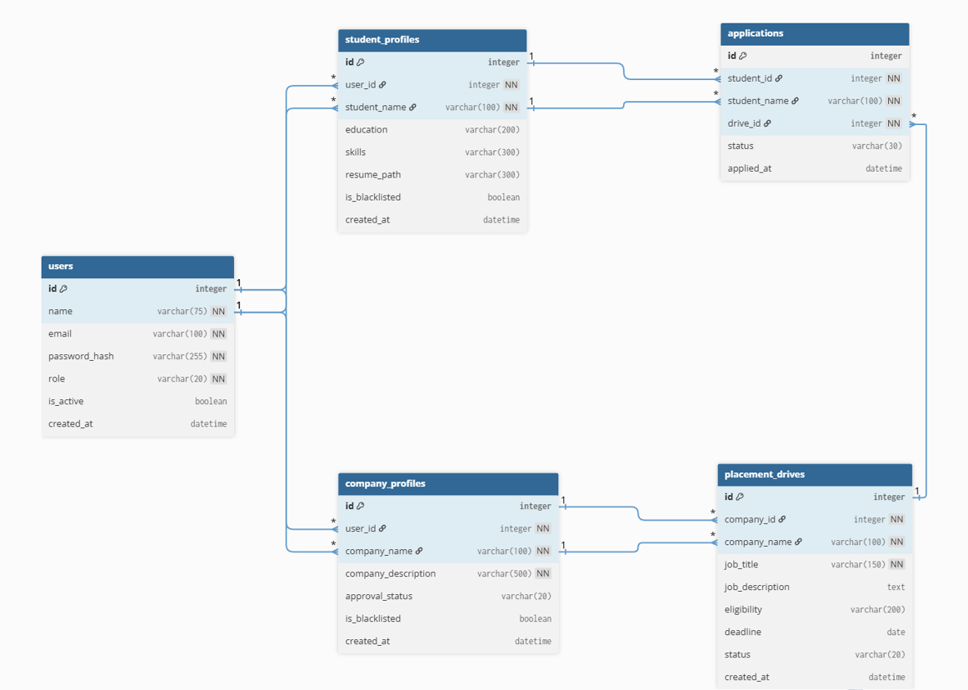

6 API DESIGN
The application uses Flask's Blueprint system to organise routes into four logical modules: auth, admin, company, and student. All routes are server-rendered (Jinja2 templates) rather than REST JSON endpoints — form submissions use POST with Flask redirects following the Post/Redirect/Get pattern. The complete YAML specification is submitted as a separate file.
Access control is enforced at the route level: company routes check is_blacklisted and company ownership (drive.company_id vs session user); student routes check is_blacklisted before rendering any content; admin routes are accessible only to the seeded admin session. Unauthenticated or unauthorized access returns 403 or renders an error string.

Blueprint | Endpoint | Method | Description
auth | / | GET | Landing / home page
 | /login | GET, POST | Unified login with role-based redirect to Admin / Company / Student dashboard
 | /logout | GET | Clears Flask session and redirects to home
 | /register/student | GET, POST | Student registration — creates User + StudentProfile, handles resume upload
 | /register/company | GET, POST | Company registration — creates User + CompanyProfile with Pending approval status
admin | /admin/dashboard | GET | Aggregated stats: total students, companies, pending approvals; lists all entities
 | /admin/search | GET | Search user by ID; redirects to appropriate company or student profile
 | /admin/approve_company/<id> | POST | Sets company approval_status to Approved
 | /admin/blacklist_company/<id> | POST | Sets company is_blacklisted to True
 | /admin/blacklist_student/<id> | POST | Sets student is_blacklisted to True
 | /admin/company_profile/<id> | GET | View full company profile details
 | /admin/student_profile/<id> | GET | View student profile and their application list
 | /admin/drive_details/<id> | GET | View individual placement drive details
 | /admin/drive_status/<drive_id> | POST | Force-closes a placement drive (status → Closed)
 | /admin/student_applications/<id> | GET | View all applications submitted by a specific student
company | /company/dashboard | GET | Company overview: active and closed drives with stats; blacklist check
 | /company/create_drive | GET, POST | Create a new placement drive (job_title, description, eligibility, deadline)
 | /company/drive_applications/<drive_id> | GET | List all student applications for a specific drive
 | /company/student_application/<id> | GET | View individual student application details and resume info
 | /company/student_application/<id>/update_status | POST | Update application status: Waiting | Shortlisted | Rejected
 | /company/drive_status/<drive_id> | POST | Close an active placement drive
student | /student/dashboard | GET | Student home: approved companies, applied drives; blacklist check
 | /student/company_profiles/<company_id> | GET | View a company's profile and their active/closed drives
 | /student/drive_details/<drive_id> | GET | View full details of a single placement drive
 | /student/drive_details/<drive_id>/apply | POST | Apply to a drive; duplicate check via DB UniqueConstraint
 | /student/applications_history | GET | View full application history with real-time status tracking

7 ARCHITECTURE & FEATURES
Project Organisation
The project uses the Flask Application Factory pattern. create_app() in app/__init__.py initialises all extensions (SQLAlchemy), creates the DB schema, seeds the Admin, and registers all Blueprints. This keeps the app object decoupled from global state and makes testing straightforward. Each Blueprint (auth_bp, admin_bp, company_bp, student_bp) is a self-contained module with its own routes file — co-located logic for each role. Models are in app/models/, one file per entity. Templates follow the same role-based hierarchy under app/templates/ (admin/, company/, student/ subdirectories). Static assets including uploaded resumes live under app/static/.

Path | Contents & Role
run.py | Application entry point — invokes create_app() factory and starts the dev server.
app/__init__.py | App factory — initialises Flask, SQLAlchemy, creates DB via db.create_all(), seeds the Admin account on first run, and registers all four Blueprints.
app/config.py | Centralised configuration: SECRET_KEY, SQLite DB URI constructed with os.path.abspath for portability.
app/models/ | One file per model: user.py, student.py, company.py, placement_drive.py, application.py — each defines SQLAlchemy columns, FKs, and relationships.
app/routes/ | Four Blueprint modules: auth_routes.py, admin_routes.py, company_routes.py, student_routes.py — each handles one role's full request lifecycle.
app/templates/ | Jinja2 HTML templates organised by role: admin/, company/, student/ sub-folders plus shared login.html, home.html, and registration pages.
app/static/ | CSS stylesheets, JavaScript files, and uploads/resumes/ directory where student PDFs are stored using a deterministic naming scheme.
instance/placement.db | Auto-generated SQLite database file — created on first run, never committed to version control.

Features Implemented
Role / Module | Feature | Implementation Detail
Authentication | Unified Login + Role Redirect | Single /login endpoint; role field in session determines redirect target (Admin/Company/Student dashboard).
 | Secure Password Hashing | Werkzeug generate_password_hash / check_password_hash — bcrypt under the hood; plaintext never stored.
 | Session Management | Flask session stores user_id, email, role; cleared on logout.
 | Admin Auto-Seed | App factory checks for existing admin on startup; creates default credentials if absent — no public registration.
Admin | System Dashboard | Aggregates total students, companies, pending approvals; lists all entities with inline action buttons.
 | Company Approval Workflow | New companies default to Pending; Admin must Approve before login is granted — enforced in login route.
 | Blacklisting (Student/Company) | Sets is_blacklisted flag; blocked at dashboard entry — data preserved, access revoked.
 | User Search by ID | GET /admin/search?id=X queries User table, resolves role, and redirects to the correct profile view.
 | Drive Force-Close | Admin can close any active drive regardless of company action.
Company | Drive Management (Full CRUD) | Create drives with title, description, eligibility, and deadline; close drives via status toggle.
 | Applicant Pipeline Management | View all applicants per drive; update each status (Waiting → Shortlisted / Rejected) via POST form.
 | Authorisation Check | Company can only view drives/applications belonging to their own company_id — 403 returned otherwise.
Student | Browse Approved Drives | Dashboard shows only Approved, non-blacklisted companies; filters ensure students see valid opportunities.
 | Apply to Drive | POST /apply checks for existing Application record; duplicate prevented at DB level via UniqueConstraint.
 | Resume Upload | PDF saved to static/uploads/resumes/ with deterministic filename student_{id}_resume.pdf.
 | Application History & Status | Real-time status tracking (Waiting / Shortlisted / Rejected) rendered in applications_history.html.
System | Duplicate Application Prevention | Database-level UniqueConstraint on (student_id, drive_id) in applications table — enforced even if flash check is bypassed.
 | Approval Gate | Companies with Pending status cannot access dashboard post-login — checked in both login route and dashboard.
 | Auto DB Creation | db.create_all() inside app factory; no migration commands or manual schema setup required.

8 VIDEO SUBMISSION
The video walkthrough demonstrates all three user role flows — Admin approval workflow, Company drive creation and applicant management, and Student registration, application, and status tracking.

▶ VIDEO DEMO LINK

