CAMPUS PLACEMENT PORTAL
Project Status & Progress Report
── Full Stack Web Application ──
Built with Flask | SQLite | Bootstrap | Jinja2
Prepared By | Kshitiz Singh
Role | Full Stack Developer & Project Lead
Report Type | Milestone-Based Progress Report
Project Start | 15 February 2026
Submission | 8 April 2026
Total Duration | 7 Weeks
Status | Completed & Submitted

Executive Summary
EXECUTIVE SUMMARY
The Campus Placement Portal is a full-stack web application developed to digitize and streamline the campus recruitment process for Students, Companies, and Administrators. The system replaces manual and scattered processes with a centralized platform that manages company registrations, placement drives, and student applications efficiently.
The application is built using Flask (Python) for backend development, SQLite for database management, and HTML, CSS, Bootstrap, and Jinja2 for the frontend. It implements role-based access control, allowing Admins to manage approvals, Companies to create and manage placement drives, and Students to apply for jobs and track their application status.
The project focuses on providing a structured, user-friendly system with proper validation, controlled workflows, and seamless interaction between all user roles.

PROJECT SNAPSHOT
Metric | Value
Total Milestones | 9 Major + 1 Final Submission Phase
Total Development Weeks | 7 Weeks
Primary Technology Stack | Flask, SQLite, Bootstrap, Jinja2, Python
User Roles Implemented | Admin, Company, Student
Modules Developed | Auth, Admin, Company, Student, Core Logic
Testing Phases | Unit, Functional, End-to-End
Development Model | Individual / Milestone-Driven
Version Control | Git & GitHub
Final Status | ✅ Completed & Submitted
Problem Statement
The Challenge
The traditional campus placement process often involves manual and unstructured workflows, leading to inefficiencies in managing student applications, company recruitment drives, and administrative tasks.
IDENTIFIED PAIN POINTS
❌ Manual, paper-based application tracking
❌ No centralized visibility for placement drives
❌ Lack of role-based access and accountability
❌ Risk of duplicate or unauthorized applications
❌ No real-time status updates for students or companies
❌ Admin has no single dashboard to monitor all activity

The Solution
The Campus Placement Portal solves these issues by:
SOLUTION HIGHLIGHTS
✅ Centralized web portal for all three user roles
✅ Role-Based Access Control (RBAC) with session management
✅ Admin approval workflows for companies
✅ Real-time application tracking for students
✅ Validation logic preventing duplicate/unauthorized actions
✅ Clean, responsive UI with Bootstrap

System Architecture
3.1 High-Level Architecture Diagram
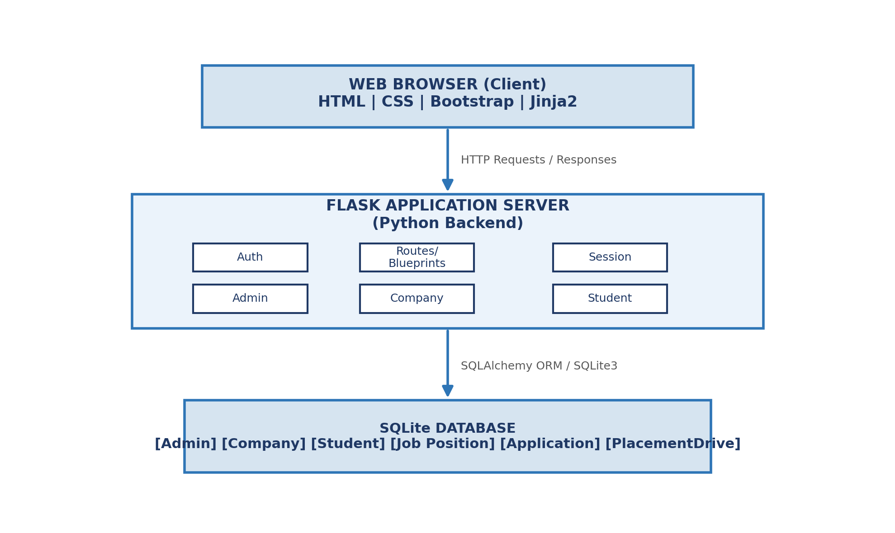
Figure 1. Three-layer architecture showing Client, Flask Server, and SQLite Database.

3.2 Database Entity Relationship (ER) Diagram
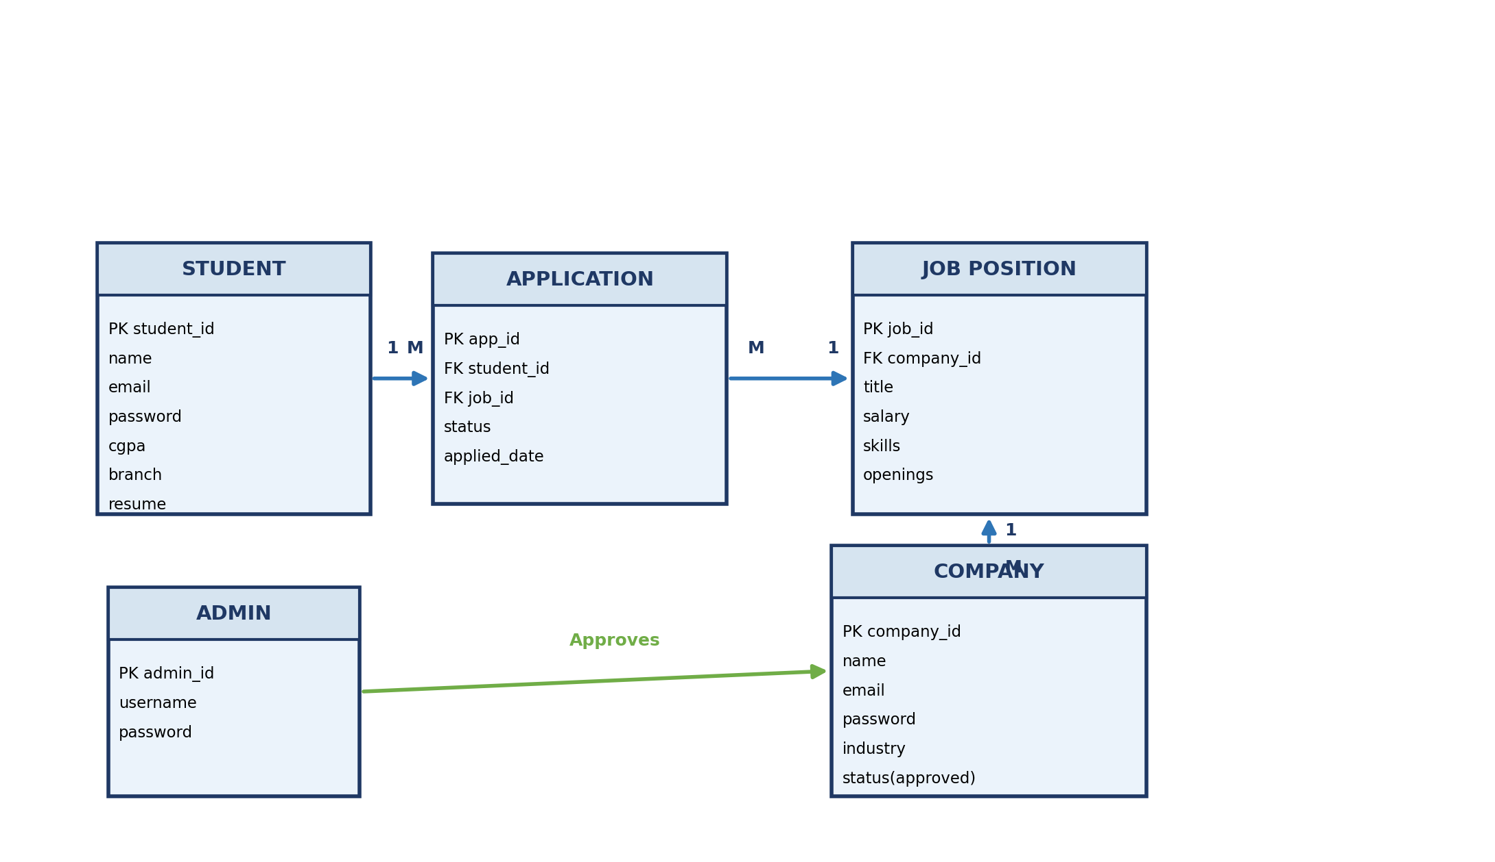
Figure 2. ER model for Admin, Company, Student, JobPosition, and Application entities
Technology Stack
TECHNOLOGY STACK OVERVIEW
Layer | Technology | Purpose
Backend | Python + Flask | Server-side logic, routing, sessions
Database | SQLite | Relational data storage
ORM | Flask-SQLAlchemy | Programmatic DB model creation
Frontend | HTML5 + CSS3 | Page structure and styling
UI Framework | Bootstrap 5 | Responsive design components
Templating | Jinja2 | Dynamic content rendering
IDE | VS Code | Development and debugging
Version Control | Git + GitHub | Code management and tracking
Auth | Flask Sessions | Login state and role management
Deployment Env | Localhost | Development and testing environment

Milestone Tracker
MILESTONE TRACKER
# | Milestone | Target Date | % | Deliverable | Git Commit
1 | Project Planning & Requirement Analysis | 20 Feb 2026 | 10% | Scope doc, user role map | Milestone-PPA Init-Planning
2 | Database Design & Schema Implementation | 27 Feb 2026 | 18% | ER diagram, SQLite models | Milestone-PPA DB-Relationship
3 | Authentication & Role-Based Access | 05 Mar 2026 | 10% | Login/Register, RBAC, Session | Milestone-PPA Auth_RBAC
4 | Admin Module Development | 12 Mar 2026 | 20% | Dashboard, Approvals, Search | Milestone-PPA Admin-Dashboard
5 | Company Module Development | 18 Mar 2026 | 15% | Profiles, Drives, App Status | Milestone-PPA Company-Module
6 | Student Module Development | 24 Mar 2026 | 12% | Registration, Apply, Track | Milestone-PPA Student-Module
7 | Core Feature Integration & Validation | 28 Mar 2026 | 07% | Dedup logic, Role checks | Milestone-PPA Core-Integration
8 | UI Enhancement & Responsive Design | 31 Mar 2026 | 04% | Bootstrap UI, nav polish | Milestone-PPA UI-Enhancement
9 | Testing, Debugging & Optimization | 03 Apr 2026 | 03% | E2E tests, bug fixes | Milestone-PPA Testing-Debug
10 | Documentation, Video & Submission | 05 Apr 2026 | 01% | Report, ER diagram, Video | Milestone-PPA Final-Submission

Feature Completion Matrix
Feature / Functionality | Status | Verified
Student Registration & Login | ✅ Complete | ✅
Company Registration & Login | ✅ Complete | ✅
Admin Pre-configured Access | ✅ Complete | ✅
Session Management & Role Redirection | ✅ Complete | ✅
Admin Dashboard with System Statistics | ✅ Complete | ✅
Company Approval / Rejection by Admin | ✅ Complete | ✅
Placement Drive Approval by Admin | ✅ Complete | ✅
Company Profile Management | ✅ Complete | ✅
Placement Drive Creation | ✅ Complete | ✅
Company Views & Updates Application Status | ✅ Complete | ✅
Student Profile Management | ✅ Complete | ✅
Student Apply to Drive | ✅ Complete | ✅
Application Status Tracking | ✅ Complete | ✅
Duplicate Application Prevention | ✅ Complete | ✅
Responsive UI with Bootstrap | ✅ Complete | ✅

Team Profile & Resource Allocation
PRIMARY CONTRIBUTOR PROFILE
Name : Kshitiz Singh
Role : Full Stack Developer & Project Lead
Project Type : Individual / Solo Development

RESPONSIBILITY AREA
• System Architecture: Designed end-to-end architecture layout
• Database Design: ER diagram, schema, SQLite models
• Backend Development: Flask routes, logic, session management
• Frontend Development: HTML, CSS, Jinja2 templates, Bootstrap
• Module Integration: Admin, Company, Student module linking
• Documentation: Report writing, ER diagram preparation
• Demonstration: Video recording and submission

Final Product Overview
FINAL PROJECT OUTCOMES
✅ Fully functional 3-role web application developed and delivered
✅ All 9 milestones completed within defined timelines
✅ 10 structured weekly status updates recorded and tracked
✅ 100% feature completion across all user modules
✅ Clean, responsive UI using Bootstrap 5
✅ Stable codebase tested in clean evaluator-simulated environment
✅ Git version control maintained with milestone-based commit history
✅ Comprehensive project report, ER diagram, and video prepared
✅ Final submission packaged and delivered on 8 April 2026

Conclusion
The Campus Placement Portal was successfully conceptualized, designed, developed, tested, and delivered as a structured milestone-driven individual project. The application effectively digitizes the campus recruitment lifecycle — from company onboarding and drive creation to student applications and real-time status tracking — all governed by a secure and role-based administrative layer.

KEY LEARNINGS & DEMONSTRATIONS
📌 Full Stack Web Development using Flask and SQLite
📌 Role-Based Access Control design and implementation
📌 Relational database design with ER modeling
📌 Structured milestone-based software development lifecycle
📌 Frontend-Backend integration with Jinja2 templating
📌 Responsive UI design with Bootstrap 5
📌 Version control and commit discipline using Git

Prepared By : Kshitiz Singh
Submitted On : 5 April 2026
Project : Campus Placement Portal
Stack : Flask | SQLite | Bootstrap | Jinja2 | Python

── End of Project Status Report ──

