ACTIVITY-5
In this activity, we demonstrate the Central Limit Theorem (CLT) using the Height data from the Weight-Height dataset. We consider two cases:
- Case I: Sampling distribution of the sample mean.
For various sample sizes $η ϵ \{5, 10, 30, 50, 100\}$, we repeatedly draw 100 samples, compute their means, and compare the empirical distribution to the theoretical normal distribution $N(μ,σ^{2}/η)$. We examine how the center, spread, and shape change with increasing $η.$
- Case II: Sampling distribution of the standardized sum.
For the same $η$ values, we compute the sum $Y$ of each sample, then standardize it to $Z = \frac{Y-ημ}{σ√η}$​. We compare the empirical distribution of $Z$to the standard normal $N(0,1)$ to observe CLT convergence for totals.

Case I:- Sampling Distribution Of The Sample Mean
We computed 100 sample means for each n and compared their distribution to $N(μ,σ^{2}/η)$.
Sample Size $(η)$ | Mean Of Sample Means | SD Of Sample Means | Theoretical SE $(σ√η)$
5 | 66.4491 | 1.840964 | 1.720581
10 | 66.6048 | 1.210076 | 1.216634
30 | 66.2649 | 0.654985 | 0.702424
50 | 66.4026 | 0.563667 | 0.544095
100 | 66.3805 | 0.403552 | 0.384734

FOR N=5
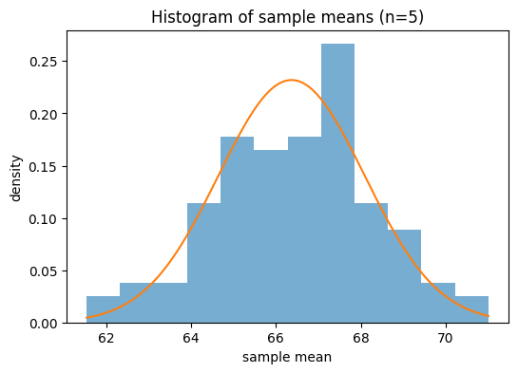
- Center (mean of sample means) ≈ 66.4491 (close to µ = 66.3676)
- Spread (SD of sample means) ≈ 1.8410, theoretical SE = σ/√n ≈ 1.7206
- Shape: approaches bell curve, larger $η$ yields smoother, narrower distribution

Interpretation: As n increases, the sampling distribution of the mean becomes more normal and concentrated around µ, and its spread closely follows σ/√n, aligning with the CLT.

FOR N=10
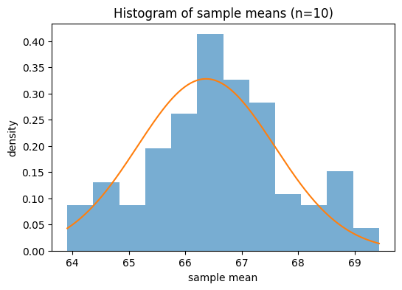
- Center (mean of sample means) ≈ 66.6048 (close to µ = 66.3676)
- Spread (SD of sample means) ≈ 1.2101, theoretical SE = σ/√n ≈ 1.2166
- Shape: approaches bell curve, larger n yields smoother, narrower distribution

Interpretation: As n increases, the sampling distribution of the mean becomes more normal and concentrated around µ, and its spread closely follows σ/√n, aligning with the CLT.

FOR N=30
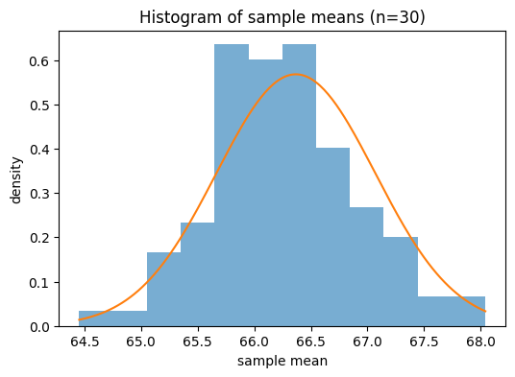
- Center (mean of sample means) ≈ 66.2649 (close to µ = 66.3676)
- Spread (SD of sample means) ≈ 0.6550, theoretical SE = σ/√n ≈ 0.7024
- Shape: approaches bell curve, larger n yields smoother, narrower distribution

Interpretation: As n increases, the sampling distribution of the mean becomes more normal and concentrated around µ, and its spread closely follows σ/√n, aligning with the CLT.

FOR N=50
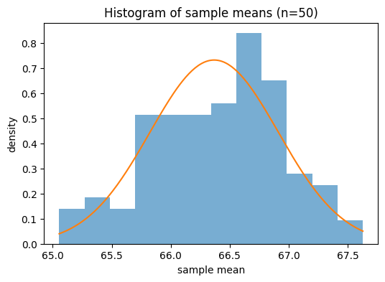
- Center (mean of sample means) ≈ 66.4026 (close to µ = 66.3676)
- Spread (SD of sample means) ≈ 0.5637, theoretical SE = σ/√n ≈ 0.5441
- Shape: approaches bell curve, larger n yields smoother, narrower distribution

Interpretation: As n increases, the sampling distribution of the mean becomes more normal and concentrated around µ, and its spread closely follows σ/√n, aligning with the CLT.

FOR N=100
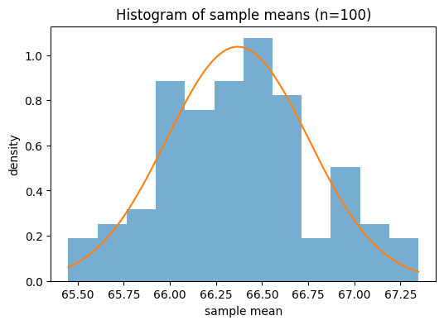
- Center (mean of sample means) ≈ 66.3805 (close to µ = 66.3676)
- Spread (SD of sample means) ≈ 0.4036, theoretical SE = σ/√n ≈ 0.3847
- Shape: approaches bell curve, larger n yields smoother, narrower distribution

Interpretation: As n increases, the sampling distribution of the mean becomes more normal and concentrated around µ, and its spread closely follows σ/√n, aligning with the CLT.

Case II:- Standardized Sums (Z)

For each $η$, we computed sums $Y$ of the n observations and standardized to $Z = \frac{(Y - ημ)}{σ√η}$. According to the CLT, Z ≈ N(0,1)

n | Mean (Z) | SD (Z)
5 | 0.0474 | 1.07
10 | 0.195 | 0.9946
30 | -0.1462 | 0.9325
50 | 0.0644 | 1.036
100 | 0.0336 | 1.0489

FOR N=5
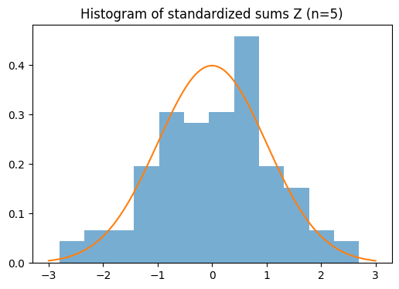
- Center: Mean(Z) ≈ 0.0474 (expected 0)
- Spread: SD(Z) ≈ 1.0700 (expected 1)
- Shape: close to bell curve, convergence improves with larger n

Interpretation: Standardized sums converge to the standard normal distribution as n grows. Minor deviations at small n diminish by n ≥ 30, confirming the CLT prediction for totals.

FOR N=10
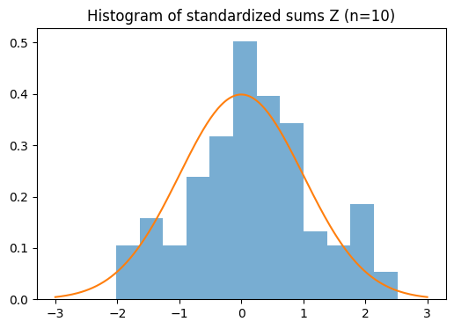
- Center: Mean(Z) ≈ 0.1950 (expected 0)
- Spread: SD(Z) ≈ 0.9946 (expected 1)
- Shape: close to bell curve, convergence improves with larger n

Interpretation: Standardized sums converge to the standard normal distribution as n grows. Minor deviations at small n diminish by n ≥ 30, confirming the CLT prediction for totals.

FOR N=30
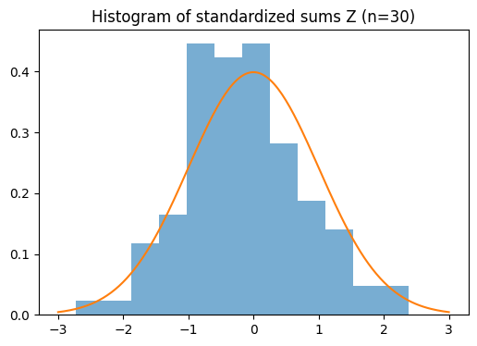
- Center: Mean(Z) ≈ -0.1462 (expected 0)
- Spread: SD(Z) ≈ 0.9325 (expected 1)
- Shape: close to bell curve, convergence improves with larger n

Interpretation: Standardized sums converge to the standard normal distribution as n grows. Minor deviations at small n diminish by n ≥ 30, confirming the CLT prediction for totals.

FOR N=50
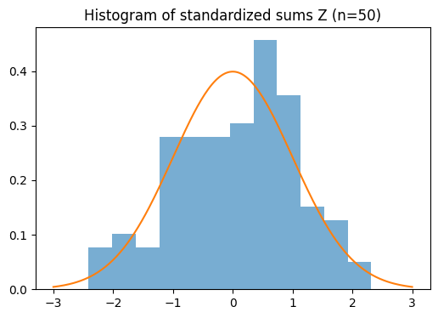
- Center: Mean(Z) ≈ 0.0644 (expected 0)
- Spread: SD(Z) ≈ 1.0360 (expected 1)
- Shape: close to bell curve, convergence improves with larger n

Interpretation: Standardized sums converge to the standard normal distribution as n grows. Minor deviations at small n diminish by n ≥ 30, confirming the CLT prediction for totals.

FOR N=100
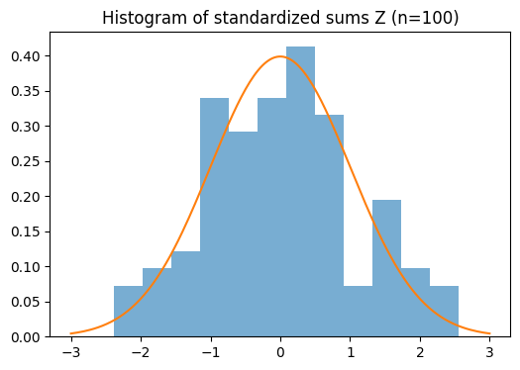
- Center: Mean(Z) ≈ 0.0336 (expected 0)
- Spread: SD(Z) ≈ 1.0489 (expected 1)
- Shape: close to bell curve, convergence improves with larger n

Interpretation: Standardized sums converge to the standard normal distribution as n grows. Minor deviations at small n diminish by n ≥ 30, confirming the CLT prediction for totals.

CONCLUSION

Across both cases, the results validate the CLT: the sampling distribution of the mean follows Normal(µ, σ²/n) and the standardized sum follows N(0,1) as n increases. Larger n gives a closer match in center and spread and a more bell-shaped histogram.

