Extra activity 4

Profit of Google company: Profit

Model: Profit of Google company for each quarter from 2009 to 2024.
Total number of years= 16
Total number of Quarters= 63

Define a random variable X as follows-{X = Errors in quarter from 2009 to 2024}

Claim: X can be modelled as Normal distribution.

So we will find the error using the best fit line.
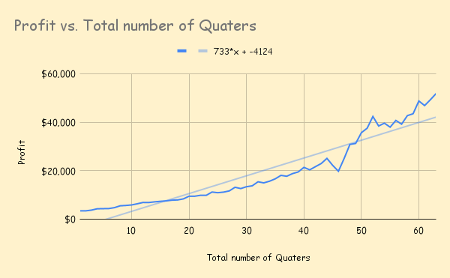

Using this knowledge, we calculated the estimated profit, identified the error, and then determined the probability of this error occurring..

Using the data points:

Formula used: 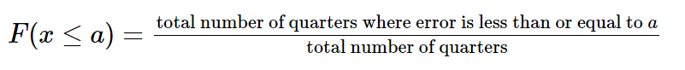

Total number of Quarters= 63

Probability
- F(0)= 0
- F(1000) = 0.09523809524
- F(2000) = 0.1111111111
- F(3000) = 0.09523809524
- F(4000) = 0.1904761905
- F(5000) = 0.2222222222
- F(6000) = 0.1428571429
- F(7000) = 0.06349206349
- F(8000) = 0.01587301587
- F(9000) = 0.03174603175
- F(10,000) = 0.03174603175

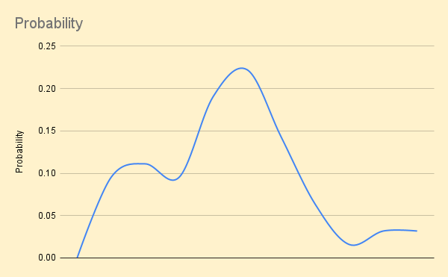

The distribution of errors appears approximately symmetric and exhibits a bell-shaped pattern. The frequencies increase towards the center and decrease towards the extremes, which is a key characteristic of a normal distribution.

Hence, it is reasonable to model the error using a normal distribution.

Calculating probability using Normal distribution:

F(a) is calculated using the Google Sheets function NORM.DIST(a, μ, σ, TRUE), where μ is the mean and σ is the standard deviation.

- F(0)= 0
- F(1000) = 0.3950589503
- F(2000) = 0.4294901186
- F(3000) = 0.4644665105
- F(4000) = 0.4997198378
- F(5000) = 0.5349753544
- F(6000) = 0.5699582629
- F(7000) = 0.6044001236
- F(8000) = 0.6380450173
- F(9000) = 0.6706552258
- F(10,000) = 0.7020162221

The calculated probabilities from the normal distribution closely match the observed values, indicating that the model provides a good fit to the data.
Although the probability may not be exact due to the uncertainty of errors and the exclusion of outliers, this model still provides valuable insights.Thus, the normal distribution serves as an effective tool for analyzing the data and making reliable predictions about future profits.

