Name: Soniya Eknath Girhe. Section: A7 Batch: B3
Roll No.:59 Date of Performance: 09/12/2026

PRACTICAL NO. 1
1. Perform the following tasks.
a) Find the number of processors your machine has.
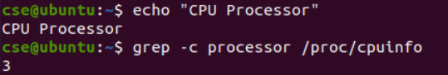
b) How many cores does your machine have?
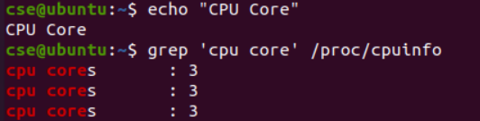
c) What is the frequency of each processor?
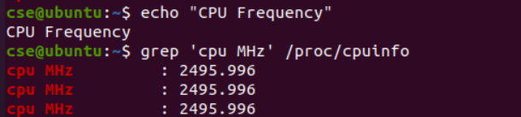
d) How much physical memory does your system have?
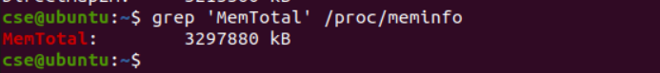
e) How much of this memory is free?
f) What is total number of forks since the boot in the system?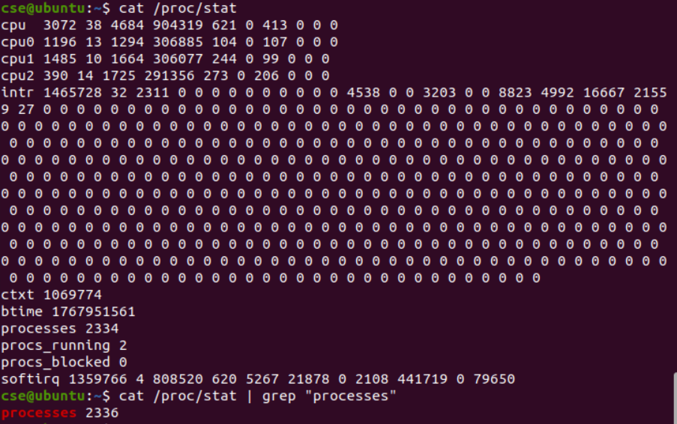
g) How many context switch has the system performed since bootup?
