Practical 02
  - Name: Soniya Eknath Girhe. Sec_Batch_RollNo.: A7_B3_59
Aim: Design a Java program to simulate an E-Commerce Checkout System using object-
oriented programming. Create a class named ECommercePortal that supports two
types of customers: Premium and Standard.
Implement a method named checkout() using method overloading with the following
requirements:
For a Premium customer, the checkout method should accept only the cart amount.
If the cart value is greater than ₹1200, the customer gets a 25% discount.
Otherwise, the customer gets a 15% discount.
For a Standard customer, the checkout method should accept cart amount and a
discount coupon code.
If the cart value is less than ₹600, the customer gets a flat ₹20 discount.
If the cart value is ₹600 or more and the coupon code matches &quot;SAVE10&quot;, the
customer gets a 10% discount. If the coupon code is invalid, no percentage discount
should be applied.n
The program should display:
Original cart value
Discount applied
Final payable amount
Create appropriate objects in the main() method to demonstrate method
overloading for both customer types.
Code:
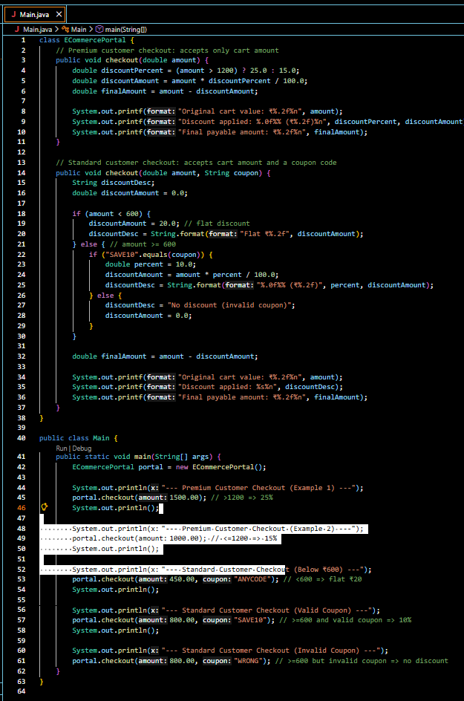
Output:
